**Competency Based Job Profile_________________________________________________________________________**

**CITY OF BRADFORD METROPOLITAN DISTRICT COUNCIL**

**JOB PROFILE**

|  |  |
| --- | --- |
| **DEPARTMENT: Children’s Services** | **SERVICE GROUP: Education and**  **Learning: Specialist Teaching and**  **Support Services; CHILDREN’S**  **MEDICAL AND HEALTH NEEDS AND**  **HOSPITAL SERVICE** |
| **POST TITLE: Teacher for Medical Needs Service** | **REPORTS TO: Service Manager** |
| **GRADE: MPS/UPS** | **SAP POSITION NUMBER :** |

The following information is furnished to help Council staff and those people considering joining the City of Bradford Metropolitan District Council to understand and appreciate the general work content of their post and the role they are to play in the organisation. The duties and responsibilities highlighted in this Job Profile are indicative and may vary over time. Post holders are expected to undertake other duties and responsibilities relevant to the nature, level and scope of the post and the grade has been established on this basis. For posts where employees speak directly to members of the Public the post holder is required to demonstrate their ability to speak fluently in English.

As a candidate you will be expected to demonstrate your ability to meet the special knowledge, experience and qualifications required for the role by providing evidence in the application form for the purpose of shortlisting. Applicants with disabilities are only required to meet the essential special knowledge requirements shown by a cross in the end column of this section.

The employee competencies are the minimum standard of behaviour expected by the Council of all its employees and the management competencies outlined are those relevant for a post operating at this level within our organisation.

Both sets of competencies will be used at interview stage and will not be used for short listing purposes. **Please see the separate guidance information on how to complete the form located on Bradnet**.

|  |
| --- |
| Key Purpose of Post: |
| These posts are subject to the full range of responsibilities of teachers as described in the School Teachers’ Pay and Conditions document 2019 and updates:   * Be an integral part of Children’s Medical Needs and Hospital Service ensuring effective teaching of children of compulsory school age and delivery of high quality learning and education for children and young people with medical and health needs across a particular key stage or phase or education to improve their outcomes * Work effectively within the service to plan, deliver and meet individual needs, working in partnership with school, families, health providers including CAMHS and other professionals and agencies * To work and liaise with schools with children and young people who have medical and health needs so that they understand and know how to meet children and young people’s needs and enhance their own capacity to meet needs and ensure effective transition back into school when appropriate |

**Competency Based Job Profile_________________________________________________________________________**

|  |
| --- |
| Main Responsibilities of Post: |
| * To work as a teacher as part of a phase or key stage team within the service providing high quality teaching and learning appropriate to that phase and/or key stage to children and young people – and the knowledge, expertise and understanding of the curriculum across that age-range, phase, or key stage * To contribute to the research, training, CPD and dissemination of best practice to the wider team in the service for that phase, key stage and age-range * To work with staff in schools/provision to directly support children and young people with medical and health needs including exemplifying good practice, modelling teaching and the direct delivery of any evidenced based programmes or effective teaching and learning strategies * To ensure own knowledge, practice and understanding are current and regularly updated in order to give current and timely advice and support to the service users based on recent research and robust evidence * To plan and deliver, to the highest standards, the requirements specified in the service level agreements with schools/provisions for children and young people with medical and health needs * To communicate effectively with children and young people, their parents and carers, school staff and service users, professional colleagues within the service, the Prevention and Early Help Service, Children’s Services, Health providers for example CAMHS and other external agencies and partners * To contribute to the effective planning for, and facilitation of effective transitions for CYP to their on roll school/education provider * To participate in meetings and professional development and training and contribute to service evaluation and improvements * To ensure that the safety and safeguarding of children and young people is paramount and to implement the policies, procedures in line with KCSIE and the Bradford Safeguarding Children Board, promoting the safety, welfare of children and young people and report to team leaders and management any concerns about children missing education, off-rolling, etc * To monitor and evaluate specific programmes/pieces of work for their impact on a range of outcomes for children and young people with medical and health needs * To contribute to any evaluative reports required by service users, the service, the Local Authority and other stakeholders on performance and the impact of the service teaching team on improving a range of outcomes for children and young people with medical and health needs * To be able assist in different areas of the Children’s Medical Needs and Hospital Service when appropriate and under the direction of management * To undertake all duties commensurate to the nature and level of the post at an initial place of work or any other venue |

**Competency Based Job Profile_________________________________________________________________________**

**Structure:**

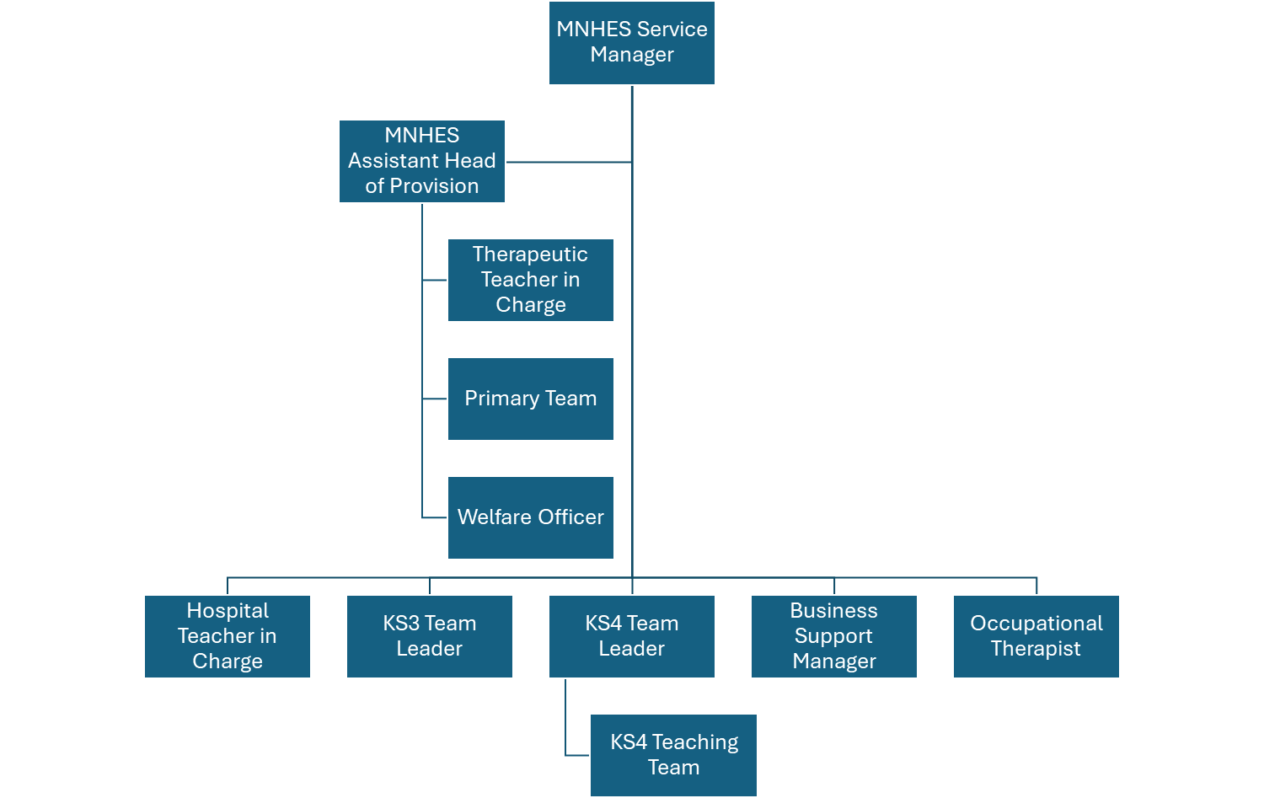

|  |  |
| --- | --- |
| **Special Knowledge Requirement: Essential for shortlisting.** | |
| **Applicants with disabilities are only required to meet the essential special knowledge requirements shown by a cross in the end column** | |
|  | Essential |
| Due to the Governments fluency in English Duty for posts where employees speak directly to members of the public the post holder is required to meet the Advanced Threshold level which will be implemented where the post requires a greater level of sensitive  interaction with the public, the person is able to demonstrate that they can during the interviews:  a) Can express themselves fluently and spontaneously, almost effortlessly  b) Only the requirement to explain difficult concepts simply hinders a natural smooth flow of language | X |
| Carries out the working practices, procedures and basic operations across a specialist area or number of specialist areas. Carries out a variety of specialist professional; or general managerial responsibilities effectively, with a considerable depth of knowledge across a range of relevant areas for example a phase, key stage of education | X |
| Uses specialist knowledge of health, safety and environmental policies, procedures and regulations, including risk in own area and/or across other areas of work including KCSIE and Prevent Plans own work, and programmes work for others, taking into account any Health, Safety and Environmental policies, procedures and issues - briefing others where relevant and carrying out checks as/when appropriate, including taking preventative and/or remedial action. Identifies and manages risk, in relation to operational objectives and completing risk assessments | X |
| Uses a range of specialist ICT systems across own work area and or across other areas of work. Understands the requirements surrounding data protection and information security and the relevant transfer of data through internal and external mechanisms including GDPR | X |
| Uses, interprets, analyses and communicates complex information from a variety of sources.eg assessment and progress information | X |
| Detailed and current knowledge of Safeguarding and the Prevent agenda and the ability to advise and respond quickly and appropriately in line with local and national legislation and advice | X |

|  |
| --- |
| Relevant experience requirement: Will be used for shortlisting |
| The applicant is required to provide evidence of having previously spoken fluently to members of the public in order to meet the advanced threshold standard outlined under Special Knowledge above |
| Specialist teaching experience of working with children and young people with medical and health needs across a specific phase, key stage of education |
| Experience of delivering high quality teaching and learning, support and interventions which have had an impact on improving outcomes for children and young people with medical and health needs |
| Recent experience of delivering impactful interventions/programmes, and support teaching children and young people with medical and health needs |
| Recent experience of using assessment tools, interpreting and using the results to improve outcomes for children and young people with medical and health needs |

|  |
| --- |
| Relevant professional qualifications requirement: Will be used in shortlisting |
| * Educated to a degree level * Qualified teacher status (QTS) * Any evidence of further accreditation, training or CPD of meeting the needs of children and young people with medical/health needs * Current and up-to-date working knowledge and training of Safeguarding – Keeping Children Safe in Education |
| Core Employee competencies to be used at the interview stage |
| **Carries Out Performance Management** – covers the employees’ capacity to manage their workload and carry out a number of specific tasks accurately to a high standard |
| **Communicates Effectively** - covers a range of spoken and written communication skills required as a regular feature of the job. It includes exchanging information/building relationships, giving advice and guidance, counselling, negotiating and persuading and handling private, confidential and sensitive  information |
| **Carries Out Effective Decision Making** - covers a range of thinking skills required for taking initiative and independent actions within the scope of the job. It includes planning and organising, self effectiveness and any requirements to quality check work |
| **Undertakes Structured Problem Solving Activity** - covers a range of analytical skills required for gathering, collating and analysing the facts needed to solve problems. It includes creative and critical thinking, developing practical solutions, applying problem solving strategies and managing interpersonal relationships |
| **Operates with Dignity and Respect** - covers treating everyone with respect and dignity, maintains impartiality/fairness with all people, is aware of the barriers people face |

|  |  |  |
| --- | --- | --- |
| **Working Conditions:** | | |
| Must be able to perform all duties and tasks with reasonable adjustment, where appropriate, in accordance with the Equality Act 2010 in relation to Disability Provisions. | | |
| **Special Conditions:** | | |
| No contra-indications in personal background or criminal record indicating unsuitability to work with children/young people/vulnerable clients/finance Enhanced DBS check required.  The post holder is required to have a useable car available at all times or as advised by the line manager. The post is designated Casual Class 1 Car User status for the better performance of the duties for which the HMRC rate is payable. | | |
| **Compiled by:**  **Hannah Whittaker**  **Reviewed by: Alice Ngondi**  **Date: June 2025** | **Grade Assessment**  **Date:** | **Post Grade: STPC MPS/UPS** |