Role Profile

Reference Number | 11000158
Role Title | Database Manager
Directorate | Office of the Chief Executive
Department | West Yorkshire Pension Fund
Reports to | Head of IT

Role Purpose
To maximise the effectiveness of West Yorkshire Pension Fund’s IT by the selection, development, implementation and ongoing enhancement of IT systems in use within the department.
To support users of WYPF’s IT systems, both internal and external within our client base, to enable maximum benefit to be extracted from our systems.
To act as WYPF’s specialist in the areas covered by this post, and to maintain working knowledge of other specialisations within the IT Team in order to provide cover during absence of colleagues and maximise the flexibility of the team.

Maintain detailed knowledge of WYPF’s UPM2 document imaging and workflow system. Responsible for database administration of WYPF’s Oracle databases.
Performance tuning of WYPF’s databases to maximise performance. Data reporting and manipulation using Oracle SQL and PL/SQL
Transfer of new clients’ data to WYPF as part of the overall onboarding process, including advising on how incoming data should be formatted and stored.
Work as part of a team within the IT Team by maintaining a working knowledge of all aspects of the teams work in order to provide a flexible service to WYPF’s users and external clients and cover for colleages during periods of absence.
Advise the Head of IT on items relating to WYPF’s IT strategy. Maintain IT system and quality management system documentation governing WYPF’s IT systems and operations.
Provide first and second line support for WYPF’s IT systems to both internal users and external clients, raising development and support requests with external system suppliers when necessary.
Identify opportunities for improvement within WYPF’s service offering, operations and IT systems and make recommendations to colleagues and management as required.
Testing of new system developments and new releases of software by suppliers.
Maintain a constant awareness of information security, taking action as appropriate to ensure compliance with EU and UK law, and council standards.
Provide professional advice to colleagues across the department.
Provide training in specialist area to colleagues within the team, across the section and WYPF’s client base as appropriate.
Responsible to the Head of IT, working within broad policy guidelines and objectives.
Works mainly on own initiative in a highly specialised field with a high degree of discretion and delegated authority.
The seniority of the post is such that the post holder is required to demonstrate strategic initiative, political awareness; professional, managerial and technical competence in carrying out the functions of the post, whilst referring matters to the Head of IT.

Knowledge / Skills / Experience required
Carries out the working practices, procedures and basic operations across a specialist area or number of specialist areas within WYPF’s IT Team.
Uses knowledge, safety and environmental policies , procedures and regulations, including risk in own area and/or other areas of work including legislation
Uses a range of specialist ICT systems across own work area and or across other areas of work.
Oversees or contributes to the management of a budget , keeping costs within agreed levels for own section/team Uses, interprets, analyses, communicates complex numerical information.
Requirements of Database Administration.
Principles of database design.
Performance tuning of databases.
Architecture and operation of the Civiva UPM2 pensions administration system, with particular reference to document imaging and workflow.
Data mapping and conversion from differing systems to the UPM2 database.

Dimensions of role (direct/ indirect as applicable) eg total number of staff managed/ total budget/ total scope of role
Manage the access to highly confidential, personal, financial, political and commercially sensitive information; to ensure compliance with appropriate legislation e.g. GDPR, FOI, Child Protection Act, etc (and any UK replacement). The unauthorised disclosure of which would prejudice the interests of the Council.

Structure Chart (role of direct reports)
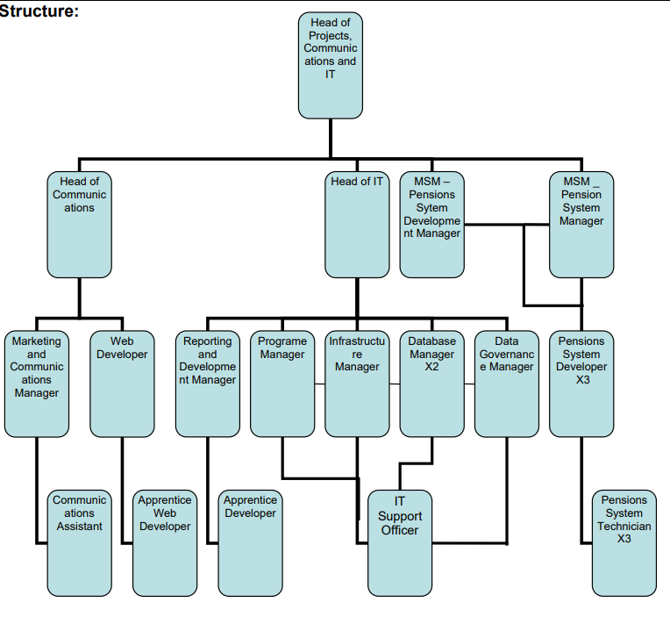

Key benchmarked competencies, traits and motives required to successfully deliver the role (not required for JE. Informs recruitment, succession planning, development and performance management
Operates with Strategic Awareness Our managers work with corporate priorities and policies in a joined up way with others, internally and externally. Works democratically, transparently and accountably.

Practices Appropriate Leadership Our managers motivate their staff to exceed expectations through raising their awareness of goals and moving them beyond self interest for the sake of the team or service. They consider serving the District in all that they do.

Delivering Successful Performance Our managers monitor performance of services, teams & individuals against targets & celebrate great performance. They promote the District’s vision & work to achieve Council’s values & agreed outcomes

Must be able to perform all duties and tasks with reasonable adjustment, where appropriate, in accordance with the Equality Act 2010 in relation to Disability Provisions.
Must be prepared to travel to address or participate in meetings, liaise with staff working in remote offices, undertake training both within and outside West Yorkshire. Must be able to work flexible hours as required by the needs of the service

The post will be subject to a DBS check.

