Information Pack
Legal Services




www.bradford.gov.uk

Great things happen here in Bradford

Big, young and diverse, we are home to more than half a million people, vibrant communities, innovative businesses and institutions. The District is alive with energy, enterprise and goodwill and represents unrivalled potential, a growing pipeline of talent and exceptional quality of life at the heart of the north. Urban, bustling, streetwise, with award-winning public realm, yet two- thirds rural with beautiful landscapes, and open spaces on the doorstep the District offers leisure and lifestyle opportunities to suit everyone. A dynamic cultural sector is at the heart of Bradford’s vision for social and economic inclusion. The district has a proud cultural heritage and an eye catching and fertile contemporary offer, with world class exponents of literature, film, music, art and cuisine.

Join the Bradford In-House Legal Team
Bradford Council’s Legal Team is at the heart of the Council, providing expert in-house legal services that help shape the future of our district. We play a vital role in delivering key public services, offering high-quality advice and representation across a broad range of disciplines.
We cover:
Social Care Law – Supporting both adult and children’s services, ensuring the protection and well-being of the most vulnerable in our community.
Employment, Education Law and Litigation – Advising on complex employment matters, special educational needs, education law , civil litigation, prosecutions, information governance and elections law.
Property, Commercial and Development Law – Covering property, contracts, and development projects that drive economic growth and regeneration in Bradford, plus other planning and highways legal issues.
Our team is friendly, supportive, and highly collaborative, creating an environment where you can thrive. Working in-house means you’ll be involved from the start of projects, seeing the direct impact of your work on the community. We encourage continuous learning and development, offering opportunities to broaden your expertise and even expand your skills into new areas of law.
This is more than just a legal job—it’s a chance to work on diverse and meaningful cases, develop professionally, and be part of a forward-thinking, ambitious council that truly values its people. If you’re looking for a rewarding legal career where you’ll feel supported and challenged in equal measure, Bradford Council is the place for you.
Join us and help shape the future of our district.

What we Offer

At Bradford Council, we value our employees. Here is what you can expect when joining our team:
- Onboarding and mentoring: People are fully inducted, mentored, and supported by experienced colleagues.
- Growth & Development: We provide an environment that nurtures personal and professional growth, with opportunities for career progression and upskilling.
- Diversity & Inclusion: We champion diversity and inclusion, ensuring our workplace is one in which all can thrive.
- Work-Life Balance: We respect and promote a healthy work-life balance with flexible working arrangements whenever possible.
- Robust Benefits Package: We offer a comprehensive benefits package, including a competitive pension scheme, generous annual leave, and access to our employee benefits and shopping discounts scheme ‘Vivup’
- Contribution to Community: Your work will have real-world impact on our community, making Bradford a better place to live, work, and play.
- Are you ready to make a difference? Join our team and be part of something special. Bradford Council - A great place to work and make a difference.

Why join Team Bradford at Bradford Council
If you care about making a difference and believe in the work you do (or the work you want to do), then we want to hear from you. Our workforce changes lives, so whatever the job might be, if you want to do it to the best of your ability and are passionate about the district then we want you in Team Bradford. Bradford Council is a great place to work and below are just a few of the reasons why!
#LoveMyJob

As the leading employer in the district, we care about creating a great place to work. We want every employee to be able to say they love their job, whatever that might be. We provide support to help that happen, from recently improved performance management systems to a wide range of training and development opportunities.
The colleagues around you can make or break how you feel about work. Having positive workmates, with a can-do attitude, who want to help and who care about getting things right, can make a massive difference. Our Bradford Behaviours provide guidance about what is expected of all employees, to help make Bradford Council a great place to work for everyone.
What can you expect from Bradford Council as an employer?

- Local Government Pension Scheme
- Flexible working (including hybrid working allowing working from home and office.)
- Annual Travel Card and Discounted Car Parking
- Cycle to Work Scheme
- Service Excellence Awards Learning and Development
- The induction process, mentoring, and support of experienced colleagues.
- Metrofit Card and Club Active
- Bradford Credit Union
- Our recently introduced employee benefits and shopping discounts scheme ‘Vivup’.
The platform gives you access to:
o Exclusive shopping discounts
o 24/7 employee assistance programme (EAP)
o Free will writing

About Bradford

From a cultural urban centre, to sweeping landscapes and stunning heritage towns – we have something for everyone across approximately 141 square miles, stretching across Airedale, Wharfedale and the Worth Valley. those moving to the area could choose Bradford city and the towns of Bingley, Ilkley, Keighley and Shipley or one of many other communities including Addingham, Baildon, Burley in Wharfedale, Cullingworth, Denholme, Eastburn, Eccleshill, Haworth, Menston, Oxenhope, Queensbury, Silsden, Steeton and Thornton. Please visit the Bradford website.
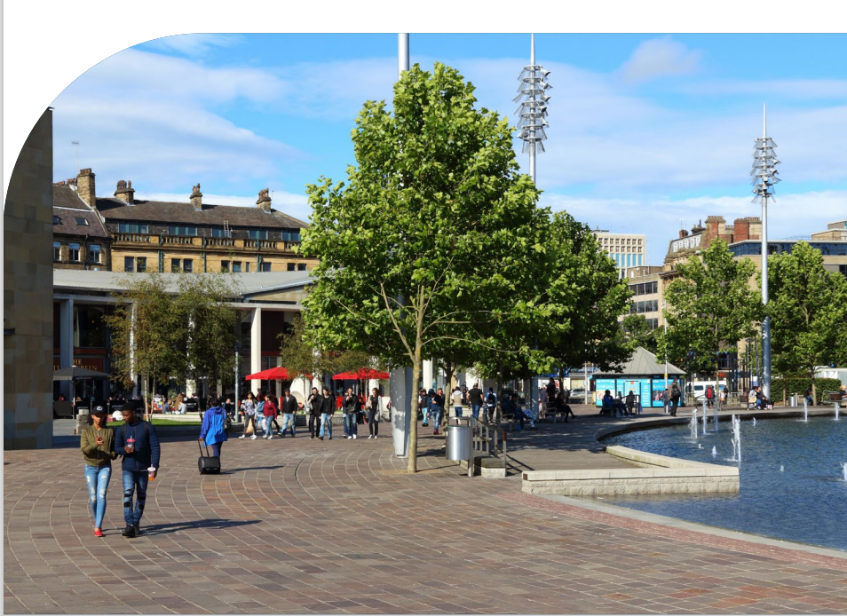
Bradford is the UK City of Culture 2025

The year is set to deliver more than 1000 new performances and events including 365 artist commissions, a series of major arts festivals as well as exciting national and international collaborations. Its themes will be rooted in the unique heritage and character of Bradford and will reveal the magic of the district that is held in its people, its ambition, and above all, its potential.

Bradford District has more to offer than you might think.
A local economy that’s valued at £12 billion. 10 million visitors a year. A compelling blend of the city and stunning countryside. The youngest district in the UK with nearly a third of the population aged under 20. Identified as the most improved city in the PricewaterhouseCoopers’s Good Growth 2019 Index. And it’s diverse – ethnic minorities form a third of the population with more than 150 languages spoken within the district. Geographically, our district includes the city of Bradford itself, the large town of Keighley and a number of smaller towns and villages many with their own strong and distinctive identities.

Equal Rights and Diversity Statement

This statement outlines the Council’s commitment to equality and diversity. We want to make our district a fairer and more equitable place for everyone in the district. The Council aims to eliminate discrimination, advance equality of opportunity and foster good relations across all protected characteristics in all its activities including its decision-making, policy development, budget setting, procurement and commissioning, service delivery and employment functions.
Pension
When you commence employment with the Council, you will immediately become a member of the West Yorkshire Pension Fund although under current regulations it is possible to opt out within the first three months.

Interview expenses
You may be able to claim travel and subsistence expenses incurred. Please discuss with the recruiting manager.

Trade Union membership
This Council supports the principle that all employees should be encouraged to be members of an appropriate trade union recognised for the purpose of negotiation and consultation.

Equality Act (2010)
As an equal rights employer we are committed to providing equality of access to employment and to development opportunities for people from all parts of the community. We particularly encourage applications from disabled people who are under-represented amongst our employees.
See below for information on the definition of disability, reasonable adjustments, guaranteed interview, alternative formats, rehabilitation of offenders, policy on employment of people with a criminal record etc

Disabilities
Bradford Council has been awarded Disability Confident status by the Department of Work and Pensions. Disability Confident is a national scheme which aims to ensure that disabled people and those with long term health conditions have the opportunities to fulfil their potential and realise their aspirations.
Definition of Disability
The Equality Act 2010 defines a ‘disabled person’ for the purpose of the Act as a person who has a ‘disability’ if he or she has a physical or mental impairment which has a substantial and long-term adverse effect on her or his ability to carry out normal day-to-day activities.
- Physical impairments - This includes for instance, a weakening of part of the body (eyes, ears, limbs, internal organs etc.) caused through illness, by accident or congenitally. Examples would be Blindness, Deafness, Paralysis of a leg, Heart Disease, Diabetes, Epilepsy, ME. Mental health - This includes a clinically well recognised mental illness.
- Mental ill health can range from feeling a bit down to common disorders such as anxiety and depression and in limited cases to severe mental illness such as bi-polar disorder or schizophrenia. Some illnesses are persistent and may be classed as a disability while others come and go, giving the individual good and bad days. For example, someone with a mild form of depression with only minor effects may not be covered but someone with severe depression with substantial effects on their daily life is likely to be considered as disabled under the act.
- Learning Disability - For example Dyslexia, Asperger’s Syndrome and Autism are also recognised disability conditions.
- Substantial - Put simply, this means the effect of the physical or mental impairment on ability to carry out normal day-to-day activities is more than minor or trivial. It does not have to be a severe effect.
- Long term adverse effect - The effect must have lasted, or be likely to last, overall, for at least 12 months and the effect must be a detrimental one.
- A person with a life expectancy of less than 12 months is also covered.
Reasonable adjustments
To support our aim of removing barriers to employment for disabled people we are committed to making any necessary reasonable adjustments. These adjustments may include modifying the selection process, the job role or the working environment. To assist us in planning to accommodate your individual needs (if any); it would be helpful if your application could be supplemented by any information you may wish to provide about your needs. This information will be treated as confidential within the recruitment process and will be used solely with your consent, for the purpose of enabling selectors (and our Occupational Health Unit if appropriate) to make a fair assessment of your capabilities.

Disability Confident
The Council has a policy to interview any disabled applicant who meets the essential special knowledge criteria (these are marked with a X). You must also be able to demonstrate that you meet the experience and qualifications criteria. We also consider any reasonable adjustments that need to be made as we wish to ensure that disabled candidates needs are considered during the selection process. Please see www.bradford.gov.uk/jobs for more information


