CITY OF BRADFORD METROPOLITAN DISTRICT COUNCIL
JOB PROFILE

DEPARTMENT: Place | SERVICE GROUP: Markets Service
POST TITLE: Food Hall Manager (Darley Street Market) | REPORTS TO: Markets Manager / Deputy Market Manager
GRADE: PO1 |  | SAP POSITION NUMBER :

The following information is furnished to help Council staff and those people considering joining the City of Bradford Metropolitan District Council to understand and appreciate the general work content of their post and the role they are to play in the organisation. The duties and responsibilities highlighted in this Job Profile are indicative and may vary over time. Post holders are expected to undertake other duties and responsibilities relevant to the nature, level and scope of the post and the grade has been established on this basis. For posts where employees speak directly to members of the Public the post holder is required to demonstrate their ability to speak fluently in English.

As a candidate you will be expected to demonstrate your ability to meet the special knowledge, experience and qualifications required for the role by providing evidence in the application form for the purpose of shortlisting. Applicants with disabilities are only required to meet the essential special knowledge requirements shown by a cross in the end column of this section.

The employee competencies are the minimum standard of behaviour expected by the Council of all its employees and the management competencies outlined are those relevant for a post operating at this level within our organisation.

Both sets of competencies will be used at interview stage and will not be used for short listing purposes.

Key Purpose of Post:
To support the Markets Manager in the leadership and management of the Markets Food Hall, with a primary responsibility for the overall day-to-day management and future development of the Food Halls operations.

To contribute to the development of relevant strategies and plans and ensure the key role of Food Hall in the district’s economic, cultural, regeneration, skills and health and well-being projects.

Main Responsibilities of Post:
- Develop positive and collaborative working relationships with the responsible representatives from each outlet within the Food and Beverage (F&B) Hall and Ground Floor Cafes to ensure that relevant rules, procedures, legislation, agreed service levels and lease conditions are adhered to. To act as the Council’s representative in approving F&B trader change requests to menu, price, product specification or uniform.
- Oversee the delivery of an ongoing F&B Trader search plan and manage the decision-making process for the allocation of leases to new traders, considering product mix and changing / developing food trends. Maintain an up-to-date pipeline of prospective new F&B tenants.

- Ensure the effective co-ordination, management, maintenance and operation of Food Hall, Kiosks, Cafes, Toilets and Public communal spaces, ensuring high levels of cleanliness, customer service, security and health and safety standards, including risk management and assessment, for traders, staff and public.
- totalling up to 10 persons with effective rostering ensuring adequate and efficient coverage with a robust system of administering forecasted costs, actual hours worked and hours billed.
- Ensure the waste streaming strategy, as developed from time to time, is adhered to by all F&B traders, subcontractors, their agents and staff from source to the collection staging area. To ensure that clear public waste streaming signage is always on display with ample available waste receptacles.
- Ensure equipment in use is operated correctly and kept clean, that faults are logged and evidence of misuse is investigated and escalated. Ensure repairs are undertaken immediately or as soon as practically possible (initially under warrantee / guarantee). Surplus equipment not in use should be clean, wrapped and stored appropriately for future use.
- Where applicable ensure equipment inspection, maintenance and or dosing/ recharging is carried out in line with insurers recommendations, legislation, manufacturers / suppliers’ guidelines or a practical timeframe, including but not limited to the buildings extraction systems, firefighting equipment, cleaning of refrigerator and freezer air intake vents, pressure vessel testing (coffee machines), first aid kits and grease traps.
- To ensure an adequate number of trained and certified; Licensees, level 2 and 3 Food Hygiene holders, First Aiders and Fire Marshalls are present on shift at any given time.
- To ensure a F&B customer complaints handling policy is in place and that all written complaints are responded to, all verbal complaints are logged. Complaints are investigated and brought to the relevant trader / department’s attention. To ensure that same theme reoccurring complaints are escalated, and originating issues are resolved.
- To work closely with the Markets Manager, Deputy Manager, Marketing Department and F&B Traders in the development, planning, management, delivery, activation, exploitation and debrief of commercial and income generating opportunities, including but not limited to, social media content staging, events, commercial rights propositions and small stage activity.
- To be responsible for delivering on financial, service, qualitative and quantitative performance targets as they pertain to the provision of public food and beverage operations and the environment around these provisions.

- Organise the secure storage, reordering, stock taking and control of cleaning chemicals, janitorial equipment and washroom consumables, ensuring COSHH compliance.

- To create and maintain a culture of continuous improvement and monitor performance targets for improving the effectiveness, efficiency and overall quality of the product and service.

- Remain up to date and compliant with all relevant legislation and adhere to organisational procedures, policies and professional codes of conduct including but not limited to Food Safety, COSHH, Fire and Evacuation Procedures, Risk Assessments, Overall Workplace Safety Standards and Premises Licencing, especially with regard to the consumption of alcohol.

Structure:
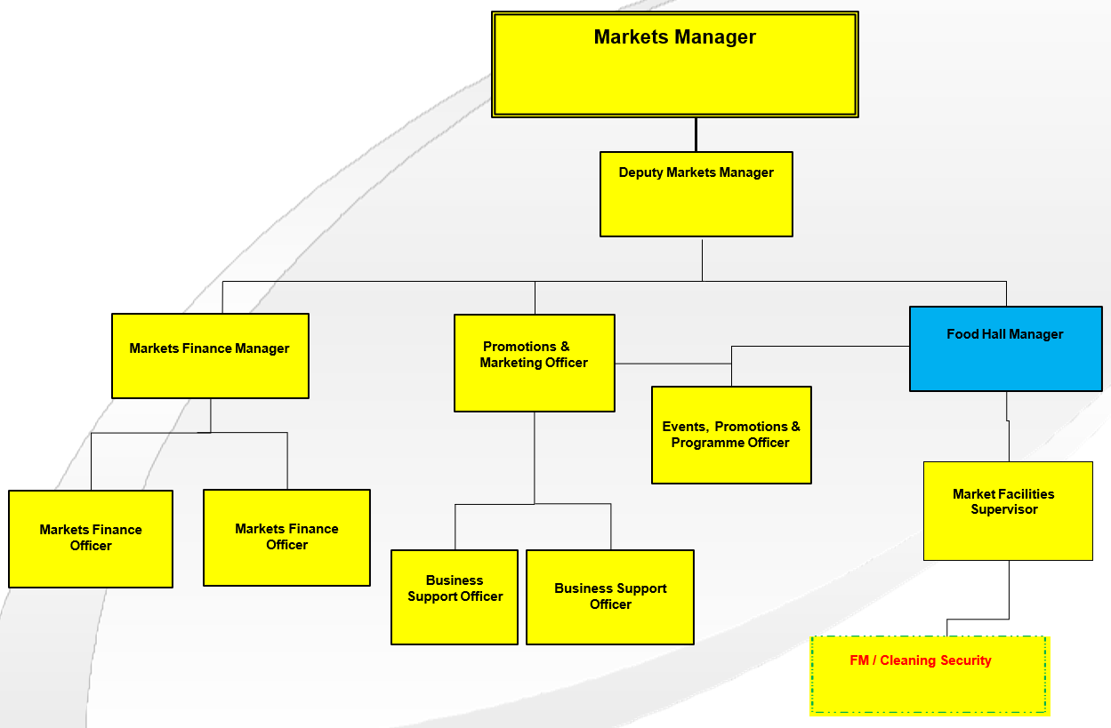

Special Knowledge Requirement: Essential for shortlisting.
Applicants with disabilities are only required to meet the essential special knowledge requirements shown by a cross in the end column
 | Essential
Due to the Government’s Fluency in English for posts where employees speak directly to members of the public the postholder is required to meet the Advanced threshold level which will be applied where the postholder requires a greater level of sensitive interaction with the public.  You must be able to demonstrate that you can express yourself fluently and spontaneously (this will also be tested during the interview). | x
Extensive and comprehensive management experience at a senior level working in a retail, leisure or food & beverage. | x
Relevant experience of managing and interrogating budgets. | x
Demonstrates experience of successfully managing and improving service efficiencies. | x
Demonstrates the ability to use, interpret, analyse and communicate complex numerical information. | x
Be able to write and present reports and use electronic document systems and use a range of standard Microsoft business software applications. | x
Strong commercial awareness including an understanding of changing food and beverage trends. | x
Ability to develop, manage and contribute to partnerships involving various stakeholders to achieve positive outcomes. | x
Demonstrate strong customer focus. | x

Relevant experience requirement: Essential for shortlisting

The applicant is required to provide evidence of having previously spoken fluently to members of the public in order to meet the Advanced threshold level outlined under Special Knowledge above.

Relevant professional qualifications requirement: Essential for shortlisting

Degree level and/or other relevant management qualification or experience in a senior management role working in either Retail, Leisure, or Food & Beverage.

Core Employee competencies at manager level to be used at the interview stage.

Carries Out Performance Management – covers the employees’ capacity to manage
their workload and carry out a number of specific tasks accurately to a high standard.

Communicates Effectively - covers a range of spoken and written communication skills required as a regular feature of the job. It includes exchanging information/building relationships, giving advice and guidance, counselling, negotiating and persuading and handling private, confidential and sensitive information.

Carries Out Effective Decision Making - covers a range of thinking skills required for taking initiative and independent actions within the scope of the job. It includes planning and organising, self-effectiveness and any requirements to quality check work.

Undertakes Structured Problem-Solving Activity - covers a range of analytical skills required for gathering, collating and analysing the facts needed to solve problems. It includes creative and critical thinking, developing practical solutions, applying problem solving strategies and managing interpersonal relationships.

Operates with Dignity and Respect - covers treating everyone with respect and dignity, maintains impartiality/fairness with all people, is aware of the barriers people face.

Management Competencies: to be used at the interview stage.

Operates with Strategic Awareness Our managers work with corporate priorities and policies in a joined-up way with others, internally and externally. Works democratically, transparently and accountably.

Practices Appropriate Leadership Our managers motivate their staff to exceed expectations through raising their awareness of goals and moving them beyond self-interest for the sake of the team or service. They consider serving the district in all that they do.

Delivering Successful Performance Our managers monitor performance of services, teams & individuals against targets & celebrate great performance. They promote the district’s vision & work to achieve Council’s values & agreed outcomes.

Applying Project and Programme Management Our manager’s work to ensure that outcomes and objectives are achieved within desired timescales, make best use of resources and take a positive approach to contingency planning.

Developing High Performing People and Teams Our managers coach individuals and teams to achieve their potential and take responsibility for continuous improvement. They champion the Council’s values and goals.

Working Conditions:

You must be able to work evenings, weekends and bank holidays as required by the
needs of the service.

You must be able to perform all duties and tasks with reasonable adjustment, where
appropriate, in accordance with the Equality Act 2010 in relation to Disability Provisions.

Special Conditions:
You must be a Licensee.

Compiled by: CW  Date: May 2024 | Grade Assessment  Date: 17th October 2024  Ref 00696 | Post Grade: PO1

