CITY OF BRADFORD METROPOLITAN DISTRICT COUNCIL
JOB PROFILE

JEGS Reference 00157
DEPARTMENT: Place | SERVICE GROUP: Hackney Carriage & Private Hire Licensing Service
POST TITLE:  Inspection & Compliance Officer | REPORTS TO:  Regulatory and Compliance Team Leader.
GRADE: SO2 |  | SAP POSITION NUMBER :  50230801 & 50230802

The following information is furnished to help Council staff and those people considering joining the City of Bradford Metropolitan District Council to understand and appreciate the general work content of their post and the role they are to play in the organisation. The duties and responsibilities highlighted in this Job Profile are indicative and may vary over time. Post holders are expected to undertake other duties and responsibilities relevant to the nature, level and scope of the post and the grade has been established on this basis.

As a candidate you will be expected to demonstrate your ability to meet the special knowledge, experience and qualifications required for the role by providing evidence in the application form for the purpose of shortlisting. Applicants with disabilities are only required to meet the essential special knowledge requirements shown by a cross in the end column of this section.

The employee competencies are the minimum standard of behaviour expected by the Council of all its employees and the management competencies outlined are those relevant for a post operating at this level within our organisation.

Both sets of competencies will be used at interview stage and will not be used for short listing purposes.

Key Purpose of Post:
The post holder is responsible for the enforcement of legislation, policy, guidelines and by-laws that cover Hackney Carriage drivers & vehicles, Private Hire operators and Private Hire drivers & vehicles to ensure the safety of the general public at all times and to ensure the district is well served in relation to its transport needs.

Working with the Hackney Carriage and Private Hire trade, key stake holders, partner agencies, other
Council departments and elected members, using in depth Licensing knowledge and customer
service skills to support and improve to standards of safety and customer service.

- To investigate non-compliance with conditions attached to Private Hire operator, vehicle and driver licences. To investigate non-compliance with conditions and by-laws attached to Hackney Carriage driver and vehicle licences.
- Impartially and equitably enforce national legislation, by-laws, conditions of licence and vehicle safety inspections on the street with both drivers and vehicles. Carrying out spot checks on private hire drivers, vehicles and operator's premises to ensure compliance with conditions of licence – carried out both day and night time, including weekends and primarily whilst lone working.
- To devise, plan and deliver an inspection and enforcement programme including shift working including through the support of wider partnership activities and operations, with a view to optimising service delivery and encouraging compliance with licensing standards.

Main Responsibilities of Post:
- Gather evidence relating to offences to assist with prosecution, appeals, panels, Crown and
Magistrates Courts.

- Work flexibly to accommodate the needs of the service including lone working during unsocial hours, at evenings and weekends for which a shift allowance is payable.

- To analyse and understand the implications of new legislation affecting the Licensing
service including participation on in-service training inputs and other training programmes as required, and maintain personal and professional development in order to meet the changing demands of the post.

- Issue enforcement/legal notices/court summons documents and serve and post legal notices as required.

- To ensure the maintenance of all electronic and paper record keeping systems in an accurate and orderly fashion to support the administration of the licensing function. Continually review processes, procedures and guidance to ensure the service operates in a cost effective, consistent and efficient way. Identify and recommend improvements to HC&PH Licensing Service delivery.

- Deal with internal and external customers face to face, over the telephone and via email, adopting the highest standards of customer care.

- Delivering modular taxi driver training and presentations to the HC&PH trade at
meetings, seminars etc.

- Demonstrate excellent written and verbal communication skills, produce written reports with a high level of accuracy and attention to detail, and work effectively to deadlines.

- Administering inspection, testing and sealing of meters for accuracy

- Demonstrating resilience under pressure and in the face of change

- Promoting the work of the HC&PH Licensing Service by attending meetings, internal and external to the Council including with strategic partners, the trade, interest groups, public meetings etc

- Delivering personal services to meet Key Performance Indicators (KPI) set by the licensing and compliance Manager as required

- Constantly observes the Council’s Health and Safety Policy and comply with current Health and Safety legislation and Departmental policy on Equal Rights in relation to Service Delivery

- Constantly acts in accordance with Data Protection Act principles and maintain confidentiality at all times.

- To undertake any other duties commensurate with the grade and overall level of the post

Structure:

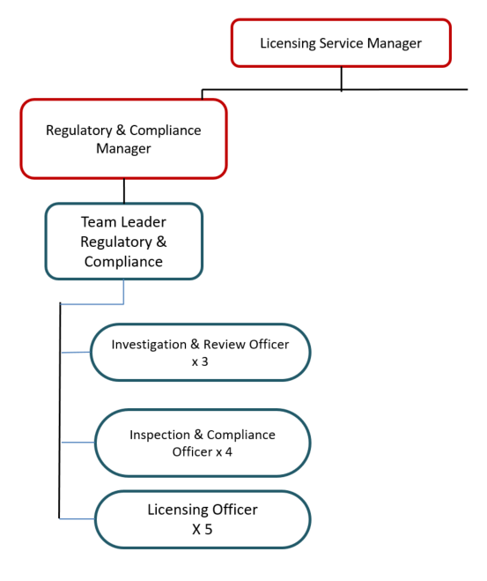
Special Knowledge Requirement: Will be used for short listing
Applicants with disabilities are only required to meet the essential special knowledge requirements shown by a cross in the end column.
 | Essential
Due to the Government’s Fluency in English Duty for posts where employees speak directly to members of the public the post holder is required to meet the Advanced threshold level (which will be implemented where the post requires a greater level of sensitive interaction with the public e.g. in children’s centres) – where the person is able to demonstrate that they can during the interview:  a) Can express themselves fluently and spontaneously, almost effortlessly  b) Only the requirement to explain difficult concepts simply hinders a natural smooth  flow of language | X
Effectively carries out the working practices, procedures and basic operations  associated with a regulatory environment e.g. licensing and enforcement, in an area of  substantial complexity applying regulations, rules, policies, procedures and processes  across a specialist area | X
Able to apply legislative and technical understanding to a wide variety of licence or registration applications | X
Able to provide verbal and written advisory and regulatory advice within a customer focused service delivery organisation | X
Able to conduct investigations, take statements and write reports in accordance with policies and procedures | X
Able to consider all relevant factors and use sound judgement to make logical decisions | X
Able to demonstrate an understanding and preparation of legal proceedings including  compliance with PACE codes, preparation of prosecution files and attendance at courts  and panels/tribunals and appeals as an expert witness | X
Able to demonstrate the preparation, drafting and service of enforcement notices | X
Able to diffuse difficult and potentially harmful situations and support colleagues in dealing with difficult situations, intervening as necessary | X
Able to demonstrate an understanding of health & safety with particular reference to violence at work when dealing with clients in an enforcement capacity | X
Able to use a wide range of basic computer applications using ICT systems & packages to improve ways of working and apply the requirements of data protection and the appropriate transfer of data through internal and external mechanisms | X
Able to act as a competent person/witness on behalf of the Council in court proceedings | X

Relevant experience requirement: Will be used for short listing
Substantial & demonstrable experience of working in a regulatory & customer focused, service delivery environment
Substantial experience of dealing with people from diverse communities including experience of dealing with hostile situations
Experience and competence in taking witness statements and giving written/oral evidence at hearings e.g. Magistrates Court, Committees, Tribunals
Experience of working in an enforcement environment and some vehicle/mechanical knowledge
would be desirable
Relevant professional qualifications requirement: Will be used for short listing
QCF Level 4, NVQ4, or 5 years equivalent demonstrable experience.

Core Employee competencies at manager level to be used at the interview stage.
Carries Out Performance Management – covers the employee’s capacity to manage
their workload and carry out a number of specific tasks accurately and at a high standard.
Communicates Effectively - covers a range of spoken and written communication skills required as a regular feature of the job. It includes exchanging information/building relationships, giving advice and guidance, counselling, negotiating and persuading and handling private, confidential and sensitive information.
Carries Out Effective Decision Making - covers a range of thinking skills required for taking initiative and independent actions within the scope of the job. It includes planning and organising, self effectiveness and any requirements to quality check work.

Undertakes Structured Problem Solving Activity - covers a range of analytical skills required for gathering, collating and analysing the facts needed to solve problems. It includes creative and critical thinking, developing practical solutions, applying problem solving strategies and managing interpersonal relationships.
Operates with Dignity and Respect - covers treating everyone with respect and dignity, maintains impartiality/fairness with all people, is aware of the barriers people face.

Management Competencies: to be used at the interview stage.

Operates with Strategic Awareness Our managers work with corporate priorities and policies in a joined up way with others, internally and externally. Works democratically, transparently and accountably.
Practices Appropriate Leadership Our managers motivate their staff to exceed expectations through raising their awareness of goals and moving them beyond self interest for the sake of the team or service. They consider serving the District in all that they do.
Delivering Successful Performance Our managers monitor performance of services, teams & individuals against targets & celebrate great performance. They promote the District’s vision & work to achieve Council’s values & agreed outcomes.
Applying Project and Programme Management Our manager’s work to ensure that outcomes and objectives are achieved within desired timescales, make best use of resources and take a positive approach to contingency planning.
Developing High Performing People and Teams Our managers coach individuals and teams to achieve their potential and take responsibility for continuous improvement. They champion the Council’s values and goals.
Working Conditions:
Must be able to perform all duties and tasks with reasonable adjustment, where appropriate, in accordance with the Equality Act 2010 in relation to Disability Provisions.
Special Conditions:

- Must hold a full UK Driving Licence
- Will be required to work outside of normal working hours on a regular basis
including late evenings, early mornings and at weekends.
- Will be required to make roadside checks on drivers and vehicles and make on
the spot decisions as to the suspension of licences where public
safety is an issue
- Will have to deal with challenging behaviour and bad language from the trade
and members of the public, both on the telephone and in person, on the street
and within the office

Compiled by: CS  Date: 2022 | Grade Assessment Date: Nov 2022 | Post Grade: SO2

