CITY OF BRADFORD METROPOLITAN DISTRICT COUNCIL
JOB PROFILE
DEPARTMENT:  PLACE | SERVICE GROUP:  Hackney Carriage & Private Hire Licensing Service
POST TITLE: LICENSING OFFICER | REPORTS TO: Team Leader - Regulatory and Compliance
GRADE: Band 7 | POST REFERENCE: 50230770, 50230771 & 50230772
JEGS 00121

The following information is furnished to help Council staff and those people considering joining the City of Bradford Metropolitan District Council to understand and appreciate the general work content of their post and the role they are to play in the organisation. The duties and responsibilities highlighted in this Job Profile are indicative and may vary over time. Post holders are expected to undertake other duties and responsibilities relevant to the nature, level and scope of the post and the grade has been established on this basis.

As a candidate you will be expected to demonstrate your ability to meet the special knowledge, experience and qualifications required for the role by providing evidence in the application form for the purpose of shortlisting. Applicants with disabilities are only required to meet the essential special knowledge requirements shown by a cross in the end column of this section.

The employee competencies are the minimum standard of behaviour expected by the Council of all its employees and the management competencies outlined are those relevant for a post operating at this level within our organisation.

Both sets of competencies will be used at interview stage and will not be used for short listing purposes. Please see the separate guidance information on how to complete the form located on Bradnet.

Key Purpose of Post
- To manage and administer licence applications in accordance with the relevant statutory provisions and the Council’s policies and procedures in all aspects of licensing, such as applications, technical enquiries and other enquiries so that they are processed in accordance with prescribed deadlines or otherwise without unreasonable delay.

- Provide advice and information (verbal, electronic and written) to customers and businesses on technical and procedural enquiries. Work as part of the team to assist in the continuity of business support to meet the varied service needs.

- Interpret HCPH licensing legislation, policy and technical matters in relation to licensing applications in a fair and proportionate manner. Communicate the requirements of sometimes complex matters in a way that is easily understood by customers and businesses.

Main Responsibilities of Post
- Ability to accurately follow and implement procedures relating to licensing functions, such as processing applications and dealing with technical requests, in accordance with prescribed regulations and service practice requirements.

- Manage information in line with the Council’s policies, procedures, and guidance on subjects such as data protection, freedom of information, confidentiality, information security and sharing, the information lifecycle and data quality, to ensure compliance and efficient and effective information governance.

- To provide a welcoming approach and maintain a polite and professional manner at all times.

- Ability to analyse complex statistical information and be able to produce management information as required, with excellent attention to detail.
- To communicate effectively with internal & external customers and colleagues in relation to work undertaken & be well informed on all current policy and conditions.

- To ensure effective, timely and efficient handling of all forms of correspondence including emails to maintain accurate records and track progress of work.

- Undertake appropriate checks in accordance with the ‘fit and proper’ test and safeguarding procedures and guidelines, including criminal record checks via the Disclosure & Barring Service (DBS), to ensure accurate application submissions are made.

- To maintain confidentiality when handling client verification documents (such as bank statements, benefit statements etc.), taking card payments over the telephone and escalating discrepancies to the Regulatory and Compliance Team Leader.

- Will be expected to work within established procedures and guidelines and to prioritise day to day work. Liaise with the Regulatory and Compliance Team Leader and relevant service managers with regard to individual cases requiring approval.

- To attend relevant meetings and in-service training and seek to further extend skills, knowledge and experience in order to develop personal effectiveness in the role.

- Assist in the preparation of legal court files, enforcement checks, officer review updates and confidential reports as maybe required.
- Have a flexible and adaptable approach to working with the team. Support and work effectively with others to achieve goals and objectives creating positive working relationships.
- Ability to use multiple IT solutions, including SAP, MS Office and service specific systems.
- Ensure familiarity with and adherence to all relevant Council Policies, including those concerning equality and diversity.
- To carry out other duties, as required, which are reasonable in terms of the nature and level of the post.

Structure:
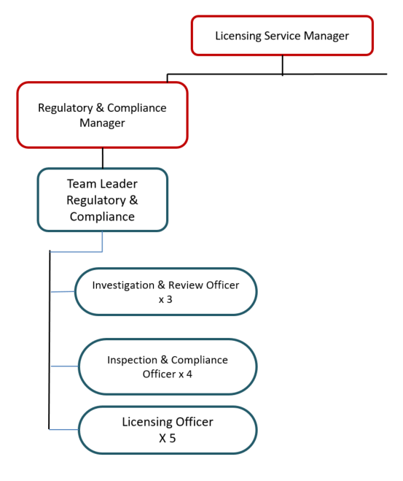

Special Knowledge Requirement (used for short listing). Applicants with disabilities are only required to meet the essential special knowledge requirements, highlighted below)
Due to the Governments Fluency in English Duty for posts where employees speak directly to members of the public the post holder is required to meet the Advanced threshold level where the person is able to demonstrate that they can during the interview:  a) Can express themselves fluently and spontaneously, almost effortlessly  b) Only the requirement to explain difficult concepts simply hinders a natural smooth  flow of language | X
Completes clerical and administrative work with accuracy and attention to detail | X
Must be accurate and able to demonstrate good numeracy & literacy skills | X
Able to implement, maintain and manage accurate information retention systems both manual and computerised | X
Able to resolve customer service problems effectively | X
Able to deal with internal and external customers both face to face and over the telephone | X
Able to diffuse difficult and potentially harmful situations, support colleagues in dealing with difficult situations and intervene as necessary | X
Able to communicate effectively – both written and verbally, including by letter & email | X
Able to competently use key IT packages as recognised by Bradford Council | X
Able to interpret and present data gathered in a meaningful format | X
Works flexibly to accommodate the needs of the business and is able to meet very busy, demanding service deadlines | X
Relevant Experience Requirement (used in short listing)
- Recent, demonstrable experience of working in a very busy customer service environment, dealing with a high volume of customers and the general public in person and on the telephone, sometimes in difficult and confrontational situations.
- Must be able to demonstrate a high standard of numeracy & literacy.
- Experience and ability to use ICT systems and applications is essential
Relevant Professional Qualification Requirement (used in short listing)
- NVQ Level 2 in Customer Services (or equivalent in a similar subject)

Core Employee competencies to be used at the interview stage.

Carries Out Performance Management
Covers the employee’s capacity to manage their workload and carry out a number of specific tasks accurately and to a high standard.
Communicates Effectively
Covers a range of spoken and written communication skills required as a regular feature of the job. It includes exchanging information/building relationships; giving advice and guidance; counselling, negotiating and persuading and handling private, confidential and sensitive information.
Carries Out Effective Decision Making
Covers a range of thinking skills required for taking initiative and independent actions within the scope of the job. It includes planning and organising, self effectiveness and any requirements to quality check work.
Undertakes Structured Problem Solving Activity
Covers a range of analytical skills required for gathering, collating and analysing the facts needed to solve problems. It includes creative and critical thinking; developing practical solutions; applying problem solving strategies and managing interpersonal relationships.
Operates with Dignity and Respect

Covers promoting equality, treating all people fairly and with dignity and respect, maintains impartiality/fairness with all people, is aware of the barriers people face.

Working Conditions:
- Must be able to perform all duties and tasks with reasonable adjustment, where appropriate, in accordance with the Equality Act 2010 in relation to Disability Provisions

- Must be legally entitled to work in the UK.

Compiled by: CS  March 2022  Reviewed by ES April 24 | Grade Assessment Date:  Nov 2022 | Post Grade: 7

