CITY OF BRADFORD METROPOLITAN DISTRICT COUNCIL
JOB PROFILE

DEPARTMENT OF PLACE  Fleet & Transport Services | SERVICE GROUP:  Fleet Workshop
POST TITLE:  Vehicle Workshop Night Shift Supervisor | REPORTS TO:  Workshop Manager
GRADE: Fixed | POST REFERENCE (SAP) /  VACANCY CONTROL NUMBER :

The following information is furnished to help Council staff and those people considering joining the City of Bradford Metropolitan District Council to understand and appreciate the general work content of their post and the role they are to play in the organisation. The duties and responsibilities highlighted in this Job Profile are indicative and may vary over time. Post holders are expected to undertake other duties and responsibilities relevant to the nature, level and scope of the post and the grade has been established on this basis.

As a candidate you will be expected to demonstrate your ability to meet the special knowledge, experience and qualifications required for the role by providing evidence in the application form for the purpose of shortlisting. Applicants with disabilities are only required to meet the essential special knowledge requirements shown by a cross in the end column of this section.

The employee competencies are the minimum standard of behaviour expected by the Council of all its employees and the management competencies outlined are those relevant for a post operating at this level within our organisation.

Both sets of competencies will be used at interview stage and will not be used for short listing purposes.

Key Purpose of Post
To supervise staff and contractors within the vehicle workshop/ remote working and undertake, in an efficient and cost effective manner, the maintenance and repair throughout a range of vehicles and machines to the required quality standard. This is to be done in a safe, legally compliant and cost efficient way to support the Council’s vehicle operations/usage.

Main Responsibilities of Post
- SKILLS:

Must be literate and numerate.

- RESPONSIBILITY FOR PEOPLE:

To undertake all duties in compliance with Health and Safety regulations, particularly in the use of machines, plant, equipment, chemicals etc. Must have due regard for the safety of other employees, contractors, members of the public and the customer in the delivery of the service.

- RESPONSIBILITY FOR RESOURCES:

Responsible for the use of and safe keeping of all workshop tools, equipment, and
Workwear. Responsible for vehicles/machines whilst under Workshop care.

- SUPERVISORY RESPONSIBILITIES:

Supervision of all workshop staff, in relation to their efficiency, safety and welfare issues. Responsible for delegating work, monitoring quality and work performance in line with procedures and policies and drawing appropriate attention to defective or substandard work.

To manage day to day staff working practices, risk assessments and service delivery in the Fleet Workshop to ensure they are in compliance with all statutory and regulatory guidelines along with all Quality Assurance and Health & Safety requirements.

- INITIATIVE:

Will be required to use initiative and be alert to different charge codes when the situation occurs. Maintain cleanliness wherever possible.
Identify issues and seek remedies in relation to operational and staff issues.

- MENTAL EFFORT:

Be constantly alert to the proper use of vehicles, plant and equipment to ensure that all safety aspects are adhered to. Responsible for the identification of materials and equipment needed for the required tasks and the completion of all associated paperwork.

- PHYSICAL EFFORT:

Physically demanding effort required on specific walking, kneeling, bending, pulling, pushing, lifting and carrying or any other physical attribute required.

- WORKING CONDITIONS:

Normally within the confines of depot/workshop, but frequently required to undertake site and roadside repairs within CBMDC area in all weathers.

- Summary of Main Tasks:
- Supervise all staff within the workshop environment in line with procedures and policies.
- Organise and allocate work, making best use of resources, in such a way to maximise output and ensure work is undertaken in line with Safe Working Practices, ACOPS.
- Carry out diagnosis to aid reception engineer on categorising repairs.
- Diagnose faults, and decide the most cost effective and efficient repairs.
- Monitor quality of work carried out and drawing appropriate attention to defective or substandard work.
- Order/authorise spare parts/materials at stores.
- Ensure cleanliness and safety of workshop equipment is maintained.
- Undertake scheduled service and safety inspections of vehicles and equipment.
- Undertake unscheduled repairs of vehicles/equipment in a cost effective and efficient manner.
- Carry out auto electrical repairs.
- Attend breakdowns and undertake vehicle / equipment recoveries.
- Occasionally collect spare parts on occasions from Suppliers.
- Manoeuvre vehicles as required.
- Complete time sheets, job sheets, service sheets and inspection reports in line with Council Policy, ‘O’ licence compliance and good practice.
- Occasionally take vehicles for MOT/DOE test, rectify minor failure items (following approval / on site).
- Repair tools and equipment within the workplace.
- Carry out welding fabrication and repairs (gas, electric, mig).
- Liaise with Management where necessary.
- Occasionally carry out as a nominated tester MOT test (training provided) and complete documentation.
- Undertake all tasks with due diligence to the best of your ability and be accountable for your repairs.
- Undertake other reasonable duties (with competence and experience) as requested in accordance with the changing needs of the organisation.
- In pursuit of the Departments commitment to quality, to carry out duties in accordance with the stated or implied requirements of the Quality Systems.
- The Department is an Equal Opportunities employer and as such Employees are required to comply with good Equal Opportunities practice in every aspect of their work and any other recent requirement.
- To be accountable for those appropriate responsibilities as set down in The Department’s Safety Policies and in addition to take reasonable care for own health and safety and that of others who may be affected by the work.
- To undertake such duties and responsibilities of an equivalent nature/level as may be determined by the Workshop Manager in view of the developing nature of the service.

Structure:

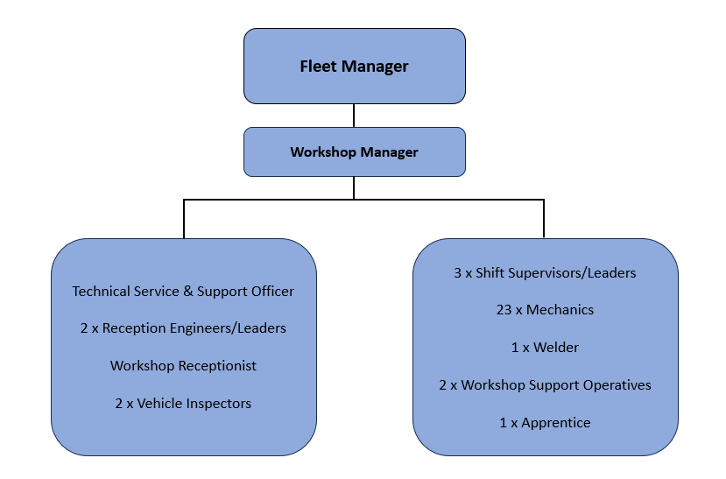

Special Knowledge Requirement (used for short listing). Applicants with disabilities are only required to meet the essential special knowledge requirements, highlighted below)
Due to the Governments Fluency in English Duty for posts where employees speak directly to members of the public, the post holder is required to meet either the Lower threshold level  – where the person is able to demonstrate that they can during the interview:  a) Use a wide range of simple words and a standard English sentence structure to express much of what they want to.  b) Maintain a conversational flow even though they pause to think of the correct words or sentence structure in order to express themselves.  Or the Advanced threshold level  – where the person is able to demonstrate that they can during the interview:  a) Can express themselves fluently and spontaneously, almost effortlessly  b) Only the requirement to explain difficult concepts simply hinders a natural smooth  flow of language | X
Must have knowledge of the Bradford area and road network | X
Able to lead, motivate, plan and prioritise workload within strict deadlines | X
Must be able to communicate effectively with internal and external customers face to face,  over the telephone and via. email | X
Must be able to work flexibly to accommodate the needs of the service as and when  required | X
Able to consider all relevant factors and use sound judgement to make logical decisions | X
Knowledge of Construction and use regulations | X
Knowledge of DVSA MOT regulations classes 4/5/7 and HGV/PSV. | X
Knowledge of DVSA Operator licencing regulations and responsibilities/implications | X
Knowledge of HSE Health and Safety regs/implications (coshh, loler, puwer) | X
Knowledge of DVSA Tachograph regulations | X
Knowledge of Authority reporting procedures. | X
Knowledge of Driving Licence Categories | X
Relevant Experience Requirement (used in short listing)
Must have experience in a team leader or deputising role.

Relevant Professional Qualification Requirement (used in short listing)
- Apprentice trained vehicle fitter to City & Guilds Level II or alternatively having undergone other training to an equivalent standard.

- Must have a current driving licence LGV Class C or C & E.

- Must have IOSH or are willing to work towards

- Must be class 4,5 & 7 MOT tester or willing to work towards.

- Must have ILM level 3 in Management or willing to work towards

Core Employee competencies to be used at the interview stage.

Carries Out Performance Management
Covers the employee’s capacity to manage their workload and carry out a number of specific tasks accurately and to a high standard.
Communicates Effectively
Covers a range of spoken and written communication skills required as a regular feature of the job. It includes exchanging information/building relationships; giving advice and guidance; counselling, negotiating and persuading and handling private, confidential and sensitive information.
Carries Out Effective Decision Making
Covers a range of thinking skills required for taking initiative and independent actions within the scope of the job. It includes planning and organising, self effectiveness and any requirements to quality check work.
Undertakes Structured Problem Solving Activity
Covers a range of analytical skills required for gathering, collating and analysing the facts needed to solve problems. It includes creative and critical thinking; developing practical solutions; applying problem solving strategies and managing interpersonal relationships.
Operates with Dignity and Respect

Covers promoting equality, treating all people fairly and with dignity and respect, maintains impartiality/fairness with all people, is aware of the barriers people face.

Working Conditions:
- Physically demanding effort required on specific walking, kneeling, bending, pulling, pushing, lifting and carrying or any other physical attribute required

- Must be able to perform all duties and tasks with reasonable adjustment, where appropriate, in accordance with the Equality Act 2010 in relation to Disability Provisions

- Must be legally entitled to work in the UK.

Compiled by: SW/PD 2015  Reformatted by SW 02/08/2018  Reformatted by PD/SW 07/02/2024 | Grade Assessment Date: | Post Grade: Fixed

