CITY OF BRADFORD METROPOLITAN DISTRICT COUNCIL
JOB PROFILE

DEPARTMENT: Education Safeguarding | SERVICE GROUP: Education Safeguarding
POST TITLE: Referral Officer | REPORTS TO: Service Support Manager
GRADE: Band 7 | SAP POSITION NUMBER :  50233536 / 50233538 / 50233539

The following information is furnished to help Council staff and those people considering joining the City of Bradford Metropolitan District Council to understand and appreciate the general work content of their post and the role they are to play in the organisation. The duties and responsibilities highlighted in this Job Profile are indicative and may vary over time. Post holders are expected to undertake other duties and responsibilities relevant to the nature, level and scope of the post and the grade has been established on this basis.
For posts where employees speak directly to members of the Public the post holder is required to demonstrate their ability to speak fluently in English.

As a candidate you will be expected to demonstrate your ability to meet the special knowledge, experience and qualifications required for the role by providing evidence in the application form for the purpose of shortlisting. Applicants with disabilities are only required to meet the essential special knowledge requirements shown by a cross in the end column of this section.

The employee competencies are the minimum standard of behaviour expected by the Council of all its employees and the management competencies outlined are those relevant for a post operating at this level within our organisation.

Both sets of competencies will be used at interview stage and will not be used for short listing purposes. Please see the separate guidance information on how to complete the form located on Bradnet.

Key Purpose of Post: Max 3 sentences
- Administer the Local Authority’s Children Missing Education and Elective Home
Education referral process
- Hold responsibility for safeguarding checks with external and internal agencies to
categorise pupils in terms of safeguarding risk and produce accurate data
- Provide efficient and effective administration and data analysis support for the
Education Safeguarding Team as required.

Main Responsibilities of Post: Max 15 Bullet points
- Lead the referral process for Children Missing Education (CME) and Elective Home Education (EHE), being the first point of contact for professionals and parents.
- Understand and share information around safeguarding concerns as new pupils are added to the EHE register, completing referrals for priority visits.
- Liaise with internal and external agencies such as Admissions, SEN, YJS, Children’s Social Care and Police to share information regarding EHE pupils.
- Prioritising visit lists for CME and EHE pupils, liaising with Safeguarding Officers to action and ensure all key risk information is shared.
- Administrate the adding and removal of pupils who are CME and EHE or returning to education settings, following up where necessary ensuring removed pupils are on role.
- Provide administrative support, producing and issuing letters and communication to families and professionals regarding CME and EHE.
- Update information on Civica and MRI to maintain accurate pupil records.
- Produce required monitoring data with RAG ratings, including census data termly and manage the EHE and CME inbox.
- Collate, produce and disseminate EHE parent information packs, updating relevant information onto Bradford Schools Online.
- Obtain the Bradford School’s Online ‘off roll’ report, comparing information and
actioning anomalies with regards to CME or EHE.
- Access council information systems such as ICS, Northgate, Civica and MRi to ensure all information is collated and centralised for CME/EHE pupils.
- Minute team meetings and disseminate information.

Structure:
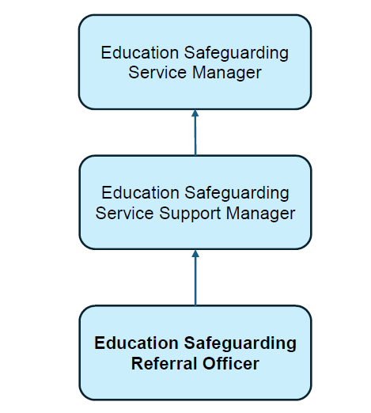

Special Knowledge Requirement. Will be used for shortlisting. Max 10
 |  |  | Essential
Applicants with disabilities are only required to meet the essential special knowledge requirements shown by a cross in the end column.
Due to the Governments Fluency in English Duty for posts where employees speak directly to members of the public the post holder is required to meet either the Lower threshold level – where the person is able to demonstrate that they can during the interview:  a) Can express themselves fluently and spontaneously , almost effortlessly  b) Only the requirement to explain difficult concepts simply hinders a natural smooth flow of language |  |  | x
Uses knowledge of Health, Safety and Environmental policies, procedures and regulations including risks in own area of work |  |  | x
Uses a range of complex IT packages relating to area of work |  |  | x
Ability to adopt a process of continual improvement and suggest ways of working more efficient and effectively to improve service delivery. |  |  | x
Knows and understands how to use, interpret, handle and communicate information |  |  | x
Able to carry out a variety of administration processes across the service including producing complex reporting data with regards to EHE pupils |  |  | x
To understand and implement legislation, policies and procedures relating to child protection, health, safety and security, confidentiality and data protection |  |  | x
Ability to prioritise workload, recognising high priority actions and sharing these with appropriate staff in the team |  |  | x
Demonstrates knowledge of the education system |  |  | x
Relevant experience requirement: Will be used for shortlisting

The applicant is required to provide evidence of having previously spoken fluently to members of the public in order to meet either the Lower threshold or Advanced threshold level outlined under Special Knowledge above.
Minimum of 2 years administration experience, including reception
Experience of using MS Office Suite of Software
Taking and producing accurate minutes at meetings
Relevant professional qualifications requirement: Will be used for shortlisting

GCSE English and Maths Grade C or above / NVQ Level 2 in Administration (and/or recent relevant experience in a similar role and area of work.)
Core Employee competencies to be used at the interview stage.
Carries Out Performance Management
Covers the employee’s capacity to manage their workload and carry out a number of specific tasks accurately and to a high standard.
Communicates Effectively
Covers a range of spoken and written communication skills required as a regular feature of the job. It includes exchanging information/building relationships; giving advice and guidance; counselling, negotiating and persuading and handling private, confidential and sensitive information.
Carries Out Effective Decision Making
Covers a range of thinking skills required for taking initiative and independent actions within the scope of the job. It includes planning and organising, self effectiveness and any requirements to quality check work.
Undertakes Structured Problem Solving Activity
Covers a range of analytical skills required for gathering, collating and analysing the facts needed to solve problems. It includes creative and critical thinking; developing practical solutions; applying problem solving strategies and managing interpersonal relationships.
Operates with Dignity and Respect

Covers promoting equality, treating all people fairly and with dignity and respect, maintains impartiality/fairness with all people, is aware of the barriers people face.
Working Conditions:

Must be able to perform all duties and tasks with reasonable adjustment, where appropriate, in accordance with the Equality Act 2010 in relation to Disability Provisions.
Special Conditions:
You will be informed if there is a requirement for the post to have recruitment checks
such as DBS, Warner Process.
Compiled by:  Danielle Wilson  Date: 20th February 2019 | Grade Assessment Date: 2019 | Post Grade: Band 7

