CITY OF BRADFORD METROPOLITAN DISTRICT COUNCIL
JOB PROFILE
DEPARTMENT:  Office of the Chief Executive | SERVICE GROUP:  Employment and Skills Service
POST TITLE:  Programme Manager - Employment and Skills | REPORTS TO:  Programme Lead – Inclusive Workforce
GRADE: PO3 | SAP POSITION NUMBER :

The following information is furnished to help Council staff and those people considering joining the City of Bradford Metropolitan District Council to understand and appreciate the general work content of their post and the role they are to play in the organisation. The duties and responsibilities highlighted in this Job Profile are indicative and may vary over time. Post holders are expected to undertake other duties and responsibilities relevant to the nature, level and scope of the post and the grade has been established on this basis. For posts where employees speak directly to members of the Public the post holder is required to demonstrate their ability to speak fluently in English.

As a candidate you will be expected to demonstrate your ability to meet the special knowledge, experience and qualifications required for the role by providing evidence in the application form for the purpose of shortlisting. Applicants with disabilities are only required to meet the essential special knowledge requirements shown by a cross in the end column of this section.

The employee competencies are the minimum standard of behaviour expected by the Council of all its employees and the management competencies outlined are those relevant for a post operating at this level within our organisation.

Both sets of competencies will be used at interview stage and will not be used for short listing purposes.

Key Purpose of Post: Max 3
To manage the delivery of transformational projects and programmes across the work of the Employment and Skills Service and its partners within agreed time, cost and quality parameters, and by applying the corporately adopted programme management methodology.

To work closely with the programme team and alongside partner organisations to deliver the ambitions of the Employment and Skills Service and its partners, using a high level of skills, knowledge and experience of the subject matter to actively contribute to the successful implementation of major transformational change.

Work with partners from across the Bradford District to manage, coordinate and communicate risks, issues, dependencies and benefit realisation across programmes and projects, reporting outcomes and ensuring visibility and transparency.

Main Responsibilities of Post: Max 15
1.Directly responsible to the Programme Lead, Inclusive Workforce,however this is a principal role and as such the post holder will receive limited line management direction and will have extensive autonomy in the range of decision making and powers in delivering of their role and responsibilities.

2. There is no direct line management responsibility, although the post holder is expected to
manage and provide leadership to the Project / Programme Team(s) to which they are assigned.

3. Expected to deal with complex problems on a regular basis, frequently using own initiative
to reach creative solutions, or making recommendations to the Strategy and Resources Programme Director and Lead, the Senior Employment Services Manager (for SkillsHouse), Council Departmental Management Teams, Elected Members, and any strategic Board (and Member partner organisations) to which the post is assigned as responsible officer for.

4. Responsible for the delivery of successful outputs/outcomes within time, quality and cost
parameters, adopting project / programme methodologies to ensure that all key deliverables are
‘fit for purpose’ and meet stakeholder expectations.

5. Ensure that there are robust plans in place for each project / programme which highlight key
deliverables and milestones, and reflect the impact of key interdependencies, and ensure robust change management control processes are in place.

6. Responsible for ensuring all risks are actively managed throughout the project, in particular all
significant risks are identified and mitigations and contingencies reported and put in place.

7. Responsible for timely, accurate and open communications across the project ensuring the
project team and stakeholders are aware of their role and updated with progress. Provide regular
reports to management and relevant Boards and other stakeholders on key issues.

8. Work effectively with members of the team and key stakeholders to investigate the causes of
variances from plans and contribute to the development and implementation of solutions.

9. To oversee and direct consultation with service users and providers, and professionally
represent the relevant Board and Authority at internal and external networking events, conferences and meetings as required.

10. Responsible for the management of quality performance monitoring and status reporting measures for the project / programme to aid decision making and ensure successful delivery to time and plan.
11.To research and understand the relationship between the delivery of major projects / programmes in relation to employment and skills at the local, regional and national policy level.
12.To facilitate the design of, and undertake to support other projects and processes aimed at solving complex policy or organisational problems, to achieve the District’s strategic priorities, and reaping maximum benefit from opportunities to transform or improve services for citizens, communities, other stakeholders or the organisation itself.
13. To be responsible for the project / programme audit trail, including recording of all decisions for governance purposes and financial accountability, working in accordance with Council Financial Regulations and Standing Orders to manage the use of resources and agreements allocated to major projects.
14. To provide professional advice, guidance and information on all aspects of the above to elected members, officers, partners as required. Routine communications at all levels internally and with a wide range of external organisations.

15. To ensure that the Council’s policies and strategies reflect the Council’s equality objectives in order to eliminate discrimination, advance equality of opportunity, foster good relations with all our communities and partners, narrow equalities gaps, reflect the needs of our communities.

16. Access to extremely confidential corporate and commercially sensitive information, including individuals, public and private individuals, bid information, service areas, strategic and policy development.

17.Responsible for the management of significant capital and revenue budgets.

Structure:
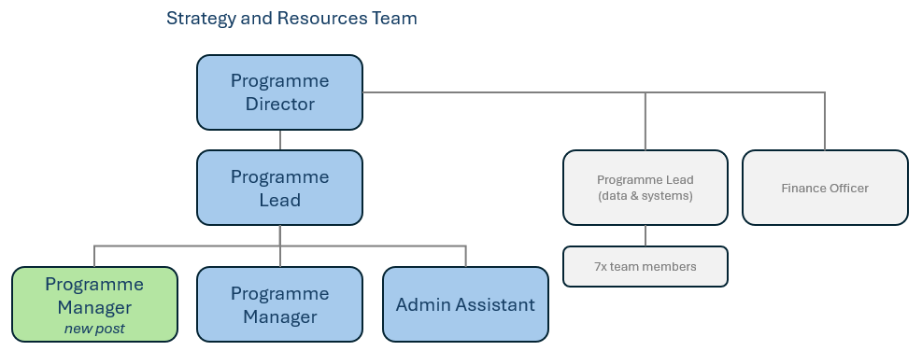

Special Knowledge Requirement: Essential for shortlisting. Max 10
Applicants with disabilities are only required to meet the essential special knowledge requirements shown by a cross in the end column
 | Essential
Due to the Government’s Fluency in English for posts where employees speak directly to members of the public the postholder is required to meet the Advanced threshold level which will be applied where the postholder requires a greater level of sensitive interaction with the public.
You must be able to demonstrate that you can express yourself fluently and spontaneously (this will also be tested during the interview).
Demonstrable knowledge and understanding of the duties and responsibilities that underpin the work of the Health and Social Care Economic Partnership. | X
Evidence of ability to carry out business change from project conception to delivery, including business analysis, business process reviews, programme and project management.
Able to successfully initiate and manage projects through to completion, including the development and introduction of new initiatives, inclusive planning, risk management, and establishing clear end points with measurable outcomes. | X
Able to work effectively with a wide range of colleagues (and other stakeholders) across the Council and in partner organisations in related strategic support and operational activities; including planning, performance management, research, consultation, finance, HR, Legal etc. | X
Demonstrate understanding of key government policies and new legislation impacting on functions, leadership and organisational parameters of CBMDC and its partners. | X
Carries out the working practices, procedures and basic operations across Programme Management. | X
Uses specialist knowledge of health, safety and environmental policies, procedures and regulations, including risk in own area and/or across other areas of work (inc legislation)
Uses a range of specialist ICT systems across own work area and or across other areas of work.
Oversees or contributes to the management of a budget, keeping costs within agreed levels for a project, own department and contributes to Corporate savings. | X
Uses, interprets, analyses and communicates complex information from a variety of sources. | X

Relevant experience requirement: Essential for shortlisting

Considerable experience of operating at middle management level within a large multifunctional public service organisation, and in a service area relevant to the specific post.
Demonstrable experience of driving and delivering change, facilitating work groups and programme and project management experience.

Relevant professional qualifications requirement: Essential for shortlisting

L5 – NQF Level 5 – Bachelors Degree or equivalent level or professional qualification in the relevant discipline OR demonstrable knowledge and experience at a similar level

A formal Project Management qualification e.g. PRINCE 2, MSP or significant strategic programme and project management in a complex multi-agency environment.

Core Employee competencies at manager level to be used at the interview stage.

Carries Out Performance Management – covers the employees capacity to manage
their workload and carry out a number of specific tasks accurately to a high standard.
Communicates Effectively - covers a range of spoken and written communication skills required as a regular feature of the job. It includes exchanging information/building relationships, giving advice and guidance, counselling, negotiating and persuading and handling private, confidential and sensitive information.
Carries Out Effective Decision Making - covers a range of thinking skills required for taking initiative and independent actions within the scope of the job. It includes planning and organising, self effectiveness and any requirements to quality check work.
Undertakes Structured Problem Solving Activity - covers a range of analytical skills required for gathering, collating and analysing the facts needed to solve problems. It includes creative and critical thinking, developing practical solutions, applying problem solving strategies and managing interpersonal relationships.
Operates with Dignity and Respect - covers treating everyone with respect and dignity, maintains impartiality/fairness with all people, is aware of the barriers people face.

Management Competencies: to be used at the interview stage.

Operates with Strategic Awareness Our managers work with corporate priorities and policies in a joined up way with others, internally and externally. Works democratically, transparently and accountably.
Practices Appropriate Leadership Our managers motivate their staff to exceed expectations through raising their awareness of goals and moving them beyond self interest for the sake of the team or service. They consider serving the District in all that they do.
Delivering Successful Performance Our managers monitor performance of services, teams & individuals against targets & celebrate great performance. They promote the District’s vision & work to achieve Council’s values & agreed outcomes.
Applying Project and Programme Management Our manager’s work to ensure that outcomes and objectives are achieved within desired timescales, make best use of resources and take a positive approach to contingency planning.
Developing High Performing People and Teams Our managers coach individuals and teams to achieve their potential and take responsibility for continuous improvement. They champion the Council’s values and goals.
Working Conditions:

Must be able to perform all duties and tasks with reasonable adjustment, where appropriate, in accordance with the Equality Act 2010 in relation to Disability Provisions.

Must be able to work evenings, weekends and bank holidays as required to meet the
needs of the service.

Special Conditions:
You will be informed if there is a requirement for the post to have recruitment checks
such as DBS, Warner Process.
Compiled by:  Kathryn Jones  Date: 01/07/2025 | Grade Assessment Date: | Post Grade:  PO3

