CITY OF BRADFORD METROPOLITAN DISTRICT COUNCIL
JOB PROFILE

DEPARTMENT: Adult Social Care | SERVICE GROUP: People Commissioning & Business Support
POST TITLE: Digital Systems Support Officer – ASC Case Management System Programme | REPORTS TO: Transformation and Business Change Manager
GRADE: Band 7 |  | SAP POSITION NUMBER:

The following information is furnished to help Council staff and those people considering joining the City of Bradford Metropolitan District Council to understand and appreciate the general work content of their post and the role they are to play in the organisation. The duties and responsibilities highlighted in this Job Profile are indicative and may vary over time. Post holders are expected to undertake other duties and responsibilities relevant to the nature, level and scope of the post and the grade has been established on this basis.

As a candidate you will be expected to demonstrate your ability to meet the special knowledge, experience and qualifications required for the role by providing evidence in the application form for the purpose of shortlisting. Applicants with disabilities are only required to meet the essential special knowledge requirements shown by a cross in the end column of this section.

The employee competencies are the minimum standard of behaviour expected by the Council of all its employees and the management competencies outlined are those relevant for a post operating at this level within our organisation.

Both sets of competencies will be used at interview stage and will not be used for short listing purposes.

Key Purpose of Post:
- To provide comprehensive administrative and organisational support to the operational programme team, including maintaining records, risk and issue logs, action tracking, and reporting to enable effective programme delivery.

- To support the development, delivery and monitoring of training and engagement activities, including maintaining learning records, assisting with materials, and coordinating programme champions and stakeholders.

- To provide project support across operational programme workstreams including coordination and administration for visioning and co-production workshops, user testing, quality assurance, communications, and continuous improvement activities.
Main Responsibilities of Post:
To provide a wide range of business support and administrative functions, which include:

- Maintain accurate programme documentation, including risk and issue logs, action trackers, decision logs and programme records.

- Support programme governance by collating highlight reports, dashboards, board papers and other reporting requirements.

- Assist with the development and updating of training materials, and support training administration by tracking participants, learning needs and completions.

- Provide coordination and administrative support for workshops, user testing, quality assurance activities, and other programme workstream events

- Support stakeholder engagement through the preparation of communications, collation of feedback, and coordination with programme champions.

- Contribute to integration planning, lessons learned capture and process improvement activities.

- Organise diary management and appointments, arranging meetings, taking, writing up and circulating minutes and agendas and assisting with the arrangements of workshops / meetings.

- To provide project and administrative support to the operational programme team across all workstreams, ensuring effective coordination and delivery.

- To participate in training and development activities to maintain professional knowledge and skills relevant to the role.

Structure:

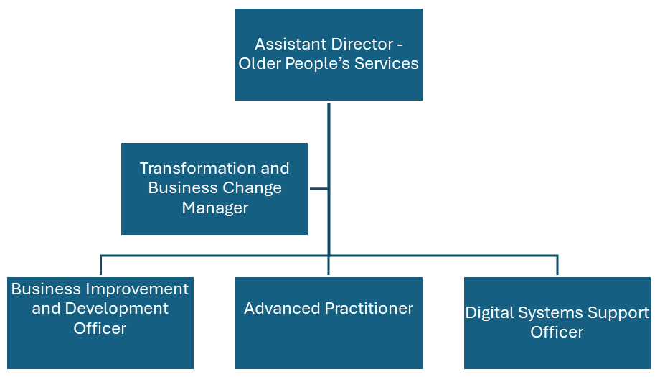

Special Knowledge Requirement. Will be used for shortlisting.
Essential
Applicants with disabilities are only required to meet the essential special knowledge requirements shown by a cross in the end column.

Due to the Governments Fluency in English Duty for posts where employees speak directly to members of the public the post holder is required to meet the Lower threshold level – where the person is able to demonstrate that they can during the interview:  a) Use a wide range of simple words and a standard English sentence structure to express much of what they want to.  b) Maintain a conversational flow even though they pause to think of the correct words or sentence structure in order to express themselves. | X
Uses knowledge of Health, Safety and Environmental policies, procedures and regulations including risks in own area of  work | X
Uses a range of complex IT packages relating to area of work | X
Ability to adopt a process of continual improvement and suggest ways of  working more efficiently and effectively to improve service delivery. | X
Knows and understands how to use, interpret, handle and communicate  information | X
Carries out a variety of working practices, applies complex regulations, rules, procedures and processes across a technical/specialist area | X
Able to communicate sensitively, effectively and appropriately with staff, Managers and other professionals, at all levels, and represent the area of work in a professional and knowledgeable manner. | X
Able to arrange events, manage diaries and service meetings, producing agendas and minutes, presentations and reports to a high standard. | X
Able to maintain professional approach and manage workload while under pressure through using effective time management techniques. | X
Thinks creatively to help solve multi-faceted problems | X

Relevant experience requirement: Will be used for shortlisting
The applicant is required to provide evidence of having previously spoken fluently to members of the public in order to meet either the Lower threshold or Advanced threshold level outlined under Special Knowledge above.
General office experience, including using computerised databases and spreadsheets.

Relevant professional qualifications requirement: Will be used for shortlisting
NVQ Level 2 in Business & Admin (or demonstrable skills to this level)

Core Employee competencies to be used at the interview stage.
Carries Out Performance Management
Covers the employee’s capacity to manage their workload and carry out a number of specific tasks accurately and to a high standard.
Communicates Effectively
Covers a range of spoken and written communication skills required as a regular feature of the job. It includes exchanging information/building relationships; giving advice and guidance; counselling, negotiating and persuading and handling private, confidential and sensitive information.
Carries Out Effective Decision Making
Covers a range of thinking skills required for taking initiative and independent actions within the scope of the job. It includes planning and organising, self effectiveness and any requirements to quality check work.
Undertakes Structured Problem Solving Activity
Covers a range of analytical skills required for gathering, collating and analysing the facts needed to solve problems. It includes creative and critical thinking; developing practical solutions; applying problem solving strategies and managing interpersonal relationships.
Operates with Dignity and Respect

Covers promoting equality, treating all people fairly and with dignity and respect, maintains impartiality/fairness with all people, is aware of the barriers people face.
Working Conditions:
Must be able to perform all duties and tasks with reasonable adjustment, where appropriate, in accordance with the Equality Act 2010 in relation to Disability Provisions.
Special Conditions:
You will be informed if there is a requirement for the post to have recruitment checks
such as DBS, Warner Process.
Compiled by:  Date: November 2015 | Grade Assessment Date:  07.12.2015 | Post Grade:  Band 7

