CITY OF BRADFORD METROPOLITAN DISTRICT COUNCIL
JOB PROFILE

DEPARTMENT: Place | SERVICE GROUP: Waste, Fleet & Transport Services
POST TITLE: MOT / Vehicle Inspector | REPORTS TO: Workshop Manager
GRADE: Band 7 SCP 11-17

The following information is furnished to help Council staff and those people considering joining the City of Bradford Metropolitan District Council to understand and appreciate the general work content of their post and the role they are to play in the organisation. The duties and responsibilities highlighted in this Job Profile are indicative and may vary over time. Post holders are expected to undertake other duties and responsibilities relevant to the nature, level and scope of the post and the grade has been established on this basis. For posts where employees speak directly to members of the Public the post holder is required to demonstrate their ability to speak fluently in English.

As a candidate you will be expected to demonstrate your ability to meet the special knowledge, experience and qualifications required for the role by providing evidence in the application form for the purpose of shortlisting. Applicants with disabilities are only required to meet the essential special knowledge requirements shown by a cross in the end column of this section.

The employee competencies are the minimum standard of behaviour expected by the Council of all its employees and the management competencies outlined are those relevant for a post operating at this level within our organisation.

Both sets of competencies will be used at interview stage and will not be used for short listing purposes.

Key Purpose of Post:
To carry out MOT Inspections on motor vehicles in accordance with DVSA Regulations and
carry out Hackney Carriage & Private Hire vehicle inspection in accordance with licensing specifications.

Main Responsibilities of Post:
- Undertake all duties in compliance with relevant health & safety regulations in relation to the inspection of motor vehicles.
- Must have due regard for the safety of other employees, members of public and the customer in the delivery of the service.
- Responsible for the use and safekeeping of all workshop tools, equipment, work wear, workstation, and associated facilities
- Maintain cleanliness of the working environment and ensure agreed procedures are followed in the workplace
- Must be constantly alert to the proper use of vehicles, plant and equipment and ensure compliance with all safety related aspects.
- Responsible for the identification of cost-effective materials and equipment needed for tasks and the completion of all associated paperwork
- Liaise with Management where necessary.
- Manoeuvre vehicles as required.
- Ensure cleanliness and safety of workshop equipment is maintained.
- Undertake other reasonable duties (with competence and experience) as requested in accordance with the changing needs of the organisation, including any training relevant to the post.
- In pursuit of the Departments commitment to quality, to carry out duties in accordance with the stated or implied requirements of the Quality Systems.
- The Department is an Equal Opportunities employer and as such Employees are required to comply with good Equal Opportunities practice in every aspect of their work and any other recent requirement.
- To be accountable for those appropriate responsibilities as set down in The Department’s Safety Policies and in addition to take reasonable care for own health and safety and that of others who may be affected by the work.
- To undertake such duties and responsibilities of an equivalent nature/level as may be determined by the Workshop Manager in view of the developing nature of the service.
- To be competent in IT in uploading vehicle test details and review test diaries.
- To be competent in taking card payments for re-tests and MOT’s.

Structure:
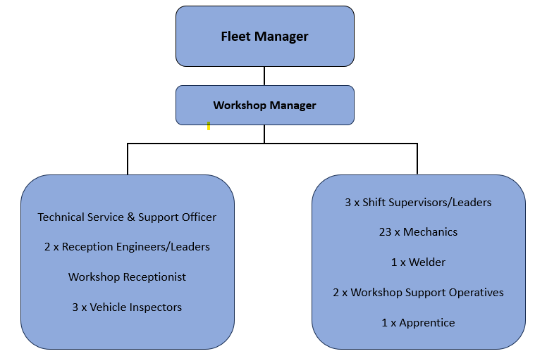

Special Knowledge Requirement: Essential for shortlisting.
Applicants with disabilities are only required to meet the essential special knowledge requirements shown by a cross in the end column
 | Essential
Due to the Government’s Fluency in English for posts where employees speak directly to members of the public the postholder is required to meet the Advanced threshold level which will be applied where the postholder requires a greater level of sensitive interaction with the public.  You must be able to demonstrate that you can express yourself fluently and spontaneously (this will also be tested during the interview). | x
Must be able to communicate effectively with internal and external customers  face to face, over the telephone and via. email | x
Must be able to work flexibly to accommodate the needs of the service as and when required | x
Able to consider all relevant factors and use sound judgement to make logical decisions | x
Must act with courtesy and professionalism at all times | x
Must be able to adopt a process of continual improvement and suggest ways of working more efficiently and effectively to improve service delivery | x
Must contribute to the maintenance of a healthy and safe working environment | x
Must have knowledge of Construction and use regulations | x
Must have knowledge of DVSA MOT regulations classes 4/5/7 | x
Must have knowledge of HSE Health and Safety regs/implications, LOLER | x

Relevant experience requirement: Essential for shortlisting

Must be able to demonstrate full time experience in a workshop environment as an experienced mechanic.

Relevant professional qualifications requirement: Essential for shortlisting

- Apprentice trained vehicle fitter to City & Guilds Level II 380 / 383 or alternatively having undergone other training to an equivalent standard.

- Must have a current driving licence

- Must be class 4,5 & 7 MOT tester or willing to work towards

Core Employee competencies at manager level to be used at the interview stage.

Carries Out Performance Management – covers the employees capacity to manage
their workload and carry out a number of specific tasks accurately to a high standard.
Communicates Effectively - covers a range of spoken and written communication skills required as a regular feature of the job. It includes exchanging information/building relationships, giving advice and guidance, counselling, negotiating and persuading and handling private, confidential and sensitive information.
Carries Out Effective Decision Making - covers a range of thinking skills required for taking initiative and independent actions within the scope of the job. It includes planning and organising, self effectiveness and any requirements to quality check work.
Undertakes Structured Problem Solving Activity - covers a range of analytical skills required for gathering, collating and analysing the facts needed to solve problems. It includes creative and critical thinking, developing practical solutions, applying problem solving strategies and managing interpersonal relationships.
Operates with Dignity and Respect - covers treating everyone with respect and dignity, maintains impartiality/fairness with all people, is aware of the barriers people face.

Core Employee competencies to be used at the interview stage.

Carries Out Performance Management
Covers the employee’s capacity to manage their workload and carry out a number of specific tasks accurately and to a high standard.
Communicates Effectively
Covers a range of spoken and written communication skills required as a regular feature of the job. It includes exchanging information/building relationships; giving advice and guidance; counselling, negotiating and persuading and handling private, confidential and sensitive information.
Carries Out Effective Decision Making
Covers a range of thinking skills required for taking initiative and independent actions within the scope of the job. It includes planning and organising, self effectiveness and any requirements to quality check work.
Undertakes Structured Problem Solving Activity
Covers a range of analytical skills required for gathering, collating and analysing the facts needed to solve problems. It includes creative and critical thinking; developing practical solutions; applying problem solving strategies and managing interpersonal relationships.
Operates with Dignity and Respect

Covers promoting equality, treating all people fairly and with dignity and respect, maintains impartiality/fairness with all people, is aware of the barriers people face.

Working Conditions:
- Physically demanding effort required on specific walking, kneeling, bending, pulling, pushing, lifting and carrying or any other physical attribute required

- Must be able to perform all duties and tasks with reasonable adjustment, where appropriate, in accordance with the Equality Act 2010 in relation to Disability Provisions

- Must be legally entitled to work in the UK.

Compiled by: SW/PD 11/06/2024 | Grade Assessment Date: | Post Grade: Fixed

