CITY OF BRADFORD METROPOLITAN DISTRICT COUNCIL
JOB PROFILE

DEPARTMENT: Childrens Services | SERVICE GROUP: Employment & Skills
POST TITLE: SkillsHouse Engagement Lead Officer | REPORTS TO: Employment Operations Manager
GRADE: PO1/2 |  | SAP POSITION NUMBER : 50230533

The following information is furnished to help Council staff and those people considering joining the City of Bradford Metropolitan District Council to understand and appreciate the general work content of their post and the role they are to play in the organisation. The duties and responsibilities highlighted in this Job Profile are indicative and may vary over time. Post holders are expected to undertake other duties and responsibilities relevant to the nature, level and scope of the post and the grade has been established on this basis.
For posts where employees speak directly to members of the Public the post holder is required to demonstrate their ability to speak fluently in English.

As a candidate you will be expected to demonstrate your ability to meet the special knowledge, experience and qualifications required for the role by providing evidence in the application form for the purpose of shortlisting. Applicants with disabilities are only required to meet the essential special knowledge requirements shown by a cross in the end column of this section.

The employee competencies are the minimum standard of behaviour expected by the Council of all its employees and the management competencies outlined are those relevant for a post operating at this level within our organisation.

Both sets of competencies will be used at interview stage and will not be used for short listing purposes. Please see the separate guidance information on how to complete the form located on Bradnet.

Key Purpose of Post: Max 3
The role is as the focal point of mutli-agency working in and across our localities and communities supporting residents on and through a tailored pathway to sustained employment. The role will build, facilitate, coordinate the development and overall functioning of community-based and accessible employment pathways through a range of partners and funding streams.

This post will lead the SkillsHouse Engagement Advisers team ensuring referrals are made into other delivery programmes. To provide, in partnership with local colleges and a team SkillsHouse Engagement Advisers, clear progression steps and pathways and offer appropriate support to engage and retain students in a high-quality learning environment.

This role focuses on provision of services for young people who are NEET or vulnerable to NEET due to particular needs and providing specific services to young people that have been purchased by an educational institution or other customer.

Main Responsibilities of Post: Max 15
- To report to the Employment Operations Manager and work closely with SkillsHouse Adult Services team, Council’s Participation and Performance Team, Childrens Trust. To act as an interface between these teams and FE providers

- To act as a lead professional in leading and managing a high quality integrated service to assist clients employability, career learning, re/training, planning and development through the further development of employability, skills academy, careers education, information, advice and guidance services.

- To work in partnership with the Care leaving service, FE providers to develop new pathways/reengagement programmes so young people can access appropriate FE provision and training if required.

- To work with FE providers to help develop a foundation and core programme of learning for young people who are NEET. This would be flexible and tailored towards an individual’s needs and interests.

- Support the development and implementation of a wide range of workstreams, projects, and pilot initiatives designed to improve or support residents pathway into sustained work, ensuring delivery of services is accessible and available in communities.

- To line manage and supervise the work of 2 FTE SkillsHouse Engagement Advisers to facilitate the young person’s transitions between different agencies and services.

- Where appropriate lead on and/or support the implementation of innovative programmes in localities. This may include the development of effective operational, financial management and performance monitoring arrangements.

- To support the effective management and delivery of services through implementing effective business and workflow processes, quality assurance arrangements, monitoring performance, and team and individual development.

- To develop and provide specialist support and expertise on locality area, working unsociable hours which include evenings and weekends with a caseload of vulnerable young people/adults

- To engage with the CTE work experience team and business engagement team to encourage them to support the project by offering work experience or training placements to priority learners who are NEET.

- To report on progress towards key performance indicators agreed at the beginning of the project and review the performance of the service at the end of one year. This will involve both quantitative measures (e.g. KPI’s) and qualitative indicators such as case studies.

- Operate from a variety of locations including Council offices, schools, Jobcentre Plus, training & education providers, community providers and local career hubs. To work evenings and weekends to ensure young people/ adults are supported.

- Meet all standards for quality of service, safeguarding, information and data security, and ensure adherence to Bradford council policies including yet not exclusive to equalities and diversity policy.

- Represent and promote Skillshouse and the Careers and Technical Education partnerships and services in a professional and commercial manner, working effectively with other agencies

The post holder will need to be flexible in developing the role in conjunction with the line manager. The post holder may be asked to carry out any other delegated duty or task that is in line with their post.

Structure:
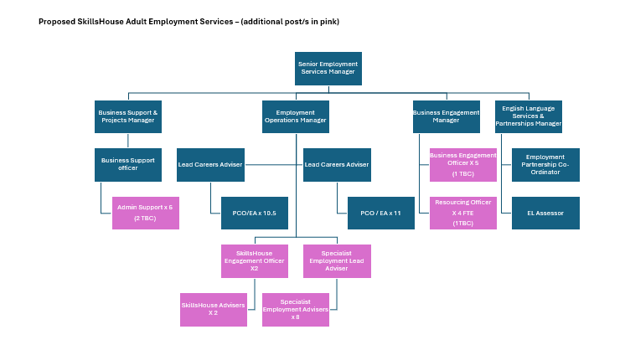

Special Knowledge Requirement: Will be used for shortlisting. Max 10

Applicants with disabilities are only required to meet the essential special knowledge requirements shown by a cross in the end column.
 | Essential
Due to the Governments Fluency in English Duty for posts where employees speak directly to members of the public the post holder is required to meet the Advanced threshold level which will be implemented where the post requires a greater level of sensitive interaction with the public,( e.g. in children’s centres) – where the person is able to demonstrate that they can during the interview:  a) Can express themselves fluently and spontaneously , almost effortlessly  b) Only the requirement to explain difficult concepts simply hinders a natural smooth flow of language  If this applies to the post you are recruiting to do not remove it . | x
Carries out the working practices, procedures and basic operations across a number of specialist areas | x
Understands and applies health and safety working practices, including risk in own area of work and or across other areas of work, understands and is committed to the protection and safeguarding of young people and vulnerable adults. | x
High level of competency, effective operation and use of ICT including its wider application e.g. use of social media | x
Knows and understands how to analyse, interpret and present complex information from a variety of sources | x
Can show competence in working in a target driven environment, and ability to meet or exceed contract targets | x
Up to date knowledge of statutory duties and guidance related to the role. | x
Able to develop, engage and maintan relationships with young people and relevant stakeholders – including school/college staff, related agencies, employers and parent/carers. | x
Demonstrates an awareness, understanding and commitment to the protection and safeguarding of young people and vulnerable adults | x
Excellent knowledge of the local labour market - routes into the labour market and knowledge of progression routes including knowledge of local and regional education, training and specialist service provision | x

Relevant experience requirement: Will be used for shortlisting

The applicant is required to provide evidence of having previously spoken fluently to members of the public in order to meet the advanced threshold level outlined under Special Knowledge above.
Experience of delivering high quality provision and/or training with young people
Demonstrates work with young people with complex needs including those NEET
Experience of work in a school / college institutions
Management Experience
Relevant professional qualifications requirement: Will be used for shortlisting

For example, desirable qualifications may include Level 6 – Bachelors Degree, Level 6 Diploma in Careers Information and Advice or NVQ 6 in Advice & Guidance or equivalent
Core Employee competencies at manager level to be used at the interview stage.

Carries Out Performance Management – covers the employees capacity to manage
their workload and carry out a number of specific tasks accurately and at a high standard.
Communicates Effectively - covers a range of spoken and written communication skills required as a regular feature of the job. It includes exchanging information/building relationships, giving advice and guidance, counselling, negotiating and persuading and handling private, confidential and sensitive information.
Carries Out Effective Decision Making - covers a range of thinking skills required for taking initiative and independent actions within the scope of the job. It includes planning and organising, self effectiveness and any requirements to quality check work.
Undertakes Structured Problem Solving Activity - covers a range of analytical skills required for gathering, collating and analysing the facts needed to solve problems. It includes creative and critical thinking, developing practical solutions, applying problem solving strategies and managing interpersonal relationships.
Operates with Dignity and Respect - covers treating everyone with respect and dignity, maintains impartiality/fairness with all people, is aware of the barriers people face.

Management Competencies: to be used at the interview stage.

Operates with Strategic Awareness Our managers work with corporate priorities and policies in a joined up way with others, internally and externally. Works democratically, transparently and accountably.
Practices Appropriate Leadership Our managers motivate their staff to exceed expectations through raising their awareness of goals and moving them beyond self interest for the sake of the team or service. They consider serving the District in all that they do.
Delivering Successful Performance Our managers monitor performance of services, teams & individuals against targets & celebrate great performance. They promote the District’s vision & work to achieve Council’s values & agreed outcomes.
Applying Project and Programme Management Our manager’s work to ensure that outcomes and objectives are achieved within desired timescales, make best use of resources and take a positive approach to contingency planning.
Developing High Performing People and Teams Our managers coach individuals and teams to achieve their potential and take responsibility for continuous improvement. They champion the Council’s values and goals.
Working Conditions:

Must be able to perform all duties and tasks with reasonable adjustment, where appropriate, in accordance with the Equality Act 2010 in relation to Disability Provisions.

The post holder must be able to work evenings, weekends and Bank Holidays as required by the needs of the service.
Special Conditions:
The post holder will have to have a successful enhanced DBS check.

Compiled by: | Grade Assessment Date: | Post Grade:

