
City of Bradford Metropolitan District Council Job Profile
Reference Number
Role Title | Recycling Advisor
Directorate | Environment
Service Area | Waste, Fleet & Environment
Reports to | Recycling Team Leader
Role Purpose (maximum of 3 points, with no sub bullet points)
- Raise awareness of recycling, composting and waste minimisation, and encourage behavioural change.

- Interrogation and collation of information databases and completing enquiries as appropriate.

- Make frequent decisions using some judgement generally but also using initiative not always within the procedures and guidance.

Duties and Responsibilities (maximum of 15 points, with no sub bullet points)
- Deal with and resolve requests for advice from the members of the public by face to face, email or telephone communication.

- Act in accordance with GDPR principles and maintain the customers confidentiality at all times.

- Attend and deputise for the Recycling Team Leader at Neighbourhood Forums, schools and public meetings.

- Use smart technology, Windows-based software, monitoring and evaluating procedures to record activities on software.

- Promote, educate and encourage recycling, composting and waste minimisation to households throughout the Bradford District providing information, advice and guidance via telephone, face to face and road shows.

- Undertake door-stepping campaigns in order to identify areas for improvement.

- To record and collate date collected from door-step campaigns to report to management.

- To distribute printed literature in support of waste management activities as and when required.

- To be proactive in targeting specific communities and audience groups such as areas of low recycling performance and BME areas.

- Ensure high quality communication, interaction and information is provided to the customers of Bradford Council.

- Work within Health & Safety guidance; always work in a safe manner.

- Be an ambassador for Bradford Council at all times and communicate positively, accurately and politely with members of the public.

- Work alongside collection crews, operational managers and key stakeholders to introduce and address any issues as they arise at first hand to maximise residents participation in the Council’s Waste Strategy and Bin Policy.

- Undertake any other duties and responsibilities appropriate to the grade and level of the post.

- Work flexible hours, including some evenings and weekends. Uniform to be worn at all times

Dimensions of role (direct or indirect as applicable) e.g. total number of staff managed, total budget, total scope of role
Responsible for promoting recycling and waste reduction by providing accurate advice and support to residents, customers, and stakeholders. The role focuses on improving recycling participation, ensuring compliance with waste management policies, and delivering excellent customer service.

Structure Chart (showing direct reports)
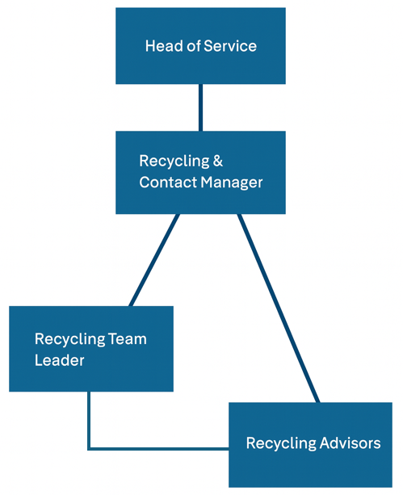

Person Specification
Knowledge / Skills / Experience required
Other Requirements:

- Must hold a full, valid UK driving licence (essential).

Relevant Experience:

- At least 2 years’ experience in a customer focused environment.

Knowledge & Skills:

- Knowledge of waste and recycling issues, including the ability to explain the benefits of reducing household waste and the importance of increasing recycling.

- Ability to use and interpret information to achieve required outcomes.

- Ability to build and maintain effective working relationships with residents, elected members, internal departments, and external stakeholders.

- Commitment to continual improvement, with the ability to suggest more efficient and effective ways of working to enhance service delivery.

- Able to diffuse potentially harmful situations, support colleagues in dealing with difficult interactions, and intervene when necessary.

- Working knowledge of health and safety and environmental regulations, including risk awareness relevant to the role.

- Understands how to use, interpret, handle, and communicate information appropriately and accurately.

- Excellent verbal communication skills, with the ability to listen actively, engage individuals and groups, and encourage positive behavioural change.

- Understands the importance of confidentiality and data protection in line with relevant legislation.

- Able to use a range of complex IT packages relevant to the role.

- Must be physically fit and willing to work outdoors in all weather conditions and able to walk long distances.

Key benchmarked competencies, traits and motives required to successfully deliver the role. These will support recruitment, succession planning, development and performance management |  | Essential
Health and Safety | Uses knowledge of Health, Safety policies, procedures and regulations including risks in own area of work | X
IT Packages | Uses a range of complex IT packages relating to area of work | X
Service Improvement | Ability to adopt a process of continual improvement and suggest ways of working more efficient and effectively to improve service delivery | X
Continued professional Improvement | Carries out a variety of working practices, applies complex regulations, rules, procedures and processes across a technical /specialist area
Communication | Knows and understands how to use, interpret, handle and communicate, often complex and detailed information, and relay it to service users/stakeholders in writing and/or over the telephone / face to face. | X
Numeracy & Literacy | Demonstrates a high level of numeracy, literacy and accuracy across a range of activities | X
Relevant Professional Qualification | GCSEs (or equivalent) in English and Maths at Grade C/4 or above. | X
Communicates Effectively | Covers a range of spoken and written communication skills required as a regular feature of the job. This includes exchanging information/building relationships, giving advice and guidance, counselling, negotiating and persuading and handling private, confidential and sensitive information. | X
Carries Out Effective Decision Making | Covers a range of thinking skills required for taking initiative and independent actions within the scope of the job. This includes planning and organising, self-effectiveness and any requirements to quality check work. | X
Undertakes Structured Problem-Solving Activity | Covers a full range of analytical skills required for gathering, collating and analysing the facts needed to solve problems. This includes creative and critical thinking, developing practical solutions, applying problem solving strategies and managing interpersonal relationships.
Operates with Dignity and Respect | Covers treating everyone with respect and dignity, maintains impartiality/fairness with all people, is aware of the barriers people face. | X

Applicants with disabilities are only required to meet the essential special knowledge requirements (clearly marked)
Due to the Government’s ‘Fluency in English Duty’ for posts where employees speak directly to members of the public, the post holder is required to meet the ‘Advanced’ threshold level as the post requires a greater level of sensitive interaction with the public. The person will need to demonstrate during the interview that:
a) They can express themselves fluently and spontaneously, almost effortlessly and
b) Only the requirement to explain difficult concepts hinders a natural, smooth flow of language.

Working Conditions:

The post is based at Harris Street Depot, Bradford.

Working hours are 37 hours per week, Monday to Friday (plus some weekend work when required).

Completed by: | FR / SW | Date: | 30/06/2026
Quality checked: |  | Date:

