
City of Bradford Metropolitan District Council Job Profile
Reference Number | TO BE COMPLETED BY JEGS / HR
Role Title | Biodiversity Officer
Directorate | Place
Service Area | Planning Transport and Highways
Reports to | Principal Biodiversity Officer

Role Purpose (maximum of 3 points, with no sub bullet points)
1. To assist the implementation of the Council’s Biodiversity Duty as set out in the Natural Environment and Rural Communities Act 2006.
2. To provide advice and technical support to development management, development planning and other Services, including identifying the need for ecological assessments and surveys, appropriate conditions and other relevant matters and assessing the impacts of development, major projects and other proposals, including the adequacy of ecological assessments and survey information.
3. Working with external organisations, appropriate user and interest groups, maintaining effective monitoring systems, maintaining appropriate data and collection systems and providing and disseminating information including digital and electronic, co-ordination of voluntary/external resource as necessary, in order to further the Council’s Biodiversity Duty.

Duties and Responsibilities (maximum of 15 points, with no sub bullet points)
- Provide consultation responses on planning applications including some Major applications,
and other proposals where there are potential impacts on biodiversity/ecology, as part of the
Development Management process.

- Designated Sites: assist with the identification of sites suitable for biodiversity net gain habitat
Bank locations and the designation of new local sites of nature conservation value such as Local
Wildlife Sites and Local Nature Reserves, obtaining relevant survey information, writing
Management Plans and advising on site management.

- Protected Species: provide advice and assessment in respect of Protected Species,
including licencing. Undertake surveys to inform of conservation priorities for species in the district.
Carry out protected species survey for other departments as required.

- To represent the Council where appropriate at external meetings, regional and sub-regional
networks and with external bodies on biodiversity matters as appropriate.

- Plan, co-ordinate and supervise occasional related activity undertaken by third parties
eg. external consultants, local recording groups or conservation volunteers.

- Support and advise local residents, wildlife groups and other groups in delivery of projects
and events aimed at nature conservation and engagement.

- Liaise with other council departments (e.g. Highway Maintenance, Structures, Asset Management, Leisure Services, Legal Services, Planning Service), Ward Councillors, statutory undertakers, parish
and town councils, user groups, landowners and any other individuals or parties in relation to
biodiversity, to provide impartial advice and guidance.

- To provide guidance and advice in respect of the Council’s Biodiversity Duty

- Maintain written, cartographic and computerised records including GIS, and disseminate this information to other Council departments and partners.

- Carry out routine, technical, clerical and administrative work associated with day-to-day operations, specific projects and Section development.Undertake site visits, sometimes on difficult terrain, for survey and scoping.
- Assist in the creation of habitats banks on council land. To identify land appropriate for habitat banks. To and carry out surveys, recommend management and prepare Habitat Management and Monitoring Plans.

Dimensions of role (direct or indirect as applicable) e.g. total number of staff managed, total budget, total scope of role
N/A

Structure Chart (showing direct reports)
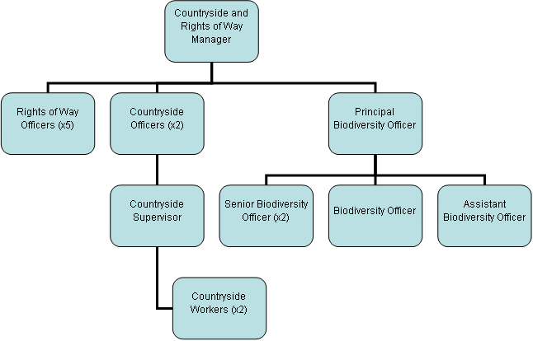

Person Specification
Knowledge / Skills / Experience required
Carries out the working practices, procedures and basic operations across a specialist area.
Knowledge of safety and environmental policies, procedures and regulations, including risk in own area.
Knowledge/experience of protected species surveys and methodologies AND habitat surveys using UKHab and Biodiversity Net Gain condition assessment and the Biodiversity Metric
Knowledge and understanding of legislation and processes relating to wildlife and biodiversity.
Knowledge to appraise basic habitats and assess suitability for protected and notable species.
Knowledge and understanding of the principles and application of planning policies and environmental legislation.
The applicant is required to provide evidence of having previously spoken fluently to members of the public in order to meet the Advanced threshold level outlined under Special Knowledge above.
Experience in local/national government, ecological consultancy or nature conservation.
Experience in efficient communication skills and an ability to work with people from a wide range of organisations.
Experience in undertaking habitat (UKHab/ Phase 1) and protected species surveys and assessing habitat value and risk.
Experience in specialist ICT systems across own work area, including GIS based mapping processes and their application to this post.
Experience in excellent communication and technical writing skills with keen attention to detail

Key benchmarked competencies, traits and motives required to successfully deliver the role These will support recruitment, succession planning, development and performance management |  | Essential
Health and Safety | Uses knowledge of Health, Safety policies, procedures and regulations including risks in own area of work | X
IT Packages | Uses a range of complex IT packages relating to area of work | X
Service Improvement | Ability to adopt a process of continual improvement and suggest ways of working more efficient and effectively to improve service delivery | X
Continued professional Improvement | Carries out a variety of working practices, applies complex regulations, rules, procedures and processes across a technical /specialist area | X
Communication | Knows and understands how to use, interpret, handle and communicate, often complex and detailed information, and relay it to service users/stakeholders in writing and/or over the telephone / face to face. | X
Numeracy & Literacy | Demonstrates a high level of numeracy, literacy and accuracy across a range of activities | X
Relevant Professional Qualification | Educated to degree level in a relevant subject (eg. ecology)  Eligible for Associate or higher Membership of the Chartered Institute for Ecology and Environmental Management (CIEEM) or other related professional body. | X
Carries out performance management | Covers the employees’ capacity to manage their workload and carry out a number of specific tasks accurately and to a high standard. | X
Communicates Effectively | Covers a range of spoken and written communication skills required as a regular feature of the job. This includes exchanging information/building relationships, giving advice and guidance, counselling, negotiating and persuading and handling private, confidential and sensitive information. | X
Carries Out Effective Decision Making | Covers a range of thinking skills required for taking initiative and independent actions within the scope of the job. This includes planning and organising, self-effectiveness and any requirements to quality check work. | X
Undertakes Structured Problem-Solving Activity | Covers a full range of analytical skills required for gathering, collating and analysing the facts needed to solve problems. This includes creative and critical thinking, developing practical solutions, applying problem solving strategies and managing interpersonal relationships. | X
Operates with Dignity and Respect | Covers treating everyone with respect and dignity, maintains impartiality/fairness with all people, is aware of the barriers people face. | X
Practices Appropriate Leadership | Our managers motivate their staff to exceed expectations through raising their awareness of goals and moving them beyond self-interest for the sake of the team or service. They consider serving the District in all that they do.
Operates with Strategic Awareness | Our managers work with corporate priorities and policies in a joined up way with others, internally and externally. Works democratically, transparently and accountably.
Delivering Successful Performance | Our managers monitor performance of services, teams & individuals against targets & celebrate great performance. They promote the District’s vision & work to achieve Council’s values & agreed outcomes.
Applying Project and Programme Management | Our manager’s work to ensure that outcomes and objectives are achieved within desired timescales, make best use of resources and take a positive approach to contingency planning
Developing High Performing People and Teams | Our managers coach individuals and teams to achieve their potential and take responsibility for continuous improvement. They champion the Council’s values and goals.

Applicants with disabilities are only required to meet the essential special knowledge requirements (clearly marked)
Due to the Governments Fluency in English Duty for posts where employees speak directly to members of the public the postholder is required to meet the Lower threshold level.
You should be able to demonstrate that you can use a wide range of simple words and a standard English sentence structure to express and maintain a flowing conversation even though you pause to think of the correct words with the ability to express and make yourself understood (this will also be tested during the interview).

Completed by: | David Campbell | Date: | 22/08/2025
Quality checked: | HR JEGS Programme Lead | Date: | 06/11/2025

