CITY OF BRADFORD METROPOLITAN DISTRICT COUNCIL
JOB PROFILE

DEPARTMENT: Place | SERVICE GROUP: Fleet & Transport Services
POST TITLE: Apprentice Heavy Goods & Motor Vehicle/Plant Mechanic | REPORTS TO: Workshop Manager, Fleet Services
GRADE: Starting from minimum wage |  | SAP POSITION NUMBER : 11006943

The following information is furnished to help Council staff and those people considering joining the City of Bradford Metropolitan District Council to understand and appreciate the general work content of their post and the role they are to play in the organisation. The duties and responsibilities highlighted in this Job Profile are indicative and may vary over time. Post holders are expected to undertake other duties and responsibilities relevant to the nature, level and scope of the post and the grade has been established on this basis.

As a candidate you will be expected to demonstrate your ability to meet the special knowledge, experience and qualifications required for the role by providing evidence in the application form for the purpose of shortlisting. Applicants with disabilities are only required to meet the essential special knowledge requirements shown by a cross in the end column of this section.

The employee competencies are the minimum standard of behaviour expected by the Council of all its employees and the management competencies outlined are those relevant for a post operating at this level within our organisation.

Both sets of competencies will be used at interview stage and will not be used for short listing purposes.

Key Purpose of Post:
To undertake an Apprenticeship Scheme of up to four years duration within the Fleet Workshop at Shearbridge depot as an apprentice HGV motor vehicle and plant mechanic.

The aim of the apprenticeship is for the trainee to gain the necessary skills, competencies and qualifications required of a fully qualified HGV motor vehicle and plant mechanic in line with National Apprenticeship Service standards i.e. NVQ level 2 and 3.

The apprentice will follow a programme of training in all aspects of maintenance and repair, to a range of vehicles, machines and plant equipment, to the required quality standards in an efficient and cost effective manner and achieve the appropriate skills, competencies and qualifications of the role by the end of the period of training.

The employer (Bradford Council) will provide the Apprentice with sufficient time, the appropriate
working environment and range of job activities within which it is possible for them to complete
their full apprenticeship.

Main Responsibilities of Post:
The apprentice will work towards achieving the relevant skills, competencies and
qualifications in order to be able to:-

- Undertake all duties in compliance with relevant health & safety regulations in relation to the repair of vehicles, machines, plant equipment and the use of chemicals and tools.
- Must have due regard for the safety of other employees, members of public and the customer in the delivery of the service
- Responsible for the use and safekeeping of all workshop tools, equipment, work wear, work station and associated facilities
- Responsible for the vehicles and plant equipment whilst undergoing maintenance/repairs
- Maintain cleanliness of the working environment and ensure agreed procedures are followed in the workplace
- Lead by good example and support managers and colleagues where appropriate
- Must be constantly alert to the proper use of vehicles, plant and equipment and ensure compliance with all safety related aspects
- Responsible for the identification of cost effective materials and equipment needed for tasks and the completion of all associated paperwork
- Undertake planned service and safety inspections of vehicles and equipment
- Diagnose faults, recommend and undertake cost effective repairs
- Carry out auto electrical repairs
- Order spares at stores, occasionally collect spare parts from Suppliers
- Maintain a clean and tidy work area
- Attend breakdowns and undertake vehicle/equipment recoveries
- Manoeuvre vehicles as required
- Complete time sheets, job sheets, service sheets and inspection reports in line with Council Policy, ‘O’ licence compliance and good practice
- In exception, undertake steam cleaning of vehicles prior to repairs including DOE/MOT preparation
- Take vehicles to MOT and DOE test stations, rectify minor failure items (following approval/ on site) and take vehicles to specialist repairers
- Repair tools and equipment within the workplace
- Carry out welding fabrication and repairs (gas, electric, mig)
- Diagnose vehicle defects to aid colleagues and categorise repairs
- Undertake all tasks with due diligence to the best of your ability and be accountable for your repairs
- Undertake other reasonable duties (with competence and experience) as requested in accordance with the changing needs of the organisation
- The Department is an Equal Opportunities employer and as such Employees are required to comply with good Equal Opportunities practice in every aspect of their work and any other recent requirement
- To be accountable for those appropriate responsibilities as set down in the department’s Safety Policies and in addition to take reasonable care for own health and safety and that of others who may be affected by the work.
- To undertake such duties and responsibilities of an equivalent nature/level as may be determined by the Workshop Manager in view of the developing nature of the service
- If required undertake MOT testing

Structure :
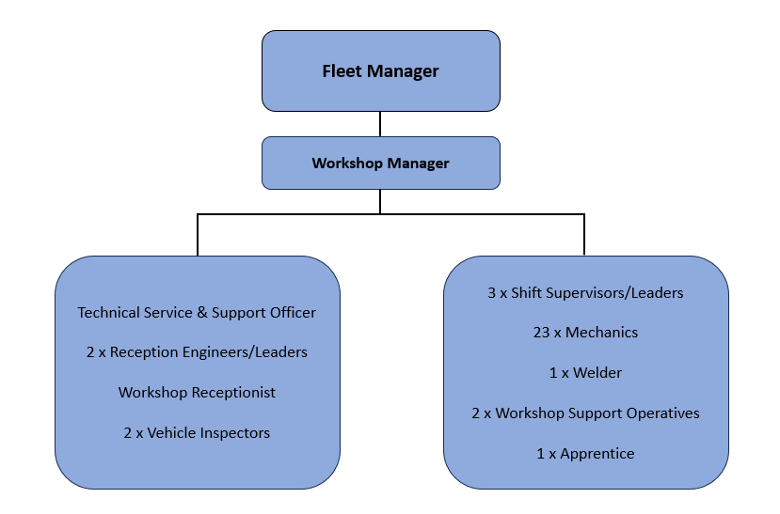

Special Knowledge Requirements: (will be used for shortlisting)
Applicants with disabilities are only required to meet the essential special knowledge requirements shown by a cross in the end column.
 |  |  | Essential
Must be accurate and able to demonstrate good numeracy and literacy skills |  |  | X
Have a responsible approach towards learning new skills |  |  | X
Able to work productively both within a team and, on occasions, alone. |  |  | X
Is punctual and able to manage time and work schedule |  |  | X
Uses basic awareness of Health, Safety and Environment |  |  | X
Follow instructions with a methodical approach |  |  | X
Solve problems in a way that demonstrates both logical and creative thinking |  |  | X
Relevant experience requirement: (will be used for shortlisting).
The successful candidate will train to become an apprentice trained motor vehicle mechanic to NVQ Level 3
standard therefore must be able to demonstrate a very high standard of English and Mathematics
and a commitment to learn and develop skills to obtain the qualification.

Core Employee competencies to be used at the interview stage.

Carries Out Performance Management
Covers the employee’s capacity to manage their workload and carry out a number of specific tasks accurately and to a high standard.
Communicates Effectively
Covers a range of spoken and written communication skills required as a regular feature of the job. It includes exchanging information/building relationships; giving advice and guidance; counselling, negotiating and persuading and handling private, confidential and sensitive information.
Carries Out Effective Decision Making
Covers a range of thinking skills required for taking initiative and independent actions within the scope of the job. It includes planning and organising, self effectiveness and any requirements to quality check work.
Undertakes structured Problem Solving Activity
Covers a range of analytical skills required for gathering, collating and analysing the facts needed to solve problems. It includes creative and critical thinking; developing practical solutions; applying problem solving strategies and managing interpersonal relationships.

Operates With Dignity and Respect

Covers promoting equality, treating all people fairly and with dignity and respect , maintains impartiality/fairness with all people, is aware of the barriers people face.
Working Conditions:

Throughout training and once qualified, will normally work within the confines of Shearbridge depot workshop but frequently required to undertake site and roadside repairs within the BMDC area in all weathers

Physically demanding effort required on specific walking, kneeling, bending, pulling, pushing, lifting and carrying or any other physical attribute required

Good hand /eye co-ordination is vital for this role.

Special Conditions:
- The apprentice will be required to attend relevant training courses and college which may involve going out of district.

- Dependant on NVQ qualification level at the start of the apprenticeship, the apprentice must achieve NVQ Level 3 by the end of the apprenticeship (If the apprentice starts the scheme without any qualification, the qualification progression that they must achieve is NVQ Level 2 to NVQ Level 3 by the end of the apprenticeship)

- The apprentice must pass the UK driving test and obtain a standard UK driving licence by the end of the apprenticeship – self funded.

- The apprentice must be able to perform all duties and tasks with reasonable adjustment,
where appropriate, in accordance with the Equality Act 2010 in relation to Disability Provisions.

Compiled by: SW/PD  Date Reformatted 23/06/2016 | Grade Assessment  Date: | Post Grade:  Apprentice rate starting from Band 5, Scale Point 13

