CITY OF BRADFORD METROPOLITAN DISTRICT COUNCIL

JOB PROFILE

DEPARTMENT: Chief Executive | SERVICE GROUP: West Yorkshire Pension Fund (WYPF)
POST TITLE: Finance Graduate | REPORTS TO: Principal Finance Manager
GRADE: SO1 to SO2 | POST REFERENCE (SAP): 50221081

The following information is furnished to help Council staff and those people considering joining the City of Bradford Metropolitan District Council to understand and appreciate the general work content of their post and the role they are to play in the organisation. The duties and responsibilities highlighted in this Job Profile are indicative and may vary over time. Post holders are expected to undertake other duties and responsibilities relevant to the nature, level and scope of the post and the grade has been established on this basis.

As a candidate you will be expected to demonstrate your ability to meet the special knowledge, experience and qualifications required for the role by providing evidence in the application form for the purpose of shortlisting. Applicants with disabilities are only required to meet the essential special knowledge requirements shown by a cross in the end column of this section.

The employee competencies are the minimum standard of behaviour expected by the Council of all its employees and the management competencies outlined are those relevant for a post operating at this level within our organisation.

Both sets of competencies will be used at interview stage and will not be used for short listing purposes. Please see the separate guidance information on how to complete the form located on Bradnet.

Key Purpose of Post:
To support WYPF in providing pensions financial services to 850 employers and 510,000 pension members across the UK, accounting for pensions payroll of £650m and pension contribution income of £500m per year; To provide pension administration shared services finance services support to UK pension funds and fire services. To managing pensions operational budget of £15m per annum. Manage and training finance staff on financial and technical accounting services. Manage technical accounting functions for WYPF and CBMDC Corporate Services. Manage SAP, UPM and HSBC corporate banking systems for WYPF and provide technical support for WYPF managers using financial systems. Complete and submit compliance, regulatory and tax returns ahead of deadlines and time limits for WYPF and shared service clients.

To undertake relevant training and achieve full qualification depending on your experience and preference. We support the following qualifications; Association of Chartered Certified Accountant (ACCA), Chartered Institute of Management Accountant (CIMA), Chartered Institute of Public Finance and Accountancy (CIPFA) and the following investment management qualifications - Investment Management Certificate (IMC) Level 1 and 2, Chartered Institute of Securities and Investments (CISI) and the Chartered Financial Analyst (CFA) Levels 1 and 2.

The role of the Finance Graduate is to:

- Responsible for managing the control, receipt, correct allocation and banking of substantial amounts of WYPF income of £500m contribution payments and investment income of £550m annually. Provide financial service and financial management advice, communicate in an informed, confident, polite and understanding manner with employers, service providers, shared service partners, clients and customers.

- Manage account receivable processes in respect of pension contributions, funded, unfunded pension costs, purchasing, creditor, payment and shared services recharges for WYPF. Process BACS payments and CHAPS payments for Pension Administration.

- Provide finance activity reports to management, service managers, Pension Committee members, elected members and WYPF officers. Liaise regularly with service managers and employers and support in conducting WYPF financial activities efficiently.

- Supervise and manage WYPF finance officers, ensure compliance with CBMDC financial policies and standing orders. Taking reasonable care of own(s) health and safety and those under the post holder’s supervision. Liaise with pension admin shared service clients to ensure all financial services provided to client are effective and compliant.

Main Responsibilities of Post:
- SO1 Principal Duties – Generic

At this level officers are required to:

- Supervise daily WYPF banking and reconciliation processes. Statement download from the banking portal and upload to SAP, petty cash and change float processes. Ensuring expenses, cash and cheques are appropriately receipted and banked. Supervise income, banking and payment terminal operations within WYPF.

- Maintenance of SAP coding structure, journal processes, ensuring journal transfers, amendments and corrections are processed by staff accurately, authorised, with sufficient source documentation to aid management information and audit.

- Monitor receipt of income in respect of account receivable debtor accounts and produce periodic reports for all debtor accounts and credit notes for WYPF. Performing daily reconciliation of WYPF bank accounts and manage daily notification of income to WYPF Service Centre and Investment Team.

- Take responsibility for own workload and manage finance officers’ workload and make appropriate adjustments to ensure tasks are completed efficiently.

- Provide timely financial information and advice WYPF to managers, employers, shared service partners, suppliers and service users. Ensure all enquiries for WYPF Finance services are followed up and effectively dealt with.

- Full reconciliation of bank, payroll and creditor payments transactions to records in SAP and follow up all queries to satisfaction.

- Prepare and send monthly bank and pensioner reconciliation report to shared services partners and collate shared service financial reports for shared service clients’ Local Pension Boards.

- SO2 Principal Duties – Generic

In addition to A.) above, officers at this level will:

- Manage HMRC accounting for tax for WYPF and shared service partners. Preparation of pension payroll tax submissions, NI payment, tax overpayment reclaims, HMRC reportable events. Allocate and reconciliation tax payment to SAP records, HSBCnet.com, and UPM financial records. Dealing with HMRC tax enquiries and liaising with HMRC on all tax matters for WYPF and Shared service partners.

- Supervise and improve finance officers’ understanding of tax implications of scheme pay issues for reportable events, HMRC timetable and deadline for payments and data return. Work with member services managers and shared service partners to ensure HMRC regulatory compliance.

- Manage debtors on the account receivable system, WYPF pension payroll deductions on SAP and UPM, and shared service recharges for pension funds and fire authorities. Manage procurement functions, authorise purchase requisitions and ensure creditors are managed effectively.

- Supervise WYPF quality assurance procedures as applied to WYPF Finance Team’s work, participate in technical accounting process reviews and application of Council policies to WYPF Finance Team’s work by observing working practices and procedures that have been put in place for best value, complaint procedures and customer care.

- Supervise pension transfer out and in for WYPF and shared service partners ensuring all payments and income are reconciled to bank statements, SAP and posted to UPM. Manage strain cost recharges to employers and ensure unfunded pensions are invoiced to employers and all payments collected for WYPF and shared service partners.

- Manage salary monitoring processes, ensuring major overspends and underspend are reported to senior managers, corrective actions are taken and reported to Finance Manager and Head of Finance.

- Carry out financial viability and going concern assessments on small employers, ensuring requests from Technical Services are dealt with promptly.

- Carry out late recall of WYPF and shared service partners’ pensioner payroll with HSBC, ensuring all recalls are dealt with promptly to minimise pension overpayment.

Structure:
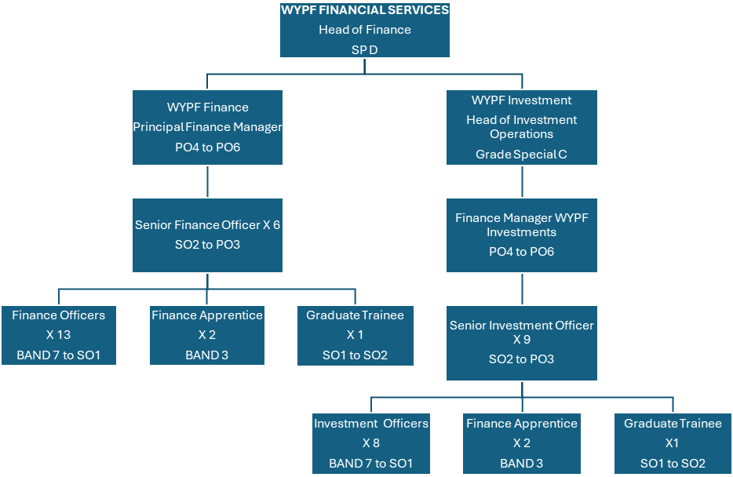

Special Knowledge Requirement: Will be used for shortlisting.
Applicants with disabilities are only required to meet the essential special knowledge requirements shown by a cross in the end column.
 |  |  | Essential
Work to financial working practices, procedures and basic operations expected in a major financial organisation. |  |  | X
Understands and applies health and safety working practices, including  risk in own area of work and or across West Yorkshire Pension Fund (inc. legislation) |  |  | X
Uses a range of complex IT packages relating to area of work i.e. financial management. |  |  | X
Oversees or contributes to the management of a budget, keeping costs within agreed levels for own section/team.
Knows and understands how to analyse, interpret and present complex  information from a variety of sources. |  |  | X
Understand costing processes, service costing, quality and service benchmarking processes, numerate with confidence in dealing with large amounts of money. |  |  | X
Detailed knowledge of applying payroll and pension systems and ability to train staff on such systems
Ability to work with minimum supervision, supervise and train others in delivering team targets. |  |  | X
Clear understanding of and ability to apply benchmarking and performance reporting processes
Ability to run and use financial reporting tools on financial systems e.g. Discoverer, Business Object, Crystal or any other general ledger integrated reporting. |  |  | X
Relevant experience requirement: Will be used for shortlisting
The applicant is required to provide evidence of having previously spoken fluently to members of the public, clients or councillors in order to meet the Advanced threshold level outlined under Special Knowledge above.

Relevant professional qualifications requirement: Will be used for shortlisting
You will need to be in your final year studying towards your degree or have already achieved at least a 2:2 in Finance or a similar subject, such as Economics or Business Studies / Management. You will also have an interest in or experience of investments and financial markets.
Core Employee competencies at manager level to be used at the interview stage.
Carries Out Performance Management – the employee’s capacity to manage their workload and carry out a number of specific tasks accurately and at a high standard.
Communicates Effectively - covers a range of spoken and written communication skills required as a regular feature of the job. It includes exchanging information/building relationships, giving advice and guidance, counselling, negotiating and persuading and handling private, confidential and sensitive information.
Carries Out Effective Decision Making - covers a range of thinking skills required for taking initiative and independent actions within the scope of the job. It includes planning and organising, self-effectiveness and any requirements to quality check work.
Undertakes Structured Problem Solving Activity - covers a range of analytical skills required for gathering, collating and analysing the facts needed to solve problems. It includes creative and critical thinking, developing practical solutions, applying problem solving strategies and managing interpersonal relationships.
Operates with Dignity and Respect - covers treating everyone with respect and dignity, maintains impartiality / fairness with all people, is aware of the barriers people
face.
Management Competencies: to be used at the interview stage.
Operates with Strategic Awareness - Our managers work with corporate priorities and policies in a joined up way with others, internally and externally. Works democratically, transparently and accountably.
Practices Appropriate Leadership - Our managers motivate their staff to exceed expectations through raising their awareness of goals and moving them beyond self-interest for the sake of the team or service. They consider serving the District in all that they do.
Delivering Successful Performance - Our managers monitor performance of services, teams & individuals against targets & celebrate great performance. They promote the District’s vision & work to achieve Council’s values & agreed outcomes.
Applying Project and Programme Management - Our manager’s work to ensure that outcomes and objectives are achieved within desired timescales, make best use of resources and take a positive approach to contingency planning.
Developing High Performing People and Teams - Our managers coach individuals and teams to achieve their potential and take responsibility for continuous improvement. They champion the Council’s values and goals.
Working Conditions:
Must be able to perform all duties and tasks with reasonable adjustment, where appropriate, in accordance with the Equality Act 2010 in relation to Disability Provisions.
Special Conditions:
This post requires a basic disclosure and barring checking service check to be carried out, and it is required for all WYPF Finance staff.
Compiled by: Ola Ajala  Date: Jan 2025 | Grade Assessment Date: Jan 2025 | Post Grade: SO1 to SO2

