CITY OF BRADFORD METROPOLITAN DISTRICT COUNCIL
JOB PROFILE

DEPARTMENT: Place | SERVICE GROUP: Museums and Galleries
POST TITLE: Museum Project Officer | REPORTS TO: James Steward, Museums & Galleries Manager
GRADE: SO2 |  | SAP POSITION NUMBER :

The following information is furnished to help Council staff and those people considering joining the City of Bradford Metropolitan District Council to understand and appreciate the general work content of their post and the role they are to play in the organisation. The duties and responsibilities highlighted in this Job Profile are indicative and may vary over time. Post holders are expected to undertake other duties and responsibilities relevant to the nature, level and scope of the post and the grade has been established on this basis.
For posts where employees speak directly to members of the Public the post holder is required to demonstrate their ability to speak fluently in English.

As a candidate you will be expected to demonstrate your ability to meet the special knowledge and qualifications required for the role by providing evidence in the application form for the purpose of shortlisting. Applicants with disabilities are only required to meet the essential special knowledge requirements shown by a cross in the end column of this section.

The employee competencies are the minimum standard of behaviour expected by the Council of all its employees and the management competencies outlined are those relevant for a post operating at this level within our organisation.

Both sets of competencies will be used at interview stage and will not be used for short listing purposes.

Key Purpose of Post: Max 3
Lead project officer for Arts Council England National Portfolio for Bradford Museums & Galleries.

Support the Museums & Galleries Manager in the delivery of the NPO Activity plan and the Investment Principles Plan for Bradford Museums & Galleries remit as a National Portfolio Organisation (NPO).

Responsible for the efficient administration and delivery of the NPO programme and related partnership liaison and funding critical to its delivery.

Coordination of all programme evaluation and Arts Council reports as required

Main Responsibilities of Post: Max 15
- Coordinate BDMG NPO activity and day-to-day responsibility for management and
effective implementation of the programme ensuring proposals meet the Arts Council’s agreed outcomes and appropriately consider and deliver actions that meet the
requirements of the Investment Principles.

- Develop work strands as identified in the agreed activity plan

- Oversee the appointment and management of freelancers, consultants and creative practioners

- Work with the NPO Board in coordinating the development and delivery of all plans
and costing, quality of outputs and critical path management.

- Support the Business Support Officer (BDMG) through the preparation and
presentation of Board papers, budget reports and Arts Council reports as required to meet the terms of the NPO funding agreement

- Provide monthly reports to the Museums & Galleries Manager to ensure delivery
within budget and to the standard required and meeting schedule.

- Work with the Museums & Galleries Manager and Learning Manager to manage the
NPO steering / oversight group

- Facilitate team meetings and coordination between the activity delivery strands of the programme to ensure this meets with other significant work being undertaken by
Bradford Museums & Galleries.

- Work with the Board and Museums & Galleries team to build relationships with key stakeholders, including identified community groups, statutory, education and
voluntary sector partners and facilitate partnership opportunities with them.

- Manage and collate the programme evaluation data and statistics and record them
in the monitoring and evaluation reporting template

- Coordinate the collection of evaluation data at NPO funded events and activities

- Manage all associated programme budget control, communication and consultation

- Coordinate meetings and training sessions in line with the Investment Principles plan

- Undertake all duties as requested by the Museums and Galleries Manager to ensure
the successful delivery of the Activity Plan and Investment Principles plan for the NPO.

Structure:
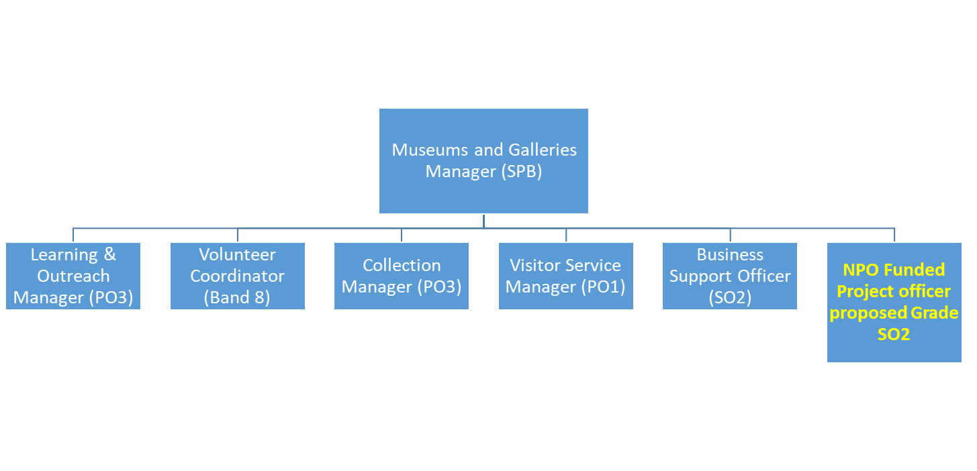

Special Knowledge Requirement: Will be used for shortlisting. Max 10

Applicants with disabilities are only required to meet the essential special knowledge requirements shown by a cross in the end column.
 | Essential
Due to the Government’s Fluency in English for posts where employees speak directly to members of the public the postholder is required to meet the Advanced threshold level which will be applied where the postholder requires a greater level of sensitive interaction with the public.  You must be able to demonstrate that you can express yourself fluently and spontaneously (this will also be tested during the interview). | x
Knowledge of cultural sector working practice and procedures
Understands and applies health and safety working practices, including risk in own area of work and or across other areas of work | x
Uses a wide range of basic computer applications | x
Understanding of procurement of services within area of responsibility | x
Knows and understands how to analyse, interpret and present (in written reports and verbally) complex information from a variety of sources | x
Able to evidence ability to administrate cultural heritage programmes within budget | x
Knows how to collect data and evidence and present for the reports | x

Relevant experience requirement: Will be used for shortlisting

The applicant is required to provide evidence of having previously worked at senior administrative level in a project environment, preferably in the arts/ heritage sector
Heritage / cultural sector experience in coordinating the delivery of creative programmes in the set-up and delivery of NPO project initiatives to achieve and report on agreed outputs and outcomes.
Experience of monitoring and planning information for reporting purposes
Experience of working in and maintaining partnerships and networks
Experience of finance/ budget monitoring and reporting
Experience of meeting deadlines and targets
Evidence of strong organisational ability.
Relevant professional qualifications requirement: Will be used for shortlisting

Relevant Degree or NVQ level 4/5 / Diploma in Business administration
Core Employee competencies at manager level to be used at the interview stage.

Carries Out Performance Management – covers the employee’s capacity to manage
their workload and carry out a number of specific tasks accurately and at a high standard.
Communicates Effectively - covers a range of spoken and written communication skills required as a regular feature of the job. It includes exchanging information/building relationships, giving advice and guidance, counselling, negotiating and persuading and handling private, confidential and sensitive information.
Carries Out Effective Decision Making - covers a range of thinking skills required for taking initiative and independent actions within the scope of the job. It includes planning and organising, self effectiveness and any requirements to quality check work.
Undertakes Structured Problem Solving Activity - covers a range of analytical skills required for gathering, collating and analysing the facts needed to solve problems. It includes creative and critical thinking, developing practical solutions, applying problem solving strategies and managing interpersonal relationships.
Operates with Dignity and Respect - covers treating everyone with respect and dignity, maintains impartiality/fairness with all people, is aware of the barriers people face.

Management Competencies: to be used at the interview stage.

Operates with Strategic Awareness Our managers work with corporate priorities and policies in a joined up way with others, internally and externally. Works democratically, transparently and accountably.
Practices Appropriate Leadership Our managers motivate their staff to exceed expectations through raising their awareness of goals and moving them beyond self interest for the sake of the team or service. They consider serving the District in all that they do.
Delivering Successful Performance Our managers monitor performance of services, teams & individuals against targets & celebrate great performance. They promote the District’s vision & work to achieve Council’s values & agreed outcomes.
Applying Project and Programme Management Our manager’s work to ensure that outcomes and objectives are achieved within desired timescales, make best use of resources and take a positive approach to contingency planning.
Developing High Performing People and Teams Our managers coach individuals and teams to achieve their potential and take responsibility for continuous improvement. They champion the Council’s values and goals.
Working Conditions:

Must be able to perform all duties and tasks with reasonable adjustment, where appropriate, in accordance with the Equality Act 2010 in relation to Disability Provisions.
Ability to work occasional weekends and evenings as required.

Special Conditions:
You will be informed outline if there is a requirement for the post to have recruitment checks
such as DBS, Warner Process.
Compiled by: James Steward  Date:14.01.25 | Grade Assessment Date: | Post Grade:

