CITY OF BRADFORD METROPOLITAN DISTRICT COUNCIL
JOB PROFILE

DEPARTMENT: Place | SERVICE GROUP: Environmental Health
POST TITLE: Technical Officer (Pollution) | REPORTS TO: Environmental Health Manager
GRADE: Band 8/S01/S02 |  | SAP POSITION NUMBER :

The following information is furnished to help Council staff and those people considering joining the City of Bradford Metropolitan District Council to understand and appreciate the general work content of their post and the role they are to play in the organisation. The duties and responsibilities highlighted in this Job Profile are indicative and may vary over time. Post holders are expected to undertake other duties and responsibilities relevant to the nature, level and scope of the post and the grade has been established on this basis.
For posts where employees speak directly to members of the Public the post holder is required to demonstrate their ability to speak fluently in English.

As a candidate you will be expected to demonstrate your ability to meet the special knowledge, experience and qualifications required for the role by providing evidence in the application form for the purpose of shortlisting. Applicants with disabilities are only required to meet the essential special knowledge requirements shown by a cross in the end column of this section.

The employee competencies are the minimum standard of behaviour expected by the Council of all its employees and the management competencies outlined are those relevant for a post operating at this level within our organisation.

Both sets of competencies will be used at interview stage and will not be used for short listing purposes.

Key Purpose of Post:
To carry out the investigation of service requests over a wide range of environmental issues from receipt through to resolution.

Undertake site visits, monitoring, collect of evidence, prepare and serve enforcement notices, monitor their compliance, conduct PACE interviews, prepare statements and to attend Court when necessary.

Main Responsibilities of Post:

- To carry out the collection of evidence to enforce appropriate statutes used in the service of notices, the defence of appeals and the prosecution of offences. Also to act as a professional witness on behalf of the Council in court and to attend meetings and panels of the Council to give technical advice when required.

- To carry out the detection, monitoring and abatement of statutory nuisance

- To carry out the monitoring and control of pollution whether to land, water, the atmosphere or by noise.

- To carry out visits and supervise remedial works to ensure compliance with statutory requirements, including compliance with enforcement notices.

- To carry out sampling of a wide range of materials including drinking water, air, land and other hazardous materials, e.g. asbestos.

- To support the delivery of the regulatory programme in respect of the district’s private water supplies.

- Prepare, draft and serve notices served in the name of the Council and in his/her own name under the supervision of an Environmental Health Manager.

- To carry out Legal proceedings and attend as required at tribunals and appeals, either as ordinary or expert witness. To prepare reports and give written and oral evidence as required in support of legal proceedings.

- To carry out detailed inspections in respect of applications for licences and approvals as directed by an Environmental Health Manager and submit reports to, and attend at, Licensing panels as required

- To carry out detailed assessments of the environmental impact of planning applications, prepare responses/reports to the planning department, and attend enquiries panel meetings as required.

- To give appropriate written and verbal advice/information to members of the public, businesses and other council departments

- To provide scientific and technical support and general assistance to other staff as required.

- To carry out the maintenance, calibration, and operation of environmental monitoring equipment, e.g. sound level meters etc.

- To assess submitted reports with respect to contaminated land and make technical recommendations to planning officers, and to participate, as directed, in the delivery of the contaminated land strategy.

- To carry out inspections, and draft authorisations, and variation notices for low risk LAPC processes.

Structure:
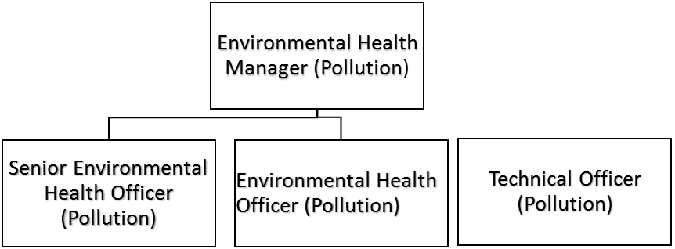

Special Knowledge Requirement. Will be used for shortlisting.
 |  |  | Essential
Applicants with disabilities are only required to meet the essential special knowledge requirements shown by a cross in the end column.
Due to the Government’s Fluency in English for posts where employees speak directly to members of the public the postholder is required to meet the Advanced threshold level which will be applied where the postholder requires a greater level of sensitive interaction with the public.  You must be able to demonstrate that you can express yourself fluently and spontaneously (this will also be tested during the interview). |  |  | X
Uses knowledge of Health, Safety and Environmental policies, procedures and regulations including risks in own area of
work
Able to use standard IT packages to undertake word processing activities and produce documents, reports, agendas etc. e.g. Microsoft Word |  |  | X
Able to provide clear verbal and written high level technical advice to a wide range of specialist and non specialist audiences, including assisting clients to comply with legislative requirements
Knows and understands how to use, interpret, handle and communicate
information
Demonstrates knowledge/understanding of technical aspects/legislative controls in relation to pollution.
Demonstrate an ability to undertake a wide range of environmental and materials sampling in support of enforcement activities.
Able to drive and holds appropriate licence |  |  | X
Relevant experience requirement: Will be used for shortlisting

The applicant is required to provide evidence of having previously spoken fluently to members of the public in order to meet either the Lower threshold or Advanced threshold level outlined under Special Knowledge above.

Relevant professional qualifications requirement: Will be used for shortlisting

- Degree in environmental or associated science OR
- Diploma in acoustics and noise control/certificate of competency in environmental noise measurement.
Core Employee competencies to be used at the interview stage.
Carries Out Performance Management
Covers the employee’s capacity to manage their workload and carry out a number of specific tasks accurately and to a high standard.
Communicates Effectively
Covers a range of spoken and written communication skills required as a regular feature of the job. It includes exchanging information/building relationships; giving advice and guidance; counselling, negotiating and persuading and handling private, confidential and sensitive information.
Carries Out Effective Decision Making
Covers a range of thinking skills required for taking initiative and independent actions within the scope of the job. It includes planning and organising, self-effectiveness and any requirements to quality check work.
Undertakes Structured Problem Solving Activity
Covers a range of analytical skills required for gathering, collating and analysing the facts needed to solve problems. It includes creative and critical thinking; developing practical solutions; applying problem solving strategies and managing interpersonal relationships.
Operates with Dignity and Respect

Covers promoting equality, treating all people fairly and with dignity and respect, maintains impartiality/fairness with all people, is aware of the barriers people face.
Working Conditions:

Must be able to perform all duties and tasks with reasonable adjustment, where appropriate, in accordance with the Equality Act 2010 in relation to Disability Provisions.

Works in the full range of conditions experienced within the range of duties from the residential situation through to potentially highly dangerous conditions mainly in commercial and industrial undertakings. Must weigh up quickly the risks and hazards involved and take all measures appropriate to eliminate personal risk including the wearing of necessary protective clothing and equipment.

Required to work outside normal office hours as the occasion demands.

Required to work in situations where there is the potential for conflict.

Required to work outside in possibly adverse weather and environmental conditions.

Special Conditions:
Compiled by: CM/JRM (reviewed JL/JH)  Date: 26/05/23 | Grade Assessment  Date: 19/06/03 | Post Grade: Band 8/SO1/SO2

