
City of Bradford Metropolitan District Council Job Profile
Reference Number | 11007729
Role Title | Area Rights of Way Officer
Directorate | Growth
Service Area | Planning Transport and Highways
Reports to | Countryside and Rights of Way Manager

Role Purpose (maximum of 3 points, with no sub bullet points)
1. To pursue the Council’s statutory duties and policies in relation to public rights of way

Duties and Responsibilities (maximum of 15 points, with no sub bullet points)
- Resolve queries and complaints from the general public, user groups, elected members,
- developers and landowners relating to public rights of way and certain access matters in
- the officer’s specific geographic area.
- Liaise with other council departments (eg Planning, Highway Maintenance, Asset Management, Legal Services), statutory undertakers, parish and town councils, user groups, landowners and any other individuals or parties having an interest in the Section’s activities, to provide impartial advice and guidance.
- Deal with correspondence from various sources on matters of varying complexity, and record and monitor correspondence.
- Respond to formal consultations from the Planning Authority and provide impartial advice and guidance on planning matters that affect public rights of way.
- Maintain written, cartographic and computerised records of public rights of way, including GIS, and disseminate this information to other Council departments that hold rights of way records for public inspection. Carry out routine, technical, clerical and administrative work associated with day to day operations, specific projects and Section development.
- Act as Lead Officer in enforcement action on public rights of way issues in the Officer’s specific geographic area.
- Administer and answer Local Land Charges searches, and any other searches, including personal searches that may be affected by public rights of way within required timescales making charges as appropriate.
- Implement specific technical projects, such as signposting and the provision of user control barriers on public rights of way.
- Act as Lead Officer in legal orders to divert, extinguish or create public rights of way.
- Inspect and survey existing, and alleged, public rights of way to ensure their registration, protection and possible enhancement.
- Implement procedures for the continuous review of the Modified Definitive Map and the preparation of a definitive map for the former County Borough of Bradford.
- Give evidence in court or attend public inquiries as required.
- Carry out any other duties as may from time to time be required.

Dimensions of role (direct or indirect as applicable) e.g. total number of staff managed, total budget, total scope of role
N/A

Structure Chart (showing direct reports)
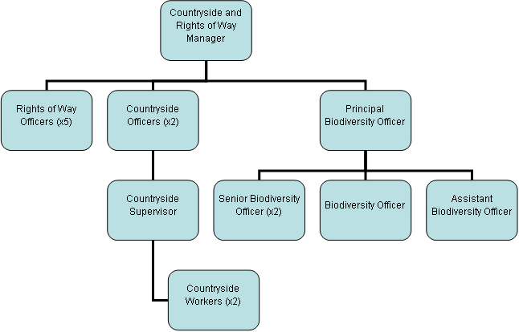

Person Specification
Knowledge / Skills / Experience required
Carries out the working practices, procedures and basic operations relating to Rights of Way.
Knowledge of Health and Safety and environmental policies, procedures and regulations, including risk in own area.
Uses a wide range of basic computer applications – including Word and Excel
Knows and understands how to analyse, interpret and present complex information from a variety of sources.
Knowledge and understanding of legislation, policy and processes relating to Rights of Way
Knowledge and understanding of planning policy in relation to Rights of Way

Knowledge and understanding of the principles and application of planning policies and environmental legislation.
The applicant is required to provide evidence of having previously spoken fluently to members of the public in order to meet the Advanced threshold level outlined above.
Relevant experience of working in countryside access or rights of way management, including rights of way legislation and policies and including addressing landowner and user issues and conflicts.

Key benchmarked competencies, traits and motives required to successfully deliver the role These will support recruitment, succession planning, development and performance management |  | Essential
Health and Safety | Uses knowledge of Health, Safety policies, procedures and regulations including risks in own area of work | X
IT Packages | Uses a range of complex IT packages relating to area of work | X
Service Improvement | Ability to adopt a process of continual improvement and suggest ways of working more efficient and effectively to improve service delivery | X
Continued professional Improvement | Carries out a variety of working practices, applies complex regulations, rules, procedures and processes across a technical /specialist area | X
Communication | Knows and understands how to use, interpret, handle and communicate, often complex and detailed information, and relay it to service users/stakeholders in writing and/or over the telephone / face to face. | X
Numeracy & Literacy | Demonstrates a high level of numeracy, literacy and accuracy across a range of activities | X
Relevant Professional Qualification | Relevant degree or equivalent OR:  Above experience plus 4 GCSE’s (or equivalent) | X
Carries out performance management | Covers the employees’ capacity to manage their workload and carry out a number of specific tasks accurately and to a high standard. | X
Communicates Effectively | Covers a range of spoken and written communication skills required as a regular feature of the job. This includes exchanging information/building relationships, giving advice and guidance, counselling, negotiating and persuading and handling private, confidential and sensitive information. | X
Carries Out Effective Decision Making | Covers a range of thinking skills required for taking initiative and independent actions within the scope of the job. This includes planning and organising, self-effectiveness and any requirements to quality check work. | X
Undertakes Structured Problem-Solving Activity | Covers a full range of analytical skills required for gathering, collating and analysing the facts needed to solve problems. This includes creative and critical thinking, developing practical solutions, applying problem solving strategies and managing interpersonal relationships. | X
Operates with Dignity and Respect | Covers treating everyone with respect and dignity, maintains impartiality/fairness with all people, is aware of the barriers people face. | X
Practices Appropriate Leadership | Our managers motivate their staff to exceed expectations through raising their awareness of goals and moving them beyond self-interest for the sake of the team or service. They consider serving the District in all that they do.
Operates with Strategic Awareness | Our managers work with corporate priorities and policies in a joined up way with others, internally and externally. Works democratically, transparently and accountably.
Delivering Successful Performance | Our managers monitor performance of services, teams & individuals against targets & celebrate great performance. They promote the District’s vision & work to achieve Council’s values & agreed outcomes.
Applying Project and Programme Management | Our manager’s work to ensure that outcomes and objectives are achieved within desired timescales, make best use of resources and take a positive approach to contingency planning
Developing High Performing People and Teams | Our managers coach individuals and teams to achieve their potential and take responsibility for continuous improvement. They champion the Council’s values and goals.

Applicants with disabilities are only required to meet the essential special knowledge requirements (clearly marked)
Due to the Governments Fluency in English Duty for posts where employees speak directly to members of the public the postholder is required to meet the Lower threshold level.
You should be able to demonstrate that you can use a wide range of simple words and a standard English sentence structure to express and maintain a flowing conversation even though you pause to think of the correct words with the ability to express and make yourself understood (this will also be tested during the interview).

Completed by: | David Campbell | Date: | 05/01//2025
Quality checked: | JEGS | Date: | 2015

