CITY OF BRADFORD METROPOLITAN DISTRICT COUNCIL
JOB PROFILE

DEPARTMENT OF PLACE | SERVICE GROUP: Fleet & Transport Services, Fleet Compliance
POST TITLE:  Fleet Enforcement & Training Officer | REPORTS TO:  Fleet Compliance Manager
GRADE: Band 8 |  | POST REFERENCE (SAP)/ VACANCY CONTROL NUMBER:

The following information is furnished to help Council staff and those people considering joining the City of Bradford Metropolitan District Council to understand and appreciate the general work content of their post and the role they are to play in the organisation. The duties and responsibilities highlighted in this Job Profile are indicative and may vary over time. Post holders are expected to undertake other duties and responsibilities relevant to the nature, level and scope of the post and the grade has been established on this basis.

As a candidate you will be expected to demonstrate your ability to meet the special knowledge, experience and qualifications required for the role by providing evidence in the application form for the purpose of shortlisting. Applicants with disabilities are only required to meet the essential special knowledge requirements shown by a cross in the end column of this section.

The employee competencies are the minimum standard of behaviour expected by the Council of all its employees and the management competencies outlined are those relevant for a post operating at this level within our organisation.

Both sets of competencies will be used at interview stage and will not be used for short listing purposes. Please see the separate guidance information on how to complete the form located on Bradnet.

Key Purpose of Post
- To support the Fleet Compliance Manager in providing a comprehensive and complex range of regulatory and procedural guidelines across all fleet vehicle users for the Council, ensuring that the whole range of vehicles are operated in a safe, effective and efficient manner, liaising as necessary with Traffic Commissioners, DVSA, Police, HSE, Insurance Companies, members of the public and colleagues. Also ensuring all manufacturer and legal requirements are met and that all authority vehicles are operating safely and fit for purpose.

- To assist in managing the operational needs and effectiveness of Bradford Council’s Fleet. Monitor and report on the condition of the Council’s vehicle and plant equipment fleet ensuring compliance with all relevant legislation and the Operator’s licence. Ensure all Council drivers are undertaking and recording statutory vehicle checks and that vehicle defects are promptly reported. Act in a liaison/advisory capacity on all transport matters with Senior Departmental managers, supervisors and other transport related staff.

- To collect, analyse and produce performance management data for senior management, develop, analyse and maintain data for training and performance management and attend regular management reviews to deliver and demonstrate ways in which Fleet & Transport Services can incorporate new challenges and provide solutions to all departments with vehicle responsibility.

Main Responsibilities of Post:
- To assist the Fleet Compliance Manager in the delivery, management and maintenance of the Council fleet. Interpret, maintain and develop regulatory systems in line with the requirements of an Operator’s licence on behalf of City of Bradford MDC.
- To ensure that the whole range of vehicles are operated in a safe, effective and efficient manner, liaising as necessary with all council departments, Senior Officers, Managers, Traffic Commissioners, DVSA, Police, HSE, Insurance Companies, members of the public and colleagues. Also ensuring all manufacturer and legal requirements are met and that all authority vehicles are operating safely and are fit for purpose.
- Carry out driving assessments and ensure these are linked to regular supervisions, using this process to continually assess the training needs of drivers and ensure drivers are fully conversant with the role they undertake, and have the relevant qualifications, ability and competence. Identify and take appropriate action arising from concerns/complaints regarding vehicle competence
- Manage vehicle and driver performance by undertaking spot checks on vehicle condition and correct completion of documentation required to comply with O licence requirements. Address any failures in working practises, advise of correct procedure and inform management as appropriate. Maintain, monitor and update vehicle inspection and report databases.
- To ensure all Council drivers are undertaking and recording statutory vehicle checks and that vehicle defects and other defects, including driver abuse are promptly recorded and reported and appropriate documentation is completed. Act in a liaison/advisory capacity on all transport matters with Senior Departmental managers, supervisors and other transport related staff.
- Carry out risk assessments and reviews in all areas of vehicle operation.
- Carry out internal audit procedure across all departments to ensure compliance with O licence requirements, ensuring all relevant documentation and paperwork is kept complete and up to date.
- Attend accidents / incidents if required and emergencies on the public highway involving Council vehicles and ensure vehicle accident investigations are completed and attend court in the capacity of a witness when defending employee/property.
- Produce and present comprehensive Excel based management and statistical reports for local and Corporate Key Performance Indicators, updating the Councils Service Plan / KPI performance database as required.
- Collect and analyse data and produce performance/compliance reports for presentation to management. Reports include:
- Workshop Performance
- Operator Compliance Risk Score
- RTC
- Avoidable Vehicle Damage
- Vehicle Test Statement
- Driver’s hours Infringement Statistics
- Vehicle Overload
- Driver / Vehicle Activity
This list is not exhaustive and may extend to ad hoc management reports when required.
- Design and develop bespoke training packages and deliver training to staff/management.
- Demonstrate compliance/contribution to health & safety management

- Ensure legal compliance in respect of “Operators Licenced” drivers’ hours in accordance with “Drivers Hours & Tachograph Rules for Goods Vehicles including European Working Time & Road Transport Directives” in line with current and changing legislation and monitor and maintain a database of weekly drivers hour’s information received via post and e mail. Liaise with departments and send out infringement correspondence where required
- Provide operational support and elements of cover to other team members where required.

Structure:
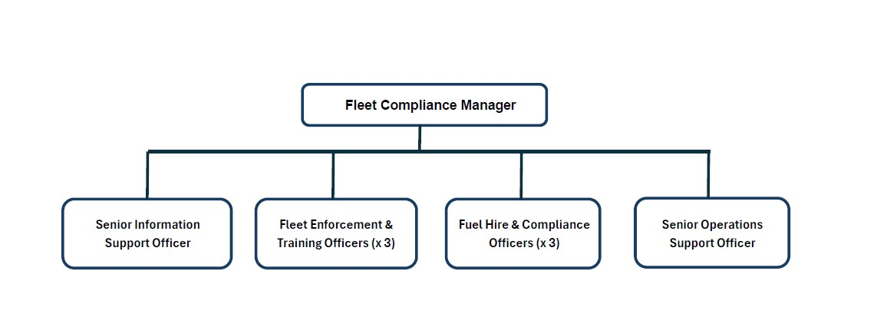

Special Knowledge Requirement (used for short listing). Applicants with disabilities are only required to meet the essential special knowledge requirements, highlighted below)
Due to the Government’s Fluency in English for posts where employees speak directly to members of the public the post holder is required to meet the Advanced threshold level which will be applied where the post holder requires a greater level of sensitive interaction with the public.  You must be able to demonstrate that you can express yourself fluently and spontaneously  (this will also be tested during the interview). | X
Carries out analysis of information and data from a range of sources to identify technical and legislative issues, determine the best course of action to resolve problems and ensure compliance with technical and legislative requirements | X
Uses a wide range of basic computer applications and is familiar with and able to accurately complete standard documentation and forms relating to vehicle management, inspection processes, insurance claims etc. | X
Able to carry out appropriate inspection of heavy and light commercial goods vehicles to recognised standards and complete relevant paperwork | X
Provide clear verbal and written high level technical advice to a wide range of specialist and non specialist audiences, including assisting clients to comply with legislative requirements | X
Technical and practical working knowledge of the Councils municipal fleet with its diverse and complex vehicle types. | X
Knowledge of DVSA legislation surrounding LGV vehicles. Experience of implementing, monitoring, reviewing and where necessary enforcing policy to ensure compliance with regulatory requirements. | X
Extensive knowledge of interpreting and applying LGV vehicle legislation and mechanical workings of LGV vehicles | X
Able to use a wide range of IT packages including Access Databases, Excel spread sheets and Word and be able to implement, maintain and manage accurate information retention systems both manual and computerised | X
Must be able to demonstrate in depth knowledge of EU and Domestic driver’s hour’s rules, including relevant Working Time Regulations. | X
Relevant Experience Requirement (used in short listing)
- Must have 2 years experience of working in a Transport Regulatory environment and a minimum of one year’s experience in analysis of EU and Domestic driver’s hours, including infringement reporting. Must be able to use PC based driver’s hours analysis equipment.

- Must be able to use excel spread sheets at an advanced level and be able to extract, collate and present extensive statistical information and data.
Relevant Professional Qualification Requirement (used in short listing)
- Must have a Level 3 Advanced NALEO qualification or equivalent or be willing to work towards
- Must hold a current full driver’s licence or demonstrate one can be achieved within 6 months.
- Must hold a current driving licence category of LGV Class C + E or be willing to work towards.

Core Employee competencies to be used at the interview stage.

Carries Out Performance Management
Covers the employee’s capacity to manage their workload and carry out several specific tasks accurately and to a high standard.
Communicates Effectively
Covers a range of spoken and written communication skills required as a regular feature of the job. It includes exchanging information/building relationships; giving advice and guidance; counselling, negotiating and persuading and handling private, confidential and sensitive information.
Carries Out Effective Decision Making
Covers a range of thinking skills required for taking initiative and independent actions within the scope of the job. It includes planning and organising, self effectiveness and any requirements to quality check work.
Undertakes Structured Problem Solving Activity
Covers a range of analytical skills required for gathering, collating and analysing the facts needed to solve problems. It includes creative and critical thinking; developing practical solutions; applying problem solving strategies and managing interpersonal relationships.
Operates with Dignity and Respect

Covers promoting equality, treating all people fairly and with dignity and respect, maintains impartiality/fairness with all people, is aware of the barriers people face.

Working Conditions:
- Must be able to perform all duties and tasks with reasonable adjustment, where appropriate, in accordance with the Equality Act 2010 in relation to Disability Provisions.
- Must be legally entitled to work in the UK.
- Must hold a valid UK driving licence or demonstrate one can be achieved within 6 Months.

Compiled by: M. Garforth | Grade Assessment Date: | Post Grade:

