
City of Bradford Metropolitan District Council Job Profile
Reference Number
Role Title | Bradford Aquatics Administrator
Directorate | Department of Environment
Service Area | Sport & Culture
Reports to | Bradford Aquatics

Role Purpose (maximum of 3 points, with no sub bullet points)
To provide high level operational finance support, efficient business and advice to the Bradford Aquatics Officers. In conjunction with 4th and 5th tier managers, monitor, co-ordinate and manage finance and related administration activity across the Bradford Aquatics Service(BA).
To provide administrative support to the Bradford Aquatics Swim Activators and Elite Training scheme coaches.
Advise and assist Bradford Aquatics Officers in the procurement processes for goods and services.

Duties and Responsibilities (maximum of 15 points, with no sub bullet points)
1. Provide high level operational support finance expertise to BA including, but not limited to, Framework Contracts, Blanket Orders, Contracts and Grants Register, Invoice Management System, Spending Panel, Capitalisation and BACS & Lead on year-end closure BA ensuring accurate, compliant and timely production of information to support the process.

2. Responsible for managing, monitoring and co-ordination of finance and administration workflow across BA in conjunction with 4th and 5th tier managers.

3. Act as SAP champion for BA, providing specialist knowledge of operating processes and techniques. Manage the role authorisation process for SAP users and ensure users have had the necessary training to become competent.

4. Working with minimal supervision, provide all aspects of operational finance and administration support to the Bradford Aquatics Manager including preparation of monthly Advice of Charges with detailed income analysis and accurate management information, statistics and reports

5. Support 4th and 5th tier managers with budget monitoring, assisting in the monitoring and evaluation of project performance targets and budgets with commitment monitoring controls, income profiling and cost reports.

6. To maintain and update staff records as appropriate e.g training records. To ensure procedures relating to the units employees are maintained e.g. signing in procedures, sickness & absence procedures, DBS checks and other security checks according to agreed department procedures.

7. Ensure the Service’s income and expenditure is correctly accounted for in line with legislative requirements and Council policies and procedures.

8. Procure goods and services using SAP and associated financial systems.

9. Process income transactions using the Swimming Lesson computer program/XN/or SAP and associated systems to:

10. To assist with the booking of Swimming lessons data bases to ensure time slots are allocated and appropriate charges are raised, including raising miscellaneous payments to third parties

11. To ensure that confidentiality of any personal information relating to the work of the department is maintained and kept in secure lock filing system.

12. To assist in the implementation of the Council’s Equality and Diversity policy in all aspects of the teams work

13. Ensure the Council’s Safeguarding protocols are implemented when arranging bookings

14. Undertake any other duties specified by the Bradford Aquatics manager

Dimensions of role (direct or indirect as applicable) e.g. total number of staff managed, total budget, total scope of role
The Administrative Officer provides high‑level business and operational support to Bradford Aquatics, with particular responsibility for financial administration, system management, and service coordination. The role oversees income and expenditure processes, including the administration of direct debit collections of approximately £2.5m per annum, financial reporting, authorisation of payments and refunds, and compliance with Council financial procedures. The post holder is responsible for the administration and integrity of key service systems, including XN/Dimensions, Home Portal, swimming lesson and online payment platforms, producing performance and budgetary data to support monitoring and evaluation. The role acts as a key operational and customer interface, managing complex enquiries from the public, schools, and internal stakeholders, while providing procedural guidance, training, and administrative support to managers and staff. The post operates with a high degree of autonomy, requiring sound judgement, confidentiality, and adherence to equality, data protection, and governance requirements, and makes a direct contribution to service performance and delivery across Sport & Culture.

Structure Chart (showing direct reports)
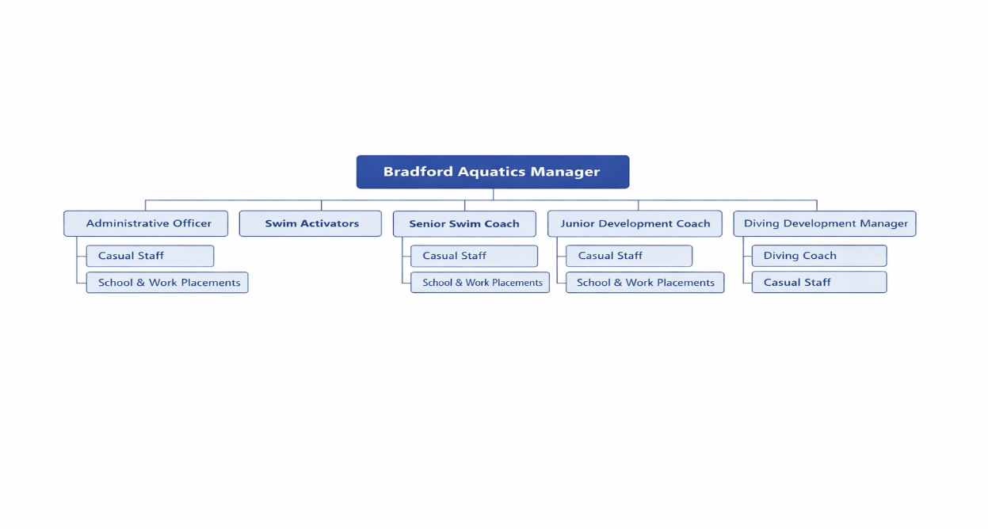

Person Specification
Knowledge / Skills / Experience required
Significant experience within an operational finance environment in an area directly relevant to the post to include: --

- Experience of policies and procedure including IT systems
- Proficient in the use of SAP
- Applied use of English in both written and spoken form with customers/public
- Extensive experience working in an office environment.

Sucessful candidate will be required to:-
- Willing and able to attend / participate in appropriate in-house / external courses which could be outside normal working hours.
- Knowledge and experience in a variety of IT programmes including the use of spreadsheets, and word processing
- Candidates should indicate an acceptance of and commitment to the principles underlying the Council’s Equal Rights policies and practices.
- They should be able to display a positive approach to achieving practical solutions to equality and diversity.
- They should demonstrate an awareness of fairness, equality and diversity issues in relation to their chosen area of work.
- Able to prioritise tasks.
- Ability to work well as part of a team.
- Ability to deal with difficult customers in a calm and professional manner.
- To be able to work as a good team player, good communicator at all levels.
- Be able to work in line with systems and procedures Work to deadlines set by the Bradford Aquatics Manager.
- Be able to work on own initiative.
- Good telephone manner.
- Good numeracy and literacy skills.

Key benchmarked competencies, traits and motives required to successfully deliver the role These will support recruitment, succession planning, development and performance management |  | Essential
Health and Safety | Uses knowledge of Health, Safety policies, procedures and regulations including risks in own area of work | x
IT Packages | Uses a range of complex IT packages relating to area of work | x
Service Improvement | Ability to adopt a process of continual improvement and suggest ways of working more efficient and effectively to improve service delivery | x
Continued professional Improvement | Carries out a variety of working practices, applies complex regulations, rules, procedures and processes across a technical /specialist area | x
Communication | Knows and understands how to use, interpret, handle and communicate, often complex and detailed information, and relay it to service users/stakeholders in writing and/or over the telephone / face to face. | x
Numeracy & Literacy | Demonstrates a high level of numeracy, literacy and accuracy across a range of activities | x
Relevant Professional Qualification | NVQ Level 3 in Business Administration or Equivalent demonstrable experience in finance and administration experience. | x
Carries out performance management | Covers the employees’ capacity to manage their workload and carry out a number of specific tasks accurately and to a high standard. | x
Communicates Effectively | Covers a range of spoken and written communication skills required as a regular feature of the job. This includes exchanging information/building relationships, giving advice and guidance, counselling, negotiating and persuading and handling private, confidential and sensitive information. | x
Carries Out Effective Decision Making | Covers a range of thinking skills required for taking initiative and independent actions within the scope of the job. This includes planning and organising, self-effectiveness and any requirements to quality check work. | x
Undertakes Structured Problem-Solving Activity | Covers a full range of analytical skills required for gathering, collating and analysing the facts needed to solve problems. This includes creative and critical thinking, developing practical solutions, applying problem solving strategies and managing interpersonal relationships. | x
Operates with Dignity and Respect | Covers treating everyone with respect and dignity, maintains impartiality/fairness with all people, is aware of the barriers people face. | x
Practices Appropriate Leadership | Our managers motivate their staff to exceed expectations through raising their awareness of goals and moving them beyond self-interest for the sake of the team or service. They consider serving the District in all that they do. | x
Operates with Strategic Awareness | Our managers work with corporate priorities and policies in a joined up way with others, internally and externally. Works democratically, transparently and accountably.
Delivering Successful Performance | Our managers monitor performance of services, teams & individuals against targets & celebrate great performance. They promote the District’s vision & work to achieve Council’s values & agreed outcomes.
Applying Project and Programme Management | Our manager’s work to ensure that outcomes and objectives are achieved within desired timescales, make best use of resources and take a positive approach to contingency planning
Developing High Performing People and Teams | Our managers coach individuals and teams to achieve their potential and take responsibility for continuous improvement. They champion the Council’s values and goals.

Applicants with disabilities are only required to meet the essential special knowledge requirements (clearly marked)
Due to the Governments Fluency in English Duty for posts where employees speak directly to members of the public the postholder is required to meet the Lower threshold level.
You should be able to demonstrate that you can use a wide range of simple words and a standard English sentence structure to express and maintain a flowing conversation even though you pause to think of the correct words with the ability to express and make yourself understood (this will also be tested during the interview).

Completed by: | Lynda Devanny | Date: | 05.06.26
Quality checked: |  | Date:

