
City of Bradford Metropolitan District Council Job Profile
Reference Number | TO BE COMPLETED BY JEGS / HR
Role Title | Specialist Practitioner (Physical Needs)
Directorate | Children’s Services
Service Area | Specialist Teaching and Support Services (STaSS) – Childrens Sensory and Physical Needs Service
Reports to | Physical Needs Team Lead

Role Purpose (maximum of 3 points, with no sub bullet points)
The Specialist Practitioner will work under an agreed system of management and supervision to support the work of the Specialist Teachers within the Physical Needs Team, to deliver a specialist service to SEND children with Physical Needs, their families, setting and schools.
To provide specialist support advice and training as part of a team and independently with families and teachers in homes, settings and schools.
To monitor, assess and review children’s progress using specialist assessment tools.

Duties and Responsibilities (maximum of 15 points, with no sub bullet points)
- To work on a peripatetic basis using professional judgement and initiative to analyse and interpret complex information or situations in order to develop and support provision for SEND children with physical needs.

- To manage a specific area of knowledge / expertise within the team, to be responsible for reseaching, sourcing, purchasing and maintaining specialist resources.

- To independently carry out specific assessments in relation to specialist area to determine child needs and to support planning and target setting.

- Independently plan and deliver teaching sessions to individuals and or groups of children as part of an agreed support package to specific settings / schools or the home.

- Independently plan and deliver specialist training to families, settings / schools and other professionals as part of agreed support package.

- To understand, convey and embed high aspirations for children’s achievement through clear target setting and focused interventions.

- To independently assess, monitor and review children’s progress and to also support Specialist Teachers to carry of specific assessments to determine a child’s needs and to support planning and target setting.

- To model and mentor appropriate interventions to teachers and support staff within various settings.

- To personally adhere to, and at all times act within Child Protection policies and procedures. To comply with and uphold all policiies, procedures, guidelines and codes of practice as laid down by the Council, Children’s Services and the Bradford Safeguarding Board especially equal rights, health and safety and safeguarding reporting any concerns about individual children’s welfare to the named person and contributing to reviews as required.

- Expected to exercise a significant degree of initiative and personal responsibility in managing time, prioritising and carrying out duties.

- A commitment to supporting children and families through transitions between phases of education.

- To keep up to date records of support provided to schools using ICT and be able to produce fluent, concise and accurate reports using ICT including contribution to statutory assessments and reviews as required.

- A commitment to working in partnership with other professionals and families following the principles of informed choice.

- To maintain confidentiality in relation to information about children and their families

- To undertake all duties commensurate to the nature and level of the post at initial place of work, or at any other venue within STaSS.

Dimensions of role (direct or indirect as applicable) e.g. total number of staff managed, total budget, total scope of role
The role involves holding a caseload of children overseen by a specialist teacher completing the duties and responsibilities described above, reporting to the team lead for physical needs. Specific responsibility for an agreed area within the physical needs team.

The specialist practitioner will not have any staff reporting to them.

This role is within the current budget of the service.

Structure Chart (showing direct reports)
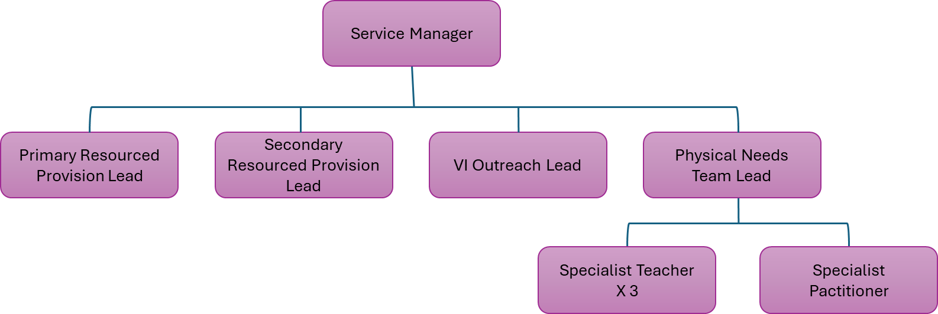

Person Specification
Knowledge / Skills / Experience required
Detailed and current knowledge of Safeguarding and the Prevent agenda and the ability to advise and respond quickly and appropriately in line with local and national legislation and advice.

Able to deal with internal and external customers both face to face, over the telephone and by email.

Effective communication and engagement with children, young people and their families to
- build trust and establish relationships
- Listening, building empathy and using clear language appropriate to age, ability, culture amd personality
- Summarising, explaining options, consulting and involving children and young people amd carers and colleagues in decisions and courses of action

Integrated working – Working with others in the children and young peoples workforce to put the child at the heart of decision making, offering help at the earliest point
- Communicating well, sharing appropriate, succinct, objective information and analysis to aid joint decision making
- Being proactive, persistent and prepared to challenge and be challenged
- Knowing your responsibilities and other roles and joint procedures

Awareness of special education needs and the graduated approach.

Knowledge of effective teaching and learning practices in a variety of settings, working with children who have physical needs.

Working within GDPR, Data Protection rules and the council’s confidentiality requirements when dealing with sensitive information, maintaining records / documents securely

Experience of supporting effective play opportunities, and teaching and learning for individual children with physical needs in various settings

Experience of delivering training, advice, support or outreach work in the field of SEND / or complex health needs to support children with physical needs

Experience of using IT Systems to maintain records and documents

Knowledge and understanding of Manual handling principles and experience of the practical application of these or a willingness to train in this area

Must be able to perform all duties and tasks with reasonable adjustments, where appropriate, in accordance with the Equality Act 2010 in relation to Disability Provisions

Must be able to work within the requirements of the Councils Flexible Working Policy

The post holder is required to have a useable car available at all times or as advised by the line manager. The post is designated Casual Class 1 Car User status for the better performance of their duties for which the HMRC rate is payable

Key benchmarked competencies, traits and motives required to successfully deliver the role These will support recruitment, succession planning, development and performance management |  | Essential
Health and Safety | Understands and uses knowledge of Health and Safety policies, procedures and regulations including risks in own area of work and or across other areas of work including relevant legislation | X
IT Packages | Uses a range of complex IT packages relating to area of work | X
Service Improvement | Ability to adopt a process of continual improvement and suggest ways of working more efficient and effectively to improve service delivery | X
Continued professional Improvement | Carries out a variety of working practices, applies complex regulations, rules, procedures and processes across a technical /specialist area | X
Communication | Knows and understands how to use, interpret, handle and communicate, often complex and detailed information, and relay it to service users/stakeholders in writing and/or over the telephone / face to face. | X
Numeracy & Literacy | Demonstrates a high level of numeracy, literacy and accuracy across a range of activities  GCSEs in English and Maths Grade A-C, or equivalent | X
Relevant Professional Qualification | NVQ Level 3 or equivalent qualification in early education, early childhood development, SEND and /or complex health and disabilities OR extensive experience in a relevant field and can demonstrate the necessary skills abilities, knowledge and understanding at this level | X
Carries out performance management | Covers the employees’ capacity to manage their workload and carry out a number of specific tasks accurately and to a high standard. | X
Communicates Effectively | Covers a range of spoken and written communication skills required as a regular feature of the role. This includes exchanging information/building relationships, giving advice and guidance, counselling, negotiating and persuading and handling private, confidential and sensitive information. | X
Carries Out Effective Decision Making | Covers a range of thinking skills required for taking initiative and independent actions within the scope of the role. This includes planning and organising, self-effectiveness and any requirements to quality check work. | X
Undertakes Structured Problem-Solving Activity | Covers a full range of analytical skills required for gathering, collating and analysing the facts needed to solve problems. This includes creative and critical thinking, developing practical solutions, applying problem solving strategies and managing interpersonal relationships. | X
Operates with Dignity and Respect | Covers treating everyone with respect and dignity, maintains impartiality/fairness with all people, is aware of the barriers people face. | X
Practices Appropriate Leadership | Our managers motivate their staff to exceed expectations through raising their awareness of goals and moving them beyond self-interest for the sake of the team or service. They consider serving the District in all that they do.
Operates with Strategic Awareness | Our managers work with corporate priorities and policies in a joined up way with others, internally and externally. Works democratically, transparently and accountably.
Delivering Successful Performance | Our managers monitor performance of services, teams & individuals against targets & celebrate great performance. They promote the District’s vision & work to achieve Council’s values & agreed outcomes.
Applying Project and Programme Management | Our manager’s work to ensure that outcomes and objectives are achieved within desired timescales, make best use of resources and take a positive approach to contingency planning
Developing High Performing People and Teams | Our managers coach individuals and teams to achieve their potential and take responsibility for continuous improvement. They champion the Council’s values and goals.

Applicants with disabilities are only required to meet the essential special knowledge requirements (clearly marked)
Due to the Governments Fluency in English Duty for posts where employees speak directly to members of the public the postholder is required to meet the Lower threshold level.
You should be able to demonstrate that you can use a wide range of simple words and a standard English sentence structure to express and maintain a flowing conversation even though you pause to think of the correct words with the ability to express and make yourself understood (this will also be tested during the interview).

Completed by: | Caroline Plum – Business Manager | Date: | 19 June 2025
Quality checked: |  | Date:

