CITY OF BRADFORD METROPOLITAN DISTRICT COUNCIL
JOB PROFILE

DEPARTMENT: Regeneration | SERVICE GROUP: Planning, Transportation & Highways
POST TITLE: Planning Assistant | REPORTS TO: Infrastructure & Local Plan Implementation Team Leader
GRADE: Band 7 to 8 |  | SAP POSITION NUMBER : 11007699

The following information is furnished to help Council staff and those people considering joining the City of Bradford Metropolitan District Council to understand and appreciate the general work content of their post and the role they are to play in the organisation. The duties and responsibilities highlighted in this Job Profile are indicative and may vary over time. Post holders are expected to undertake other duties and responsibilities relevant to the nature, level and scope of the post and the grade has been established on this basis.

As a candidate you will be expected to demonstrate your ability to meet the special knowledge, experience and qualifications required for the role by providing evidence in the application form for the purpose of shortlisting. Applicants with disabilities are only required to meet the essential special knowledge requirements shown by a cross in the end column of this section.

The employee competencies are the minimum standard of behaviour expected by the Council of all its employees and the management competencies outlined are those relevant for a post operating at this level within our organisation.

Both sets of competencies will be used at interview stage and will not be used for short listing purposes.

Key Purpose of Post:
- To contribute to the preparation of a range of planning policy documents contributing to the Council maintaining an up to date and effective Local Plan for the district, which provides a sustainable development strategy which addresses the districts priorities and meets statutory requirements.

- To contribute to the implementation of the Local plan through providing policy advice and guidance, preparation and publication of data and information as required and support the implementation and delivery of key development projects and programmes in line with the Local Plan.

- To help maintain effective monitoring performance information requirements, maintaining appropriate data and collection systems and providing information by GIS, digital and electronic means.

Main Responsibilities of Post:
- Preparing Local Plan Documents (including neighbourhood plans and Supplementary Planning Documents) and other planning information in delivery of the Local Development Scheme and other agreed priorities.

- Understanding fully the policies and proposals of the Local Plan and to explain and interpret them to colleagues, third parties and the general public and in so doing to have regard to the Council's wider policies and priorities.

- Understanding Local Plan, corporate, regional and Government performance information requirements, maintaining appropriate data and collection systems and providing information in accordance with timeframes.

- Liaising with relevant Services and Departments on GIS, digital and electronic management and display of information relevant to the Local Plan.

- Appraising development proposals against the Local Plan and other relevant planning considerations and provision of appropriate recommendations to colleagues and senior managers.

- To secure planning obligations in furtherance of Council Policy in accordance with Government guidance;

- Securing a high standard of building and landscape design appropriate to good practice in sustainability design guidance, in particular with regard to central areas and public realm;

- Participating in corporate regeneration activities;

- Working with other Council Services, the Bradford District Partnership and external partners to ensure effective integration of the spatial objectives of the District plan and other district wide strategies with the Local Plan.

- Undertaking strategic planning activities in support of the Local Plan, including discharge of the Council’s Duty to Cooperate in preparation of the Local Plan as well as preparation of Local Plan documents prepared by other Councils, and support spatial planning work within Leeds City Region and any subsequent body under a devolution agreement.

- Representing the Council at public meetings, public inquiries/Examination in Public and other events as required;

- Conveying factual information to the Press Office and direct to Press as required;

- Monitoring national planning policy, guidance and legislation;

- Carrying out the content of the work area and such other matters which are the responsibility of the Section as may be required from time to time.

Structure:
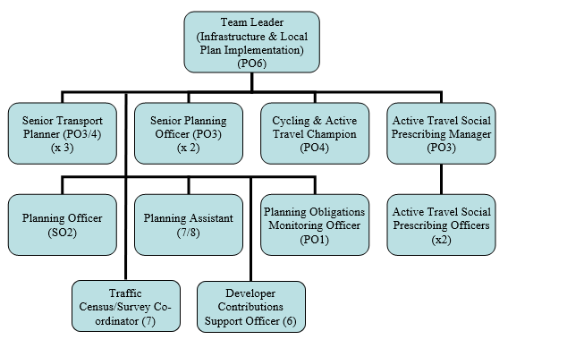

Special Knowledge Requirement. Will be used for shortlisting.
 | Essential
Applicants with disabilities are only required to meet the essential special knowledge requirements shown by a cross in the end column.
Uses knowledge of Health, Safety and Environmental policies, procedures and regulations including risks in own area of  work | X
Uses a range of complex IT packages relating to area of work | X
Ability to adopt a process of continual improvement and suggest ways of  working more efficient and effectively to improve service delivery. | X
Knows and understands how to use, interpret, handle and communicate  information | X
Able to draft complex, non-standard letters, emails and reports in a logical and accurate manner.
Using creative professional ability and judgement to seek and secure effective and realistic resolution of matters in the work area and in support of other work areas.
Able to use appropriate and suitable consultation and engagement techniques as relevant to the work area and its customers.

Relevant experience requirement: Will be used for shortlisting
Experience of working in a planning or related environment. Preferable but not required.
Progression dependent on further qualifications and experience as set out in career grade (see end of JP)
Relevant professional qualifications requirement: Will be used for shortlisting
Educated to degree level preferably in a planning or related subject
Progression dependent on further qualifications and experience as set out in career grade
Core Employee competencies to be used at the interview stage.
Carries Out Performance Management
Covers the employee’s capacity to manage their workload and carry out a number of specific tasks accurately and to a high standard.
Communicates Effectively
Covers a range of spoken and written communication skills required as a regular feature of the job. It includes exchanging information/building relationships; giving advice and guidance; counselling, negotiating and persuading and handling private, confidential and sensitive information.
Carries Out Effective Decision Making
Covers a range of thinking skills required for taking initiative and independent actions within the scope of the job. It includes planning and organising, self effectiveness and any requirements to quality check work.
Undertakes Structured Problem Solving Activity
Covers a range of analytical skills required for gathering, collating and analysing the facts needed to solve problems. It includes creative and critical thinking; developing practical solutions; applying problem solving strategies and managing interpersonal relationships.
Operates with Dignity and Respect

Covers promoting equality, treating all people fairly and with dignity and respect, maintains impartiality/fairness with all people, is aware of the barriers people face.
Working Conditions:
Must be able to perform all duties and tasks with reasonable adjustment, where appropriate, in accordance with the Equality Act 2010 in relation to Disability Provisions.
Will be required occasionally to undertake work outside normal office working hours by agreement in accordance with the Council's Conditions of Service and contract of
employment.
This post is a classed as a ‘Mobile and Flexible Worker’ position for which a Mobile and
Flexible Working Agreement will be mandated. The post holder may be required to work
from a number of operational bases within the Bradford District.
Special Conditions:
You will be informed if there is a requirement for the post to have recruitment checks
such as DBS, Warner Process.
Compiled by:  A Marshall  Date: 16 /1/23 | Grade Assessment Date: | Post Grade:  Band 7 - 8

