CITY OF BRADFORD METROPOLITAN DISTRICT COUNCIL
JOB PROFILE

DEPARTMENT: Place | SERVICE GROUP: Economy & Development Service
POST TITLE: International Business Officer (Northern Region) | REPORTS TO: Project Manager (Innovate UK Business Growth)
GRADE: SO1 |  | SAP POSITION NUMBER : 11007136

The following information is furnished to help Council staff and those people considering joining the City of Bradford Metropolitan District Council to understand and appreciate the general work content of their post and the role they are to play in the organisation. The duties and responsibilities highlighted in this Job Profile are indicative and may vary over time. Post holders are expected to undertake other duties and responsibilities relevant to the nature, level and scope of the post and the grade has been established on this basis.
For posts where employees speak directly to members of the Public the post holder is required to demonstrate their ability to speak fluently in English.

As a candidate you will be expected to demonstrate your ability to meet the special knowledge, experience and qualifications required for the role by providing evidence in the application form for the purpose of shortlisting. Applicants with disabilities are only required to meet the essential special knowledge requirements shown by a cross in the end column of this section.

The employee competencies are the minimum standard of behaviour expected by the Council of all its employees and the management competencies outlined are those relevant for a post operating at this level within our organisation.

Both sets of competencies will be used at interview stage and will not be used for short listing purposes.

Key Purpose of Post:
To assist innovation-led companies in the growth and development of their business in international markets, by facilitating contacts between local firms and potential partners overseas (the internationalisation service), as part of the Innovate UK Business Growth service offer;

To provide information and advice to Innovate UK Business Growth clients, especially innovation-led small and medium sized businesses, on matters relating to innovation and international business which may affect them, in particular around regulatory issues, standards, market access and market research.

Main Responsibilities of Post:
1.To identify – from enquiries, meetings, referrals or events – innovation-led regional companies with an ambition or potential to grow their business through international collaboration; then to carry out further analysis of the companies’ current business and future growth ambitions by means of a business review and to agree a plan of action alongside the Project Manager or Senior Manager;

2. To prepare, in conjunction with the companies’ representatives, cooperation profiles which meet the required format and quality (as determined by the European Innovation Council and SMEs Executive Agency (EISMEA)) and to disseminate these to other members of the Enterprise Europe Network (EEN) via the cooperation database run by EISMEA; then, to assist regional companies in following up any expressions of interest (EOIs) received and in converting these EOIs into partnership agreements;

3. To process responses from local firms requiring more details of business cooperation requests received from firms overseas via other EEN members and disseminated via the Innovate UK Business Growth website; then, to help regional firms follow up these opportunities and develop contacts / agreements with potential partners abroad;

4. To encourage regional firms to take part in such company missions, business-to-business brokerage events or Global Business Innovation Programmes as may be organised by Innovate UK Business Growth or the EEN in other regions or countries; then, to help regional firms in such participation, for example by carrying out business reviews and preparing cooperation profiles, or by running pre-mission briefings;

5. To help organise or co-organise brokerage events or inward missions to the northern region of England, where appropriate. This will include, with assistance of the Project Support Officer, the identification and booking of appropriate venues, promotion of the event, organisation of business-to-business meetings and all follow-up and evaluation;

6. To provide information and advice to Innovate UK Business Growth clients on matters relating to international business, and in particular on relevant national legislation and standards in other countries covered by the EEN, appropriate market information, market access etc;

7. To help organise events in the region, to inform local companies about matters relating to innovation, business growth, funding or programmes with relevance to business;

8. To help produce regional content for the Innovate UK Business Growth website and newsletter, including success stories of companies assisted;

9. To maintain accurate records of all interactions with regional companies in the customer relationship management system of the Innovate UK Business Growth and to record all partnership agreements and/or assistance resulting in a significant impact.

10 To assist in the monitoring and evaluation of the Innovate UK Business Growth services and their impact;

11. To assist in the promotion of Innovate UK Business Growth and its services in general, for example via attendance at, or organisation of, events and exhibitions;

12. To signpost companies to other support services and organisations which may be appropriate to their business, including those of Bradford Council, Innovate UK, Department for International Trade, Growth Hubs and other local, regional and national business support services;

13. To take part in any training or professional development activity which may be identified as appropriate through staff appraisals and to participate actively in any team meetings or training workshops as may be organised at local, regional, national or European level;

14. To assist with other aspects of the section’s work, as directed by the Senior Manager, Innovate UK Business Growth or the Economy & Development Programme Manager of Bradford Council.

Structure: *
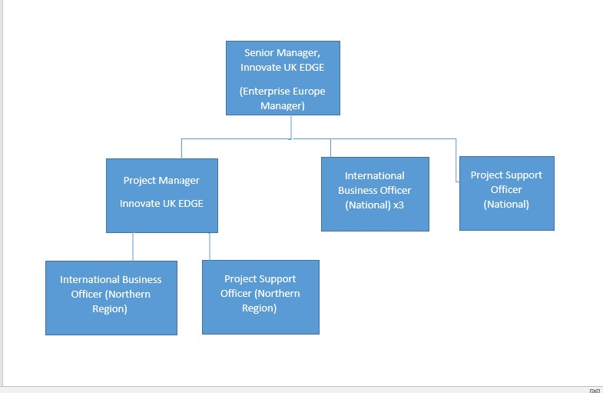

*Subject to on-going Departmental Restructure

Special Knowledge Requirement: Will be used for shortlisting.

Applicants with disabilities are only required to meet the essential special knowledge requirements shown by a cross in the end column.
 | Essential
Due to the Government’s Fluency in English for posts where employees speak directly to members of the public the postholder is required to meet the Advanced threshold level which will be applied where the postholder requires a greater level of sensitive interaction with the public.  You must be able to demonstrate that you can express yourself fluently and spontaneously (this will also be tested during the interview). | X
Has established the needs of business customers, using appropriate questioning techniques and listening skills and used them to implement solutions | X
Has demonstrated an ability to assimilate and apply complex and detailed information and relay it to customers | X
Has an understanding of the demands of operating in international markets and the impact of different regulatory regimes on businesses | X
Has demonstrated an ability to sell services to external and internal customers and displayed a commitment to providing a quality service | X
Has demonstrated an ability to organise events, workshops and briefings | X
Understands the economic issues affecting the region and the key drivers for the future, as well as the local, regional and national business support landscape | X
Has implemented, maintained and managed accurate information retention systems, both manual and computerised | X
Has been involved with consultation, particularly with businesses to seek feedback, and with service evaluation | X
Has demonstrated an ability to write clearly and concisely in English, for example company action plans, meeting notes and reports, promotional materials and/or news items | X
Has shown a commitment to service and personal development, through training and other development activity

Relevant experience requirement: Will be used for shortlisting

The applicant is required to provide evidence of having previously spoken fluently to members of the public in order to meet the advanced threshold level outlined under Special Knowledge above.
Demonstrable experience of the delivery of information or advisory services to businesses and / or business support organisations
Relevant professional qualifications requirement: Will be used for shortlisting

Has a degree, or equivalent qualification at RQF level 6 ie BTEC advanced professional
award, certificate or diploma level 6, in an appropriate discipline including
business studies, international business studies, languages with business or European
studies.
Or: has demonstrable experience in the delivery of business support and advice to small & medium sized enterprises
Knowledge of other European languages would be an advantage
Core Employee competencies at manager level to be used at the interview stage.

Carries Out Performance Management – covers the employees capacity to manage
their workload and carry out a number of specific tasks accurately and at a high standard.
Communicates Effectively - covers a range of spoken and written communication skills required as a regular feature of the job. It includes exchanging information/building relationships, giving advice and guidance, counselling, negotiating and persuading and handling private, confidential and sensitive information.
Carries Out Effective Decision Making - covers a range of thinking skills required for taking initiative and independent actions within the scope of the job. It includes planning and organising, self effectiveness and any requirements to quality check work.
Undertakes Structured Problem Solving Activity - covers a range of analytical skills required for gathering, collating and analysing the facts needed to solve problems. It includes creative and critical thinking, developing practical solutions, applying problem solving strategies and managing interpersonal relationships.
Operates with Dignity and Respect - covers treating everyone with respect and dignity, maintains impartiality/fairness with all people, is aware of the barriers people face.

Management Competencies: to be used at the interview stage.

Operates with Strategic Awareness Our managers work with corporate priorities and policies in a joined up way with others, internally and externally. Works democratically, transparently and accountably.
Practices Appropriate Leadership Our managers motivate their staff to exceed expectations through raising their awareness of goals and moving them beyond self interest for the sake of the team or service. They consider serving the District in all that they do.
Delivering Successful Performance Our managers monitor performance of services, teams & individuals against targets & celebrate great performance. They promote the District’s vision & work to achieve Council’s values & agreed outcomes.
Applying Project and Programme Management Our manager’s work to ensure that outcomes and objectives are achieved within desired timescales, make best use of resources and take a positive approach to contingency planning.
Developing High Performing People and Teams Our managers coach individuals and teams to achieve their potential and take responsibility for continuous improvement. They champion the Council’s values and goals.
Working Conditions:

Must be able to perform all duties and tasks with reasonable adjustment, where appropriate, in accordance with the Equality Act 2010 in relation to Disability Provisions.
May be required to work very occasionally outside normal working hours, for e.g. evening
events

Special Conditions:
You will be informed outline if there is a requirement for the post to have recruitment checks
such as DBS, Warner Process.
Compiled by: JL  Date: 7/1//14  Update: 14/3/16 & 13/4/22 & 15/10/24 (DH) | Grade Assessment Date:  06/01/15 | Post Grade:  SO1

