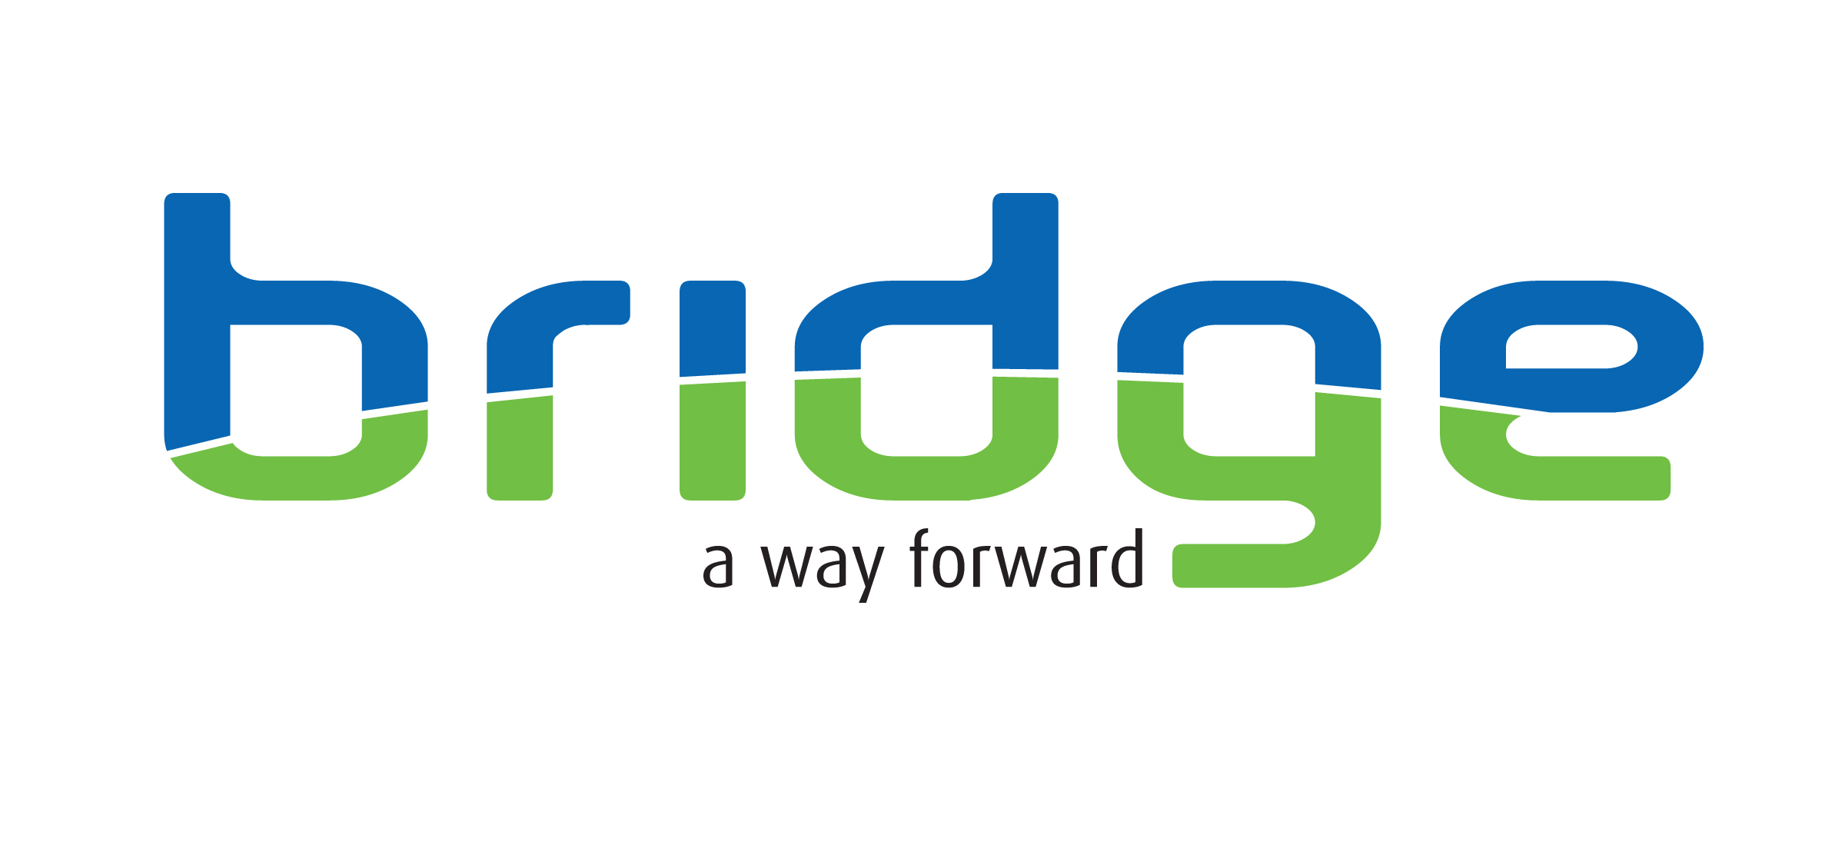

Title of post: Support Coordinator – Multiple posts available

Location: New Cross Street, Bradford, BD5 8BT (please note, you will be supporting women into temporary accommodation, therefore you will work across our managed properties).

Responsible to: Team Manager

Grade/Job £24,050 - £28,000
Evaluation Level:

Hours of Work: 37.5 hours FTE Flexible shift patterns which may include evening and weekend work
Note: The post holder is expected to flexibly deliver the service to meet the needs of the client

Special Provisions: The post is subject to enhanced disclosure and barring check, the results of which would not necessarily exclude applicants from consideration.

This post requires full driving licence and use of a vehicle.

About the service
Working in partnership, Waythrough and the Bridge Project, are providing temporary accommodation on behalf of Bradford Metropolitan District Council as part of their Bradford Temporary Accommodation Service. Our service supports women who present as homeless to the Local Authority.

About the role
As a Support Coordinator with Waythrough or Bridge you will support women around their housing needs, including: Applying for housing, multi-agency working, signposting, completing risk assessments and more. Roles are based in Bradford and Keighley and involve supporting women who were homeless and have a history or risk of offending now living in temporary accommodation. You will provide flexible support, in groups or one to one along with housing management support within our managed properties.

At Bridge and at Waythrough, we believe in providing comprehensive training to ensure that our team members have the skills and knowledge necessary to fulfil their roles. So, if you have a passion for making a positive impact on people's lives but lack some of the necessary skills, we encourage you to apply.

About you...
- Experience of supporting vulnerable people is essential.
- Knowledge of the causes of alcohol/substance misuse, mental health and homelessness.
- Experience of support planning and risk assessing is desirable.
- Knowledge of housing options available and relevant legislation is desirable.
- A full UK driving licence and access to a vehicle, is essential for this role.

Interviews will take place weekend commencing 24/03/2025 at Discovery House, 133 Barkerend Road, Bradford, BD3 9AU.

Main Duties and Responsibilities
- Support clients to live independently in their own accommodation and progress towards sustained independent housing.
- Manage a caseload of service users as allocated by the Team Manager and complete high quality and comprehensive needs assessments and risk assessments for those service users.
- Develop comprehensive support / risk plans to identify how individual service user needs will be met in order to help each service user live independently within the community and achieve sustained outcomes.
- Review individual support / risk plans within appropriate timescales and no later than once every three months.
- Deliver housing support and recovery focused sessions one to one and in groups, which may include training on housing options, tenancy ready and other support programmes.
- Record case notes, input information onto the database promptly and maintain other relevant Management Information Systems as required in order to ensure effective case management and assist monitoring and evaluation of service delivery.
- Liaise with statutory and other appropriate agencies / network/ forums to contribute to the development of a comprehensive needs and risk assessment for each client and general service provision.
- Work as part of a team providing cross provision/ service support where reasonable and attending regular team meetings.

General Accountabilities
- Undertake continuing professional development including participating in performance reviews and attending training as/when required.
- Ensure that vulnerable people are protected through knowledge and application of Adult and Child Safeguarding Procedures.
- Work in accordance with all relevant legislation, policies & procedures and guidelines – both internal and external. This includes the service’s clinical governance framework.
- Maintain accurate and up to date records and reports and provide written and verbal reports as required.
- Keep abreast of policy and professional development within your area of professional expertise.
- Work flexibly across operational sites and within an agreed number of hours to maintain appropriate service provision. This will include evening and weekend working.
- Promote, adhere to and live our workplace values of being honest, committed and inventive.
- Apply reflective practice skills to evaluate work carried out.
- Contribute to training needs of other workers in this field.
- Fully participate in all of Bridge’s supervision and support structures.
- Recognise one’s own personal and professional limitations and boundaries and discuss these at supervision and related support meetings.
- Undertake any additional duties, as directed by management which are commensurate with this post.

Job title: Support Coordinator
Attributes | Essential criteria | Desirable criteria | How Identified
Qualifications | NVQ Level 3 in Health & Social Care (or above or equivalent) or willing to work towards this in post. |  | Application Form  Interview
Experience | - Knowledge of welfare benefits system and relevant legislation.  - Knowledge of housing options available and relevant legislation.  - Knowledge of Safeguarding practice and relevant legislation.  - Experience of multi-agency working with a wide range of external partners.  - Experience of supporting vulnerable people, including support planning and risk management.  - Experience of, and ability to, manage a case load of service users, supporting them to achieve greater independence.  - Ability to communicate well and maintain accurate records within appropriate case management systems. | - Knowledge of the Criminal Justice System, including MAPPA offenders and associated processes. | Application Form  Interview
Skills | Proficient in Microsoft Office programmes |  | Application Form  Interview

Key Behaviours | Works Proactively  Demonstrates initiative, thinks ahead, and takes prompt action to solve problems; completes tasks, overcomes obstacles and seize opportunities.
Key Behaviours | Leads Change & Improves Performance  Responds quickly and positively to change, seeking to continuously improve performance by learning quickly from our mistakes, celebrating our successes, and constantly developing our people and processes.
Key Behaviours | Demonstrates Creativity & Innovation  Applies creative and lateral thinking to organisational issues; challenges the status quo and introduces new ideas, methods and processes.
Key Behaviours | Client & Customer Focused  Focuses on and understand the needs of internal and external service users, members and other stakeholders and strives to deliver a prompt, effective and personalised service. (For ‘service users’, please also read members, stakeholders, and audiences).
Key Behaviours | Influences Others & Communicates Effectively  Positively influences others and where appropriate persuades them to change their views, intentions or actions. Listens closely and communicates clearly both verbally and in writing.
Key Behaviours | Applies & Shares Expert Knowledge  Demonstrates the specialist knowledge and technical requirements of the job. Applies skills and experience to perform the job effectively, completes work to a high standard and shares knowledge across the organisation.
Key Behaviours | Works Collaboratively with Others  Works collaboratively with others for the good of the business; builds a network of good relationships and develops a thorough understanding of the organisation and the wider sector.
Key Behaviours | Values & Respects Others  Respects other individuals; listens and takes into account different opinions, feelings and motivations; is trustworthy and acts with integrity; responds and acts constructively towards others.

