
City of Bradford Metropolitian District Council Job Profile
Reference Number | 11000186
Role Title | Marketing and Communications Manager
Directorate | Chief Executives Office
Service Area | West Yorkshire Pension Fund
Reports to | Head of Communications and Digital

Role Purpose (maximum of 3 points, with no sub bullet points)
To lead and manage the strategic marketing and communication activities of West Yorkshire Pension Fund and the administration shared service. As a senior member of the communications and digital function, the Marketing and Communications Manager will act as brand guardian, lead integrated communication strategies, and produce high-quality, targeted content across all channels (digital, social media, print and events). The role plays a key part in enhancing stakeholder engagement, supporting corporate objectives, and maintaining brand trust across both internal and external audiences.
You will report on communications performance and insights directly to senior leadership, including the Managing Director and Chief Investment Officer, and play a central role in shaping the fund’s voice and public reputation.

Duties and Responsibilities (maximum of 15 points, with no sub bullet points)
- Strategic brand stewardship: Maintain and evolve the fund’s brand identity, ensuring strategic alignment and consistency across all stakeholder communications, while protecting brand integrity in high-visibility materials.
- Insight-driven communications: Develop and implement communication strategies informed by audience data, feedback, and wider sector intelligence, ensuring alignment with organisational goals and supporting the Managing Director, CIO and Senior Leadership Team (SLT) with timely insights and recommendations.
- Reporting and evaluation: Lead on reporting of communication and engagement activity, providing analysis of reach, effectiveness, and stakeholder sentiment to inform SLT decision-making and strategic planning.
- Content creation: Produce clear, accessible content across omni-channel platforms, including bulk communications (emails, newsletters), print publications, web content, and social media, maintaining high standards and adherence to Plain English principles suitably catered to the audience.
- Professional publications: Manage the production of professional, high-impact publications and statutory reports, ensuring accuracy, compliance, and accessibility.
- Campaign management: Plan and deliver integrated campaigns across B2B and B2C audiences, ensuring relevance to diverse stakeholder groups including scheme members, employers, recruitment spaces and partners across an omni-channel landscape.
- Internal engagement: Oversee internal communication strategies and platforms, supporting organisational cohesion, clarity of purpose, and employee engagement through effective messaging.
- Digital and UX oversight: Lead content strategy and delivery through the organisation’s web platforms and social media platforms, ensuring a strong user experience and brand consistency across digital interfaces.
- Multimedia development: Explore and lead the use of video, animation, and AI tools in content delivery, creating engaging media assets such as interviews and explainer content.
- Agency and supplier management: Oversee third-party relationships to deliver communication materials on time, on brand, and within budget.
- Policy and compliance: Develop and maintain communication policies in line with UK GDPR, accessibility, and good governance practices.

Dimensions of role (direct or indirect as applicable) e.g. total number of staff managed, total budget, total scope of role
Manage access to highly confidential, personal, financial, political and commercially sensitive information; to ensure compliance with appropriate legislation e.g. GDPR, FOI, Child Protection Act, etc (and any UK replacement). The unauthorised disclosure of which would prejudice the interests of the Council.
To lead production of communications and digital projects (with 1 direct report) delivering services to approx. 850 users across scheme employers and 500,000 members and across the shared service client base currently comprising of 3 LGPS funds and 24 Fire Authorities.

Structure Chart (showing direct reports)
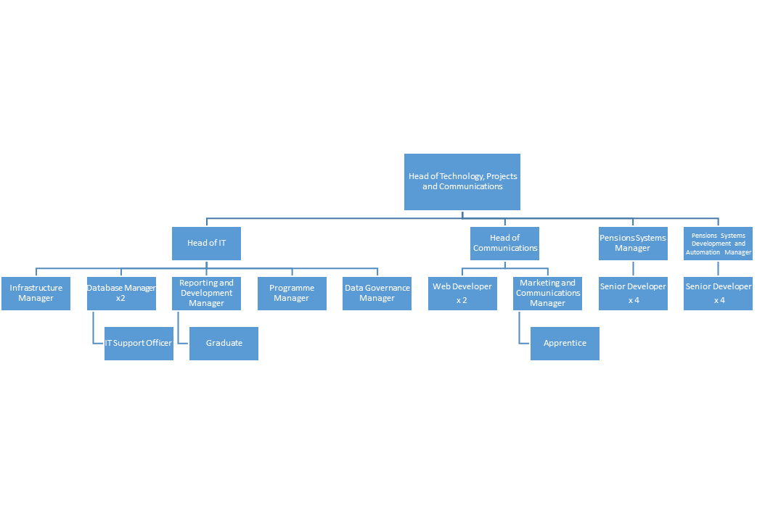

Person Specification
Knowledge / Skills / Experience required
Skills and competencies
- Strategic thinking: Ability to link communications with organisational priorities and governance requirements, with confidence presenting to or advising senior leadership.
- Plain English copywriting & editing: Strong ability to translate complex pensions and financial topics into clear, engaging language.
- Design & technical proficiency: Skilled in Adobe Creative Suite (indesign, Photoshop, Illustrator) and Microsoft Office, with solid working knowledge of CMS platforms, preferably Umbraco.
- Digital and UX awareness: Understanding of UX/UI principles to enhance online engagement and content effectiveness.
- Marcomms expertise:
  - Traditional Media: Experience in producing and placing content in print, radio, and other traditional outlets.
  - Digital Channels: Confident in social media strategy, SEO, online engagement and analytics.
  - Event Comms: Skilled in planning and executing communications for live and online events, including conferences, roadshows and briefings.
- Analytics & governance: Ability to interpret engagement data, draw actionable insights, and maintain governance and compliance.
- Leadership & influence: A collaborative, confident communicator who can lead initiatives, influence stakeholders, and foster a culture of excellence.

Experience required
- Sector experience: 3 + years demonstrable experience in a senior marketing and communications role, ideally but not necessarily within the financial services or pensions sector.
- Portfolio: A strong portfolio showcasing integrated, brand-led communication across multiple platforms, with proven outcomes in stakeholder engagement.

Personal attributes
- Excellent communication and interpersonal skills, with credibility at senior levels.
- A strategic mindset with strong attention to detail and quality.
- Curious and forward-looking, with a proactive approach to innovation and sector developments.
- Resilient, organised, and able to lead or contribute effectively to cross-functional teams.

This role is a rare opportunity to shape the voice and engagement approach of a significant public sector fund. It will suit a senior communications professional who thrives on responsibility, collaboration with executive leaders, and delivering impact in a regulated, high-trust environment.

Key benchmarked competencies, traits and motives required to successfully deliver the role These will support recruitment, succession planning, development and performance management |  | Essential
Health and Safety | Uses knowledge of Health, Safety policies, procedures and regulations including risks in own area of work | X
IT Packages | Uses a range of complex IT packages relating to area of work | X
Service Improvement | Ability to adopt a process of continual improvement and suggest ways ofworking more efficient and effectively to improve service delivery | X
Continued professional Improvement | Carries out a variety of working practices, applies complex regulations, rules, procedures and processes across a technical /specialist area | X
Communication | Knows and understands how to use, interpret, handle and communicate, often complex and detailed information, and relay it to service users/stakeholders in writing and/or over the telephone / face to face. | X
Numeracy & Literacy | Demonstrates a high level of numeracy, literacy and accuracy across a range of activities | X
Relevant Professional Qualification | A degree in a relevant discipline | X
Carries out performance management | Covers the employees’ capacity to manage their workload and carry out a number of specific tasks accurately and to a high standard.
Communicates Effectively | Covers a range of spoken and written communication skills required as a regular feature of the job. It includes exchanging information/building relationships, giving advice and guidance, counselling, negotiating and persuading and handling private, confidential and sensitive information. | X
Carries Out Effective Decision Making | Covers a range of thinking skills required for taking initiative and independent actions within the scope of the job. It includes planning and organising, self-effectiveness and any requirements to quality check work. | X
Undertakes Structured Problem-Solving Activity | Covers a full range of analytical skills required for gathering, collating and analysing the facts needed to solve problems. It includes creative and critical thinking, developing practical solutions, applying problem solving strategies and managing interpersonal relationships. | X
Operates with Dignity and Respect | Covers treating everyone with respect and dignity, maintains impartiality/fairness with all people, is aware of the barriers people face. | X
Practices Appropriate Leadership | Our managers motivate their staff to exceed expectations through raising their awareness of goals and moving them beyond self-interest for the sake of the team or service. They consider serving the District in all that they do.
Operates with Strategic Awareness | Our managers work with corporate priorities and policies in a joined up way with others, internally and externally. Works democratically, transparently and accountably. | X
Delivering Successful Performance | Our managers monitor performance of services, teams & individuals against targets & celebrate great performance. They promote the District’s vision & work to achieve Council’s values & agreed outcomes. | X
Applying Project and Programme Management | Our manager’s work to ensure that outcomes and objectives are achieved within desired timescales, make best use of resources and take a positive approach to contingency planning | X
Developing High Performing People and Teams | Our managers coach individuals and teams to achieve their potential and take responsibility for continuous improvement. They champion the Council’s values and goals. | X

Applicants with disabilities are only required to meet the essential special knowledge requirements (clearly marked)
Due to the Governments Fluency in English Duty for posts where employees speak directly to members of the public the postholder is required to meet the Lower threshold level.
You should be able to demonstrate that you can use a wide range of simple words and a standard English sentence structure to express and maintain a flowing conversation even though you pause to think of the correct words with the ability to express and make yourself understood (this will also be tested during the interview).

Completed by: | Stuart Duncombe | Date: | October 2025
Quality checked: |  | Date:

