CITY OF BRADFORD METROPOLITAN DISTRICT COUNCIL
JOB PROFILE

JEGS 00120
DEPARTMENT: Place – Fleet & Transport Services | SERVICE GROUP: Hackney Carriage & Private Hire Licensing Service
POST TITLE: Business Support Officer | REPORTS TO: Team Leader - Customer & Business Support
GRADE: BAND 6 |  | SAP POSITION NUMBER:

The following information is furnished to help Council staff and those people considering joining the City of Bradford Metropolitan District Council to understand and appreciate the general work content of their post and the role they are to play in the organisation. The duties and responsibilities highlighted in this Job Profile are indicative and may vary over time. Post holders are expected to undertake other duties and responsibilities relevant to the nature, level and scope of the post and the grade has been established on this basis.

As a candidate you will be expected to demonstrate your ability to meet the special knowledge, experience and qualifications required for the role by providing evidence in the application form for the purpose of shortlisting. Applicants with disabilities are only required to meet the essential special knowledge requirements shown by a cross in the end column of this section.

The employee competencies are the minimum standard of behaviour expected by the Council of all its employees and the management competencies outlined are those relevant for a post operating at this level within our organisation.

Both sets of competencies will be used at interview stage and will not be used for short listing purposes.

Key Purpose of Post:
- To assist the Licensing Service in the provision of a flexible and proficient administrative service dealing with generic and service-specific duties.

- To provide prompt and effective information, advice and access to officers in other parts of the Council, members of the public, other public sector bodies and external agencies.

- To undertake duties in data inputting/updating of client information, tracking and monitoring cases, extracting of information from various sources for various reports and audiences (including for court). Document management, organising and co-ordinating diaries and rota’s, setting up and facilitating meetings, activities, events and contacts, co-ordinating diaries, minute taking, communicating with clients and professionals, ordering of equipment, goods and services and setting up new staff as part of facilitating the effective and efficient delivery of service

Main Responsibilities of Post:
To provide a wide range of administrative functions to officers and managers, to include:

- Provide support to the Licensing Service and ensure that all administrative tasks are done in compliance with various Legislative standards and departmental policies, procedures and regulations.

- Telephonist responsibility; taking and distributing messages, logging and scanning of post, dealing with internal and external customers over all mediums.

- Maintaining a range of information systems in line with service user guidelines and procedures.

- Interrogating information databases and inputting to forms/databases, completing enquiries as appropriate.

- Organise electronic and manual filing of documentation centrally and in a secure manner in readiness for circulation to those involved with a case or for submission to court by secure means or as authorised by the Enforcement Manager.

- Organise diaries and arrange meetings including booking venues, equipment and refreshments as required, schedule reminders for reports due for various meetings Prepare the Officer in advance and create and update distribution lists linked to meetings and communication. Produce rotas/schedules as required within a designated area, these could be for activities, events, meetings, staffing and attendance in court ensuring there is cover for times of absence or high demand

- Participating in any specialist groups, contributing to the resolution of issues and assisting in the development of new procedures and efficiencies to address new issues or operational methods.

- Maintaining and co-ordinating records as requested by service user managers.

- Organising diary management and appointments, arranging meetings, taking notes, writing up and circulating minutes and agendas where required.

- Collating information and communicating to relevant parties in preparation for meetings.

- Undertaking calculations as appropriate to service needs.

- To deal with and resolve requests for advice and help.

- Provide administrative support with specialist projects such as Operation Steerside, general administrative support for the Service

- Monitor and service Licensing email inbox

- Any other administrative duties as required by management

Structure:
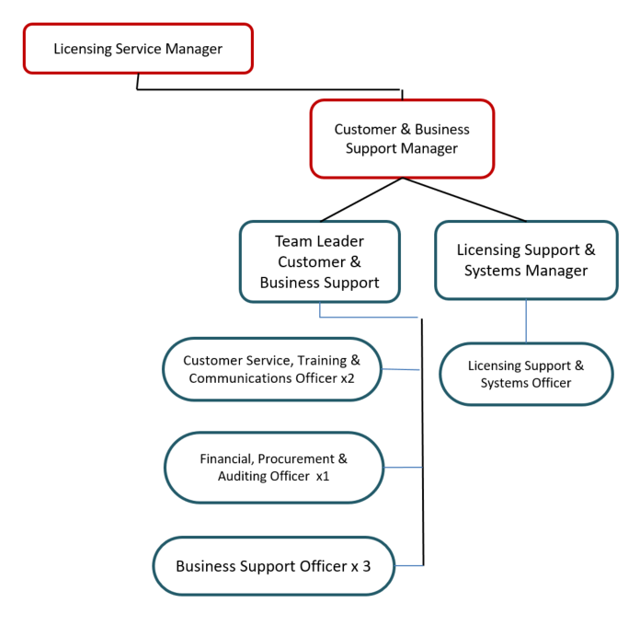

Special Knowledge Requirement. Will be used for shortlisting.
 | Essential
Applicants with disabilities are only required to meet the essential special knowledge requirements shown by a cross in the end column
Due to the Government’s Fluency in English for posts where employees speak directly to members of the public the postholder is required to meet the Advanced threshold level which will be applied where the postholder requires a greater level of sensitive interaction with the public.  You must be able to demonstrate that you can express yourself fluently and spontaneously (this will also be tested during the interview). | X
Uses knowledge of health, safety and environmental policies, procedures and regulations including risks in own area of work | X
Uses a range of complex IT packages across various areas of work. | X
Ability to adopt a process of continual improvement and suggest ways of working more efficiently and effectively to improve service delivery. | X
Knows and understands how to use, interpret, handle and communicate information and data | X
Able to put together written communication as well as compile reports and other documentation to a high standard with excellent attention to detail | X
Will make frequent decisions using some judgement, but within established procedures and guidelines, regarding workload and priorities. | X
Ability to use a range of administrative and financial systems, processes and procedures. | X

Relevant experience requirement: Will be used for shortlisting
Substantial experience of office work including email/telephone experience and provision of financial or management information via electronic systems.
Excellent attention to detail
Relevant professional qualifications requirement: Will be used for shortlisting
NVQ level 3 or equivalent in a relevant subject or significant experience in an administrative role.
Core Employee competencies to be used at the interview stage.
Carries Out Performance Management
Covers the employee’s capacity to manage their workload and carry out a number of specific tasks accurately and to a high standard.
Communicates Effectively
Covers a range of spoken and written communication skills required as a regular feature of the job. It includes exchanging information/building relationships; giving advice and guidance; counselling, negotiating and persuading and handling private, confidential and sensitive information.
Carries Out Effective Decision Making
Covers a range of thinking skills required for taking initiative and independent actions within the scope of the job. It includes planning and organising, self effectiveness and any requirements to quality check work.
Undertakes Structured Problem Solving Activity
Covers a range of analytical skills required for gathering, collating and analysing the facts needed to solve problems. It includes creative and critical thinking; developing practical solutions; applying problem solving strategies and managing interpersonal relationships.
Operates with Dignity and Respect

Covers promoting equality, treating all people fairly and with dignity and respect, maintains impartiality/fairness with all people, is aware of the barriers people face.
Working Conditions:
Must be able to perform all duties and tasks with reasonable adjustment, where appropriate, in accordance with the Equality Act 2010 in relation to Disability Provisions.
Special Conditions:
Compiled by: CS  Date: 2022  Reviewed Aug 24 ES | Grade Assessment  Date: Nov2022 | Post Grade:  Band 6

