CITY OF BRADFORD METROPOLITAN DISTRICT COUNCIL

JOB PROFILE

DEPARTMENT: Chief Executive | SERVICE GROUP: West Yorkshire Pension Fund (WYPF)
POST TITLE: Finance Graduate (Investment Admin) | REPORTS TO: Finance Manager Investments
GRADE: SO1 to SO2 | POST REFERENCE (SAP):

The following information is furnished to help Council staff and those people considering joining the City of Bradford Metropolitan District Council to understand and appreciate the general work content of their post and the role they are to play in the organisation. The duties and responsibilities highlighted in this Job Profile are indicative and may vary over time. Post holders are expected to undertake other duties and responsibilities relevant to the nature, level and scope of the post and the grade has been established on this basis.

As a candidate you will be expected to demonstrate your ability to meet the special knowledge, experience and qualifications required for the role by providing evidence in the application form for the purpose of shortlisting. Applicants with disabilities are only required to meet the essential special knowledge requirements shown by a cross in the end column of this section.

The employee competencies are the minimum standard of behaviour expected by the Council of all its employees and the management competencies outlined are those relevant for a post operating at this level within our organisation.

Both sets of competencies will be used at interview stage and will not be used for short listing purposes.

Key Purpose of Post:
To support WYPF in providing investments administrative and financial services for internal UK and overseas asset managers in managing financial assets of over £19 billion. Essentially provide fund investment back office support for WYPF. Provide compliant investment cash transaction and document processing grossing £4 billion a year. Carry out corporate banking and custodial service duties for WYPF. Process investment transactions and administrative records on ICON (Linedata), Private-i custodian systems and SAP. Undertake treasury administrative duties for WYPF and CBMDC. Oversee stock lending activities conducted by custodian. Ensure investment compliance, regulatory and tax returns are filed ahead of deadlines and time limits for UK and overseas investments.

To undertake relevant training and achieve full qualification depending on your experience and preference. We support the following qualifications; Association of Chartered Certified Accountant (ACCA), Chartered Institute of Management Accountant (CIMA), Chartered Institute of Public Finance and Accountancy (CIPFA) and the following investment management qualifications - Investment Management Certificate (IMC) Level 1 and 2, Chartered Institute of Securities and Investments (CISI) and the Chartered Financial Analyst (CFA) Levels 1 and 2.

The role of the Finance Graduate (Investment Admin) is to:

- Undertake administrative work arising from the treasury management activities, ensuring all appropriate internal checks are carried out. Process and manage stock lending activities carried out by our custodial Northern Trust, ensuring stock out on loan are accurately recorded on Northern Trust; commissions due from Northern Trust are accurate and duly paid by Northern Trust to WYPF ensuring total stock on loan is within the 35% loan limit.

- Process CHAPS payments, ensuring CHAPS payments are appropriately authorized and manage all investments trade settlements - UK and overseas transactions ensuring they are authorised and accurately recorded in ICON, Private-i and SAP. Complete performance reports, provide statutory returns to HMRC and general statistical information to Office of the Office for National Statistics (ONS).

- Provide investment activity reports to management, investment managers, Pension Committee members, elected members and WYPF officers. Liaise regularly with investment fund managers and brokers and support both in conducting WYPF’s investment trading activities efficiently.

- Supervise and manage WYPF finance officers, ensure compliance with CBMDC financial policies and standing orders. Taking reasonable care of own(s) health and safety and those under the post holder’s supervision. Liaise with pension admin shared service clients to ensure all financial services provided to client are effective and compliant.

Main Responsibilities of Post:
A.) SO1 Principal Duties – Generic

At this level Finance Graduates (Investment Admin) are required to:

  - Manage daily update of financial transactions e.g. daily WYPF bank statement download from the banking portal and upload to SAP, petty cash and change float processes. Ensuring expenses, cash and cheques are appropriately receipted and banked. Perform cash reconciliations for income received and monies paid by WYPF. Supervise income and banking functions, including the operation of payment terminals within WYPF.

  - Manage general ledger (SAP) processes for coding, journals, amendments and suspense account management for WYPF.

  - Monitor receipt of income in respect of account receivable debtor accounts and produce periodic reports for all debtor accounts and credit notes for WYPF. Performing daily reconciliation of WYPF bank accounts and manage daily notification of income to WYPF Service Centre and Investment Team.

  - Take responsibility for own workload and manage investment administration officers’ workload and make appropriate adjustments to ensure tasks are completed efficiently.

  - Provide timely financial information and support to WYPF investment managers, suppliers and service users. Ensure all enquiries for WYPF investment administration services are followed up and effectively dealt with.

  - Full reconciliation of bank, investment records and creditor payments transactions to records in SAP and follow up all queries to satisfaction.

  - Prepare and send monthly bank and investment reconciliation report to investment managers.

B.) SO2 Principal Duties – Generic

In addition to A.) above, senior investment administration officers at this level will:

  - Preparation of tax reclaims and reconciliation of tax refunds back to investment accounts. Reconciliation of withholding tax balances to originating tax and refund balances. Ensuring correct rates of tax are applied and WYPF receives all reclaims available.

  - Identifying, processing and accounting for WYPF corporate actions.

  - Responsibility for completion and the accuracy of investment performance data and statistical returns to Government Departments.

  - Dealing with distributions and drawdown payments in respect of Private Equity, Hedge Funds and Property Unit Trusts, monitoring income receipts on custodian systems and record keeping on Icon and Private-i.

  - Processing valuations and exchange rates on Private-i for alternative assets.

  - Assessing the suitability of any new money brokers engaged on stock lending by Northern Trust prior to approval by the panel.

  - Dealing with compliance and anti-money laundering requests in relation to the Fund’s investments.

  - Understand tax implications on income distributions and liaise with KPMG to ensure tax reclaims are made within deadlines for alternative assets.

Structure:
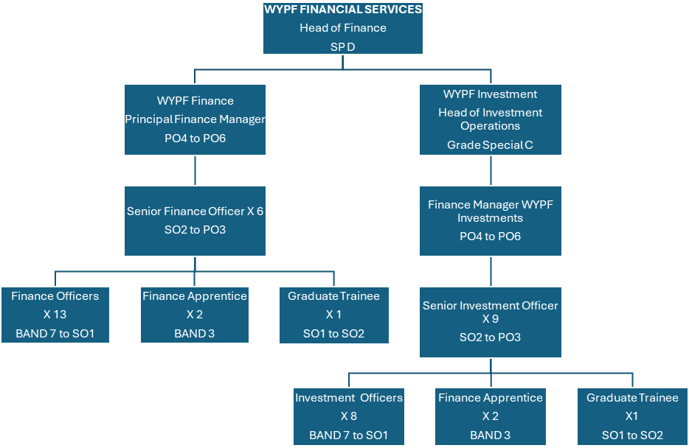

Special Knowledge Requirement: Will be used for shortlisting.
Applicants with disabilities are only required to meet the essential special knowledge requirements shown by a cross in the end column.
 |  |  | Essential
Work to financial working practices, procedures and basic operations expected in a major financial organisation. |  |  | X
Understands and applies health and safety working practices, including  risk in own area of work and or across West Yorkshire Pension Fund (inc. legislation) |  |  | X
Uses a range of complex IT packages relating to area of work i.e. financial management. |  |  | X
Oversees or contributes to the management of a budget, keeping costs within agreed levels for own section/team.
Knows and understands how to analyse, interpret and present complex  information from a variety of sources. |  |  | X
Understand costing processes, service costing, quality and service benchmarking processes, numerate with confidence in dealing with large amounts of money. |  |  | X
Familiar with the operation of UK and Overseas stock market procedures.
Ability to work with minimum supervision, supervise and train others in delivering team targets. |  |  | X
Clear understanding of and ability to apply benchmarking and performance reporting processes
Ability to run and use financial reporting tools on financial systems e.g. Discoverer, Business Object, Crystal or any other general ledger integrated reporting. |  |  | X
Relevant experience requirement: Will be used for shortlisting
The applicant is required to provide evidence of having previously spoken fluently to members of the public, clients or councillors in order to meet the Advanced threshold level outlined under Special Knowledge above.

Relevant professional qualifications requirement: Will be used for shortlisting
You will need to be in your final year studying towards your degree or have already achieved at least a 2:2 in Finance or a similar subject, such as Economics or Business Studies / Management. You will also have an interest in or experience of investments and financial markets.
Core Employee competencies at manager level to be used at the interview stage.
Carries Out Performance Management – the employee’s capacity to manage their workload and carry out a number of specific tasks accurately and at a high standard.
Communicates Effectively - covers a range of spoken and written communication skills required as a regular feature of the job. It includes exchanging information/building relationships, giving advice and guidance, counselling, negotiating and persuading and handling private, confidential and sensitive information.
Carries Out Effective Decision Making - covers a range of thinking skills required for taking initiative and independent actions within the scope of the job. It includes planning and organising, self-effectiveness and any requirements to quality check work.
Undertakes Structured Problem Solving Activity - covers a range of analytical skills required for gathering, collating and analysing the facts needed to solve problems. It includes creative and critical thinking, developing practical solutions, applying problem solving strategies and managing interpersonal relationships.
Operates with Dignity and Respect - covers treating everyone with respect and dignity, maintains impartiality / fairness with all people, is aware of the barriers people
face.
Management Competencies: to be used at the interview stage.
Operates with Strategic Awareness - Our managers work with corporate priorities and policies in a joined up way with others, internally and externally. Works democratically, transparently and accountably.
Practices Appropriate Leadership - Our managers motivate their staff to exceed expectations through raising their awareness of goals and moving them beyond self-interest for the sake of the team or service. They consider serving the District in all that they do.
Delivering Successful Performance - Our managers monitor performance of services, teams & individuals against targets & celebrate great performance. They promote the District’s vision & work to achieve Council’s values & agreed outcomes.
Applying Project and Programme Management - Our manager’s work to ensure that outcomes and objectives are achieved within desired timescales, make best use of resources and take a positive approach to contingency planning.
Developing High Performing People and Teams - Our managers coach individuals and teams to achieve their potential and take responsibility for continuous improvement. They champion the Council’s values and goals.

Working Conditions:
Must be able to perform all duties and tasks with reasonable adjustment, where appropriate, in accordance with the Equality Act 2010 in relation to Disability Provisions.
Special Conditions:
This post requires a basic disclosure and barring checking service check to be carried out, and it is required for all WYPF Finance staff.
Compiled by: Ola Ajala  Date: Jan 2025 | Grade Assessment Date: Jan 2025 | Post Grade: SO1 to SO2

