CITY OF BRADFORD METROPOLITAN DISTRICT COUNCIL
JOB PROFILE

DEPARTMENT: Corporate Resources | SERVICE GROUP: Finance
POST TITLE: Senior Finance Officer | REPORTS TO: Finance Manager
GRADE: PO2 | SAP POSITION NUMBER: 50202893 & 50228827

The following information is furnished to help Council staff and those people considering joining the City of Bradford Metropolitan District Council to understand and appreciate the general work content of their post and the role they are to play in the organisation. The duties and responsibilities highlighted in this Job Profile are indicative and may vary over time. Post holders are expected to undertake other duties and responsibilities relevant to the nature, level and scope of the post and the grade has been established on this basis. For posts where employees speak directly to members of the Public, the post holder will be required to demonstrate their ability to speak fluently in English.

As a candidate, you will be expected to demonstrate your ability to meet the special knowledge, experience and qualifications required for the role by providing evidence in the application form for the purpose of shortlisting. Applicants with disabilities are only required to meet the essential special knowledge requirements shown by a cross in the end column of this section.

The employee competencies are the minimum standard of behaviour expected by the Council of all its employees and the management competencies outlined are those relevant for a post operating at this level within our organisation.

Both sets of competencies will be used at interview stage and will not be used for short listing purposes.

Key Purpose of Post: Max 3 sentences
To provide a professional finance and management information service to services / departments throughout the Council, ensuring principles of best value, value for money and risk management are embedded in service delivery.

To undertake complex pieces of accountancy work and to support and advise services in achieving their objectives.

To support the Finance Team and promote the delivery of an excellent service to customers and to communicate in an informed, confident, polite and understanding manner with all clients and customers.

Main Responsibilities of Post: Max 15 Bullet points
1. Work with Budget Managers to assist with costing and help identify and confirm areas of potential pressures and savings. Listen to service customers and provide timely information and advice, offering solutions as required.
Version 5 | Dated August 2021| Created by IJ | Job Profile
- Anticipate and identify financial issues affecting the business, help managers to ensure net expenditure is within budget, and escalate any business issues not resolved by Service Managers

- Contribute to regular monthly meetings with business areas to challenge and scrutinise (offer critical evaluation of) monitoring figures.

- Undertake service analysis to support the year-end position and the Accounts.

- Contribute to financial modelling of new services or changes to existing services, work with business area and/or third parties to enhance financial and business performance.

- Provide support to Budget Managers during budget preparation, monthly monitoring, year-end and closure of accounts, and help them to understand the financial information required and processes to be followed.

- To research and maintain specialised knowledge in various financial disciplines to provide expert advice to and on behalf of the Council.

- Ensure that all cashbook, budgeting and year-end accounting procedures are complied with, including the operation of financial policies and controls, Financial Regulations and Standing Orders.

- Prepare, analyse and interpret financial and other service performance information to influence and enable managers to make the correct operational decisions. Ensure the Council’s income and expenditure are correctly accounted for in line with legislative requirements and Council policies and procedures.

- Support service departments and budget holders by providing a comprehensive financial support service which will include budget realignment and forecasting with links to performance management information. Prepare and present reports as required.

- Represent the Strategic Finance Manager and Finance Manager on internal working groups and project teams.

- Organise, deliver and participate in training events to improve the skills, knowledge and understanding of financial and non-financial managers.

- Undertake more complex financial activities within the Accountancy function including working on corporate projects, government and other returns and multi-disciplinary working parties.

- Supervision of finance officers and apprentices as and when required.

- Promote continuous improvement by maintaining knowledge of relevant guidance, ensuring quality and consistency of financial information, and promoting governance and risk management awareness and the maximising of resources to improve value for money.
Version 5 | Dated August 2021| Created by IJ | Job Profile
Structure:
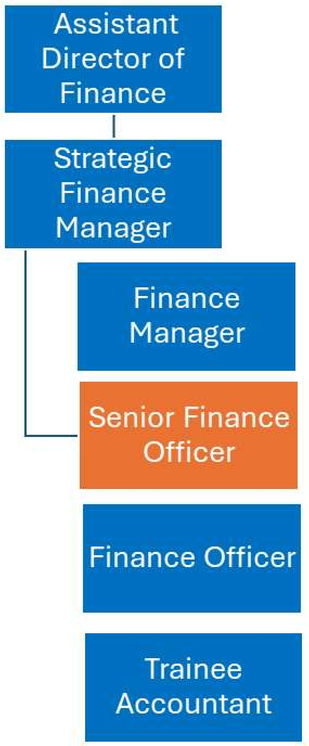
Special Knowledge Requirement. Will be used for shortlisting. Max 10
 | Essential
Applicants with disabilities are only required to meet the essential special knowledge requirements shown by a cross in the end column.
Due to the Government's Fluency in English Duty for posts where employees speak directly to members of the public, the postholder is required to meet the Lower threshold level.  You should be able to demonstrate that you can use a wide range of simple words and a standard English sentence structure to express and maintain a flowing conversation even though you pause to think of the correct words, with the ability to express and make yourself understood (this will also be tested during the interview). | x
Version 5 | Dated August 2021| Created by IJ | Job Profile
Uses knowledge of Health, Safety and Environmental policies, procedures and regulations, including risks in own area of work | x
Uses a range of complex IT packages relating to area of work | x
Ability to adopt a process of continual improvement and suggest ways of working more efficiently and effectively to improve service delivery. | x
Carries out a variety of working practices, applies complex regulations, rules, procedures and processes across a technical /specialist area | x
Able to provide telephone advice and ICT support to end users | x
Knows and understands how to use, interpret, handle and communicate, often complex and detailed information, and relay it to service users / stakeholders in writing and/or over the telephone / face to face. | x
Demonstrates a high level of numeracy, literacy and accuracy across a range of activities | x
Relevant experience requirement: Will be used for shortlisting

Dealing with officers at all levels and various disciplines, being articulate and a good listener with good communication skills both oral and written

Three years' practical experience in financial services

Preparation of reports and maintenance of financial systems and procedures

Working collaboratively with service and project officers who may have limited financial skills

Staff management

Persuasive and can work on own or in a team

Effective time management

Relevant professional qualifications requirement: Will be used for shortlisting

AAT or equivalent professional qualification

Evidence of sustained personal and professional development

Core Employee competencies to be used at the interview stage.
Carries Out Performance Management
Covers the employee’s capacity to manage their workload and carry out a number of tasks accurately and to a high standard.

Communicates Effectively
Covers a range of spoken and written communication skills required as a regular feature of the job. It includes exchanging information/building relationships; giving advice and guidance; counselling, negotiating and persuading and handling private, confidential and sensitive information.
Carries Out Effective Decision Making
Covers a range of thinking skills required for taking initiative and independent actions within the scope of the job. It includes planning and organising, self-effectiveness, and any requirements to quality-check work.

Undertakes Structured Problem-Solving Activity
Covers a range of analytical skills required for gathering, collating and analysing the facts needed to solve problems. It includes creative and critical thinking; developing practical solutions; applying problem-solving strategies and managing interpersonal relationships.

Operates with Dignity and Respect
Covers promoting equality, treating all people fairly and with dignity and respect, maintaining impartiality/fairness with all people, is aware of the barriers people face.

Working Conditions:

Must be able to perform all duties and tasks with reasonable adjustment, where appropriate, in accordance with the Equality Act 2010 in relation to Disability Provisions.

Special Conditions:
Basic DBS is required.
Compiled by:  Michael Thomas  Date: 30 July 2024 | Grade Assessment Date:  12 Sept 2024 | Post Grade:  PO2

Version 5 | Dated August 2021| Created by IJ | Job Profile

