CITY OF BRADFORD METROPOLITAN DISTRICT COUNCIL
JOB PROFILE

DEPARTMENT: Office of the Chief Executive | SERVICE GROUP: Safeguarding Adults and Children
POST TITLE: Partnership and Engagement Officer | REPORTS TO: Board Manager and Deputy
GRADE: SO1/2 |  | SAP POSITION NUMBER :

The following information is furnished to help Council staff and those people considering joining the City of Bradford Metropolitan District Council to understand and appreciate the general work content of their post and the role they are to play in the organisation. The duties and responsibilities highlighted in this Job Profile are indicative and may vary over time. Post holders are expected to undertake other duties and responsibilities relevant to the nature, level and scope of the post and the grade has been established on this basis.
For posts where employees speak directly to members of the Public the post holder is required to demonstrate their ability to speak fluently in English.

As a candidate you will be expected to demonstrate your ability to meet the special knowledge, experience and qualifications required for the role by providing evidence in the application form for the purpose of shortlisting. Applicants with disabilities are only required to meet the essential special knowledge requirements shown by a cross in the end column of this section.

The employee competencies are the minimum standard of behaviour expected by the Council of all its employees and the management competencies outlined are those relevant for a post operating at this level within our organisation.

Both sets of competencies will be used at interview stage and will not be used for short listing purposes.

Key Purpose of Post:
- To assist the Safeguarding Partnership Business Unit Manager and Deputy Managers in ensuring agencies are working together in Bradford to keep children, young people and adults safe. To support officers of BDSCP and BSAB and partner agencies to achieve the effective implementation of improvements to safeguarding children and adult arrangements arising from statutory guidance.
- To support and implement BDSCP and BSAB strategies, focusing on the community engagement and outreach element, increasing a profile of the multi agency partnership work and engaging/developing relationships with those communities with least awareness of public services.
- Developing and undertaking activities and projects to caputure the voice of children, service users and parents about the services they receive, whether they are feeling safer as a result and what they believe will keep them safe in the future.

Main Responsibilities of Post:
- To assist the Business Unit Manager and Deputy Managers in working closely with other strategic Boards with regards to links between safeguarding adults/children.
- Develop and implement an engagement strategy for the Stronger Communities Service, which covers our approach to days of significance, events and engagement of all communities, across a spectrum of characteristics.
- To lead on community engagement and outreach activity that increases awareness of and recruitment to programmes, projects and service by engaging with a wide range of stakeholders such as councillors, businesses and residents to events and online activity through social media.
- To lead, design and implement the engagement of communities on consultation activities, and work with others/ partners to ensure these meet ethic standards and are placed centrally across the Council to improve access to information.
- To foster positive working relationships with colleagues in partner agencies and to represent BDSCP and BSAB on working groups and at corporate meetings as appropriate.
- To establish and maintain good working relationships with partner agencies in order to assist with the early intervention and prevention and promote responsible information sharing between organisations and to promote good working practices.
- To support the delivery of a regular programme of organisational and case audit and appropriate case reviews, undertaking engagement activites which supports the delivery of quality assurance
- To develop a range of appropriate community engagement tools such as displays, videos, marketing material, merchandise and running of neighbourhood activities.
- Professionally represent the service and the Council at internal and external networking events, conferences and meetings and facilitate, convene or chair meetings as required.
- To keep abreast of local and national developments of safeguarding children and adults, and to assist in the development of briefings to elected members, Council management and partner organisations as required.
- To work with the Learning and Development function to effectively disseminate learning from audits and reviews and to collate and present evidence of organisational and practice improvement resulting from this activity.
- Undertake any other duties in support of the Business Unit or relevant to the nature, level and scope of the post and the grade.
- Respond to new and emerging needs and communities, developing and contributing to communities of interest forums, and progressing opportunities, access and creating space for voice of service users
- Responsible for timely, accurate and open communications across the partnerships, providing regular written or verbal reports to the relebant sub groups and boards; and other stakeholders on key issues and where relevant to aid decision making.

Structure:
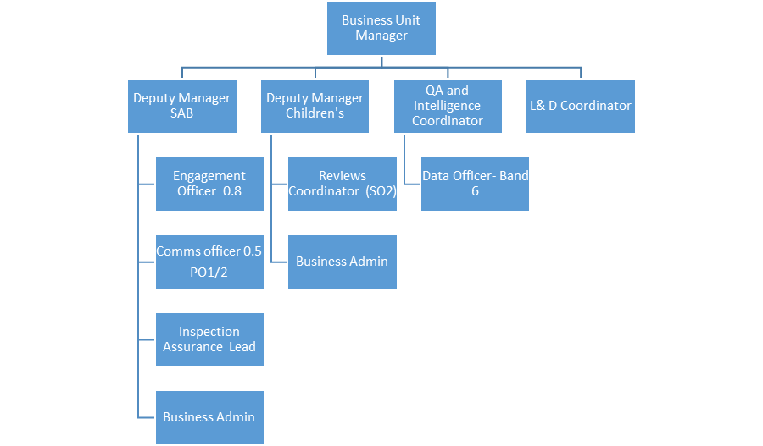

Special Knowledge Requirement: Will be used for shortlisting.

Applicants with disabilities are only required to meet the essential special knowledge requirements shown by a cross in the end column.
 | Essential
Due to the Governments Fluency in English Duty for posts where employees speak directly to members of the public the post holder is required to meet the Advanced threshold level which will be implemented where the post requires a greater level of sensitive interaction with the public,( e.g. in children’s centres) – where the person is able to demonstrate that they can during the interview:  a) Can express themselves fluently and spontaneously , almost effortlessly  Ability and commitment to develop productive working relationships across the BSCB/SAB that commands respect, trust and confidence and which facilitates effective challenge where appropriate. | X
Carries out the working practices, procedures and basic operations across a specialist area of safeguarding adults & children and any other relevant legislation/guidance. | X
Understands and applies health and safety working practices, including risk in own area of work and or across other areas of work.
Uses a wide range of basic computer applications including internet and social media. | X
Knowledge and experience of programme and project management and methodologies. | X
A good understanding of effective community and youth engagement methods and approaches. | X
Safeguarding and promoting welfare of children and adults. This requires understanding of what harm or abuse is, recognising it and responding to it proportionately.  - Assessing risk and emotional resilience  - Reflecting and making informed judgements  - Acting within local procedures, arrangements and resources  - Responding with a trauma informed approach | X
Partnership working – working with others within the service and external partners to put children and adults at the heart of decision making.  - Communicating well, sharing appropriate, succinct, objective information and analysis to aid joint decision making  - Being practice, persistent and prepared to challenge and be challenged  Knowing your own responsibilities and others roles and joint procedures | X
Ability to work to strict deadlines with conflicting priorities and to manage work and time effectively | X

Relevant experience requirement: Will be used for shortlisting

Experience of partnership working with all relevant statutory sector agencies (especially the Local Authority, health and criminal justice agencies) at all levels.
A good working knowledge of issues around child and adult safeguarding and an ability to work with partner agencies across the criminal justice, health and social care spectrum.
A good working knowledge of developing delivery plans which demonstrate evidence based outcomes. Experience of the contribution to or preparation, development and review of service/business plans/ reports and bid writing.
Effective communication at all levels with using a variety of formats, including written and oral reports including managing sensitive and confidential data. Ability to negotiate and influence in order to achieve positive outcomes.
Experience of representing organisations at internal/external meetings and working groups.
A good working knowledge of communication methodology including IT skills around website and social media platforms.
Relevant professional qualifications requirement: Will be used for shortlisting

NVQ 4 or equivalent in a related subject area e.g. social sciences or humanities plus experience in related field.
Core Employee competencies at manager level to be used at the interview stage.

Carries Out Performance Management – covers the employees capacity to manage
Their workload and carry out a number of specific tasks accurately and at a high standard.
Communicates Effectively - covers a range of spoken and written communication skills required as a regular feature of the job. It includes exchanging information/building relationships, giving advice and guidance, counselling, negotiating and persuading and handling private, confidential and sensitive information.
Carries Out Effective Decision Making - covers a range of thinking skills required for taking initiative and independent actions within the scope of the job. It includes planning and organising, self effectiveness and any requirements to quality check work.

Undertakes Structured Problem Solving Activity - covers a range of analytical skills required for gathering, collating and analysing the facts needed to solve problems. It includes creative and critical thinking, developing practical solutions, applying problem solving strategies and managing interpersonal relationships.
Operates with Dignity and Respect - covers treating everyone with respect and dignity, maintains impartiality/fairness with all people, is aware of the barriers people face.
Management Competencies: to be used at the interview stage.

Operates with Strategic Awareness Our managers work with corporate priorities and policies in a joined up way with others, internally and externally. Works democratically, transparently and accountably.
Practices Appropriate Leadership Our managers motivate their staff to exceed expectations through raising their awareness of goals and moving them beyond self interest for the sake of the team or service. They consider serving the District in all that they do.
Delivering Successful Performance Our managers monitor performance of services, teams & individuals against targets & celebrate great performance. They promote the District’s vision & work to achieve Council’s values & agreed outcomes.
Applying Project and Programme Management Our manager’s work to ensure that outcomes and objectives are achieved within desired timescales make best use of resources and take a positive approach to contingency planning.
Developing High Performing People and Teams Our managers coach individuals and teams to achieve their potential and take responsibility for continuous improvement. They champion the Council’s values and goals.
Working Conditions:

Must be able to perform all duties and tasks with reasonable adjustment, where appropriate, in accordance with the Equality Act 2010 in relation to Disability Provisions.
Special Conditions:
You will be informed outline if there is a requirement for the post to have recruitment checks
such as DBS, Warner Process.
Compiled by:  Darren Minton  Date:24/01/2023 | Grade Assessment Date: | Post Grade:  So1/2

