CITY OF BRADFORD METROPOLITAN DISTRICT COUNCIL
JOB PROFILE

DEPARTMENT: Corporate Resources  Legal and Democratic Services | SERVICE GROUP: Property, Commercial and Development
POST TITLE: Lawyer/Senior Lawyer  Commercial (Contract and Procurement) | REPORTS TO: Team Leader  (Property Commercial and Development)
GRADE: PO 3-6 (Career Grade) |  | SAP POSITION NUMBERS :  50228617 & 50227770

The following information is furnished to help Council staff and those people considering joining the City of Bradford Metropolitan District Council to understand and appreciate the general work content of the post and the role they are to play in the organisation. The duties and responsibilities highlighted in the Job Profile are indicative and may vary over time. Post holders are expected to undertake other duties and responsibilities relevant to the nature, level, and scope of the post and the grade has been established on that basis. For posts where employees speak directly to the public the post holder is required to demonstrate their ability to speak fluently in English.

As a candidate you will be expected to demonstrate your ability to meet the special knowledge, experience and qualifications required for the role by providing evidence in the application form for the purpose of shortlisting. Applicants with disabilities are only required to meet the essential special knowledge requirements shown by a cross in the end column of this section.

The employee competencies are the minimum standard of behaviour expected by the Council of all its employees and the management competencies outlined are those relevant for a post operating at this level within our organisation.

Both sets of competencies will be used at interview stage and will not be used for short listing purposes.

Key Purpose of Post:
To provide high level, effective and relevant legal advice to the Council, its committees and service units, in one of the core areas of law being contract and procurement, company.

To assist the Team Leader of the Property, Commercial and Development Team in fulfilling the overall objectives of the team in providing a comprehensive high quality legal service.

To provide supervision and support to more junior staff.

Main Responsibilities of Post:
The main purpose of the role is to support the Team Leader of the Property, Commercial and Development team in the provision of a high quality legal service to the Council, its committees and Directorates. In doing so you will exercise professional judgment and make all day-to-day operational decisions on allocated matters and cases.

The post holder will hold an excellent understanding of one of the core areas of law being: contract, procurement, company and corporate projects.

The post holder will also have the ability to influence stakeholders which includes officers at Chief Executive level and below, elected members, Courts, Tribunals and regulatory bodies of staff, private practice solicitors and barristers and other professionals.

The main duties of the post are:

- To act as a case holder with a varied mix of matters and provide professional legal services to the Council related to the Council’s contracts, procurement, company and corporate projects, including funding and joint venture agreements.

- To provide supervision and support to more junior staff.

- To deliver training to colleagues, clients and elected members.

- To assist with the co-ordination of the work of the team, to ensure that matters are prepared to professional standards and in compliance with relevant legislation, Regulations, Statutory Guidance and Practice Directions and deadlines are properly met.

- To research and keep abreast of recent developments in the relevant area of legal work covered and to deliver training to client departments from time to time.

- To advise Committees, Sub-Committees, Members, Officers and any organisation with which the Council has a formal arrangement for the giving of advice.

- To provide professional legal services to the Council which includes: to officers of the Departments of Corporate Services, Place and the Chief Executives Office and others as may be required from time to time.

- To assist other public authorities within the West Yorkshire area (members of WYLAW) on legal matters as may be required from time to time.

- Responsibility for confidential case papers and files.

- To develop and maintain effective working relationships with key stakeholders within and external to the Council.
Structure
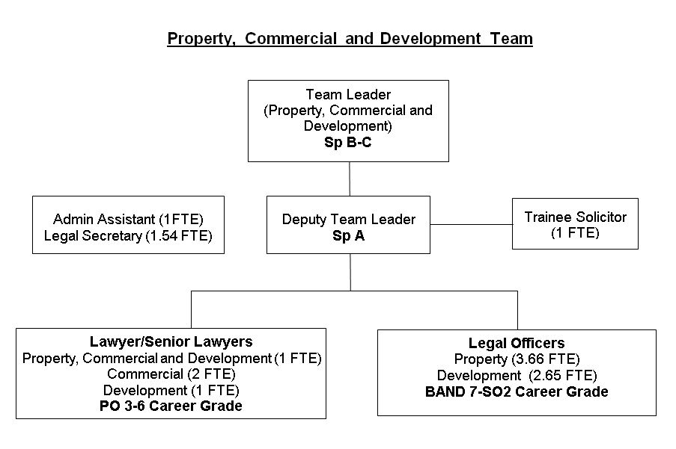

Special Knowledge Requirement:
Applicants with disabilities are only required to meet the essential special knowledge requirements shown by a cross in the end column.
 |  |  | Essential
Due to the Government’s Fluency in English for posts where employees speak directly to members of the public the postholder is required to meet the Advanced threshold level which will be applied where the postholder requires a greater level of sensitive interaction with the public.  You must be able to demonstrate that you can express yourself fluently and spontaneously (this will also be tested during the interview). |  |  | x
Detailed knowledge of, commercial, contract, procurement law, policies and company law, including with third parties supplier, funding and corporate projects. |  |  | x
Ability to correctly advise on the working practices, procedures and operations across contracts, procurement and projects. |  |  | x
Excellent communication skills with an ability to effectively communicate to provide advice in your specialist area to senior staff and Members |  |  | x
Ability to demonstrate knowledge and / or experience of equalities and diversity issues |  |  | x
Knowledge of data protection and the requirement to ensure data security |  |  | x
Understands the role of management and / or supervision of staff |  |  | x
Uses a wide range of basic computer applications |  |  | x
Self-reliant and organised with the ability to work as part of a team sharing responsibilities.
Relevant experience requirement:
To achieve PO5-6: Significant experience of one area within contract and procurement law obtained in either private practice or local government; other experience may be acceptable for an outstanding candidate.

Relevant professional qualifications requirement:
The post holder will be a qualified barrister or solicitor or chartered legal executive.
Core Employee Competencies
Carries out Performance Management – covers the employees capacity to manage their own workload and carry out a number of specific tasks accurately to a high standard
Communicates Effectively – covers a range of spoken and written communication skills required as a regular feature of the job. It includes exchanging information/building relationships, giving advice and guidance, counselling, negotiating and persuading and handling private, confidential and sensitive information.
Carries Out Effective Decision Making - covers a range of thinking skills required for taking initiative and independent actions within the scope of the job. It includes planning and organising, self-effectiveness and any requirements to quality check work.
Operates with Dignity and Respect - covers treating everyone with respect and dignity, maintains impartiality/fairness with all people, is aware of the barriers people face.
Management Competencies: (At interview stage only where relevant to the grade)
Operates with Strategic Awareness Our managers work with corporate priorities and policies in a joined up way with others, internally and externally. Works democratically, transparently and accountably.
Practices Appropriate Leadership Our managers motivate their staff to exceed expectations through raising their awareness of goals and moving them beyond self-interest for the sake of the team or service. They consider serving the District in all that they do.
Delivering Successful Performance Our managers monitor performance of services, teams & individuals against targets & celebrate great performance. They promote the District’s vision & work to achieve Council’s values & agreed outcomes.
Applying Project and Programme Management Our manager’s work to ensure that outcomes and objectives are achieved within desired timescales, make best use of resources and take a positive approach to contingency planning.
Developing High Performing People and Teams Our managers coach individuals and teams to achieve their potential and take responsibility for continuous improvement. They champion the Council’s values and goals.
Working Conditions:
Must be able to perform all duties and tasks with reasonable adjustment, where appropriate, in accordance with the Council’s responsibilities under the Equality Act 2010.

Availability may be required to work the occasional evenings, weekends and bank holidays as required by the needs of the service.
Special Conditions:
Management may require that a Disclosure and Barring check or similar be carried out as part of the recruitment process, depending on the areas of work being undertaken.
Compiled by:  Date: 10 November 2022 | Grade Assessment Date: | Post Grade:
For HR use only | SAP Input Date | Name of Data Inputter

/tmp/in/input.doc

