CITY OF BRADFORD METROPOLITAN DISTRICT COUNCIL
JOB PROFILE

DEPARTMENT: Children’s Services | SERVICE GROUP: Education and Learning  Resourced Provisions
POST TITLE: SEND Learning Support assistants | REPORTS TO: Teacher in Charge
GRADE: Band 6 Scale points 6-11 (pro rata)  TTO + 5 days (39 weeks) 35 hours per week |  | SAP POSITION NUMBER :  50200327

The following information is furnished to help Council staff and those people considering joining the City of Bradford Metropolitan District Council to understand and appreciate the general work content of their post and the role they are to play in the organisation. The duties and responsibilities highlighted in this Job Profile are indicative and may vary over time. Post holders are expected to undertake other duties and responsibilities relevant to the nature, level and scope of the post and the grade has been established on this basis.
For posts where employees speak directly to members of the Public the post holder is required to demonstrate their ability to speak fluently in English.

As a candidate you will be expected to demonstrate your ability to meet the special knowledge, experience and qualifications required for the role by providing evidence in the application form for the purpose of shortlisting. Applicants with disabilities are only required to meet the essential special knowledge requirements shown by a cross in the end column of this section.

The employee competencies are the minimum standard of behaviour expected by the Council of all its employees and the management competencies outlined are those relevant for a post operating at this level within our organisation.

Both sets of competencies will be used at interview stage and will not be used for short listing purposes.

Key Purpose of Post
- To work as a team member in the Resourced Provisions team to support the learning, progress and care of the pupils to support them to achieve their potential and personal best. The role is under the direction of the teacher in charge to provide support for pupils in lessons within the Resourced Provision classrooms and the mainstream school and for groups or individual interventions. To assist teachers to manage and prepare appropriate teaching resources.
- Provide detailed and regular feedback to teachers on pupils’ achievement, progress, personal development, areas for development and improvements and concerns.
- Support effective liaison and communication between the Resourced Provisions team and mainstream school staff, teachers, SENCO to work together to plan for the effective support of the pupils
Main Responsibilities of Post
- Provide skilled delivery and support for pupils with SEND to promote their learning and achievement, independence and confidence

- Provide feedback to pupils in relation to progress and achievement under the guidance of the teacher

- Accurately record and provide detailed and regular feedback to teachers and other key staff on pupils’ achievement, progress, barriers and other relevant issues or concerns

- Promote good pupil behaviour, dealing promptly with conflict and incidents in line with the established policies of the school and encourage pupils to take responsibility for their own behaviour

- Promote the inclusion and integration of the pupils in the resourced provisions into the mainstream school and access to the curriculum and other educational opportunities
- Prepare, maintain and use specialist and other curriculum resources required to meet the lesson plan / relevant learning activity and assist pupils in their use and assist in the development of lessons, worksheets, programmes for implementation under the guidance of the teacher and carry out related tasks as directed by a teacher

- Liaise regularly and effectively with staff in the resourced provisions and key staff in the mainstream school for example the SENCO, pastoral and safeguarding staff etc
- Contribute to reports, recording keeping and maintenance, information and data, pupil profiles and in the reviews of EHCPs .

- As part of the wider duties and responsibilities the postholder must actively promote and support and be vigilant and knowledgeable about Keeping Children Safe in Education, including compulsory training and fully comply with School and council policies and procedures relating to child protection, safeguarding, health, safety and information security, confidentiality and data protection, reporting all concerns to an appropriate senior person.

- Attend and participate in relevant meetings including planning meetings as required and participate in training and other learning activities and performance management, supervision and development as required.

- Assist with the supervision of pupils out of lesson times, including before and after school and at lunchtime, break times as required

- To participate in and assist teaching staff on any educational visits, trips or out of school activities and take responsibility for a group under the supervision of the teacher in charge.

- Any other duties relevant to the scale and nature of the post as directed by the senior leadership team of the Resourced Provisions and carry out the duties with due regard to policies, procedures and legislation.

Structure:
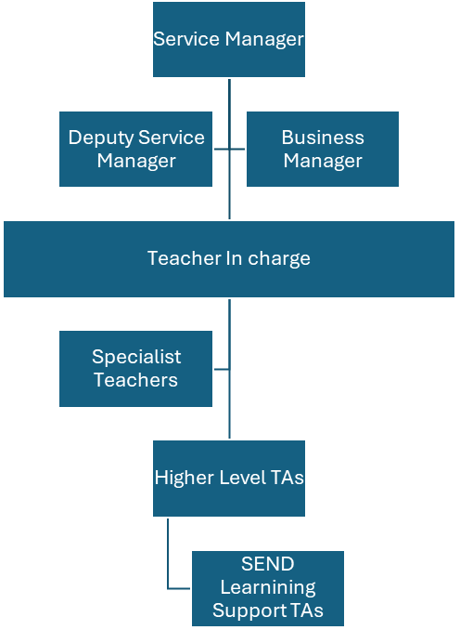

Special Knowledge Requirement. Will be used for shortlisting.
 | Essential
Applicants with disabilities are only required to meet the essential special knowledge requirements shown by a cross in the end column.
Due to the Governments Fluency in English Duty for posts where employees speak directly to members of the public the post holder is required to meet the Advanced Threshold level which will be implemented where the post requires a greater level of sensitive interaction with the public, ( e.g. in schools) – where the person is able to demonstrate that they can during the interview:  a) Can express themselves fluently and spontaneously, almost effortlessly  b) Only the requirement to explain difficult concepts simply hinders a natural smooth flow of language | X
Uses knowledge of Health, Safety and Environmental policies, Educational Safeguarding procedures and promoting the welfare of pupils and regulations including risks in own area of work (SEND) | X
Uses a range of IT packages relating to area of work | X
Ability to adopt a process of continual improvement and suggest ways of  working more efficiently and effectively to improve service delivery. | X
Knows and understands how to use, interpret, handle and communicate  Information and data | X
Understands how to adapt and respond flexibly to support the learning needs of pupils with SEND | X
Has knowledge of the working practices of mainstream schools, classrooms, small group working and effective SEND interventions including 1:1 support | X
An understanding of how SEND and the primary needs of ASD and/or SEMH impacts upon learning and development and behaviours | X
Good understanding and willingness to use positive behaviour and physical interventions in line with national guidelines. | X

Relevant experience requirement: Will be used for shortlisting
The applicant is required to provide evidence of having previously spoken fluently to members of the public in order to meet either the Lower threshold or Advanced threshold level outlined under Special Knowledge above.
Experience of working within an educational setting with pupils with SEND particularly ASD and/or SEMH, with an age range of children appropriate to the role
Experience of the EHCP process including supporting with the annual review process and planning activities to meet the needs within an EHCP
Experience of assessment, planning and preparation for learning
Experience of supporting and delivering interventions or programmes of work for pupils with ASD and/or SEMH
Experience and training in educational safeguarding
Relevant professional qualifications requirement: Will be used for shortlisting
NVQ 3 or above in a relevant qualification eg learning support, NNEB
English and Mathematics GCSE A* - C or equivalent
Training in literacy, numeracy strategies, programmes
Core Employee competencies to be used at the interview stage
Carries Out Performance Management
Covers the employee’s capacity to manage their workload and carry out a number of specific tasks accurately and to a high standard.
Communicates Effectively
Covers a range of spoken and written communication skills required as a regular feature of the job. It includes exchanging information/building relationships; giving advice and guidance; counselling, negotiating and persuading and handling private, confidential and sensitive information.
Carries Out Effective Decision Making
Covers a range of thinking skills required for taking initiative and independent actions within the scope of the job. It includes planning and organising, self effectiveness and any requirements to quality check work.
Undertakes Structured Problem Solving Activity
Covers a range of analytical skills required for gathering, collating and analysing the facts needed to solve problems. It includes creative and critical thinking; developing practical solutions; applying problem solving strategies and managing interpersonal relationships.
Operates with Dignity and Respect

Covers promoting equality, treating all people fairly and with dignity and respect, maintains impartiality/fairness with all people, is aware of the barriers people face.
Working Conditions:
Must be able to perform all duties and tasks with reasonable adjustment, where appropriate, in accordance with the Equality Act 2010 in relation to Disability Provisions.
Be prepared to work occasionally outside normal hours
Special Conditions:
No contra-indications in personal background or criminal record indicating unsuitability to work with children/young people/vulnerable clients/finance
Enhanced DBS check is required
Compiled by:  Lynn Donohue  Date: July 2019 | Grade Assessment Date: May 2019 | Post Grade: Band 6 Scale points 6-11 (pro rata)

