CITY OF BRADFORD METROPOLITAN DISTRICT COUNCIL
JOB PROFILE

DEPARTMENT: Children’s Services | SERVICE GROUP: Education and Learning: Specialist Teaching and Support Services; CHILDREN’S MEDICAL NEEDS AND HOSPITAL SERVICE
POST TITLE: Education Engagement Worker | REPORTS TO: line manager – see structure
GRADE: Band 6 |  | SAP POSITION NUMBER :

The following information is furnished to help Council staff and those people considering joining the City of Bradford Metropolitan District Council to understand and appreciate the general work content of their post and the role they are to play in the organisation. The duties and responsibilities highlighted in this Job Profile are indicative and may vary over time. Post holders are expected to undertake other duties and responsibilities relevant to the nature, level and scope of the post and the grade has been established on this basis.
For posts where employees speak directly to members of the Public the post holder is required to demonstrate their ability to speak fluently in English.

As a candidate you will be expected to demonstrate your ability to meet the special knowledge, experience and qualifications required for the role by providing evidence in the application form for the purpose of shortlisting. Applicants with disabilities are only required to meet the essential special knowledge requirements shown by a cross in the end column of this section.

The employee competencies are the minimum standard of behaviour expected by the Council of all its employees and the management competencies outlined are those relevant for a post operating at this level within our organisation.

Both sets of competencies will be used at interview stage and will not be used for short listing purposes. Please see the separate guidance information on how to complete the form located on Bradnet.

Key Purpose of Post:
- To work in partnership with all service staff, health services, schools and education providers to
support children and young people with a wide range of health and medical needs
- To work with individual CYP or groups of CYP with a wide range of health and medical needs
- To support teachers and managers within the service to ensure that learning continues while not
in full time education

Main Responsibilities of Post:
- To work as part of the service providing high quality services to service users and offering an area of specialism and generic skills, knowledge, expertise and understanding.
- To work with individuals or small groups of CYP with a wide range of medical and health needs under the direction of the line manager
- To implement personalised learning activities/teaching programmes, planning, adjusting and assessing according to the pupils’ responses and needs
- To understand specific learning needs and styles and provide differentiated support to pupils
- To support learning by selecting appropriate resources to ensure that targets are met
- To provide feedback to pupils in relation to attainment and progress under the guidance of the teachers within the service
- To monitor and record pupil responses and learning achievements, using the knowledge of other staff and teachers if appropriate
- To be able to provide general first aid, administer medication and willingness to train in any medical and personal care
- To ensure own knowledge, practice and understanding are current and regularly updated
- To provide support to pupils with complex medical and health needs which may include physical difficulties, and associated sensory, social, emotional or mental health needs
- To communicate effectively with children and young people, their parents and carers, school staff and service users, professional colleagues within the service, the Prevention and Early Help Service, Children’s Services, Health Providers for example CAMHS and other external agencies and partners
- To take an active role in the preparation and maintenance of resources
- To participate in meetings and professional development and training
- To ensure that the safety and safeguarding of children and young people is paramount and to implement the policies, procedures in line with KCSIE and the Bradford Safeguarding Children Board, promoting the safety, welfare of children and young people and work with other council colleagues to safeguard children and young people.
- To visit CYP in their homes or other venues to ensure continuity of education for CYP with a wide range of medical and health needs
- To work with schools and education providers to ensure smooth and effective transition and accurate information sharing
- To be able to assist in different areas of the Children’s Medical Needs and Hospital Service when appropriate and under the direction of management
- To undertake all duties commensurate to the nature and level of the post at an initial place of work or any other venue

Structure:
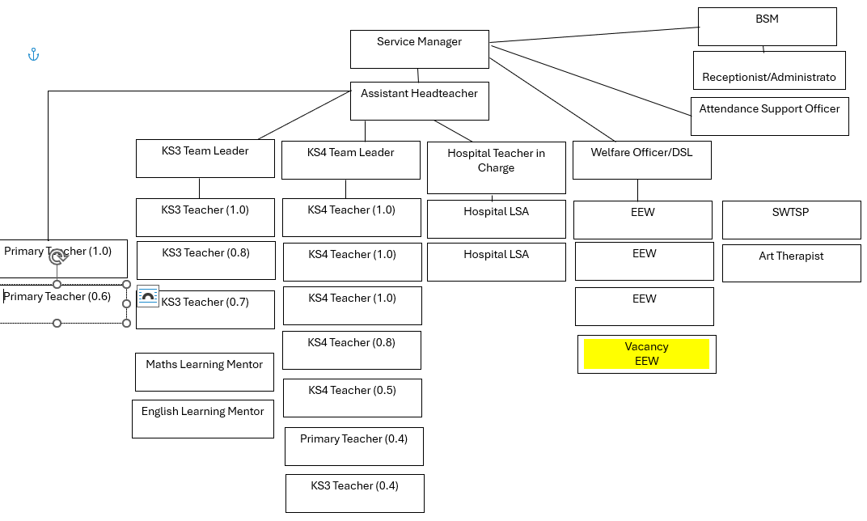

Special Knowledge Requirement. Will be used for shortlisting. Max 10
 |  |  | Essential
Applicants with disabilities are only required to meet the essential special knowledge requirements shown by a cross in the end column.
Due to the Government’s Fluency in English for posts where employees speak directly to members of the public the postholder is required to meet the Advanced threshold level which will be applied where the postholder requires a greater level of sensitive interaction with the public.  You must be able to demonstrate that you can express yourself fluently and spontaneously (this will also be tested during the interview). |  |  | X
Uses knowledge of Health, Safety and Environmental policies, procedures and regulations including risks in own area of  Work including KCSIE and completes risk assessments |  |  | X
Uses a range of complex IT packages relating to area of work and has an understanding of GDPR |  |  | X
Ability to adopt a process of continual improvement and suggest ways of  working more efficient and effectively to improve service delivery. |  |  | X
Knows and understands how to use, interpret, handle and communicate  information |  |  | X
Detailed and current knowledge of Safeguarding and the Prevent agenda and the ability to advise and respond quickly and appropriately in line with local and national legislation and advice. |  |  | X
Establishes positive relationships with pupils and other staff and schools |  |  | X
Relevant experience requirement: Will be used for shortlisting

The applicant is required to provide evidence of having previously spoken fluently to members of the public in order to meet either the Lower threshold or Advanced threshold level outlined under Special Knowledge above.
A minimum of 3 years specialist experience of working with children and young people with medical and health needs.
Experience of differentiated learning to ensure personalised targets are met
Recent experience of delivering impactful interventions to children and young people with medical and health needs
Recent experience of delivering effective support for pupils with a range of medical and health needs
Relevant professional qualifications requirement: Will be used in shortlisting
- GCSE Grade C or above in Maths and English
- Any evidence of further accreditation, training or CPD of meeting the needs of children and young people with medical/health needs

Core Employee competencies to be used at the interview stage.
Carries Out Performance Management
Covers the employee’s capacity to manage their workload and carry out a number of specific tasks accurately and to a high standard.
Communicates Effectively
Covers a range of spoken and written communication skills required as a regular feature of the job. It includes exchanging information/building relationships; giving advice and guidance; counselling, negotiating and persuading and handling private, confidential and sensitive information.
Carries Out Effective Decision Making
Covers a range of thinking skills required for taking initiative and independent actions within the scope of the job. It includes planning and organising, self-effectiveness and any requirements to quality check work.
Undertakes Structured Problem Solving Activity
Covers a range of analytical skills required for gathering, collating and analysing the facts needed to solve problems. It includes creative and critical thinking; developing practical solutions; applying problem solving strategies and managing interpersonal relationships.
Operates with Dignity and Respect

Covers promoting equality, treating all people fairly and with dignity and respect, maintains impartiality/fairness with all people, is aware of the barriers people face.
Working Conditions:

Must be able to perform all duties and tasks with reasonable adjustment, where appropriate, in accordance with the Equality Act 2010 in relation to Disability Provisions.
Special Conditions:
No contra-indications in personal background or criminal record indicating unsuitability to work with children/young people/vulnerable clients/finance Enhanced DBS check required.
The post holder is required to have a useable car available at all times or as advised by the line
manager. The post is designated Casual Class 1 Car User status for the better performance of the duties for which the HMRC rate is payable...
Compiled by:  Hannah Whittaker  Reviewed by: Lynn Donohue January 2020 | Grade Assessment Date: | Post Grade:

