CITY OF BRADFORD METROPOLITAN DISTRICT COUNCIL
JOB PROFILE

DEPARTMENT: Employment & Skills | SERVICE GROUP: Adult Employment Services
POST TITLE: Employment Specialist Lead Officer | REPORTS TO: Employment Operations Manager
GRADE: PO2 |  | SAP POSITION NUMBER :

The following information is furnished to help Council staff and those people considering joining the City of Bradford Metropolitan District Council to understand and appreciate the general work content of their post and the role they are to play in the organisation. The duties and responsibilities highlighted in this Job Profile are indicative and may vary over time. Post holders are expected to undertake other duties and responsibilities relevant to the nature, level and scope of the post and the grade has been established on this basis. For posts where employees speak directly to members of the Public the post holder is required to demonstrate their ability to speak fluently in English.

As a candidate you will be expected to demonstrate your ability to meet the special knowledge, experience and qualifications required for the role by providing evidence in the application form for the purpose of shortlisting. Applicants with disabilities are only required to meet the essential special knowledge requirements shown by a cross in the end column of this section.

The employee competencies are the minimum standard of behaviour expected by the Council of all its employees and the management competencies outlined are those relevant for a post operating at this level within our organisation.

Both sets of competencies will be used at interview stage and will not be used for short listing purposes. Please see the separate guidance information on how to complete the form located on Bradnet.

Key Purpose of Post: Max 3
The role is as the focal point of mutli-agency working in and across our localities and communities supporting residents with health barriers on and through a tailored pathway to sustained employment. The role will build, facilitate, coordinate the development and overall functioning of community-based and accessible employment pathways through a range of partners and funding streams.

To lead and manage a team of Specialist Employment advisers and apply the strategic skills pipeline to provide individualised tailored support and guidance shaped by business demand to enable young people and adults, particularly those most vulnerable, to secure relevant and timely specialist and employability skill development through a range of structured and progressive interventions.

The role holder will be a key representative of SkillsHouse to a wide range of partners and employers in localities.
Main Responsibilities of Post: Max 15
- This role will be crucial to the successful delivery of the Connect to Work programme. You will lead a team of up to 6–8 Employment Specialists in a fast-paced, target-driven environment—ensuring they have the tools, resources, and relationships needed to manage their caseloads effectively and meet programme targets.
- Build and facilitate locality based multi-agency employment related services to create seamless demand-led pathways utilising the strategic skills pipeline to support residents, particulay those who are vulnerable, into sustained employment and broker opportunities.
- To act as a lead professional in leading and managing a team of Specialist Employment Advisers to deliver a high quality integegrated service to assist clients employability, career learning, re/training, planning and development through the further development of employability, careers education, information, advice and guidance services.
- Responsible for the development delivery a proactive and focussed range of careers and employability services, models of practice, and programmes to support the inclusive employment agenda, transforming services and programmes to meet changing employment markets and expectations.
- Support the development and implementation of a wide range of workstreams, projects, and pilot intiatives designed to improve or support residents pathway into sustained work, ensuring delivery of services is accessible and available in communities.
- Build and lead multi-agency working and offer across the strategic skills pipeline to support particpants through and into sustained employment, act as a key link between SkillsHouse and patners across with defined localities.
- Produce and contribute to high quality information, analysis and research to inform and support service development and improvement on employment support services.
- Where appropriate lead on and/or support the implementation of innovative programmes in localities. This may include the development of effective operational, financial management and performance monitoring arrangements.
- To support the effective management and delivery of services through implementing effective business and workflow processes, quality assurance arrangements, monitoring performance, and team and individual development. Contribute on monthly reporting.
- To support the effective partnership management and delivery of services through implementing effective business and workflow processes, quality assurance arrangements, and monitoring performance.
- To develop and provide specialist support and expertise on locatily area.
- Act as an effective ambassador and advocate within localities.
- Undertake any duties commensurate with the general level of responsibility of this post.
- To complete all participant administration, audit, financial documentation, ensuring all records are accurate and kept up-to-date.
- To promote diverse and respectful team culture and fully comply with health and safety, equal opportunities and diversity,quality assurance, safe guarding and data protection.

Structure:

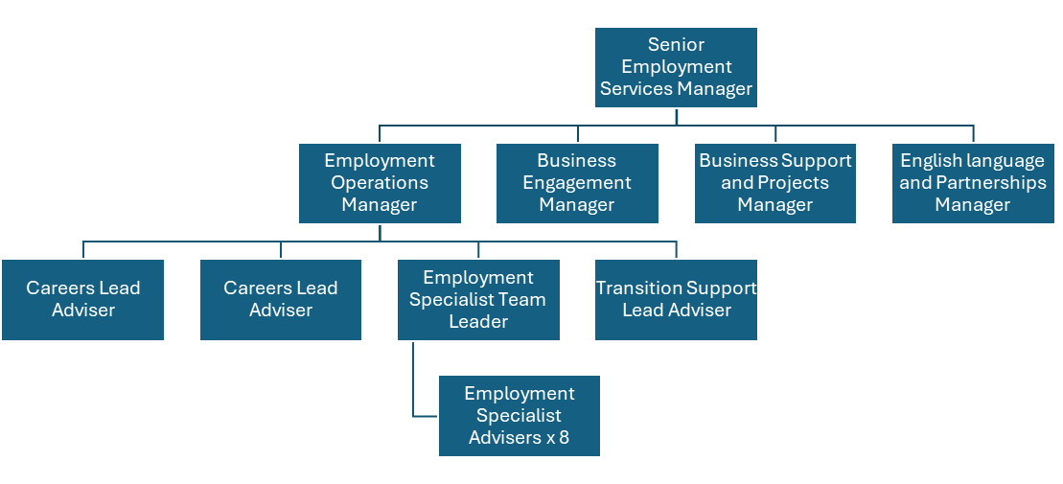

Special Knowledge Requirement: Essential for shortlisting. Max 10
Applicants with disabilities are only required to meet the essential special knowledge requirements shown by a cross in the end column
 | Essential
Due to the Government’s Fluency in English for posts where employees speak directly to members of the public the postholder is required to meet the Advanced threshold level which will be applied where the postholder requires a greater level of sensitive interaction with the public.  You must be able to demonstrate that you can express yourself fluently and spontaneously (this will also be tested during the interview). | x
Carries out the working practices, procedures and basic operations across a specialist area or number of specialist areas across employment and skills. | x
Uses knowledge, safety and environmental policies , procedures and regulations, including risk in own area and/or other areas of work | x
Uses a range of specialist ICT systems across own work area and or across other areas of work. | x
Oversees or contributes to the management of a budget , keeping costs within agreed levels for own section/team | x
Uses, interprets, analyses, communicates complex numerical information. | x
Understand and engages with individuals with complex health conditions | x
Supports relevant partners/managers in the work of their team with day to day organisation of workloads / allocation of resources | x
Able to develop, maintain and use appropriate monitoring systems and produce reports. | x
Able to involve partner organisations in the problem solving activity | x
Implements and monitors solutions | x

Relevant experience requirement: Essential for shortlisting

The applicant is required to provide evidence of having previously spoken fluently to members of the public in order to meet the Advanced threshold level outlined under Special Knowledge above.
Three years of managing a team with a employment, training, education or related setting.
Experience of deliverying employment support or training to young people and adults with a range of barriers to success
Experience of effective partnership working to deliver improved employment outcomes for young and adults
Relevant professional qualifications requirement: Essential for shortlisting

Educated to degree level or equivilent
Advice and Guidance Level 4 / 6 Desirable
Core Employee competencies at manager level to be used at the interview stage.

Carries Out Performance Management – covers the employees capacity to manage
their workload and carry out a number of specific tasks accurately to a high standard.
Communicates Effectively - covers a range of spoken and written communication skills required as a regular feature of the job. It includes exchanging information/building relationships, giving advice and guidance, counselling, negotiating and persuading and handling private, confidential and sensitive information.
Carries Out Effective Decision Making - covers a range of thinking skills required for taking initiative and independent actions within the scope of the job. It includes planning and organising, self effectiveness and any requirements to quality check work.
Undertakes Structured Problem Solving Activity - covers a range of analytical skills required for gathering, collating and analysing the facts needed to solve problems. It includes creative and critical thinking, developing practical solutions, applying problem solving strategies and managing interpersonal relationships.
Operates with Dignity and Respect - covers treating everyone with respect and dignity, maintains impartiality/fairness with all people, is aware of the barriers people face.

Management Competencies: to be used at the interview stage.

Operates with Strategic Awareness Our managers work with corporate priorities and policies in a joined up way with others, internally and externally. Works democratically, transparently and accountably.
Practices Appropriate Leadership Our managers motivate their staff to exceed expectations through raising their awareness of goals and moving them beyond self interest for the sake of the team or service. They consider serving the District in all that they do.
Delivering Successful Performance Our managers monitor performance of services, teams & individuals against targets & celebrate great performance. They promote the District’s vision & work to achieve Council’s values & agreed outcomes.
Applying Project and Programme Management Our manager’s work to ensure that outcomes and objectives are achieved within desired timescales, make best use of resources and take a positive approach to contingency planning.
Developing High Performing People and Teams Our managers coach individuals and teams to achieve their potential and take responsibility for continuous improvement. They champion the Council’s values and goals.
Working Conditions:

The post holder must be able to work evenings, weekends and
Bank Holidays as required by the needs of the service. Must be able to perform all duties and tasks with reasonable adjustment, where appropriate, in accordance with the
Equality Act 2010 in relation to Disability Provisions.
Special Conditions:
You will outline here if there is a requirement for the post to have recruitment checks
such as DBS, Warner Process.
Compiled by: Shazia Qureshi  Date: 14th May 2025 | Grade Assessment Date: | Post Grade:

