Role Profile

Reference Number | 01118
Role Title | Senior Database Engineer and Developer
Directorate | Office of the Chief Executive
Department | West Yorkshire Pension Fund
Reports to | Special Head of Databases and Development

Role Purpose
Develops the overall design and strategy of large-scale core client and data migrations, solutions and delivery.
Sets the strategy for individual client migrations of external pension funds into WYPF from a technology perspective in terms of both target platform and migration approach.
Develops WYPF own code and applications that allows WYPF to be industry leading in feature rich code and services and provide WYPF USP’s in the marketplace e.g. WYPF’s payroll and HMRC systems.
Designs, builds, and maintains robust databases and systems, ensuring data integrity and security, scalability, and performance.

Accountabilities
Operations
Lead the development of the client integration strategy, creates schema’s, protocols and procedures, prepares relevant documentation and defines standards to be implemented in all scheme migrations/integrations.
Builds schema’s, protocols and data-structures to seamlessly transfer pensions schemes into and out of WYPF.
Leads the technology due diligence of clients’ scheme’s data from external suppliers e.g. Capita, to provide the structural impact of the acquisition into WYPF technology.
Leads all IT aspects of the acquisition, providing leadership, coordination, development and oversight across IT teams into administration.
Troubleshoots issues with software, working collaboratively with administration, UPM and infrastructure.
Responsible for the design, implementation, and maintenance of databases that store and process large volumes of data efficiently.
Manage the IT risks, issue and change resolution process taking corrective action as needed.
Manage highly complex and time-sensitive migrations ensuring pensioners payrolls are established, pensions paid and HMRC processes are created and run.
Designing, analysing and creating new features and software services implementing these across WYPF and clients.
Lead the design and management of data warehousing solutions.
Ensure availability, performance, and scalability of systems and services through proactive monitoring, maintenance, and capacity planning.
Resolution, analysis and response to system outages and disruptions, and implement measures to prevent similar incidents from recurring.
Development of tools and scripts to automate operational processes, reducing manual workload, increasing efficiency, and improving system resilience.
Maintaining and improving compliance and security standards across the database estate.
Ensuring seamless integration of technology systems and upgrades.
Ensures that integrations occur smoothly and seamlessly without disrupting the business operations of either environment.
People
Providing technical support to other members of Databases and Development staff.

Knowledge / Skills / Experience required
Expert knowledge of migration of clients from different providers and client set up processes.
Key technical leadership role requiring the ability to shape the direction of our databases and feature rich services.
Experience making effective decisions through the analysis of technical information and executing them.
Ability to collaborate with internal and external Technology leadership and across technology functions.
A proven track record of implementing and leading Site Reliability Engineering practices across large organisations or complex teams.
Expert in scripting languages (e.g. Oracle, SQL, Python) for development, database and automation/migration tasks.
Bachelor's degree in Computer Science, Information Technology, or equivalent experience.
At least 5 years of experience in database development, management and development coding.
Expert understanding of SQL and relational database design.
Experience with database technologies such as MySQL, TSQL, Python, PostgreSQL, Oracle, or SQL Server.
Proven problem-solving skills and attention to detail.
Good communication and interpersonal skills.
Experience of large-scale core migrations and migration strategy, solutions and delivery. With the ability to migrating a pension fund into another system in terms of both target platform and migration approach.
Relevant experience requirement: Will be used in shortlisting
Proven ability to lead and deliver client migrations in a complex and high-pressure environment against hard pensioner monthly payment deadlines.
Strong expertise in managing critical database and software services, including their risk, and compliance.
A strategic thinker with a track record of driving transformation, delivering transformational change and excellence.
Significant experience in understanding the bigger picture to uncover potential challenges and opportunities for the long term and turning these into a compelling vision for action.
Relevant professional qualifications requirement: Will be used in shortlisting
A relevant degree in an IT discipline, or equivalent.
Demonstrate recent and continuing professional and personal development

Dimensions of role (direct/ indirect as applicable) e.g. total number of staff managed/ total budget/ total scope of role
Manage the access to highly confidential, personal, financial, political and commercially sensitive information; to ensure compliance with appropriate legislation e.g. GDPR, FOI, etc (and any UK replacement). The unauthorised disclosure of which would prejudice the interests of the Council.
Key Metric’s:
- £1.2bn payroll paid annually from WYPF built and maintained payroll systems
- 50 payrolls per month run from WYPF built and maintained payroll systems
- 500,000 members, with over 1bn data records (Shared)
- Circa 2.4m transactions annually supported (Shared)
- 5,220 systems users and 850 employer bodies supported (Shared)
- 29 client companies with commercial agreements supported plus their professional bodies e.g. external auditors supported annually. (Shared)
- Total value of pensions supported circa £60bn
- Highly complex general pension legislation e.g. Pension Dashboard, Bank of England, LGPS and Fire authority legislation plus GDPR, FOI, unauthorised disclosure of which would prejudice the interests of the Council and led to regulatory fines.
- Manage the access to highly confidential, personal, financial, political and commercially sensitive information

Structure Chart (role of direct reports)
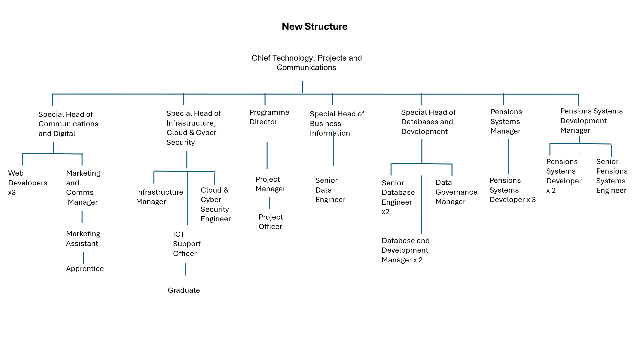

Key benchmarked competencies, traits and motives required to successfully deliver the role (not required for JE. Informs recruitment, succession planning, development and performance management
Operates with Strategic Awareness Our managers work with corporate priorities and policies in a joined-up way with others, internally and externally. Works democratically, transparently and accountably.

Practices Appropriate Leadership Our managers motivate their staff to exceed expectations through raising their awareness of goals and moving them beyond self-interest for the sake of the team or service. They consider serving the District in all that they do.

Delivering Successful Performance Our managers monitor performance of services, teams & individuals against targets & celebrate great performance. They promote the District’s vision & work to achieve Council’s values & agreed outcomes

Must be able to perform all duties and tasks with reasonable adjustment, where appropriate, in accordance with the Equality Act 2010 in relation to Disability Provisions.
Must be prepared to travel to address or participate in meetings, liaise with staff working in remote offices, undertake training both within and outside West Yorkshire. Must be able to work flexible hours as required by the needs of the service

The post will be subject to a DBS check.

