CITY OF BRADFORD METROPOLITAN DISTRICT COUNCIL

JOB PROFILE

DEPARTMENT: Chief Executive | SERVICE GROUP: West Yorkshire Pension Fund (WYPF)
POST TITLE: Finance Officer | REPORTS TO: Senior Finance Officer
GRADE: Band 7 to SO1 |  | POST REFERENCE (SAP): 11000180

The following information is furnished to help Council staff and those people considering joining the City of Bradford Metropolitan District Council to understand and appreciate the general work content of their post and the role they are to play in the organisation. The duties and responsibilities highlighted in this Job Profile are indicative and may vary over time. Post holders are expected to undertake other duties and responsibilities relevant to the nature, level and scope of the post and the grade has been established on this basis.

As a candidate you will be expected to demonstrate your ability to meet the special knowledge, experience and qualifications required for the role by providing evidence in the application form for the purpose of shortlisting. Applicants with disabilities are only required to meet the essential special knowledge requirements shown by a cross in the end column of this section.

The employee competencies are the minimum standard of behaviour expected by the Council of all its employees and the management competencies outlined are those relevant for a post operating at this level within our organisation.

Both sets of competencies will be used at interview stage and will not be used for short listing purposes. Please see the separate guidance information on how to complete the form located on Bradnet.

Key Purpose of Post:
Is to support WYPF in providing pensions financial services to 570 employers and 343,870 pension members across the UK, accounting for pensions payroll of £450m and pension contribution income of £400m per year; managing pensions operational budget of £9m per annum. Work within WYPF Finance Team in delivering WYPF statutory financial responsibilities, maintain financial controls by providing a range of transactional and technical accounting services to services within WYPF and CBMDC Corporate Services. The role of finance officers is to:

- Ensure timely receipt of all income due to WYPF, payments made are paid correctly by WYPF, active members data returns are recorded and fully accounted for in the general ledger system (SAP) and pension administrative system (UPM).

- Monitor employers’ performance on financial activities, data and statistical returns with WYPF.

- Process, validate and where necessary investigate and correct monthly data returns from employers and post validated monthly data returns and financial transactions on pensions administration system.

- Assist senior finance officers in carrying out WYPF day to day financial services operations, deputise as necessary for senior finance officers, at all times operate with appropriate financial discipline, confidentiality and data protection policies on payroll information, whilst maintaining a good working relationship with all business contacts.

- Take reasonable care of own health and safety and that of others who may be affected by the work of the post holder.

Main Responsibilities of Post:
- Band 7 Principal Duties – Generic

At this level finance officers are required to

- Develop specific knowledge about pension financial transactions, pension contributions payments – employers’ and employee rates, pensions benefit payments and general pension finances.

- Understand and apply CBMDC’s general finance policies and procedures and basic understanding of accounting rules and policies.

- Support the team in processing monthly returns from employers, follow up on employers, members and service partners’ enquiries on payments, monthly data returns and contribution payments.

- Provide timely financial information and advice to WYPF officers, employers and suppliers and service users.

- Band 8 Principal Duties –

In addition to A.) above, finance officers at this level will

- Act as the named Finance Business Partner and primary finance contact for a set number of allotted employers on all data returns and financial queries, with responsibility for managing financial transactions, monthly data returns, data processing on pension systems, employers performance monitoring, contribution monitoring for the allotted employers.

- Analyse and carry out monthly reconciliation of contributions due and paid employers allocated to them and provide annual statement of payments to employer for audit certification.

- Process, validate, investigate errors and post validated monthly data returns and financial transactions from employers on pensions’ administration systems.

- Take responsibility for managing their employers’ monthly data return performance, ensure data returns are processed within agreed deadlines and find solutions for employers to ensure monthly data returns and contributions payment processes are managed efficiently with individual employers.

- Ensure WYPF pension administration processes, procedures and policies are followed for recording members’ contributions, detailed entitlement records such as hours, start and leaver dates.

- Support in the completion of pensions statistical returns.

- Manage WYPF stationery store and provide support in maintaining stationery supplies, ordering goods on P2P for service across WYPF, ensuring CBMDC processes and policies are followed.

- Provide training to new staff and pension officers on monthly data returns and processes.

- Band SO1 Principal Duties –

In addition to A.) + B.) above, finance officers at this level will

- Participate in cross Pension Fund team tasks and projects in improving members and employers records on SAP and pension administration systems.

- Promote continuous improvement by exploring ways of improving WYPF finance processes and work with WYPF ICT and UPM Team in implementing WYPF Finance Team processes and system changes

- Provide a range of finance business support roles to WYPF service teams.

- Supervise a significant part of the WYPF finance processes for example :

  - Monthly contribution secure web site
  - Live monthly data processes
  - Training of new employers on monthly data return
  - Reconcile third party recharges for fire service, unfunded pension strain, shared service recharges.

Structure:
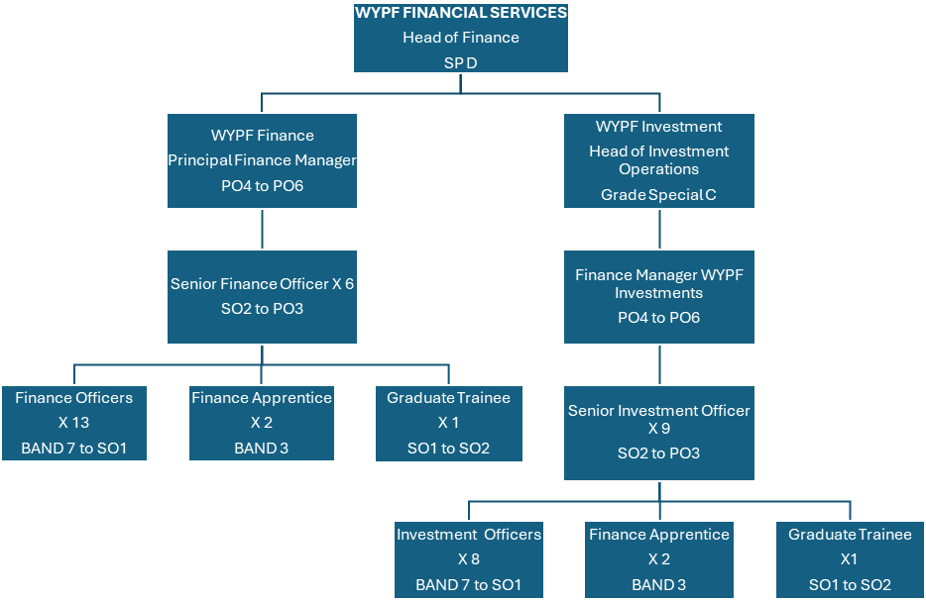

Special Knowledge Requirement. Will be used for shortlisting.
 | Essential
Applicants with disabilities are only required to meet the essential special knowledge requirements shown by a cross in the end column.
Uses knowledge of Health, Safety and Environmental policies, procedures and regulations including risks in own area of work i.e. financial management | X
Uses a wide range of basic computer applications such as Microsoft Excel, Word and Outlook. | X
Ability to adopt a process of continual improvement and suggest ways of working more efficiently and effectively to improve service delivery. | X
Knows and understands how to use, interpret, handle and communicate  information | X
Applies a working knowledge of payroll and or pension systems | X
Ability to use general ledger financial systems competently | X
Knowledge of banking and operating BACs payment processes | X

Relevant experience requirement: Will be used for shortlisting

Applicants for Band 7 posts are expected to have
At least one year experience of working in a finance service on general ledger financial systems, processes and procedures.

Applicants for Band 8 posts are expected to have
Relevant experience of working within a finance service environment carrying out a range of duties with limited supervision

Applicants for Band SO1 posts are expected to have
- Experience of income management and collection
- Experienced in using general ledger systems, Microsoft Excel, Word and Outlook
- Experience of supervising a significant finance or accounting process e.g. :

  - banking, BACS and BACs recall processes
  - pension data return processes

Relevant professional qualifications requirement: Will be used for shortlisting

Applicants for Posts working at Band 7 are expected to have:
5 Grade A to C GCSEs including English and Maths (or equivalent qualification)

Applicants for Posts working at Band 8 are expected to have:
5 Grade A to C GCSEs including English and Maths (or equivalent qualification)

and

Relevant experience of working within a finance service environment carrying out a range of duties with limited supervision

Applicants for Posts working at Band SO1 are expected to have:

Part qualified AAT and actively studying for full AAT qualification.

Core Employee competencies to be used at the interview stage.
Carries Out Performance Management
Covers the employee’s capacity to manage their workload and carry out a number of specific tasks accurately and to a high standard.

Communicates Effectively
Covers a range of spoken and written communication skills required as a regular feature of the job. It includes exchanging information/building relationships; giving advice and guidance; counselling, negotiating and persuading and handling private, confidential and sensitive information.

Carries Out Effective Decision Making
Covers a range of thinking skills required for taking initiative and independent actions within the scope of the job. It includes planning and organising, self effectiveness and any requirements to quality check work.

Undertakes Structured Problem Solving Activity
Covers a range of analytical skills required for gathering, collating and analysing the facts needed to solve problems. It includes creative and critical thinking; developing practical solutions; applying problem solving strategies and managing interpersonal relationships.

Operates with Dignity and Respect

Covers promoting equality, treating all people fairly and with dignity and respect, maintains impartiality/fairness with all people, is aware of the barriers people face.

Working Conditions:

Must be able to perform all duties and tasks with reasonable adjustment, where appropriate, in accordance with the Equality Act 2010 in relation to Disability Provisions.

Special Conditions:
You will be informed if there is a requirement for the post to have recruitment checks
such as DBS, Warner Process. (basic disclosure and barring service check is required for WYPF finance Staff).

Compiled by: Ola Ajala  Date: 1st March 2020 | Grade Assessment Date: July 2020 | Post Grade: 7/SO1

