Role Profile

Reference Number | 01098
Role Title | Cloud and Cyber Security Engineer
Directorate | Office of the Chief Executive
Department | West Yorkshire Pension Fund
Reports to | Special Head of Infrastructure, Cloud and Cyber Security

Role Purpose
Leads and manages the development of cloud-based applications and infrastructure for WYPF.
The role requires the incumbent to design, implement, and maintain scalable, secure, and high performing hybrid cloud environment. Proactively supports other technology teams and WYPF’s wider objectives.
Leads the implementation of WYPF’s advanced cloud framework and management systems in a Hybrid environment, covering virtualised and containerised IT systems.
Designs, implements, and manages cloud infrastructure and services, working with platforms like AWS, Azure, and Google Cloud to build scalable and reliable solutions.
Assisting in the architecture of our Cyber Security solutions, ensuring they meet business requirements, scalability needs, pensions and financial services industry and regulatory standards.
Lead WYPF’s cyber security, i.e. design monitoring, detection, and response to security threats; being the first line of defence in keeping systems safe.

Accountabilities
Operations
Design and implement Azure cloud-based solutions to meet organisational needs.
Select the appropriate frameworks, platforms, and technology stacks to create cloud-based solutions.
Lead the integration of various services and APIs, requiring coding skills to connect different systems and automate workflows.
Integrate various services and APIs, requiring coding skills to connect different systems and automate workflows.
Manage the infrastructure of cloud platforms, ensuring that it is running efficiently and effectively collaborating with Cloud platforms and external suppliers.
Lead the cyber security and robustness of all cloud environments.
Lead the strategic planning for WYPF cyber security and contribute to technology roadmaps.
Lead the development of infrastructure as code and cloud automation.
Investigating and responding to security alerts, documenting findings and collaborating with relevant teams.
Leading internal audits to ensure compliance with ISO 27001 and our security policies.
Identifying vulnerabilities across networks, operating systems, applications, and databases, ensuring risks are addressed effectively.
Staying ahead of emerging cyber threats, driving improvements in our security strategy and processes.
Engaging with clients and external auditors to demonstrate the strength of our security controls.
Manage and optimise cloud cost and efficiency.
Responsible for cloud products, features, unit testing, code reviews and resolve bugs that are discovered.
Developing both test and development production environments.
Basic management of switching, configuring, and maintaining network devices like SD-WAN, routers, switches, and firewalls for reliable and secure connectivity.
Familiarity with security hardening principles and an ability to implement in line with financial services industry benchmarks.
Continue to provide performance tuning, automation and to optimise our IT systems. Determine operating costs, productivity levels, and any upgrade requirements.
Creating and maintaining our technical documentation, including system configurations, diagrams, and operational procedures. Ensuring infrastructure, security or application components comply with relevant industry standards and regulations
Provide cyber security cloud posture reports for cyber compliance reporting requirements.
Be ready to assist with resolving tickets during high volumes or overwhelming demand, demonstrating a team-oriented approach
Assist with vision and leadership for developing and implementing information technology initiatives to develop and manage our application portfolios, to plan, organise, and manage our IT transformation.
Assist in the development of business case justifications and cost/benefit analyses for IT spending and initiatives.

Knowledge / Skills / Experience required
Significant commercial experience of designing, deploying and managing enterprise cloud environments.
Experience of containers and container orchestration.
In-depth configuration management, automation and scripting using tools such as Python, Ruby and Go.
Detailed knowledge of platform and application automated deployment technologies like Puppet, Chef, SaltStack etc.
Exposure to iterative/agile development methodologies and experience of enabling team delivery through technology.
Provide subject matter expertise on cloud architecture and design.
Transformational expertise, superior analytical and problem-solving abilities with an attention to detail.
Bachelor’s degree in technology and 5+ years of related experience; or equivalent experience.
Certification/s in relevant IT Cloud disciplines.
Experience, networking, security & scripting.
A strong understanding of the Linux operating system, the architecture, maintenance and administration of Linux servers.
Strong general programming skills of programming languages such as SQL, Java, Python, Ruby, Golang, PHP and .NET.
Knowledge of open standards, such as XML (Extensible Markup Language), WSDL (Web Services Description Language) and UDDI (Universal Description, Discovery and Integration), and an expert understanding of how APIs are engineered.
Professional certifications such as Certified Information Systems Security Professional (CISSP), Certified Information Security Manager (CISM), Certified in Risk and Information Systems Control (CRISC) or similar.
Proven experience conducting comprehensive cyber security risk assessments and developing risk management strategies in alignment with industry standards and best practice.

Dimensions of role (direct/ indirect as applicable) e.g. total number of staff managed/ total budget/ total scope of role
Manage the access to highly confidential, personal, financial, political and commercially sensitive information; to ensure compliance with appropriate legislation e.g. GDPR, FOI, Child Protection Act, etc (and any UK replacement). The unauthorised disclosure of which would prejudice the interests of the Council.
It is a requirement to comply with the following legislation that applies in financial services and pensions:
- FCA EC 3.16 Information technology systems
- MiFID RTS 7 (now UK regs)
- SYSC 13.7 Processes and systems
- CTPS 4.5 Requirement 4: Technology and cyber resilience
- PRA SS2/21 Outsourcing and third-party risk management

Structure Chart (role of direct reports)
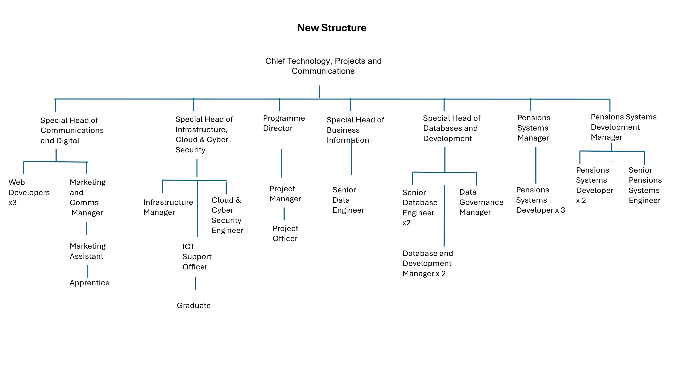

Key benchmarked competencies, traits and motives required to successfully deliver the role (not required for JE. Informs recruitment, succession planning, development and performance management
Operates with Strategic Awareness Our managers work with corporate priorities and policies in a joined-up way with others, internally and externally. Works democratically, transparently and accountably.

Practices Appropriate Leadership Our managers motivate their staff to exceed expectations through raising their awareness of goals and moving them beyond self-interest for the sake of the team or service. They consider serving the District in all that they do.

Delivering Successful Performance Our managers monitor performance of services, teams & individuals against targets & celebrate great performance. They promote the District’s vision & work to achieve Council’s values & agreed outcomes

Must be able to perform all duties and tasks with reasonable adjustment, where appropriate, in accordance with the Equality Act 2010 in relation to Disability Provisions.
Must be prepared to travel to address or participate in meetings, liaise with staff working in remote offices, undertake training both within and outside West Yorkshire. Must be able to work flexible hours as required by the needs of the service

The post will be subject to a DBS check.

