

Job Profile – Head of Service - Licensing.
(POST GRADE)

Department: Environment

Responsible to: Assistant Director – Waste, Fleet, Environmental Health, and Licensing

Responsible for: Regulatory and Compliance Manager
Customer and Business Support Manager
Senior Licensing Officer
Enforcement Officers
Licensing Officers

Job purpose

Be responsible and accountable for the strategic direction performance and professional delivery of Bradford council's licencing service. Manage and deliver all aspects of the council's licencing functions in accordance with statutory requirements and guidance. Deliver innovative financial and operationally sustainable solutions against agreed requirements and the legislative framework which meets budgetary and financial targets.

Promote and safeguard public safety through the operation of the licensing, control and regulatory regime in accordance with relevant legislation.

Lead on the development, statutory review and publication of the Council’s policies required by the Licensing and Gambling Acts. Develop strategies and key initiatives to support the licensees to deliver a compliant fair and equitable customer focused service to the public.

Key responsibilities

- Ensure the provision of a legally compliant, customer focused Licensing Service and to ensure that the safety of the public is not compromised. This will include flexible, responsive, and effective licensing service operations to support decision making on sound principles which comply with both the Council’s and legislative procedures and processes.

- Responsible to the Assistant Director, Dept Environment, with a high degree of discretion and delegated authority. The seniority of the post is such that the post holder is required to demonstrate initiative, high levels of political awareness, professional and managerial competence in carrying out the functions of the post.

- Responsible for providing operational management direction and area expertise responsible for providing professional advice support and guidance to all service users across a range of licensable activities.

- Direct management responsibility of the licensing service management team to ensure that they manage the day to day workload of all licensing, compliance, customer service and support staff, set priorities and monitor progress to ensure that the Licensing Service objectives and targets are achieved speedily and effectively.

- Have wide-ranging and extensive authority to act on matters of professional judgement, particularly with reference to technical, legal and regulatory licensing matters and compliance.

- Review, develop and implement Council policies relating to the licensing regime, including delivering specialist projects in accordance with Government guidance and legislation. Deliver innovative financially and operationally sustainable solutions which meet recognised guidance and legislative frameworks for an operational budget of approximately £3 million.

- Deal with highly complex legal, sensitive and confidential licensing matters on a regular basis, liaise with Barristers, Solicitors and the Council’s Legal Services in connection with the preparation of court documents, represent the licensing service at Magistrates Court, County, Crown or High Court on behalf of the Council

- Provide early and proactive engagement with Senior Managers, Assistant Directors, Strategic Directors, Portfolio Holder, Leader of the Council, external agencies and other Council Members, providing professional information to ensure clarity and understanding on licensing matters

- Work collaboratively with external agencies, give specialist advice and maintain effective communications and relationships with the Council’s strategic partners whilst being politically aware and informed of national issues.

- Exercise creative judgement in ensuring the promotion of good public image on Council policy such as the pursuit of liaison with ethnic minority groups, disability and gender groups and the promotion of the Equality Act 2010

- To foster, develop and maintain constructive working relationships with key stakeholder groups which includes external safeguarding agencies (e.g Police, Bradford Safeguarding Board) and other local authorities to continuously promote effective communication and education of safeguarding matters to the licensed trade (e.g training in CSE, Human Trafficking, Modern Day Slavery and County Lines)

- Actively develop and ensure appropriate mechanisms are in place for achieving a continuous improvement in the performance and development of the licensing service and facilitating best value in service delivery.

- Manage the effective operation of a range of complex licensing ICT systems including IDOX and CIVICA ensuring team managers supervise staff training on ICT systems and that they constantly monitor the skill and performance of staff to ensure a high level of ICT skills across all licensing service staff

- Ensure confidentiality and the security and protection of sensitive and personal customer information/data in line with GDPR (2018) and Council policies and procedures. Effectively process all Freedom of Information and Data Protection requests received within the terms of legislation, ensuring that the Council meets its duties under the (FOI) Act, (EIR) and (GDPR) Act.

- To comply with Council Standing Orders, Financial Regulations, Codes of Conduct; including Equal Rights, Health & Safety and Departmental policies and procedures

Dimensions of role (direct/ indirect as applicable) e.g., total number of staff managed/ total budget/ total scope of role

The scope of the role includes all licencing provision and enforcement compliance, dealing with licensees, stakeholders, members of the public, elected members, committees, and other enforcement agencies. It is the responsibility of the post holder to review recommend and implement policies, conditions, and procedures which both safeguard the public, the reputation of the council and are conducive to licensees.
Current numbers off taxi licencing and private hire licencing stand at over 10,000 drivers and over 7000 vehicles with 160 operators. There are approximately 8500 premises & personal licences, plus an additional 800 temporary event notices.

Overall assurance that these services should remain at cost neutral with surpluses required to be ring fenced to the relevant licensing activity budget with the potential to reduce licencing fees where appropriate. This should be achieved whilst ensuring that the utmost level of compliance is maintained.

General licencing includes the Licencing Act 2003 has four licencing objectives, the prevention of crime and disorder, public safety prevention of public nuisance and the protection of children from harm. The post holder must ensure that these objectives are met, failure to so so may lead to reputational damage, fines and prosecution of the council.

7 Direct Line reports – over sees a team of 44
Budget responsibility for £3 to 3.5 Million

Structure Chart (role of direct reports)
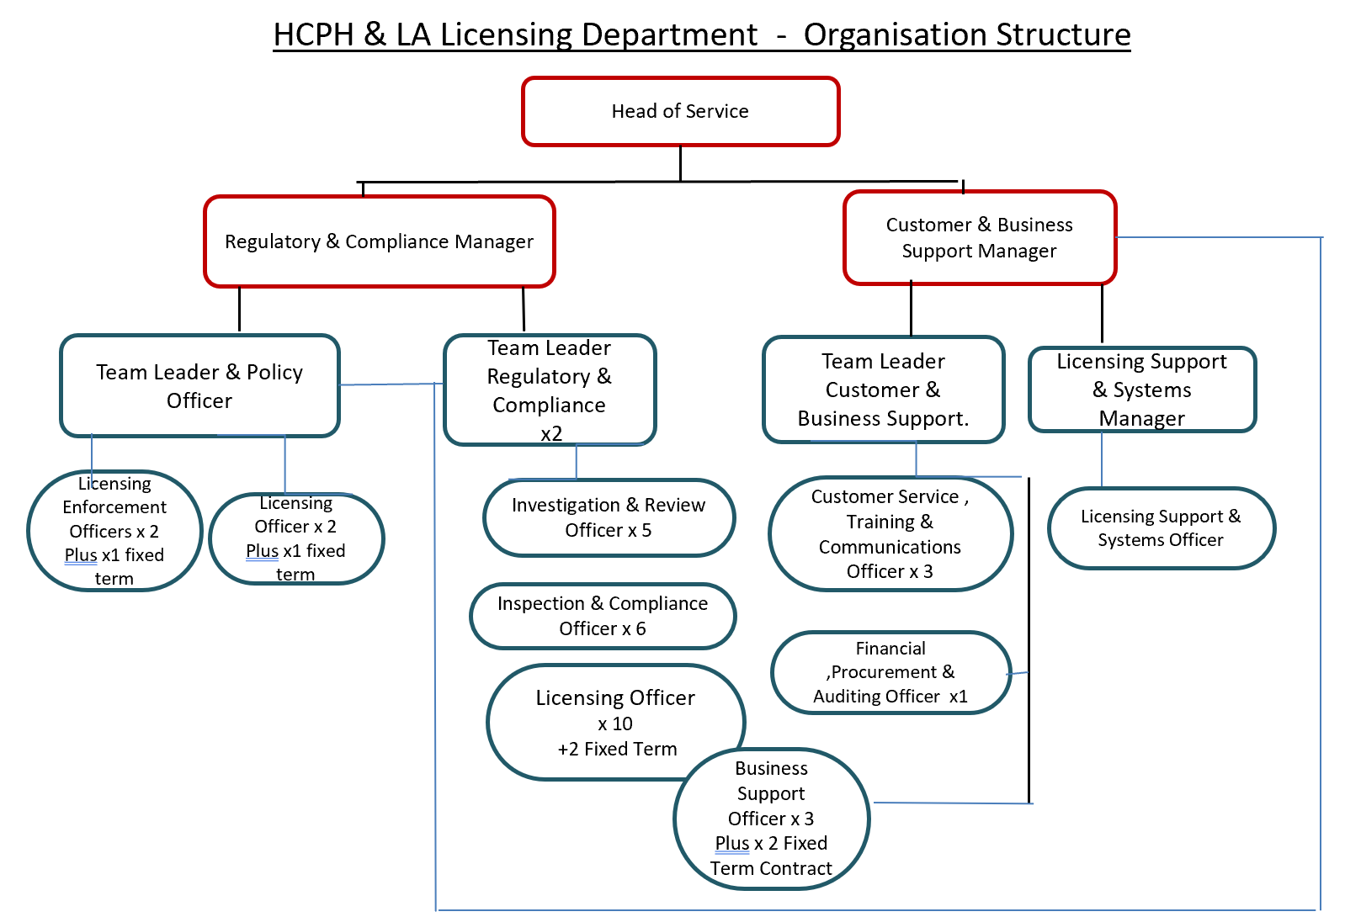

Person specification – Head of Service Licensing.
Qualifications | Degree or Extensive demonstrable evidence of operating in the Licensing or related professional field at a senior level.
Knowledge and  experience | The applicant is required to provide evidence of having previously spoken fluently to members of the public in order to meet the advanced threshold standard outlined under Special Knowledge above.  Experience of managing a diverse range of teams and the ability to adapt and employ differing management styles to achieve the desired results with Team Managers.  Extensive experience in managing a regulatory operational field which includes management experience, financial management and accountability of service budget.  Significant experience of interpreting and applying the law relating a regulated service.  Experience of procurement and customer service management and ensuring standards and performance are met.  Experience of making managerial decisions in relation to business growth with collaborative leadership skills and the ability to deputise for the Assistant Director in own area of responsibility.  Have excellent communication skills to work with the general public and will need to be confident in ability to deal with a wide range of stakeholders and difficult situations with the need to convey complex detailed information.  Ability to develop policies and procedures and lead the teams to achieve good practise in relation to enforcement activities, including investigation and prosecution.  Understanding to prepare and present formal and informal reports to all levels of management and to relevant committees and to lead on the agenda for licencing committees work with stakeholders including the chair of the licencing committees.  Understanding and experience of the finer financial aspects of the role, regarding the varying legislation and associated policies and the specific guidance which needs to be considered when setting fees.  The post holder must have the ability to be able to provide detailed advice and guidance to senior management and elected members, the public and other stakeholders, in order to avoid reputational damage to the Council  Evidence of being a creative and innovative thinker, to support plans and restructuring as a result of external pressures whilst maintaining the best service possible
Core Employee competencies at manager level to be used at the interview stage.

Carries Out Performance Management – covers the employees’ capacity to manage
their workload and carry out a number of specific tasks accurately and to a high standard.
Communicates Effectively - covers a range of spoken and written communication skills required as a regular feature of the job. It includes exchanging information/building relationships, giving advice and guidance, counselling, negotiating and persuading and handling private, confidential and sensitive information.
Carries Out Effective Decision Making - covers a range of thinking skills required for taking initiative and independent actions within the scope of the job. It includes planning and organising, self-effectiveness and any requirements to quality check work.
Undertakes Structured Problem Solving Activity - covers a range of analytical skills required for gathering, collating and analysing the facts needed to solve problems. It includes creative and critical thinking, developing practical solutions, applying problem solving strategies and managing interpersonal relationships.
Operates with Dignity and Respect - covers treating everyone with respect and dignity, maintains impartiality/fairness with all people, is aware of the barriers people face.

Management Competencies: to be used at the interview stage.

Operates with Strategic Awareness Our managers work with corporate priorities and policies in a joined up way with others, internally and externally. Works democratically, transparently and accountably.
Practices Appropriate Leadership Our managers motivate their staff to exceed expectations through raising their awareness of goals and moving them beyond self-interest for the sake of the team or service. They consider serving the District in all that they do.
Delivering Successful Performance Our managers monitor performance of services, teams & individuals against targets & celebrate great performance. They promote the District’s vision & work to achieve Council’s values & agreed outcomes.
Applying Project and Programme Management Our manager’s work to ensure that outcomes and objectives are achieved within desired timescales make best use of resources and take a positive approach to contingency planning.
Developing High Performing People and Teams Our managers coach individuals and teams to achieve their potential and take responsibility for continuous improvement. They champion the Council’s values and goals.
Working Conditions:

Must be able to perform all duties and tasks with reasonable adjustment, where appropriate, in accordance with the Equality Act 2010 in relation to Disability Provisions.
Special Conditions:

You will be informed if there is a requirement for the post to have recruitment checks
such as DBS, Warner Process.

Completed by: | Susan Spink – AD WFEH&L | Date: | 29/04/2024
Quality checked:  (HR) | Ian Poppleton - HRBP | Date: | 02.05.2024

