
City of Bradford Metropolitan District Council Job Profile
Reference Number | 01127
Role Title | Travel Assistance Co-ordinator
Directorate | Children’s Services
Service Area | SEND & Inclusion
Reports to | Operations Manager - Assessment

Role Purpose (maximum of 3 points, with no sub bullet points)
In accordance with agreed home to school travel policies, to oversee and implement the application and assessment process for travel assistance, including reviews and appeals, ensuring that all those identified as eligible receive assistance, and determining travel assistance arrangements based on the needs the young person.
Contribute to policy review, development and implementation. Make recommendations for improvement.
Lead on travel assistance appeals and put forward the Council’s case for declining assistance with travel. You will need to have a firm understanding of the statutory guidance and the Council’s home to school travel policies.

Duties and Responsibilities (maximum of 15 points, with no sub bullet points)
- Maintain effective communication with parents, schools, internal and external stakeholders to resolve queries and complaints.

- Coordinate with education and support professionals to obtain relevant information regarding the needs of children for travel assistance assessment purposes.

- Disseminate policy and entitlement information to ensure parents/carers are informed of available support.

- Arrange travel assistance with full consideration of individual needs and liaise with colleagues to implement provision and review as necessary.

- Manage the appeals process, including preparation, presentation, and follow-up.

- Complete Stage One Reviews when required and escalate complex cases to the Operations Manager.

- Liaise with Metro, Passenger Transport Services and other colleagues as appropriate to manage the issuing of travel passes, tickets, reimbursements and other authorisations, ensuring accurate and timely transport provision.
- Support and administer assessment panels by preparing and delivering accurate pupil information.

- Maintain and update secure databases for pupils receiving travel assistance and generate management reports.

- Ensure timely updates and accuracy of service-related information across service websites.

- Maintain up-to-date knowledge of policies and issues relevant to home-to-school travel.

- Monitor service delivery standards and take corrective action to improve operational performance.

- Deputise for the Operations Manager when necessary to ensure service continuity.

- Daily use of specialist IT mobility solutions, SAP for financing, invoicing, order raising, payments, requisitioning and the Microsoft office suite. Actively manage data protection including ensuring the safe keeping of personal, confidential, sensitive and business critical data retained in a variety of formats complying with GDPR regulations and requirements.

- The post holder will need to be a strong communicator verbally and in writing with a wide range of people, for example: Members of the public and staff across the Council at appropriate levels, Council partners, government departments and other public sector organisations and external agencies.

Dimensions of role (direct or indirect as applicable) e.g. total number of staff managed, total budget, total scope of role
Implementing specialist administrative procedures and routinely dealing with a range of customers, stakeholders and other organisations. Deputising for the Operation Manager only when necessary for 4 other staff (3 Travel Assistance Assessors – 2 are full time and 1 is part time, 1 full time Admistrative Assistance).

Structure Chart (showing direct reports)
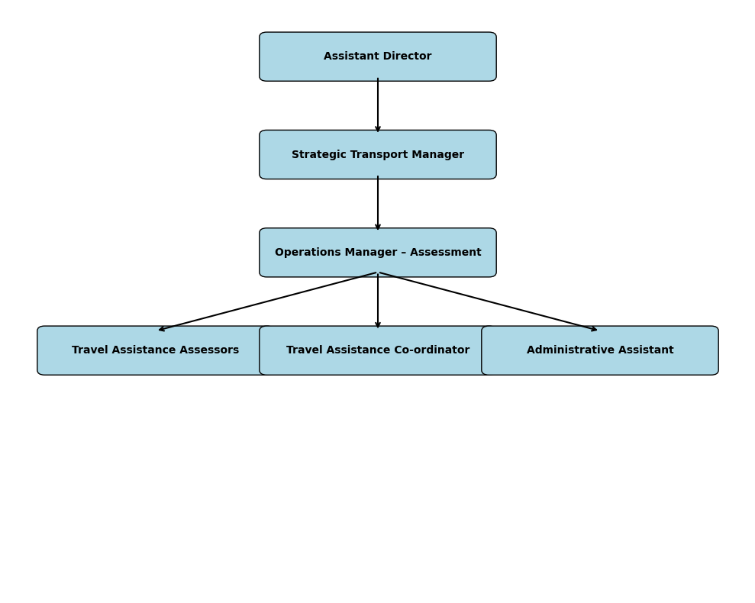

Person Specification
Knowledge / Skills / Experience required
Due to the Governments Fluency in English Duty for posts where employees speak directly to members of the public the post holder is required to meet the Advanced threshold level which will be implemented where the post requires a greater level of sensitive interaction with the public,( e.g. in children’s centres) – where the person is able to demonstrate that they can during the interview:  - Can express themselves fluently and spontaneously, almost effortlessly  - Only the requirement to explain difficult concepts simply hinders a natural smooth flow of language. | x
Demonstrates a strong understanding of statutory obligations and Council policy relating to travel assistance, ensuring fair and compliant service delivery. | x
Communicates professionally with service users, using effective questioning, sensitivity and discretion, identifying individual needs and responding accordingly. | x
Knows and understands how to analyse, interpret and present complex information from a vairiety of sources. | x
Provides specialist advice and support to managers and colleagues when necessary. | x
Knowledge of health, safety, and risk management procedures and regulations in relation to own area of work. | x
Uses a wide range of computer applications, understands the requirements surrounding data protection and the relevant transfer of data using appropriate mechanisms. | x
Carries out a variety of working practices, implements complex regulations, rules, procedures and processes. | x
Ability to adopt a process of continual improvement and suggest ways of working more efficiently and effectively to improve service delivery. | x

Key benchmarked competencies, traits and motives required to successfully deliver the role These will support recruitment, succession planning, development and performance management |  | Essential
Health and Safety | Uses knowledge of Health, Safety policies, procedures and regulations including risks in own area of work | x
IT Packages | Uses a range of complex IT packages relating to area of work | x
Service Improvement | Ability to adopt a process of continual improvement and suggest ways of working more efficient and effectively to improve service delivery | x
Continued professional Improvement | Carries out a variety of working practices, applies complex regulations, rules, procedures and processes across a technical /specialist area | x
Communication | Knows and understands how to use, interpret, handle and communicate, often complex and detailed information, and relay it to service users/stakeholders in writing and/or over the telephone / face to face. | x
Numeracy & Literacy | Demonstrates a high level of numeracy, literacy and accuracy across a range of activities | x
Relevant Professional Qualification | Five GCSE Grade A-C (or equivalent), including Maths and English, or experience demonstrating the ability and achievement to work at this level.  NVQ Level 3 or equivalent qualification at Level 3, for example, two or more A-levels. | x
Carries out performance management | Covers the employees’ capacity to manage their workload and carry out a number of specific tasks accurately and to a high standard. | x
Communicates Effectively | Covers a range of spoken and written communication skills required as a regular feature of the job. This includes exchanging information/building relationships, giving advice and guidance, counselling, negotiating and persuading and handling private, confidential and sensitive information. | x
Carries Out Effective Decision Making | Covers a range of thinking skills required for taking initiative and independent actions within the scope of the job. This includes planning and organising, self-effectiveness and any requirements to quality check work. | x
Undertakes Structured Problem-Solving Activity | Covers a full range of analytical skills required for gathering, collating and analysing the facts needed to solve problems. This includes creative and critical thinking, developing practical solutions, applying problem solving strategies and managing interpersonal relationships. | x
Operates with Dignity and Respect | Covers treating everyone with respect and dignity, maintains impartiality/fairness with all people, is aware of the barriers people face. | x
Practices Appropriate Leadership | Our managers motivate their staff to exceed expectations through raising their awareness of goals and moving them beyond self-interest for the sake of the team or service. They consider serving the District in all that they do.
Operates with Strategic Awareness | Our managers work with corporate priorities and policies in a joined up way with others, internally and externally. Works democratically, transparently and accountably.
Delivering Successful Performance | Our managers monitor performance of services, teams & individuals against targets & celebrate great performance. They promote the District’s vision & work to achieve Council’s values & agreed outcomes.
Applying Project and Programme Management | Our manager’s work to ensure that outcomes and objectives are achieved within desired timescales, make best use of resources and take a positive approach to contingency planning
Developing High Performing People and Teams | Our managers coach individuals and teams to achieve their potential and take responsibility for continuous improvement. They champion the Council’s values and goals.

Applicants with disabilities are only required to meet the essential special knowledge requirements (clearly marked)
Due to the Governments Fluency in English Duty for posts where employees speak directly to members of the public the postholder is required to meet the Advanced threshold level.
You should be able to demonstrate that you can use a wide range of simple words and a standard English sentence structure to express and maintain a flowing conversation even though you pause to think of the correct words with the ability to express and make yourself understood (this will also be tested during the interview).

Completed by: | Liam Casey | Date: | 14/10/2025
Quality checked: |  | Date:

