
City of Bradford Metropolitan District Council Job Profile
Reference Number | 50230253
Role Title | Senior Biodiversity Officer
Directorate | Place
Service Area | Planning, Transportation and Highways
Reports to | Principal Biodiversity Officer

Role Purpose (maximum of 3 points, with no sub bullet points)
1. To support the implementation of the Council’s Biodiversity Duty as set out in the Natural Environment and Rural Communities Act 2006.
2. To provide advice and technical support to development management, development planning and other Services, including identifying the need for ecological assessments and surveys, appropriate conditions and other relevant matters and assessing the impacts of development, major projects and other proposals, including the adequacy of ecological assessments and survey information.
3. Working with external governmental and non-governmental agencies and organisations, appropriate user and interest groups, maintaining effective monitoring systems, maintaining appropriate data and collection systems and providing and disseminating information including digital and electronic, co-ordination of voluntary/external resource as necessary, in order to further the Council’s Biodiversity Duty.

Duties and Responsibilities (maximum of 15 points, with no sub bullet points)
1. Comment on consultation responses on planning applications (including major applications), and other proposals where there are potential impacts on biodiversity/ ecology, as part of the Development Management process.

2. Provide ecological advice to assist in the development and preparation of policies within local plans/frameworks and other initiatives relating to development and biodiversity, including support to Biodiversity Net Gain, Habitat Regulations
Assessment, Strategic Environmental Assessment and Sustainability Appraisal of local plan documents.

3. Designated Sites: contribute to designation of new local sites of nature conservation value such as Local Wildlife Sites and Local Nature Reserves, obtaining relevant survey information, writing ,management plans and advising on site management.

4. Develop the creation of habitats banks on council land. To identify land appropriate for habitat banks. To include habitat surveying, sometimes on difficult terrain, and creation of HMMP and engagement with legal processes.

5. Protected Species: provide advice and assessment in respect of Protected Species, including licencing. Undertake surveys for other departments as required, sometimes on difficult terrain.

6. To represent the Council where appropriate on external partnerships such as: Bradford Biodiversity Partnership; the West Yorkshire Local Sites Partnership in relation to the review of Bradford’s Local Wildlife Sites; the Advisory Group for West Yorkshire Ecology Service (the county-based service which advises on sub regional biodiversity conservation and hosts the West Yorkshire Ecological Records Centre); at external meetings, regional and sub-regional networks and with external bodies on biodiversity matters as appropriate.

7. Plan, co-ordinate and supervise occasional related activity undertaken by third parties eg. external consultants, local recording groups or conservation volunteers.

8. Support the Biodiversity Team at public inquiries as required and write reports for senior officers and appropriate committees, recommending appropriate courses of action regarding biodiversity issues.

9. Resolve queries and complaints from the general public, user groups, elected members, local MPs, developers and landowners relating to biodiversity and wildlife matters and provide general guidance and advice in respect of the Council’s Biodiversity Duty.

10. Liaise with other council departments (e.g. Highway Maintenance, Structures, Estate Management, Leisure Services, Legal Services, Planning Service), Ward Councillors, statutory undertakers, parish and town councils, user groups, and owners and any other individuals or parties in relation to biodiversity, to provide impartial advice and guidance.

11. Maintain written, cartographic and computerised records including GIS, and disseminate this information to other Council departments and partners.

13. Contribute to training of junior colleagues within the Biodiversity Team.

Dimensions of role (direct or indirect as applicable) e.g. total number of staff managed, total budget, total scope of role
N/A

Structure Chart (showing direct reports)
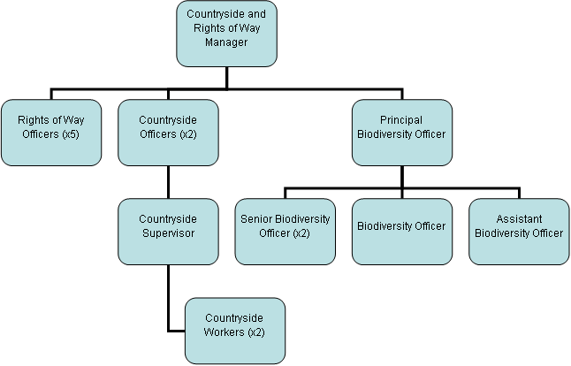

Person Specification
Knowledge / Skills / Experience required
Knowledge and understanding of legislation and processes relating to wildlife and biodiversity including designated sites; and the Council’s duties in this respect.
Knowledge and understanding of the relevant parts of the development management and the strategic planning process in relation to biodiversity
Working knowledge of UK and regional wildlife and their habitat requirements.
Ability to appraise habitats, in particular in relation to regional and UK Priority Habitats and value for protected species.
Comprehensive experience in habitat and protected species survey and assessment, familiarity with and understanding of UKHabs survey methodology
Experience of the writing of ecological survey reports and assessment documents.
Understanding and experience of Biodiversity Net Gain methodologies, legislation and principles.

Key benchmarked competencies, traits and motives required to successfully deliver the role These will support recruitment, succession planning, development and performance management |  | Essential
Health and Safety | Uses knowledge of Health, Safety policies, procedures and regulations including risks in own area of work | X
IT Packages | Uses a range of complex IT packages relating to area of work | X
Service Improvement | Ability to adopt a process of continual improvement and suggest ways of working more efficient and effectively to improve service delivery | X
Continued professional Improvement | Carries out a variety of working practices, applies complex regulations, rules, procedures and processes across a technical /specialist area | X
Communication | Knows and understands how to use, interpret, handle and communicate, often complex and detailed information, and relay it to service users/stakeholders in writing and/or over the telephone / face to face. | X
Numeracy & Literacy | Demonstrates a high level of numeracy, literacy and accuracy across a range of activities | X
Relevant Professional Qualification | - A degree in Ecology or other relevant environmental subject  - Eligibility for membership of CIEEM (Associate level or above) | X
Carries out performance management | Covers the employees’ capacity to manage their workload and carry out a number of specific tasks accurately and to a high standard. | X
Communicates Effectively | Covers a range of spoken and written communication skills required as a regular feature of the job. This includes exchanging information/building relationships, giving advice and guidance, counselling, negotiating and persuading and handling private, confidential and sensitive information. | X
Carries Out Effective Decision Making | Covers a range of thinking skills required for taking initiative and independent actions within the scope of the job. This includes planning and organising, self-effectiveness and any requirements to quality check work. | X
Undertakes Structured Problem-Solving Activity | Covers a full range of analytical skills required for gathering, collating and analysing the facts needed to solve problems. This includes creative and critical thinking, developing practical solutions, applying problem solving strategies and managing interpersonal relationships. | X
Operates with Dignity and Respect | Covers treating everyone with respect and dignity, maintains impartiality/fairness with all people, is aware of the barriers people face. | X
Practices Appropriate Leadership | Our managers motivate their staff to exceed expectations through raising their awareness of goals and moving them beyond self-interest for the sake of the team or service. They consider serving the District in all that they do.
Operates with Strategic Awareness | Our managers work with corporate priorities and policies in a joined up way with others, internally and externally. Works democratically, transparently and accountably.
Delivering Successful Performance | Our managers monitor performance of services, teams & individuals against targets & celebrate great performance. They promote the District’s vision & work to achieve Council’s values & agreed outcomes.
Applying Project and Programme Management | Our manager’s work to ensure that outcomes and objectives are achieved within desired timescales, make best use of resources and take a positive approach to contingency planning
Developing High Performing People and Teams | Our managers coach individuals and teams to achieve their potential and take responsibility for continuous improvement. They champion the Council’s values and goals.

Applicants with disabilities are only required to meet the essential special knowledge requirements (clearly marked)
Due to the Governments Fluency in English Duty for posts where employees speak directly to members of the public the postholder is required to meet the Lower threshold level.
You should be able to demonstrate that you can use a wide range of simple words and a standard English sentence structure to express and maintain a flowing conversation even though you pause to think of the correct words with the ability to express and make yourself understood (this will also be tested during the interview).

Completed by: | Danny Jackson | Date: | 18/03/2021
Quality checked: |  | Date: | 07/08/2023

