CITY OF BRADFORD METROPOLITAN DISTRICT COUNCIL JOB PROFILE

DEPARTMENT: Children’s Services | SERVICE GROUP: Education and Learning
POST TITLE: Assistant Head and Primary Phase Lead | REPORTS TO: Service Manager, MNHES
GRADE: Leadership Scale 8 - 12 | SAP POSITION NUMBER : tbc
The following information is furnished to help Council staff and those people considering joining the City of Bradford Metropolitan District Council to understand and appreciate the general work content of their post and the role they are to play in the organisation. The duties and responsibilities highlighted in this Job Profile are indicative and may vary over time. Post holders are expected to undertake other duties and responsibilities relevant to the nature, level and scope of the post and the grade has been established on this basis. For posts where employees speak directly to members of the Public the post holder is required to demonstrate their ability to speak fluently in English.

As a candidate you will be expected to demonstrate your ability to meet the special knowledge, experience and qualifications required for the role by providing evidence in the application form for the purpose of shortlisting. Applicants with disabilities are only required to meet the essential special knowledge requirements shown by a cross in the end column of this section.

The employee competencies are the minimum standard of behaviour expected by the Council of all its employees and the management competencies outlined are those relevant for a post operating at this level within our organisation.

Both sets of competencies will be used at interview stage and will not be used for short listing purposes. As a candidate/employee you will be expected to demonstrate your ability to meet the special knowledge, experience and qualifications required for the role.

Key Purpose of Post:
- To provide leadership capacity for and support the overall management of MNHES, to develop the quality of provision, teaching and learning and support for pupils within the provisions to improve their outcomes including the line management of members of the Leadership Team

- To lead the Primary staff team and work with Primary teaching in the hospitals to specialise in Primary phase teaching & learning, curriculum and working with pupils with a range of medical and health needs and be an integral part of the leadership team to provide education for children and young people with medical needs across the district

- To ensure effective differentiation for all children’s needs including those with SEND across MNHES while working closely with the LA SEND team and school SENCOs to ensure effective training is delivered to staff and appropriate curriculum is delivered to pupils
Main Responsibilities of Post:
- In partnership with the MNHES Service Manager and other Service Managers under STaSS, support the development of MNHES development plan which identifies Key Performance indicators, priorities and targets and measurable outcomes and regularly report on these.

- Support the overall responsibility for implementing monitoring and evaluation, quality assurance systems and processes for MNHES

- Accountable for reporting quality, effectiveness and outcomes of MNHES and identifying areas of improvement; working with LA senior leadership to ensure provision is of the highest quality and meeting needs.

- Liaise with schools to ensure appropriate exit and entry plans are in place and that working relationships remain fit for purpose and appropriate and regularly reviewed

- Keep up to date with current research, best practice in medical needs & SEND, communication & interaction (including autism), SEMH teaching and learning and provision to ensure the practice in MNHES is current, highly effective and meets needs.

- Ensure there is effective and regular communication and engagement with parents, families and children and young people including the statutory processes for example, Annual Reviews and use this information and other data and information to feed into a clear cycle of improvement.

- Working with HR and liaising with other managers and the Business Support Manager and School Funding team to support the recruitment of staff in line with the budget and funding rates per pupil and implement an induction process for new staff.

- Support the Service Manager with aspects of staff deployment to cover across the provision and staff management including appraisal and performance management and line management of the Primary phase team and the Therapeutic & Welfare Teams

- Work closely with the service managers in other specialist teaching and support services and collaborate with schools to share good practice.

- Be responsible for staff training to meet service needs, drawing on current research, best practice and effective work across the region and nationally, including planning the use of statutory training days.

- Produce information about the service for a wide range of audiences including the Local Offer, Head teachers and schools, Education & Learning Leadership and where necessary Elected members and ensure this is regularly updated and provide feedback for the Local Offer.

- Facilitate and co-ordinate partnership working with schools and other agencies, services, Teams and organisations to ensure the needs of children and families are met and outcomes are improved.

- Facilitate and co-ordinate partnerships with a range of professionals, agencies, organisations, parents and carers and schools – their Head teachers and Governing bodies and across Education, Health and Social Care and the Voluntary sector to establish effective communication, co-production and engagement to extend, develop and enhance the work of the provisions to meet need and improve outcomes.

- Representing and promoting the service at local, regional and national meetings when needed, and networking across the region to continuously review and improve provisions.

- Deputise for the Service Manager if required and be an integral part of the STASS services senior management team to facilitate flexible working across teams and build capacity, for example, outreach teaching and support.

Staff Structure

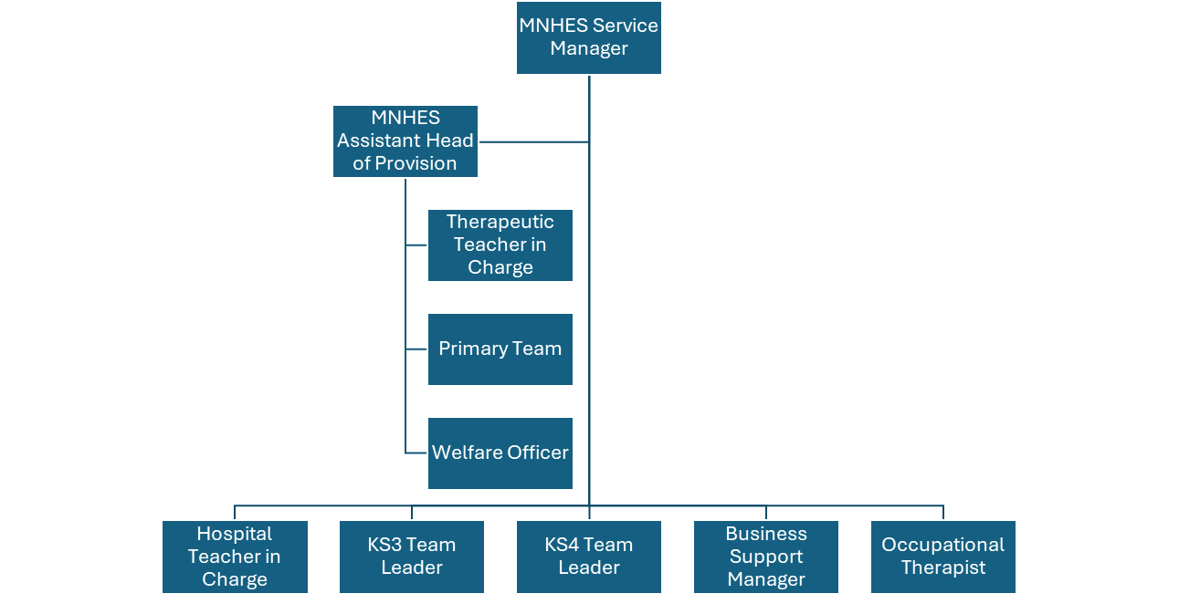
Special Knowledge Requirement: Essential for shortlisting.
Applicants with disabilities are only required to meet the essential special knowledge requirements shown by a cross in the end column
 | Essential
Due to the Governments Fluency in English Duty for posts where employees speak directly to members of the public the post holder is required to meet the Advanced Threshold level which will be implemented where the post requires a greater level of sensitive interaction with the public– where the person is able to demonstrate that they can during the interview:  - Can express themselves fluently and spontaneously, almost effortlessly  - Only the requirement to explain difficult concepts simply hinders a natural smooth flow of language | x
Carries out the working practices, procedures and basic operations across education particularly relating to additional needs and Uses knowledge, safety and environmental policies, procedures and | x

regulations, including risk in own area and/or other areas of Education Education Safeguarding, risk assessments and Health and
Safety (including relevant legislation) such as KCSIE, PREVENT, FGM etc.
Uses a range of specialist ICT systems across own work area – use of Microsoft packages and some knowledge of SIMS/Capita | x
Oversees the use of, interprets, analyses, and communicates complex numerical information – i.e. assessment outcomes, progress, achievement, educational attainment - outcomes and results, including attendance, and progress towards outcomes e.g. in EHCPs | X
Demonstrate effective management of a range of staff, including,  recruitment, induction, coaching & mentoring, line management and Performance Management processes and their professional  development and CPD. | x
Able to demonstrate a thorough knowledge of Learning needs and support the educational provision and teaching and learning strategies; evidence-based interventions and strategies - to explain and  communicate this effectively to a range of colleagues and professionals, parents and carers. | x
Maintain an up-to-date knowledge of developments in Education including SEND education and research in order to lead teaching and support staff and the provisions and facilitate good communication with families, on the most effective strategies to optimise individual children’s learning experiences and outcomes. | x
Able to promote effective strategic partnership and good practice in the resourced provisions schools, work closely with their leadership teams to promote co-ordinated effective support and joint strategies  to meet the needs of the pupils in the MNEHS provision | x

Relevant experience requirement: Essential for shortlisting
The applicant is required to provide evidence of having previously spoken fluently to members of the public to meet the Advanced threshold level outlined under
Special Knowledge above.
At least 5 years teaching experience of children and young people of statutory school age at the Primary phase
At least 3 years leadership and management experience within education
Substantial experience of Education Safeguarding either as DSL or Deputy DSL or
alternatively attended recent DSL training
Experience of partnership working with other organisations, agencies, staff, parents/carers/families to improve outcomes for CYP
Must be able to travel across the district
Relevant professional qualifications requirement: Essential for shortlisting
Essential: Educated to degree level and QTS
Desirable: Further qualification in leadership and management
Core Employee competencies at manager level to be used at the interview stage.

Carries Out Performance Management – covers the employees capacity to manage
their workload and carry out a number of specific tasks accurately to a high standard.
Communicates Effectively - covers a range of spoken and written communication skills required as a regular feature of the job. It includes exchanging information/building relationships, giving advice and guidance, counselling, negotiating and persuading and
handling private, confidential and sensitive information.
Carries Out Effective Decision Making - covers a range of thinking skills required for taking initiative and independent actions within the scope of the job. It includes planning
and organising, self-effectiveness and any requirements to quality check work.
Undertakes Structured Problem Solving Activity - covers a range of analytical skills required for gathering, collating and analysing the facts needed to solve problems. It includes creative and critical thinking, developing practical solutions, applying problem
solving strategies and managing interpersonal relationships.
Operates with Dignity and Respect - covers treating everyone with respect and dignity, maintains impartiality/fairness with all people, is aware of the barriers people face.

Management Competencies: to be used at the interview stage.
Operates with Strategic Awareness Our leaders work with corporate priorities and
policies in a joined up way with others, internally and externally. Works democratically, transparently and accountably.
Practices Appropriate Leadership Our leaders motivate their staff to exceed expectations
through raising their awareness of goals and moving them beyond self-interest for the sake of the team or service. They consider serving the District in all that they do.
Delivering Successful Performance Our leaders monitor performance of services, teams
& individuals against targets & celebrate great performance. They promote the District’s vision & work to achieve Council’s values & agreed outcomes.
Applying Project and Programme Management Our leaders work to ensure that
outcomes and objectives are achieved within desired timescales, make best use of resources and take a positive approach to contingency planning.
Developing High Performing People and Teams Our leaders coach individuals and
teams to achieve their potential and take responsibility for continuous improvement. They champion the Council’s values and goals.
Working Conditions:
Must be able to perform all duties and tasks with reasonable adjustment, where appropriate, in accordance with the Equality Act 2010 in relation to Disability Provisions.
Special Conditions:
This post will require an enhanced DBS with barring list
Compiled by: HW  Reviewed by AN  Date: July 2025 | Grade Assessment Date: tbc | Post Grade: Leadership Scale 8 - 12

