CITY OF BRADFORD METROPOLITAN DISTRICT COUNCIL
JOB PROFILE

DEPARTMENT: Health Determinants Research Collaborative (HDRC) | SERVICE GROUP: Public Health
POST TITLE: HDRC Research Data Manager | REPORTS TO: HDRC Consultant in Public Health
GRADE: PO4/PO5 |  | SAP POSITION NUMBER : 50214771

The following information is furnished to help Council staff and those people considering joining the City of Bradford Metropolitan District Council to understand and appreciate the general work content of their post and the role they are to play in the organisation. The duties and responsibilities highlighted in this Job Profile are indicative and may vary over time. Post holders are expected to undertake other duties and responsibilities relevant to the nature, level and scope of the post and the grade has been established on this basis.
For posts where employees speak directly to members of the Public the post holder is required to demonstrate their ability to speak fluently in English.

As a candidate you will be expected to demonstrate your ability to meet the special knowledge, experience and qualifications required for the role by providing evidence in the application form for the purpose of shortlisting. Applicants with disabilities are only required to meet the essential special knowledge requirements shown by a cross in the end column of this section.

The employee competencies are the minimum standard of behaviour expected by the Council of all its employees and the management competencies outlined are those relevant for a post operating at this level within our organisation.

Both sets of competencies will be used at interview stage and will not be used for short listing purposes.

Key Purpose of Post: Max 3 sentences
The HDRC Data Manager will lead the HDRC data workstream that seeks to support whole-system linked data across local government, the NHS and other local agencies (e.g. police) for epidemiology, modelling, decision support and evaluation; and demonstrate the power of data science and connected data for evidence-based decision making within the Council and with partners. They will manage the team of data scientists.

Main Responsibilities of Post:
- To manage a team of data scientists to provide the data and intelligence required to inform the delivery of the HDRC and related research projects.

2 To lead on the provision of high quality data science support to key business processes such as commissioning, system/service re-design, performance management, needs assessment, equity audit, health impact assessment, to enable the effective delivery of the priority outcomes of the Council and the Council’s partnerships.

3 To collect, analyse, interpret and present complex public health, epidemiological and other data and intelligence to a wide range of audiences.

4 To define and provide the intelligence needed; (seeking out the best available information to assess options), inform decision-making and evaluate impact in practice, in programme development and against policy frameworks.

5 To lead on the work of the data science team and provide timely analysis and reports for the Research Director, DPH, Public Health Consultants, the ICB and the broader LA.

6 To support the development of Needs Assessment, through intelligence inputs.

7 To enable access to a wide range of data systems and information sources and advise elected members and senior officers on the availability and interpretation of data.

8 To lead on the design and adaptation of information systems and datasets in conjunction with partner organisations as appropriate, to reflect the information and intelligence needs of the Council and its partnerships.

9 To liaise and negotiate with a wide range of data providers, to secure access to datasets for both ad hoc projects and routine monitoring requirements in support of the delivery of the HDRC.

10 To lead on the co-ordination, the receipt, and validation of datasets from various sources, identifying data problems and proposing solutions. Ensure compliance to data sharing agreements and information governance specifically in relation to health data.

11 Under the direction of the HDRC Research Director and Public Health Consultant , undertake literature searches and critically appraise the evidence to support commissioning strategies and plans, programme and project development, evaluations and the development of new evidence.

12 To lead on discrete HDRC data science projects, such as carrying out equity audits, undertaking inequalities monitoring, needs assessments, and developing profiles in collaboration with the ICB and other partners as required.

13 To allocate work, provide advice, guidance and training to other analysts and the HDRC data scientists. team and the Council.

14 To keep up-to-date with emerging developments in relation to data science, advising senior officers, members and partners of these and developing and refining intelligence practice and policy. This includes attending regional and national meetings to influence and improve local analysis.

15 To provides intelligence and expertise to support the evaluation of Council programmes and initiatives; this includes support for the development of outcomes and indicators to monitor progress.

Structure:

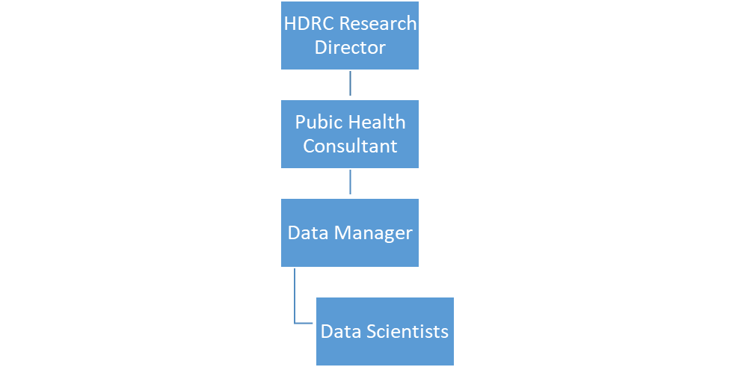

Special Knowledge Requirement. Will be used for shortlisting.
 |  |  | Essential
Applicants with disabilities are only required to meet the essential special knowledge requirements shown by a cross in the end column.
Due to the Governments Fluency in English Duty for posts where employees speak directly to members of the public the postholder is required to meet the Lower threshold level.  You should be able to demonstrate that you can use a wide range of simple words and a standard English sentence structure to express and maintain a flowing conversation even though you pause to think of the correct words with the ability to express and make yourself understood (this will also be tested during the interview). |  |  | X
Highly numerate with highly developed analytical skills to present complex and/or sensitive information clearly |  |  | X
Knowledge of health and demographic data sources and datasets |  |  | X
Knowledge of current public health policy, an understanding of health inequalities and the social determinants of health |  |  | X
Substantial experience of analysing and interpreting public health data sources including illness and mortality data, hospital activity data and demographic data |  |  | X
Experience in the use of statistical and epidemiological methods for analysing and interpreting or NHS datasets |  |  | X
Uses, interprets, analyses and communicates complex information from a variety of sources and to a range of audiences  . |  |  | X
Specialist knowledge concerning statistical techniques and procedures relevant to the analysis and interpretation of health data sets, such as standardisation, confidence intervals, statistical process control |  |  | X
A very good understanding of data security and confidentiality issues |  |  | X
A high level of skill in interpreting users’ requirements and good problem solving ability |  |  | X
Able to prioritise work, schedule and organise own time |  |  | X
Able to manage and prioritise the work of a team of public health analysts |  |  | X
Good oral and written communication skills and an ability to work with a wide range of internal and external stakeholders |  |  | X
Ability to work effectively with elected members |  |  | X
Experience of working with large complex datasets |  |  | X
Relevant experience requirement: Will be used for shortlisting

- Significant experience of supporting research, literature searching and critical appraisal, including experience at a senior at a senior level.

- Experience of using office products, SPSS or other statistical software for data analysis, preferably experience of SQL, R or Python

Relevant professional qualifications requirement: Will be used for shortlisting

- Postgraduate qualification or equivalent experience in a public health or research related field
Core Employee competencies to be used at the interview stage.
Carries Out Performance Management
Covers the employee’s capacity to manage their workload and carry out a number of specific tasks accurately and to a high standard.
Communicates Effectively
Covers a range of spoken and written communication skills required as a regular feature of the job. It includes exchanging information/building relationships; giving advice and guidance; counselling, negotiating and persuading and handling private, confidential and sensitive information.
Carries Out Effective Decision Making
Covers a range of thinking skills required for taking initiative and independent actions within the scope of the job. It includes planning and organising, self effectiveness and any requirements to quality check work.
Undertakes Structured Problem Solving Activity
Covers a range of analytical skills required for gathering, collating and analysing the facts needed to solve problems. It includes creative and critical thinking; developing practical solutions; applying problem solving strategies and managing interpersonal relationships.
Operates with Dignity and Respect

Covers promoting equality, treating all people fairly and with dignity and respect, maintains impartiality/fairness with all people, is aware of the barriers people face.
Working Conditions:

Must be able to perform all duties and tasks with reasonable adjustment, where appropriate, in accordance with the Equality Act 2010 in relation to Disability Provisions.

Special Conditions:
Basic DBS is required.
Compiled by: Dr Caroline Tait  Date: 27/11/2024 | Grade Assessment Date: | Post Grade: PO4/PO5

