CITY OF BRADFORD METROPOLITAN DISTRICT COUNCIL
JOB PROFILE

JEGS 00118
DEPARTMENT: Place | SERVICE GROUP: Fleet & Transport
POST TITLE: Finance, Procurement & Auditing Officer | REPORTS TO: Team Leader – Customer & Business Support
GRADE: 7 |  | SAP POSITION NUMBER:

The following information is furnished to help Council staff and those people considering joining the City of Bradford Metropolitan District Council to understand and appreciate the general work content of their post and the role they are to play in the organisation. The duties and responsibilities highlighted in this Job Profile are indicative and may vary over time. Post holders are expected to undertake other duties and responsibilities relevant to the nature, level and scope of the post and the grade has been established on this basis.

As a candidate you will be expected to demonstrate your ability to meet the special knowledge, experience and qualifications required for the role by providing evidence in the application form for the purpose of shortlisting. Applicants with disabilities are only required to meet the essential special knowledge requirements shown by a cross in the end column of this section.

The employee competencies are the minimum standard of behaviour expected by the Council of all its employees and the management competencies outlined are those relevant for a post operating at this level within our organisation.

Both sets of competencies will be used at interview stage and will not be used for short listing purposes.

Key Purpose of Post:
- To assist the Customer & Business Support Team Leader in the provision of a flexible and proficient administrative service dealing with generic and service-specific duties.
- To provide prompt, accurate and effective financial information, including, but not limited to – procurement, stock, system audits, financial and budgeting information, invoices.
- To complete any other administrative duties in line with the role and as required by the service.
Main Responsibilities of Post:
- To assist in the management of the financial aspects of administering licensing functions, including ensuring the correct fees are levied for expenditure incurred. Complete annual Fees Review, including process of Service, ensuring ongoing time allocated to tasks are within fees legal framework, highlighting any area of concern.
- Audit all aspects of Service work, including all roles, checking compliance with processes, policies & procedures.

- Has the ability to organise their own workload and work to deadlines. Contribute to service improvement planning and undertake project work. Can work using own initiative, take ownership, solve and respond to problems.
- Set up and maintain spreadsheets and databases to provide accurate data which provides financial reports on a weekly/monthly/annual basis to enable to service to evaluate income and expenditure against the legal requirement of the service which determines the fees charged to the trade for licences.

- Act as the Financial Systems Champion in supporting and guiding colleagues with their financial tasks.

- Procuring and paying for goods and supplies in accordance with Council procurement procedures and policies including processing SAP requisitions.
Following internal guidance for procurement, invoicing, purchase orders.
- Provide financial and performance information to assist in the completion of internal and external reporting used to make recommendations which are used to brief Council Committees, Senior Managers and Stakeholders as required.
- Have literacy and numeracy skills to be able to produce complex and specialist documentation and statistical information.
- Ability to analyse complex statistical information and be able to produce management information as required, with excellent attention to detail.
- Ensure inventory and audit of stock is completed and recorded regularly, ordering where required.
- Have a flexible and adaptable approach to working with the team. support and work effectively with others to achieve goals and objectives creating positive working relationships.
- Ability to use multiple IT solutions, including SAP, MS Office and service specific systems.
- Ensure familiarity with and adherence to all relevant Council Policies, including those concerning equality and diversity.
- To carry out other duties, as required, which are reasonable in terms of the nature and level of the post.

Structure:
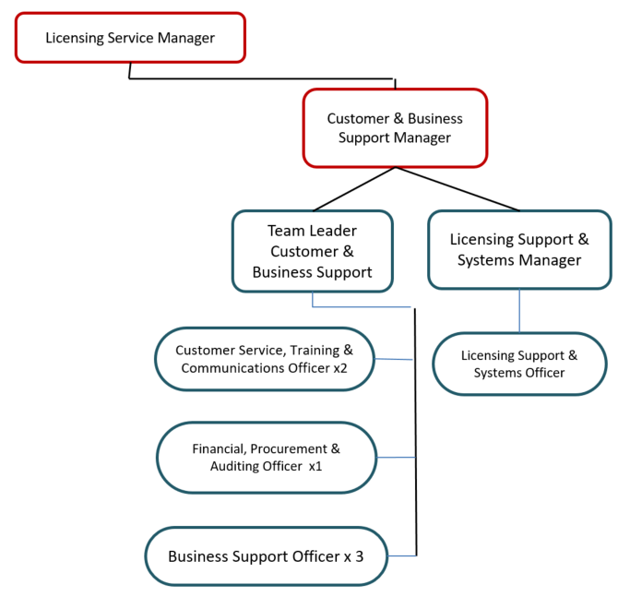

Special Knowledge Requirement. Will be used for shortlisting.
 | Essential
Applicants with disabilities are only required to meet the essential special knowledge requirements shown by a cross in the end column
Due to the Government’s Fluency in English for posts where employees speak directly to members of the public the postholder is required to meet the Advanced threshold level which will be applied where the postholder requires a greater level of sensitive interaction with the public.  You must be able to demonstrate that you can express yourself fluently and spontaneously (this will also be tested during the interview). | X
Knows and understands how to use, interpret, handle and communicate, often complex and detailed information, and relay it to service users/stakeholders in writing and/or over the telephone / face to face | X
Uses a range of complex IT packages across various areas of work. | X
Ability to adopt a process of continual improvement and suggest ways of working more efficiently and effectively to improve service delivery. | X
Able to demonstrate a high level of numeracy, literacy and accuracy across a range of activities | X
Will make frequent decisions using some judgement, but within established procedures and guidelines, regarding workload and priorities. | X
Ability to use a range of administrative and financial systems, processes and procedures. | X
Experience of working effectively to tight deadlines with accuracy using complex numerical information, and able to demonstrate understanding of working in a financial and commercial environment | X

Relevant experience requirement: Will be used for shortlisting
Worked in a financial/procurement service
Substantial and demonstrable experience in a finance and/or customer service environment
Relevant professional qualifications requirement: Will be used for shortlisting
Three GCSEs (including maths & English)
Core Employee competencies to be used at the interview stage.
Carries Out Performance Management
Covers the employee’s capacity to manage their workload and carry out a number of specific tasks accurately and to a high standard.
Communicates Effectively
Covers a range of spoken and written communication skills required as a regular feature of the job. It includes exchanging information/building relationships; giving advice and guidance; counselling, negotiating and persuading and handling private, confidential and sensitive information.
Carries Out Effective Decision Making
Covers a range of thinking skills required for taking initiative and independent actions within the scope of the job. It includes planning and organising, self effectiveness and any requirements to quality check work.
Undertakes Structured Problem Solving Activity
Covers a range of analytical skills required for gathering, collating and analysing the facts needed to solve problems. It includes creative and critical thinking; developing practical solutions; applying problem solving strategies and managing interpersonal relationships.
Operates with Dignity and Respect

Covers promoting equality, treating all people fairly and with dignity and respect, maintains impartiality/fairness with all people, is aware of the barriers people face.
Working Conditions:
Must be able to perform all duties and tasks with reasonable adjustment, where appropriate, in accordance with the Equality Act 2010 in relation to Disability Provisions.
Special Conditions:
Compiled by: CS  Date: March 2022  Reviewed: ES  Date: June 2025 | Grade Assessment  Date: April 2023 | Post Grade:  Band 7

