CITY OF BRADFORD METROPOLITAN DISTRICT COUNCIL
JOB PROFILE

DEPARTMENT: Place | SERVICE GROUP: Waste, Fleet, Environmental Health and Licensing
POST TITLE: Area Operations Manager (City of Culture) | REPORTS TO: Principal Street Cleansing Officer
GRADE: SO2 |  | SAP POSITION NUMBER:

The following information is furnished to help Council staff and those people considering joining the City of Bradford Metropolitan District Council to understand and appreciate the general work content of their post and the role they are to play in the organisation. The duties and responsibilities highlighted in this Job Profile are indicative and may vary over time. Post holders are expected to undertake other duties and responsibilities relevant to the nature, level and scope of the post and the grade has been established on this basis.
For posts where employees speak directly to members of the Public the post holder is required to demonstrate their ability to speak fluently in English.

As a candidate you will be expected to demonstrate your ability to meet the special knowledge, experience and qualifications required for the role by providing evidence in the application form for the purpose of shortlisting. Applicants with disabilities are only required to meet the essential special knowledge requirements shown by a cross in the end column of this section.

The employee competencies are the minimum standard of behaviour expected by the Council of all its employees and the management competencies outlined are those relevant for a post operating at this level within our organisation.

Both sets of competencies will be used at interview stage and will not be used for short listing purposes.

Key Purpose of Post:
- To lead and manage a team of 20 Street Cleansing Ambassadors, 4 Supervisors and a Mechanical Sweeper Driver as well as matrix managing Neighbourhood Wardens, Environmental Enforcement Officers, PSPO Officers and other officers - responsible for delivering high quality and consistent cleansing the district.

- To assist in the development and implementation of strategies and approaches to promote a clean, green and safe district. Ensure all staff and vehicles are compliant with all relevant legislation, policies and practices in relation to this specialist area of work.

- To provide a service to support the delivery of City Of Culture events over a 14 months’ programme to maintain a high level of cleanliness and enforcement of environmental issues.

Main Responsibilities of Post:
Staff Management, Deployment and Safety:
1. Assist in the recruitment, organisation, training and management of staff, workloads and resources including co-ordinating daily work patterns and operations, allocating work and resources, undertaking supervisions and appraisals and ensuring on site performance monitoring. Develop and continually review prescriptive working patterns and new routes and joined up working. Support the Principal Street Cleansing Manager with disciplinary and attendance issues, such as return to work interviews, setting informal and formal targets, undertaking management investigations and preparing and presenting at formal reviews and capability hearings.

2. Ensure that staff are encouraged to report health and safety issues and that these are properly recorded, followed-up, monitored and actioned. Review risk assessments and operational procedures on an on-going basis, in consultation with the Health and Safety Advisor, to ensure that they are implemented consistently across the service. Ensure that staff operate in accordance with policies and procedures.

3. Deliver training on operational issues such as health and safety, customer care and operational procedures. Continually assess the training needs of staff and work with the Health and Safety Advisor to ensure that training needs are met.

4. Create and implement deployment plans and routes for all staff and vehicles. Monitor the deployment of operational staff on a real time daily basis to maximise resources and improve performance, reporting through any issues to the Principal Street Cleansing Officer.

Financial Management:
5. Consider opportunities for income generation, including keeping abreast of developments in respect street cleansing initiatives, fleet and waste

6. Price/estimate and provide quotes for internal and external customers.

Information Handling:
7. Respond to correspondence, enquiries, complaints and Freedom of Information requests in line with Council procedures.

8. Collate information from a range of sources, including quantitative and qualitative data, in reference to street cleansing needs and issues and ensure that this is built into deployment plans to support the best use of resources.

Partnership Working:
9. Co-ordinate responses for special operations, days of action and events.

10. Work closely with the Environmental Enforcement Manager to look at schedules and deployment of Neighbourhood Wardens, Environmental Enforcement Officers, Public Space Protection Officers and other staff.

Vehicles and Equipment:

11. Ensure fleet vehicles comply with all laws and regulations relating to the safe operation of Council vehicles and keep up-to-date and accurate records, e.g. accidents, breakdowns and vehicle checks.

12. Ensure that all equipment is maintained to a high standard.

Other Duties:

13. Work closely with Project Officers for the City of Culture to ensure street cleansing arrangements are maximised to cover events to maintain cleanliness across the Bradford District.

Structure:

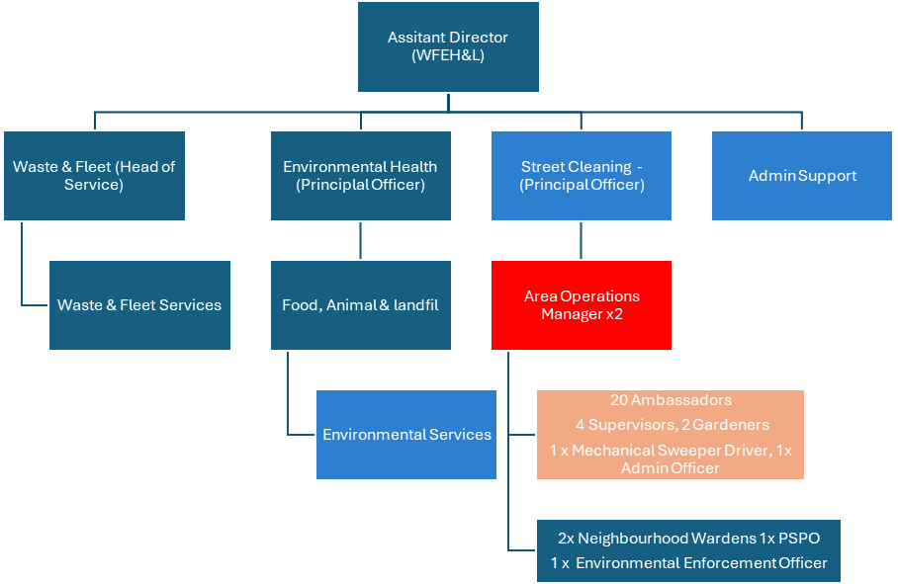

Special Knowledge Requirement. Will be used for shortlisting.
 |  |  | Essential
Applicants with disabilities are only required to meet the essential special knowledge requirements shown by a cross in the end column.
Due to the Governments Fluency in English Duty for posts where employees speak directly to members of the public the postholder is required to meet the Lower threshold level.  You should be able to demonstrate that you can use a wide range of simple words and a standard English sentence structure to express and maintain a flowing conversation even though you pause to think of the correct words with the ability to express and make yourself understood (this will also be tested during the interview). |  |  | X
Able to understand and apply enhanced knowledge of health and safety and environmental operations, policies, procedures and regulations, including risk, across one or more specialist areas. |  |  | X
Ability to manage a budget, including income generation and the ability to prepare quotes based on knowledge of the work area. |  |  | X
Uses a range of specialist ICT systems across own work area and or across other areas of work. |  |  | X
Uses, interprets, analyses and communicates complex information from a variety of sources. |  |  | X
Knowledge of Council services and structure and how they relate to this specialist area of work. |  |  | X
Ability to deliver training in relation to a specialist area of work i.e. health and safety, customer care, operational procedures. |  |  | X
Able to manage successful service delivery, and an ability to build and manage relationships effectively and bring people together to optimise partnership working. |  |  | X
Awareness of and ability to apply approaches that can bring about behaviour change within communities. |  |  | X
Able to carry out vehicle evaluations against established standards. |  |  | X
Relevant experience requirement: Will be used for shortlisting

Relevant and demonstrable experience of managing staff and resources.
Experience of working with a wide range of partners and an understanding of the needs of diverse communities.
Relevant professional qualifications requirement: Will be used for shortlisting

NQF Level 3 or equivalent.
Core Employee competencies to be used at the interview stage.
Carries Out Performance Management
Covers the employee’s capacity to manage their workload and carry out a number of specific tasks accurately and to a high standard.
Communicates Effectively
Covers a range of spoken and written communication skills required as a regular feature of the job. It includes exchanging information/building relationships; giving advice and guidance; counselling, negotiating and persuading and handling private, confidential and sensitive information.
Carries Out Effective Decision Making
Covers a range of thinking skills required for taking initiative and independent actions within the scope of the job. It includes planning and organising, self-effectiveness and any requirements to quality check work.
Undertakes Structured Problem Solving Activity
Covers a range of analytical skills required for gathering, collating and analysing the facts needed to solve problems. It includes creative and critical thinking; developing practical solutions; applying problem solving strategies and managing interpersonal relationships.
Operates with Dignity and Respect

Covers promoting equality, treating all people fairly and with dignity and respect, maintains impartiality/fairness with all people, is aware of the barriers people face.
Working Conditions:

Must be able to perform all duties and tasks with reasonable adjustment, where appropriate, in accordance with the Equality Act 2010 in relation to Disability Provisions.

Post holders will be expected to work unsocial hours, including weekends, occasionally.

The nature of the post means that the post holder will come into contact with irate members of the public. Verbal abuse is not uncommon and while physical assault is very rare, there is a potential for this.

Special Conditions:
Full UK driving licence
Compiled by: CS.  Date: 26.07.24 | Grade Assessment Date:  08.08.24 | Post Grade:  SO2

