
City of Bradford Metropolitan District Council Job Profile
Reference Number | TO BE COMPLETED BY JEGS / HR
Role Title | Adventure Instructor (Casual)
Directorate | Environment
Service Area | Sport & Leisure
Reports to | Adventure Outreach Team Leader & Doe Park Water Activities Centre Manager

Role Purpose (maximum of 3 points, with no sub bullet points)
- Adventure Instructors will lead outdoor and adventurous activities (e.g. Climbing, Cycling, Paddlesport’s, Sailing, High Ropes, Walking) to a wide variety of customers and groups (e.g. Schools, Colleges, Alternative Provisions, Youth Groups and Leisure Courses).

- Adventure Instructors will undertake routine maintenance of facilities and equipment, administrative and promotional tasks and be an integral part of the delivery team.

- Adventure Instructors will be committed to delivering excellent Adventure learning and leisure programmes to support the Bradford Districts priorities including Health, Education and Active Communities.

Duties and Responsibilities (maximum of 15 points, with no sub bullet points)
- To support all aspects of provision of Adventure Development and Doe Park Water Activities Centre. This will primarily be to instruct activities but will also include maintenance and administrative tasks as part of the delivery team.

- To work within proven levels of competence to deliver at least one; or preferably a range of adventure activities. These may include Rock Climbing, Paddlesport’s, Sailing, Cycling, Low level and Mountain Walking, Caving, Gorge Scrambling, Raft building, Dragon boating, High Ropes, Bushcraft, Group Initiative challenges, Camping, or other outdoor and adventurous activities.

- To work with a high degree of interpersonal skills to support customers with a wide range of abilities needs and confidence levels to achieve positive outcomes from their experience.

- To understand the differing aims of clients such as skills training, educational learning, personal and social development and deliver activities in a way which achieves the desired outcomes.

- To understand and work within the services safety management framework.

- To have a high level of commitment and flexibility to respond to customer needs. Adventure Instructors must be prepared to work flexible and unsocial hours including full and half days, evenings, weekends, and overnight stays, with increased hours in summer high season and decreased hours in winter.

- Adventure Instructors will be deployed by and directly responsible to the relevant Adventure Manager; however, will be in sole charge of activities and expected to show initiative to determine successful programme outcomes. Instructors will need to make dynamic decisions during that period, concerning the suitability of planned activities and the welfare of all participants, assistants, group leaders, and trainees - safety being of paramount importance.

- Adventure Instructors may be required to consult with customer groups to plan, prepare for and/or organise a programme.

- Adventure Instructors may be given higher levels of autonomy and decision-making responsibility according to their levels of experience, qualification, interpersonal skills and knowledge. This may include a lead project role or leading a programme at a remote base.

- Adventure Instructors may be responsible for children in 'loco parentis'; however pastoral care will be the responsibility of accompanying group leaders when present.

- Adventure Instructors will be responsible for routine care, daily checks and maintenance of equipment and facilities. Instructors may be deployed to conduct detailed periodic equipment checks, site and facility improvements and maintenance.

- Adventure Instructors will undertake routine administrative tasks, ensuring that records are up to date and issues and incidents are reported promptly. Instructors may be given additional administrative and promotional duties according to their level of expertise.

- Adventure Instructors may be deployed to development projects including the design of new programmes, activities, and site improvements.

- Adventure Instructors will report to the relevant Adventure Manager seeking advice and guidance as required.

- Adventure Instructors may occasionally be deployed to other areas of the Sport and Culture Service according to need and competencies.

Dimensions of role (direct or indirect as applicable) e.g. total number of staff managed, total budget, total scope of role
Will be directly responsible for any adventure assistants or trainees working alongside them on day-to-day programmes.

Structure Chart (showing direct reports)
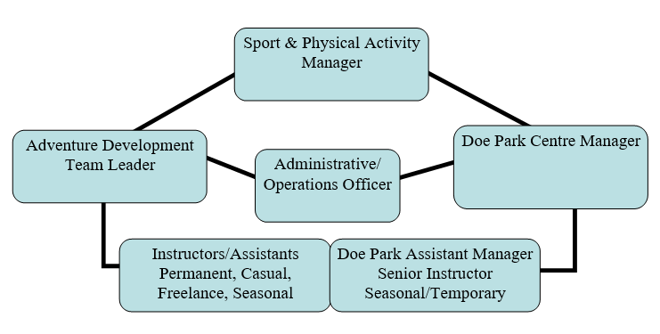

Person Specification
Knowledge / Skills / Experience required
- Knowledge of a range of instructing, coaching and leadership techniques and how these are applied in different situations.

- Knowledge of Safety Regulations, National Governing Body Awards and how safe practice is implemented in the field.

- Knowledge of both the natural and urban environments; personal, social and team development; and learning opportunities which can be applied to the delivery of activity programmes.

- Knowledge of the care and maintenance of specialist outdoor PPE.

- Experience of Instructing Outdoor and Adventurous Activities.

- Experience of Instructing children and adults with a wide range of needs, abilities, and backgrounds.

- Deployment of Instructors will be determined by their levels of experience and qualification.

Key benchmarked competencies, traits, and motives required to successfully deliver the role. These will support recruitment, succession planning, development, and performance management |  | Essential
Health and Safety | Uses knowledge of Health, Safety policies, procedures, and regulations including risks in own area of work | X
Service Improvement | Ability to adopt a process of continual improvement and suggest ways of working more efficient and effectively to improve service delivery | X
Continued professional Improvement | Carries out a variety of working practices, applies complex regulations, rules, procedures, and processes across a technical /specialist area.  Will undertake continuous professional development to improve competencies. | X
Communication | Knows and understands how to use, interpret, handle and communicate, often complex and detailed information, and relay it to service users/managers in writing and/or over the telephone / face to face. | X
Numeracy & Literacy | Demonstrates a high level of numeracy, literacy, and accuracy across a range of activities. | X
Relevant Professional Qualification | To hold current, valid qualifications in one or more outdoor activities (Mountain Biking, Climbing, Paddlesport’s, Hillwalking, Archery etc.) showing personal and instructional competence.  To hold a valid First Aid Award which is appropriate to activity qualifications.  To hold relevant Safeguarding training appropriate to activity qualifications. | X
Carries out performance management | Covers the employees’ capacity to manage their workload and carry out a number of specific tasks accurately and to a high standard.  Able to manage daily routines to organise, prepare and deliver activity sessions as well as undertake routine maintenance of equipment/facilities and administrative tasks. | X
Communicates Effectively | Covers a range of spoken and written communication skills required as a regular feature of the job. It includes exchanging information/building relationships, giving advice and guidance, counselling, negotiating, and persuading and handling private, confidential, and sensitive information.  Able to give clear verbal instructions and/or demonstrations to participants, group leaders, and assistants.  Able to seek out and exchange information from Group leaders and participants to determine expectations, abilities, and potential concerns.  Able to pick up non-verbal and verbal signals to deliver appropriate activity levels.  Able to communicate well with other staff and assistants as part of an effective delivery team. | X
Carries Out Effective Decision Making | Covers a range of thinking skills required for taking initiative and independent actions within the scope of the job. It includes planning and organising, self-effectiveness and any requirements to quality check work.  Will be required to make good dynamic judgements to ensure that activity sessions are safe and appropriate, considering individual participant needs, group dynamics, changeable weather and environmental factors and other people at the venue.  Will contribute to monitoring and review of sessions and services.  Will be responsible for safety decisions in remote locations within the services safety management framework and know when further advice is required. | X
Undertakes Structured Problem-Solving Activity | Covers a full range of analytical skills required for gathering, collating, and analysing the facts needed to solve problems. It includes creative and critical thinking, developing practical solutions, applying problem solving strategies and managing interpersonal relationships.  Instructors will be required to apply creative, practical, and logistical solutions to plan, prepare for, and deliver successful Adventure programme outcomes. This will include both planned and dynamic solutions which respond to the needs of customers and the service operation. | X
Operates with Dignity and Respect | Covers treating everyone with respect and dignity, maintains impartiality/fairness with all people, is aware of the barriers people face.  Instructors are required to apply the Adventure Development Service Code of Conduct to all areas of work. | X
Working Conditions | Adventure Instructors must be prepared to work flexible, variable, and unsocial hours including full and half days, evenings, weekends, and overnight stays, with increased hours in summer high season and decreased hours in winter. | X
Special Conditions | Enhanced DBS is required. | X

Applicants with disabilities are only required to meet the essential special knowledge requirements (clearly marked)
Due to the Governments Fluency in English Duty for posts where employees speak directly to members of the public the postholder is required to meet the Higher threshold level.
You should be able to demonstrate that you can use a wide range of simple words and a standard English sentence structure to express and maintain a flowing conversation even though you pause to think of the correct words with the ability to express and make yourself understood (this will also be tested during the interview)

Completed by: | Louise Clarke | Date: | 06/10/2025
Quality checked: |  | Date:

