CITY OF BRADFORD METROPOLITAN DISTRICT COUNCIL
JOB PROFILE

DEPARTMENT: Children’s Services | SERVICE GROUP: Education and Learning
POST TITLE: Senior SEND Officer | REPORTS TO: 0-25 Strategic Manager, Integrated Assessment
GRADE: PO4/5 |  | SAP POSITION NUMBER :

The following information is furnished to help Council staff and those people considering joining the City of Bradford Metropolitan District Council to understand and appreciate the general work content of their post and the role they are to play in the organisation. The duties and responsibilities highlighted in this Job Profile are indicative and may vary over time. Post holders are expected to undertake other duties and responsibilities relevant to the nature, level and scope of the post and the grade has been established on this basis. For posts where employees speak directly to members of the Public the post holder is required to demonstrate their ability to speak fluently in English.

As a candidate you will be expected to demonstrate your ability to meet the special knowledge, experience and qualifications required for the role by providing evidence in the application form for the purpose of shortlisting. Applicants with disabilities are only required to meet the essential special knowledge requirements shown by a cross in the end column of this section.

The employee competencies are the minimum standard of behaviour expected by the Council of all its employees and the management competencies outlined are those relevant for a post operating at this level within our organisation.

Both sets of competencies will be used at interview stage and will not be used for short listing purposes.

Key Purpose of Post:
- . To deal with an agreed caseload in relation to the statutory processes and
procedures under the Children and Families Act 2014, SEND Code of Practice 2015 and subsequent legislation to a consistently high standard in terms of working positively with parents, schools and other agencies and professionals in accordance with the Council’s policy and budgetary framework requirements.
- To line manage SEND Casework Officers and work co-operatively within a team and contribute towards team/service plans, policy development and implementation within the 0-25 Integrated Assessment SEND Team and the Education and Learning Directorate overall, including lead responsibility for some tasks when required.
- To lead on agreed area of specialism across the 0-25 team and provide peer support and/or training to colleagues as necessary.

Main Responsibilities of Post:
- To draft accurate and concise EHCPs within the specified statutory timescales based on the written advice provided.
- To scrutinise and quality assure annual reviews of EHCPs in a timely manner providing clear, written feedback to schools; to attend annual reviews where necessary including schools out of Bradford.
- Under the supervision of the Team Manager, 0-25 Integrated Assessment, to prepare and present cases to the EHC Panel regarding placement and support for pupils with SEND and promote inclusion in the educational setting, through liaison with schools, other LAs and parents as necessary.
- To prepare individual cases and present them as the representative of Bradford Council at the Special Educational Needs and Disability
Tribunal undertaking training where necessary.
- To work in partnership with parents in relation to individual pupil cases, to offer a listening ear, showing empathy and support at all times; to liaise with the Parent Partnership Service and the local Mediation Service where necessary to support a solution focussed approach to resolving casework.
- In the course of casework, to develop positive professional relationships with all the schools/settings that you come into contact with in respect of SEND processes, ensuring schools/settings are fully compliant with their duties and to signpost them where necessary to other relevant practitioners.
- To work collaboratively with a range of professional colleagues within Bradford Council, and Casework Officers across the 0-25 Integrated Assessment Team as well as partners from other agencies such as health and social care to ensure that EHCPs and annual reviews are fully compliant.
- From time to time, to assist in the planning or provision of training/support for parents or a range of professionals both within Children’s Services and in outside agencies in relation to SEND processes.
- To ensure that appropriate and timely responses are made to requests for
information and reports from a variety of sources.
- To represent Children’s Services at multi-agency meetings, convening and
chairing meetings as necessary in relation to SEND casework.
- Through agreed procedures to monitor, support and challenge schools’
implementation of their statutory duties in relation to SEND and report these to the 0-25 Integrated Assessment Team Manager
- To contribute to monitoring of individual pupil progress via annual reviews of EHCPs and to promote the raising of achievement for pupils with EHCPs.
- To continually update own knowledge of relevant developments in all areas of SEND education, undertaking training as necessary.
- To contribute to planning, policy development within the 0-25 Integrated Assessment Team and the Education and Learning Directorate, preparing reports, collating information and collaborating with colleagues as appropriate.
- Ensure electronic records and data systems (Capita) are maintained for children and young people with SEND and assist in the development of systems to monitor and record the progress, outcomes and other required information for children and young people with SEND.
- Promote and safeguard the welfare of children and/or vulnerable adults
- Undertake any other duties which fall within the scope and purpose of the post.

Structure:
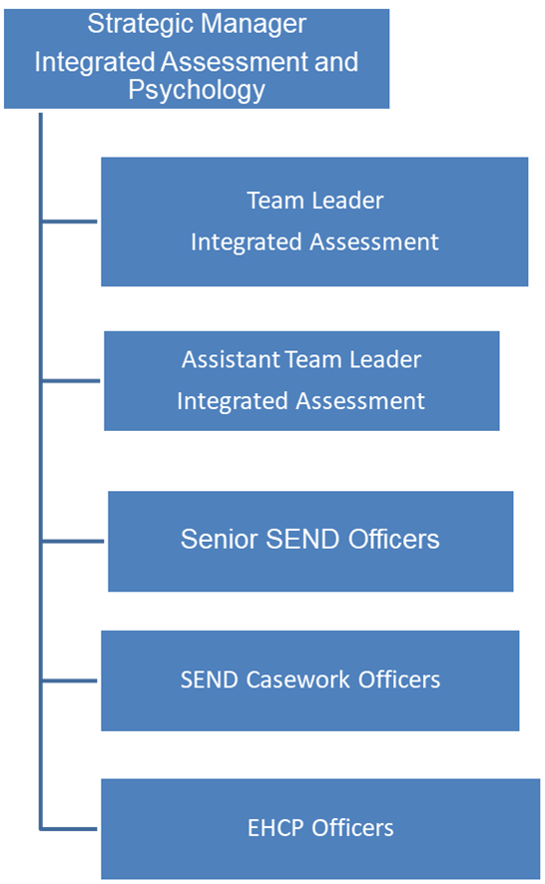

Special Knowledge Requirement: Essential for shortlisting.
 | Essential
Due to the Governments Fluency in English Duty for posts where  employees speak directly to members of the public the post holder is  required to meet either the Advanced threshold level (which will be implemented where the post requires a greater level of sensitive interaction with the public e.g. in children’s centres) – where the person is able to demonstrate that they can during the interview:  a) Can express themselves fluently and spontaneously , almost  effortlessly  b) Only the requirement to explain difficult concepts simply hinders a  natural smooth flow of language | X
Carries out the working practices and procedures across a specialist area – providing SEND support or in a number of specialist areas. | X
Uses knowledge of Health, Safety and Environmental policies, procedures and regulations, including risk in own area - providing SEND support and/or across other areas of work. | X
Uses a range of specialist ICT systems across own work area - providing SEN support and/or across other areas of work. | X
Oversees or contributes to the management of a budget, keeping costs within agreed levels for own section/team. | X
Uses, interprets, analyses and communicates complex information from a variety of sources. | X
To have knowledge and practical understanding of working with the SEND Code of Practice and EHCP process. | X
Significant experience of child development. | X

Relevant experience requirement: Essential for shortlisting

The applicant is required to provide evidence of having previously spoken fluently to members of the public in order to meet the Advanced threshold level outlined under Special Knowledge above.
Understanding of issues relating to identification, assessment and provision for SEND as set out in the SEND Code of Practice.
​​​

Understanding of current national and local educational legislation and guidance in
relation to SEN and Inclusion.
Awareness of current national education issues in relation to school improvement.

Relevant professional qualifications requirement: Essential for shortlisting

Experience of working in the field of education including SEND either:
working directly with pupils in schools; or working in an administrative role in a LA.
Experience of working with other agencies.
Graduate level or equivalent.
A qualification specific to SEND would be an advantage.
Core Employee competencies at manager level to be used at the interview stage.

Carries Out Performance Management – covers the employees capacity to manage
their workload and carry out a number of specific tasks accurately to a high standard.
Communicates Effectively - covers a range of spoken and written communication skills required as a regular feature of the job. It includes exchanging information/building relationships, giving advice and guidance, counselling, negotiating and persuading and handling private, confidential and sensitive information.
Carries Out Effective Decision Making - covers a range of thinking skills required for taking initiative and independent actions within the scope of the job. It includes planning and organising, self effectiveness and any requirements to quality check work.
Undertakes Structured Problem Solving Activity - covers a range of analytical skills required for gathering, collating and analysing the facts needed to solve problems. It includes creative and critical thinking, developing practical solutions, applying problem solving strategies and managing interpersonal relationships.
Operates with Dignity and Respect - covers treating everyone with respect and dignity, maintains impartiality/fairness with all people, is aware of the barriers people face.

Management Competencies: to be used at the interview stage.

Operates with Strategic Awareness Our managers work with corporate priorities and policies in a joined up way with others, internally and externally. Works democratically, transparently and accountably.
Practices Appropriate Leadership Our managers motivate their staff to exceed expectations through raising their awareness of goals and moving them beyond self interest for the sake of the team or service. They consider serving the District in all that they do.
Delivering Successful Performance Our managers monitor performance of services, teams & individuals against targets & celebrate great performance. They promote the District’s vision & work to achieve Council’s values & agreed outcomes.
Applying Project and Programme Management Our manager’s work to ensure that outcomes and objectives are achieved within desired timescales, make best use of resources and take a positive approach to contingency planning.
Developing High Performing People and Teams Our managers coach individuals and teams to achieve their potential and take responsibility for continuous improvement. They champion the Council’s values and goals.
Working Conditions:

You will outline here if the post holder must be able to work evenings, weekends and
Bank Holidays as required by the needs of the service. Must be able to perform all duties and tasks with reasonable adjustment, where appropriate, in accordance with the
Equality Act 2010 in relation to Disability Provisions.
Special Conditions:
You will outline here if there is a requirement for the post to have recruitment checks
such as DBS, Warner Process.
Compiled by:  Date: | Grade Assessment Date: | Post Grade: PO4/5

Version 2 June 2019
Review due March 2022

