,
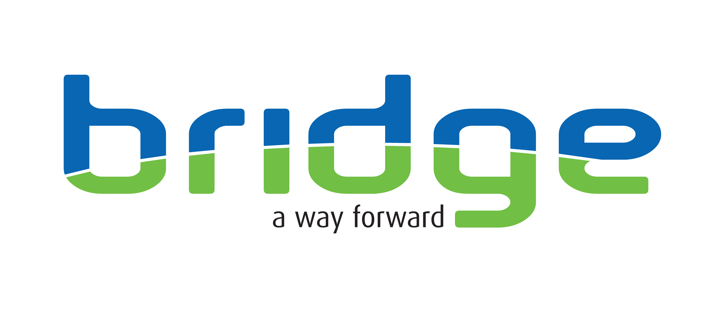

Title of post: Bradford RESET: Domestic Abuse Perpetrator Navigator
Recognising, Engaging and Supporting Everyone to Transform

Location: Salem Street, Bradford. The post holder will be expected to travel anywhere in Bradford MBC

Responsible to: Team Leader

Salary Scale: £29,760 Full time 37.5 hours.

Hours of Work: Core hours Monday to Friday 9.30-5.30
Note: The post holder is expected to flexibly deliver the service to meet the needs of the client, this may require adjusting hours on the day to ensure support to appointments or other activities/ interventions/ attending meetings that fall outside of these core hours.

Contract: Fixed term until at least 31st March 2026, expected to be longer term subject to funding.

Special Provisions: The post is subject to enhanced disclosure and barring check, the results of which would not necessarily exclude applicants from consideration.

This post requires full driving licence and use of a vehicle.

About the role and service

The Domestic Abuse Navigator is an exciting role, taking referrals and working with people who are identified as but may not self-identify as perpetrators of domestic abuse. Referrals into this element of Bradford RESET will come through two routes 1. the Integrated Offender Management (IOM) Police Team who are based within the DA Unit – for standard and medium risk cases and 2. the Multi-Agency Risk Assessment Conference (MARAC) – high risk cases. Specifically, the post holder will work with standard through to high-risk people harming in their intimate and/or family relationships. The primary role is to proactively engage and provide trauma informed motivational intervention and prevention to perpetrators, identifying their strengths and areas of unmet need and navigate people into a wide range of health and wellbeing services to meet these needs Once fully engaged in services and a reduction/ cessation of offending has been achieved, the post holder will work to engage the person into the longer term support element of the Bradford RESET service. This will evolve clear transition processes to ensure full engagement aimed at longer term cessation of offending and improved wellbeing.

The successful candidate will be based within the Bradford RESET team will:

- Provide aspirational person-centred, trauma informed support through building a trusting relationship with the person to start to address issues that contribute to incidents of abuse.
- Proactivity and intensively conduct face to face work with the perpetrator to build all the networks of support that wrap around the individual to facilitate recovery, building and sustaining hope.

Main Duties and Responsibilities

- Assertively make face to face contact and proactively engage with referred individuals through all routes such as, meeting at an individual home, Bridge Project, friends or family members home or any agreed place.

- Provide creative person-centred trauma informed solutions to the unmet needs of individuals who are hard to reach and engage.

- Build a trusted, motivational and highly supportive relationship, individualising support for change through undertaking a mutually agreed personalised review of their strengths and support needs and levels of wider social and community engagement.

- Mutually identify and work together to overcome barriers and access a wide range of health and wellbeing services, providing appropriate advocacy. Working in a trauma informed way, use high support high challenge techniques to affect recognition of DA behaviours and support change.

- Proactively link and practically support individuals into the agreed appropriate agencies, services and community assets relevant to their expressed needs and the level of risk e.g. physical and mental health, domestic abuse services, sexual health, housing, drug and alcohol services, benefit claims, criminal justice services, employment, training and education programmes and any specialist support services as required etc. this will include transporting people to their appointments.

- Liaise on a regular basis with the IOM Police Team/ MARAC spending a minimum of half a day per week in the Domestic Abuse HUB to discuss and review cases.

- Maintain appropriate case notes and administrative systems linked to the programme, including maintaining programme data performance/ evaluation systems.

- Produce high quality, accurate written reports and letters of support as and when required, this routinely includes reports for multi-agency bodies and letters outlining individual support needs as part of the overall package of care.

- Develop and maintain excellent working relationships with a full range of partner organisations, services and community programmes, colleagues and assets.

- Attend project governance case review meetings, applying risk analysis skills and contributing to the exchange of relevant risk information, problem solve to make positive appropriate case direction decisions.

- Provide a pro-active response to any repeated incidence of domestic abuse working directly within the local multi-agency framework including MARAC and local partnership responses to domestic abuse.

- Apply reflective practice skills to evaluate work carried out.

- Contribute to training needs of other workers in this field.

- Participate in personal and professional development, updating knowledge as appropriate.

- Fully participate in all of Bridge’s supervision and support structures.

- To recognise one’s own personal and professional limitations and boundaries and discuss these at supervision and related support meetings.

- To undertake any additional duties, as directed by management which are commensurate with this post.

Job title: Person Specification DRAMM Navigator
Attributes | Essential criteria | Desirable criteria | How Identified
Qualifications | Qualified to Health and Social Care Level 3 or equivalent relevant qualification  Or  Qualified through appropriate work and life experience. |  | Application Form  Interview  Certificates
Experience | - Within the last 5 years at least two years’ full-time equivalent experience of successfully delivering casework/ support services to people experiencing multiple needs/ multiple disadvantages.  - Experience of working with and/or managing high-risk cases therapeutically.  - Experience of conducting person centred and strengths-based assessments of need and creating mutually agreed action plans.  - Experience of creating mutually agreed risk management plans.  - Experience of working co-operatively within a partnership working environment/ model.  - Experience of effectively managing risks associated with personal safety. | - Experience of working with victims or perpetrators of domestic abuse. | Application Form  Interview  Certificates
Knowledge and skills | - Demonstrable skills in effective engagement and maintaining inspiring supportive relationships with individuals with multi-needs who may be resistant to support or have had negative experiences of support in the past.  - Demonstrates the skills of personal resilience, being tenacious and a strong ability to deal with difficult situations calmly, tactfully, responsibly and safely.  - Demonstrates an understanding of the needs of chronically excluded and vulnerable people.  - Applied knowledge of legislation in relation to safeguarding vulnerable groups, including children.  - Adaptability in working patterns and style to provide a flexible approach in order to develop and deliver services which are accessible and responsive to the needs of clients.  - Skilled cooperative communicator, with evidence of communicating clearly, concisely effectively (both orally and in writing) with individuals, groups, organisations and the public.  - Evidence of having worked independently and under pressure, prioritising, planning and managing own workload on a day-to-day basis, using effective time management skills.  - Skilled at preparing reports and letters and maintaining a care record to a high professional standard.  - Skilled at using IT systems – email, word, and entering accurate data into IT databases/ spreadsheets.  - Demonstrate motivation, reliability, commitment to clients, team and interagency working. | - Demonstrate skills in the use of motivational interviewing techniques.  - Understanding of Trauma Informed Care approaches. | Application Form  Interview
GENERAL | - Willingness to keep abreast of relevant professional developments and to undertake training for the post.  - The post-holder must adhere to Bridge Policies/Guidelines in force within the organisation.  - A dynamic experienced practitioner.  - The post-holder is expected to be flexible with regards to working hours in order to meet the requirements of the post.  - Willingness to work within a performance managed environment and contribute to performance reporting.  - Willingness to contribute to the training and development of others, undertake regular supervision and appraisal in line with Bridge policies and actively participate in own professional/personal development and have clear resiliency strategies.  - Willing to travel in order to fulfil the requirements of the post.  - Conform to standards of dress, which reflects a professional service.  - This post requires a full driving license and use of a vehicle |  | Application Form  Interview

Key Behaviours | Works Proactively  Demonstrates initiative, thinks ahead, and takes prompt action to solve problems; completes tasks, overcomes obstacles and seize opportunities.
Key Behaviours | Leads Change & Improves Performance  Responds quickly and positively to change, seeking to continuously improve performance by learning quickly from our mistakes, celebrating our successes, and constantly developing our people and processes.
Key Behaviours | Demonstrates Creativity & Innovation  Applies creative and lateral thinking to organisational issues; challenges the status quo and introduces new ideas, methods and processes.
Key Behaviours | Client & Customer Focused  Focuses on and understand the needs of internal and external service users, members and other stakeholders and strives to deliver a prompt, effective and personalised service. (For ‘service users’, please also read members, stakeholders, and audiences).
Key Behaviours | Influences Others & Communicates Effectively  Positively influences others and where appropriate persuades them to change their views, intentions or actions. Listens closely and communicates clearly both verbally and in writing.
Key Behaviours | Applies & Shares Expert Knowledge  Demonstrates the specialist knowledge and technical requirements of the job. Applies skills and experience to perform the job effectively, completes work to a high standard and shares knowledge across the organisation.
Key Behaviours | Works Collaboratively with Others  Works collaboratively with others for the good of the business; builds a network of good relationships and develops a thorough understanding of the organisation and the wider sector.
Key Behaviours | Values & Respects Others  Respects other individuals; listens and takes into account different opinions, feelings and motivations; is trustworthy and acts with integrity; responds and acts constructively towards others.

