CITY OF BRADFORD METROPOLITAN DISTRICT COUNCIL
JOB PROFILE

DEPARTMENT: Education Safeguarding | SERVICE GROUP: Children’s Services
POST TITLE: Senior Elective Home Education Officer | REPORTS TO: Access Team Manager
GRADE: PO2 | SAP POSITION NUMBER:  50233528 & 50233493

The following information is furnished to help Council staff and those people considering joining the City of Bradford Metropolitan District Council to understand and appreciate the general work content of their post and the role they are to play in the organisation. The duties and responsibilities highlighted in this Job Profile are indicative and may vary over time. Post holders are expected to undertake other duties and responsibilities relevant to the nature, level and scope of the post and the grade has been established on this basis. For posts where employees speak directly to members of the public the post holder is required to demonstrate their ability to speak fluently in English.

As a candidate you will be expected to demonstrate your ability to meet the special knowledge, experience and qualifications required for the role by providing evidence in the application form for the purpose of shortlisting. Applicants with disabilities are only required to meet the essential special knowledge requirements shown by a cross in the end column of this section.

The employee competencies are the minimum standard of behaviour expected by the Council of all its employees and the management competencies outlined are those relevant for a post operating at this level within our organisation.

Both sets of competencies will be used at interview stage and will not be used for short listing purposes.

Key Purpose of Post:
- To lead on delivery of the Local Authority statutory duties in respect of EHE
- To analyse and prioritise safeguarding risks for children who are not in receipt of suitable education or who do not have access to a suitable education placement and autonomously act upon risks.
- To develop and implement processes in respect of EHE which provide appropriate challenge to schools and other agencies around statutory duties.

Main Responsibilities of Post:
The points below represent an outline of key accountabilities. Although not expressly stated in this document, more detailed accountabilities and duties will naturally form part of such accountabilities:
- To provide high level specialist support, challenge and guidance to multi agency professionals in respect of children who are EHE.
- Ensure relevant statutory requirements are met and department policies and guidelines are adhered to ensuring service delivery in accordance with these.
- Support the inclusion of vulnerable pupils across the district, working to reduce children who are at risk of or become missing from education.
- To support the wider education safeguarding team where required for example in safeguarding visits and planned reviews.
- Use evidence and theory to assist in quality assurance and monitoring of schools to ensure statutory duties are being met and legislation is adhered to.
- Develop procedures, documentation and communication in conjunction with Service and Team Managers to support schools and raise awareness of EHE.
- Plan, contribute and deliver training.
- To work as part of a multi-agency team providing professionals with safeguarding advice and guidance in respect of EHE.
- To have responsibility for overseeing children who are EHE, providing high quality support and assessment of wider family needs where required, linking to family hubs and other agencies both within Bradford and nationally to support and safeguard families.
- To produce and analyse data in respect of EHE, demonstrating impact and improvements.
- Contribute to wider developments within Children’s Services and work with other officers and agencies to devise and deliver innovative and creative approaches.
- To manage the intake and allocation of work across a team of personnel.
- To undertake all duties commensurate to the nature and level of the post at initial place of work or at any other venue.
Structure:
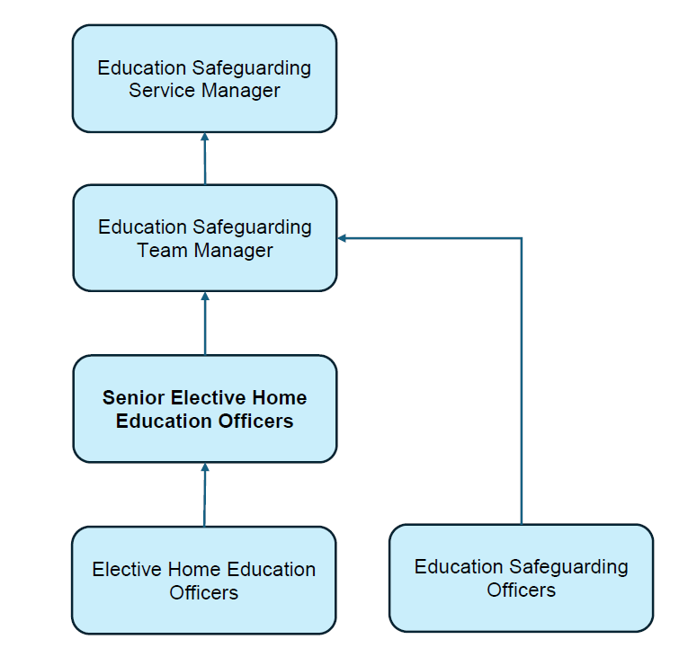

Special Knowledge Requirement: Essential for shortlisting.
Applicants with disabilities are only required to meet the essential special knowledge requirements shown by a cross in the end column
 | Essential
Due to the Governments Fluency in English Duty for posts where employees speak directly to members of the public, the post holder is required to meet the Advanced Threshold level which will be implemented where the post requires a greater level of sensitive interaction with the public, (e.g. in children’s centres) – where the person is able to demonstrate that they can during the interview:  a) Can express themselves fluently and spontaneously, almost effortlessly | X

Considerable depth of knowledge across the relevant specialist area, and knowledge across a range of other relevant areas. | X
Uses specialist knowledge of Health, Safety and Environmental policies, procedures and regulations, including risk in own area and/or across other areas of work. | X
Uses a range of specialist ICT systems across own work area and/or across other areas of work. | X
Analyses and presents statistical / numerical information using graphics e.g. management information requests, presentations, information leaflets, booklets. | X
Service delivery is regularly reviewed against changing business requirements and changes are made where necessary to improve performance or adjust to different business circumstances. | X
Communicates detailed/difficult to understand information clearly and effectively with a range of different audiences e.g. legislation updates, workshops, meetings, briefings, training events, consultations. | X
Produces well-structured letters, briefings, reports, e-mails to different people and deals with conflicting points of view effectively. | X
Makes decisions which could carry a higher risk using own personal judgement in situations which are complex/politically sensitive and not covered by Council guidelines, involving higher risk consequences and a greater degree of uncertainty. | X

Relevant experience requirement: Essential for shortlisting
The applicant is required to provide evidence of having previously spoken fluently to members of the public in order to meet the Advanced Threshold level outlined under Special Knowledge above.
Experience of working with parents, children and young people.
Recent experience of teaching, training, social work, health or other relevant work experience.
Experience of developing new procedures.
A proven track record of the ability to build meaningful relationships with multi-agency professionals.
Excellent communication, interpersonal and team-building skills. Maintain effective links with organisations.
Relevant professional qualifications requirement: Essential for shortlisting
Graduate and/or Level 4 Teaching, Social Work, Health or equivalent qualification.
Core Employee competencies at manager level: To be used at the interview stage
Carries Out Performance Management – covers the employee’s capacity to manage their workload and carry out a number of specific tasks accurately to a high standard.
Communicates Effectively - covers a range of spoken and written communication skills required as a regular feature of the job. It includes exchanging information/building relationships, giving advice and guidance, counselling, negotiating and persuading and handling private, confidential and sensitive information.
Carries Out Effective Decision Making - covers a range of thinking skills required for taking initiative and independent actions within the scope of the job. It includes planning and organising, self effectiveness and any requirements to quality check work.
Undertakes Structured Problem Solving Activity - covers a range of analytical skills required for gathering, collating and analysing the facts needed to solve problems. It includes creative and critical thinking, developing practical solutions, applying problem solving strategies and managing interpersonal relationships.
Operates with Dignity and Respect - covers treating everyone with respect and dignity, maintains impartiality/fairness with all people, is aware of the barriers people face.
Management Competencies: To be used at the interview stage.
Operates with Strategic Awareness Our managers work with corporate priorities and policies in a joined up way with others, internally and externally. Works democratically, transparently and accountably.
Practices Appropriate Leadership Our managers motivate their staff to exceed expectations through raising their awareness of goals and moving them beyond self interest for the sake of the team or service. They consider serving the District in all that they do.
Delivering Successful Performance Our managers monitor performance of services, teams and individuals against targets and celebrate great performance. They promote the District’s vision and work to achieve Council’s values and agreed outcomes.
Applying Project and Programme Management Our managers work to ensure that outcomes and objectives are achieved within desired timescales, make best use of resources and take a positive approach to contingency planning.
Developing High Performing People and Teams Our managers coach individuals and teams to achieve their potential and take responsibility for continuous improvement. They champion the Council’s values and goals.
Working Conditions:
Working in a school facing service and may be required to work evenings. Working hours reflect that the service is school facing.
Must be able to perform all duties and tasks with reasonable adjustment, where appropriate, in accordance with the Equality Act 2010 in relation to Disability Provisions.

Special Conditions:
You will require an Enhanced DBS check and hold a full and valid UK driving licence and have access to personal transport.
Compiled by:  Danielle Wilson  Date: April 2021 | Grade Assessment Date: July 2021 | Post Grade: PO2

