
City of Bradford Metropolitan District Council Job Profile
Reference Number
Role Title | Skills for Work Head of SEND (Special Educational Needs) P03/4
Directorate | Office of The Chief Executive
Service Area | Skills for Work
Reports to | Prinicipal Skills for Work

Role Purpose (maximum of 3 points, with no sub bullet points)
Reporting to Skills for Work Principal:
To lead and manage the development and delivery of Skills for Work inclusive skills and employability programmes for learners with Special Educational Needs and Disabilities (SEND).
The postholder will ensure compliance with statutory requirements, promote accessibility and inclusion, and work collaboratively with internal teams, external partners, and employers to create pathways into sustainable employment/learning and skills for SEND learners.

Duties and Responsibilities (maximum of 15 points, with no sub bullet points)
Key Responsibilities: Reporting to Skills for Work Principal:

- Develop and implement a SEND strategy within Skills for Work aligned to Bradford Council priorities and statutory duties.
- Programme Design and Delivery – Oversee curriculum design and delivery models tailored to SEND learners, ensuring accessibility and reasonable adjustments.
- Compliance and Quality Assurance – Ensure compliance with SEND Code of Practice, Equality Act, and Ofsted Education Inspection Framework.
- Employer and Stakeholder Engagement – Develop partnerships with Skills House, BMDC SEND teams, DWP, VCS and employers to create supported internships, work placements, and job opportunities for SEND learners.
- Safeguarding and Wellbeing – Act as safeguarding lead for SEND learners; ensure robust processes for risk assessment and learner support.
- Line-manage Skills for Work teaching and support staff delivering SEND provision; provide coaching and professional development.
- Data and Reporting – Maintain accurate learner records and progression data; produce reports for internal governance and external stakeholders.

Dimensions of role (direct or indirect as applicable) e.g. total number of staff managed, total budget, total scope of role

Key Performance Indicators (KPIs)
- Learner Engagement & Progression – Minimum X% of SEND learners enrolled complete their programme successfully; at least X% progression rate into employment, supported internships, or further learning.
- Employer Partnerships – Establish X new employer partnerships offering supported internships or placements within 6 months; deliver inclusive recruitment training to at least X employers per quarter.
- Compliance and Quality – 100% compliance with SEND Code of Practice and statutory requirements; achieve zero major findings in internal/external audits and Ofsted inspections.
- Learner Satisfaction – Achieve 90%+ learner satisfaction in feedback surveys for SEND provision; implement quality improvement actions based on learner voice.
- Staff Development – Ensure 100% of team members complete SEND-specific CPD within agreed timescales; conduct monthly supervision and performance reviews for all direct reports.
- Data and Reporting – Submit accurate weekly/monthly performance reports to senior management on time; maintain audit-ready documentation for all SEND learners and employer agreements.

Structure Chart (showing direct reports)
Report to Principal Skills for Work

Direct line management reports – Senior Tutors and support staff
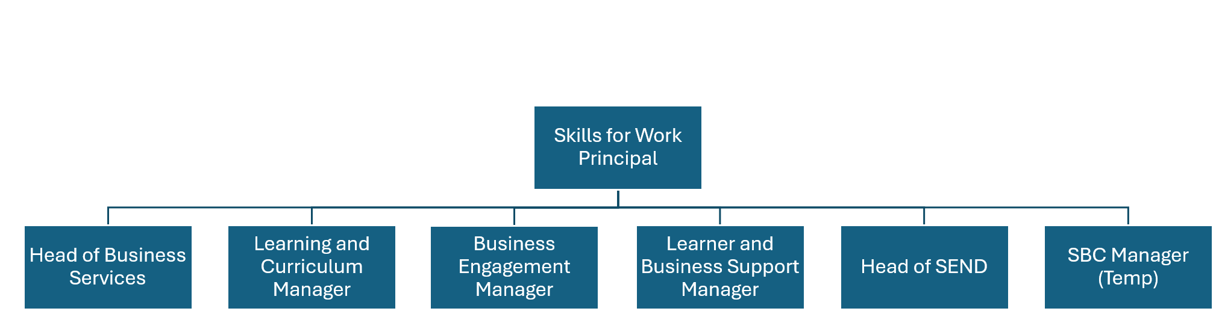

Person Specification
Knowledge / Skills / Experience required

Essential
- Degree level or equivalent qualifications in education, SEND, or related field.
- Proven experience managing SEND provision within education or skills settings.
- Strong knowledge of SEND Code of Practice and statutory requirements.
- Experience in curriculum adaptation and inclusive practice.
- Excellent leadership, organisational, and communication skills.
- Knowledge of Ofsted Education Inspection Framework.

Desirable
- Experience within education, local authority or public sector.
- Understanding of local labour market and employer engagement strategies.

Key benchmarked competencies, traits and motives required to successfully deliver the role These will support recruitment, succession planning, development and performance management |  | Essential
Health and Safety | Uses knowledge of Health, Safety policies, procedures and regulations including risks in own area of work
IT Packages | Uses a range of complex IT packages relating to area of work
Service Improvement | Ability to adopt a process of continual improvement and suggest ways of working more efficient and effectively to improve service delivery
Continued professional Improvement | Carries out a variety of working practices, applies complex regulations, rules, procedures and processes across a technical /specialist area
Communication | Knows and understands how to use, interpret, handle and communicate, often complex and detailed information, and relay it to service users/stakeholders in writing and/or over the telephone / face to face.
Numeracy & Literacy | Demonstrates a high level of numeracy, literacy and accuracy across a range of activities
Relevant Professional Qualification | Degree level or equivalent experience in education, SEND, or related field.
Carries out performance management | Covers the employees’ capacity to manage their workload and carry out a number of specific tasks accurately and to a high standard.
Communicates Effectively | Covers a range of spoken and written communication skills required as a regular feature of the job. This includes exchanging information/building relationships, giving advice and guidance, counselling, negotiating and persuading and handling private, confidential and sensitive information.
Carries Out Effective Decision Making | Covers a range of thinking skills required for taking initiative and independent actions within the scope of the job. This includes planning and organising, self-effectiveness and any requirements to quality check work.
Undertakes Structured Problem-Solving Activity | Covers a full range of analytical skills required for gathering, collating and analysing the facts needed to solve problems. This includes creative and critical thinking, developing practical solutions, applying problem solving strategies and managing interpersonal relationships.
Operates with Dignity and Respect | Covers treating everyone with respect and dignity, maintains impartiality/fairness with all people, is aware of the barriers people face.
Practices Appropriate Leadership | Our managers motivate their staff to exceed expectations through raising their awareness of goals and moving them beyond self-interest for the sake of the team or service. They consider serving the District in all that they do.
Operates with Strategic Awareness | Our managers work with corporate priorities and policies in a joined up way with others, internally and externally. Works democratically, transparently and accountably.
Delivering Successful Performance | Our managers monitor performance of services, teams & individuals against targets & celebrate great performance. They promote the District’s vision & work to achieve Council’s values & agreed outcomes.
Applying Project and Programme Management | Our manager’s work to ensure that outcomes and objectives are achieved within desired timescales, make best use of resources and take a positive approach to contingency planning
Developing High Performing People and Teams | Our managers coach individuals and teams to achieve their potential and take responsibility for continuous improvement. They champion the Council’s values and goals.

Applicants with disabilities are only required to meet the essential special knowledge requirements (clearly marked)
Due to the Governments Fluency in English Duty for posts where employees speak directly to members of the public the postholder is required to meet the Lower threshold level.
You should be able to demonstrate that you can use a wide range of simple words and a standard English sentence structure to express and maintain a flowing conversation even though you pause to think of the correct words with the ability to express and make yourself understood (this will also be tested during the interview).

Completed by: | Suzan McGladdery | Date: | 15/12/25
Quality checked: |  | Date:

