CITY OF BRADFORD METROPOLITAN DISTRICT COUNCIL
JOB PROFILE

DEPARTMENT: Office of the Chief Executive | SERVICE GROUP: Policy and Performance
POST TITLE: Graduate Policy Officer | REPORTS TO: Senior Policy Officer
GRADE: Band 8 (SCP 20 – 22)  Centrally funded |  | SAP POSITION NUMBER: 50233396

The following information is furnished to help Council staff and those people considering joining the City of Bradford Metropolitan District Council to understand and appreciate the general work content of their post and the role they are to play in the organisation. The duties and responsibilities highlighted in this Job Profile are indicative and may vary over time. In addition, post holders are expected to undertake other duties, and responsibilities relevant to the nature, level, and scope of the post, and the grade has been established on this basis.

As a candidate, you will be expected to demonstrate your ability to meet the special knowledge, experience and qualifications required for the role by providing evidence in the application form for the purpose of shortlisting. Applicants with disabilities are only required to meet the essential special knowledge requirements shown by a cross in the end column of this section.

The employee competencies are the minimum standard of behaviour expected by the Council of all its employees and the management competencies outlined are those relevant for a post operating at this level within our organisation.

Both sets of competencies will be used at interview stage and will not be used for shortlisting purposes.

Key Purpose of Post:

Graduates who join BMDC are expected to:

- To provide and deliver key projects within the organisation.

- Provide support to the corporate policy function.

- Demonstrate the Council values and behaviours to enable a supportive and inclusive working culture where all staff are encouraged, supported and developed irrespective of their background.

Main Responsibilities of Post:

- Undertake policy and business analysis using management and other information, recognised techniques to outline challenges, opportunities, good practices, and solutions within clearly defined boundaries.

- Provide advice, guidance and support on all aspects of Council related policy, always ensuring that advice provided is compliant with relevant legislation, as well as working proactively to ensure that BMDC is a forward thinking, proactive organisation.
- Prepare clearly written reports, briefings and presentations for a range of audiences and purposes, and to support higher level decision making.

- Define, scope, and manage smaller projects as defined by the line manager.
- No line management responsibility but will work with and co-ordinate the work of individuals, both internal within the Department and external to the Department relating to the work assigned.
- Work with colleagues and stakeholders from across different services and with external partners to support the efficient and effective delivery of agreed objectives.

- To demonstrate Bradford Councils expected behaviours: Positive, Engaging, Responsible, Flexible.
- To investigate, share and transfer best practice to improve capacity within the Department and ensure lessons learned and knowledge transfer opportunities are exploited.
- To research and collate data from external sources to inform effective decision making to support a proactive policy function.
- Effectively manage own time to ensure deadlines are met.
- To ensure that all activities comply with the Council policies, values, and vision.
- To work flexibly with colleagues across the Council and partners in achieving the Councils’ priorities.
- Undertake any other duties as required by the line manager in relation to this post.

Special Knowledge Requirement: Essential for shortlisting. Max 10

Applicants with disabilities are only required to meet the essential special knowledge requirements shown by a cross in the end column
 | Essential
Demonstrate an understanding of how policies, procedures and practices can be used to achieve the desired results, benefits and outcomes. | X
Demonstrate an ability to use, interpret and analyse information, and complex information, from a variety of sources, and to communicate and present it effectively. | X
Demonstrate an ability to work with others in planning activities or projects. | X
Demonstrate some experience of managing multiple activities within set deadlines | X
Demonstrate some experience of project or business analysis in a work setting or as part of degree work. | X
Demonstrate some experience of managing multi activities within set deadlines. | X
Demonstrate involving and working with others in planning activities or projects. | X
Demonstrate an ability to use a range of ICT systems across your own work area and or across other areas of work. | X
Able to develop positive working relationships across all levels of the Council. | X
Able to provide written information in a variety of formats: for a range of audiences, and to support decision-making.
Structure
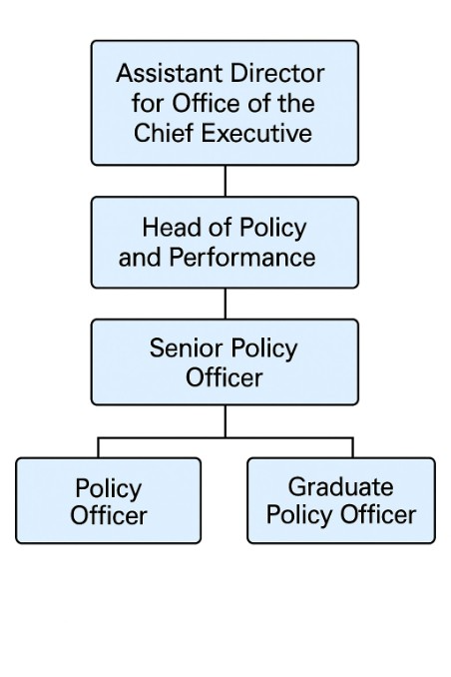

Relevant experience requirement: Essential for shortlisting

None

Relevant professional qualifications requirement: Essential for shortlisting

Achieved or predicted to achieve a degree (any class).

Core Employee competencies to be used at the interview stage.

Carries Out Performance Management – covers the employees capacity to manage
their workload and carry out a number of specific tasks accurately to a high standard.
Communicates Effectively - covers a range of spoken and written communication skills required as a regular feature of the job. It includes exchanging information/building relationships, giving advice and guidance, counselling, negotiating and persuading and handling private, confidential and sensitive information.
Carries Out Effective Decision Making - covers a range of thinking skills required for taking initiative and independent actions within the scope of the job. It includes planning and organising, and self-direction.
Undertakes Structured Problem Solving Activity - covers a range of analytical skills required for gathering, collating and analysing the facts needed to solve problems. It includes creative and critical thinking, developing practical solutions, applying problem solving strategies and managing interpersonal relationships.
Operates with Dignity and Respect - covers treating everyone with respect and dignity, maintains impartiality/fairness with all people, is aware of the barriers people face.

Competencies: to be used at the interview stage.

Operates with Strategic Awareness Our officers work with corporate priorities and policies in a joined up way with others, internally and externally. Works democratically, transparently and accountably.
Practices Appropriate Leadership Our officers motivate their staff to exceed expectations through raising their awareness of goals and moving them beyond self-interest for the sake of the team or service. They consider serving the District in all that they do.
Delivering Successful Performance Our officers monitor performance of services, teams & individuals against targets & celebrate great performance. They promote the District’s vision & work to achieve Council’s values & agreed outcomes.
Applying Project and Programme Management Our officers work to ensure that outcomes and objectives are achieved within desired timescales, make best use of resources and take a positive approach to contingency planning.
Developing High Performing People and Teams Our officers coach individuals and teams to achieve their potential and take responsibility for continuous improvement. They champion the Council’s values and goals.
Working Conditions:

Must be able to perform all duties and tasks with reasonable adjustment, where appropriate, in accordance with the Equality Act 2010 in relation to Disability Provisions.
Special Conditions:
Occasionally will need to be able to work evenings, weekends and bank holidays as
required by the needs of the service.
Compiled by: Helen Johnston  Date: March 2026 | Grade Assessment Date:  Graduate roles at Band 8. | Post Grade:  Band 8 (SCP 20 – 22)

